**Appendix D. Inverse Modelling: Methodological Details and Models**

The intratooth δ18O profiles presented in this study were obtained through inverse modelling using an adapted version of the code published in reference (Passey et al., 2005). This modelling approach allowed for correcting the damping effect and reconstructing the original δ18O input time series. The model utilises different species-specific parameters related to enamel formation, which vary between bovines and equids. Based on previous studies, these parameters have been established (Bendrey et al., 2015; Blumenthal et al., 2014; Kohn, 2004; Passey and Cerling, 2002; Zazzo et al., 2012). For Bos/Bison sp., the initial mineral content of enamel is fixed at 25%, the enamel appositional length is set at 1.5 mm, and the maturation length is 25 mm. For *Equus* sp., the initial mineral content of enamel is fixed at 22%, the enamel appositional length is set at 6 mm, and the maturation length is 28 mm.

In addition, the model requires other variables related to sampling geometry and error estimates derived from mass spectrometer measurements. The distance between samples varies for each tooth, but as a general trend, the sampling depth on the tooth enamel surface in the samples of this study represents approximately 70% of the total enamel depth. The standard deviation of the measurements obtained from the mass spectrometer was typically set at 0.12%, considering the uncertainty associated with the standards. Finally, the models require a damping factor that determines the cumulative damping along the isotopic profile by adjusting the measured error (Emeas) to the prediction error (Epred). The damping factor ranged from 0.001 to 0.1 in the teeth analysed in this study. The most likely model solutions were selected, and summer and winter values were extracted from the δ18O profiles, considering the original peaks and troughs identified in the unmodelled δ18O profile. This approach was adopted to prevent the introduction of artificial peaks that the model may produce, particularly in teeth without a distinct sinusoidal shape.

**Axlor**

**El Castillo**

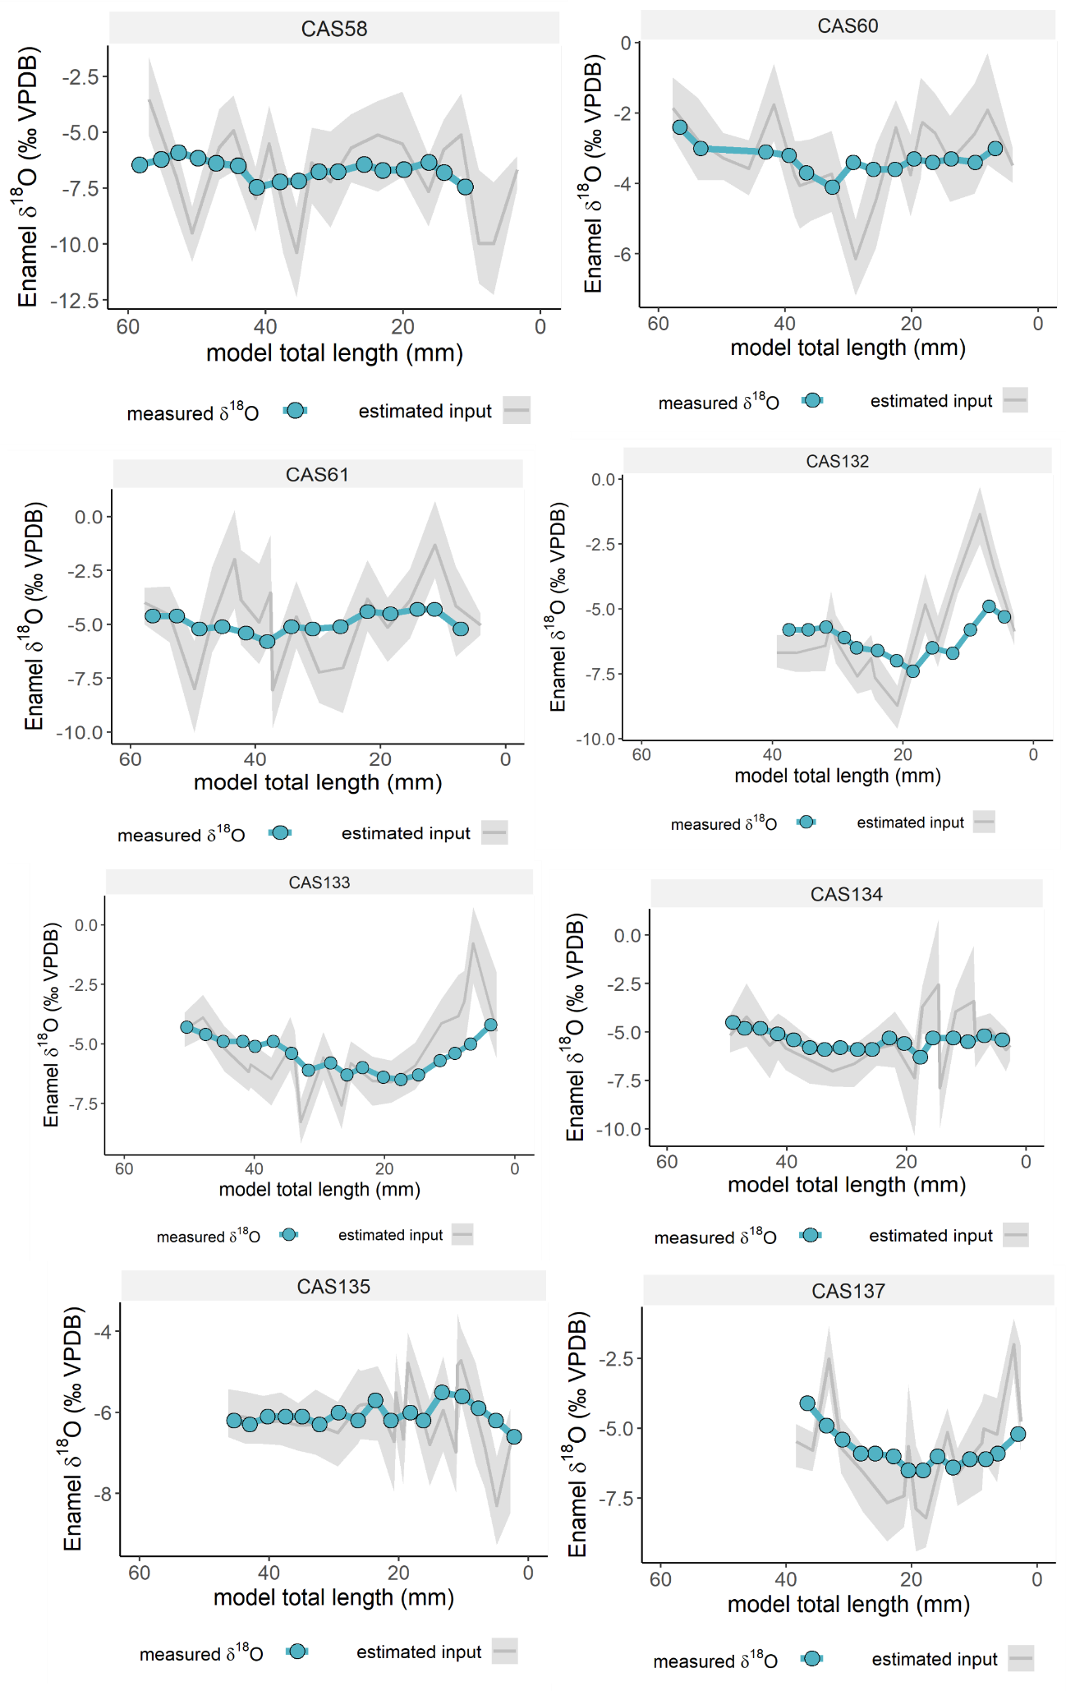

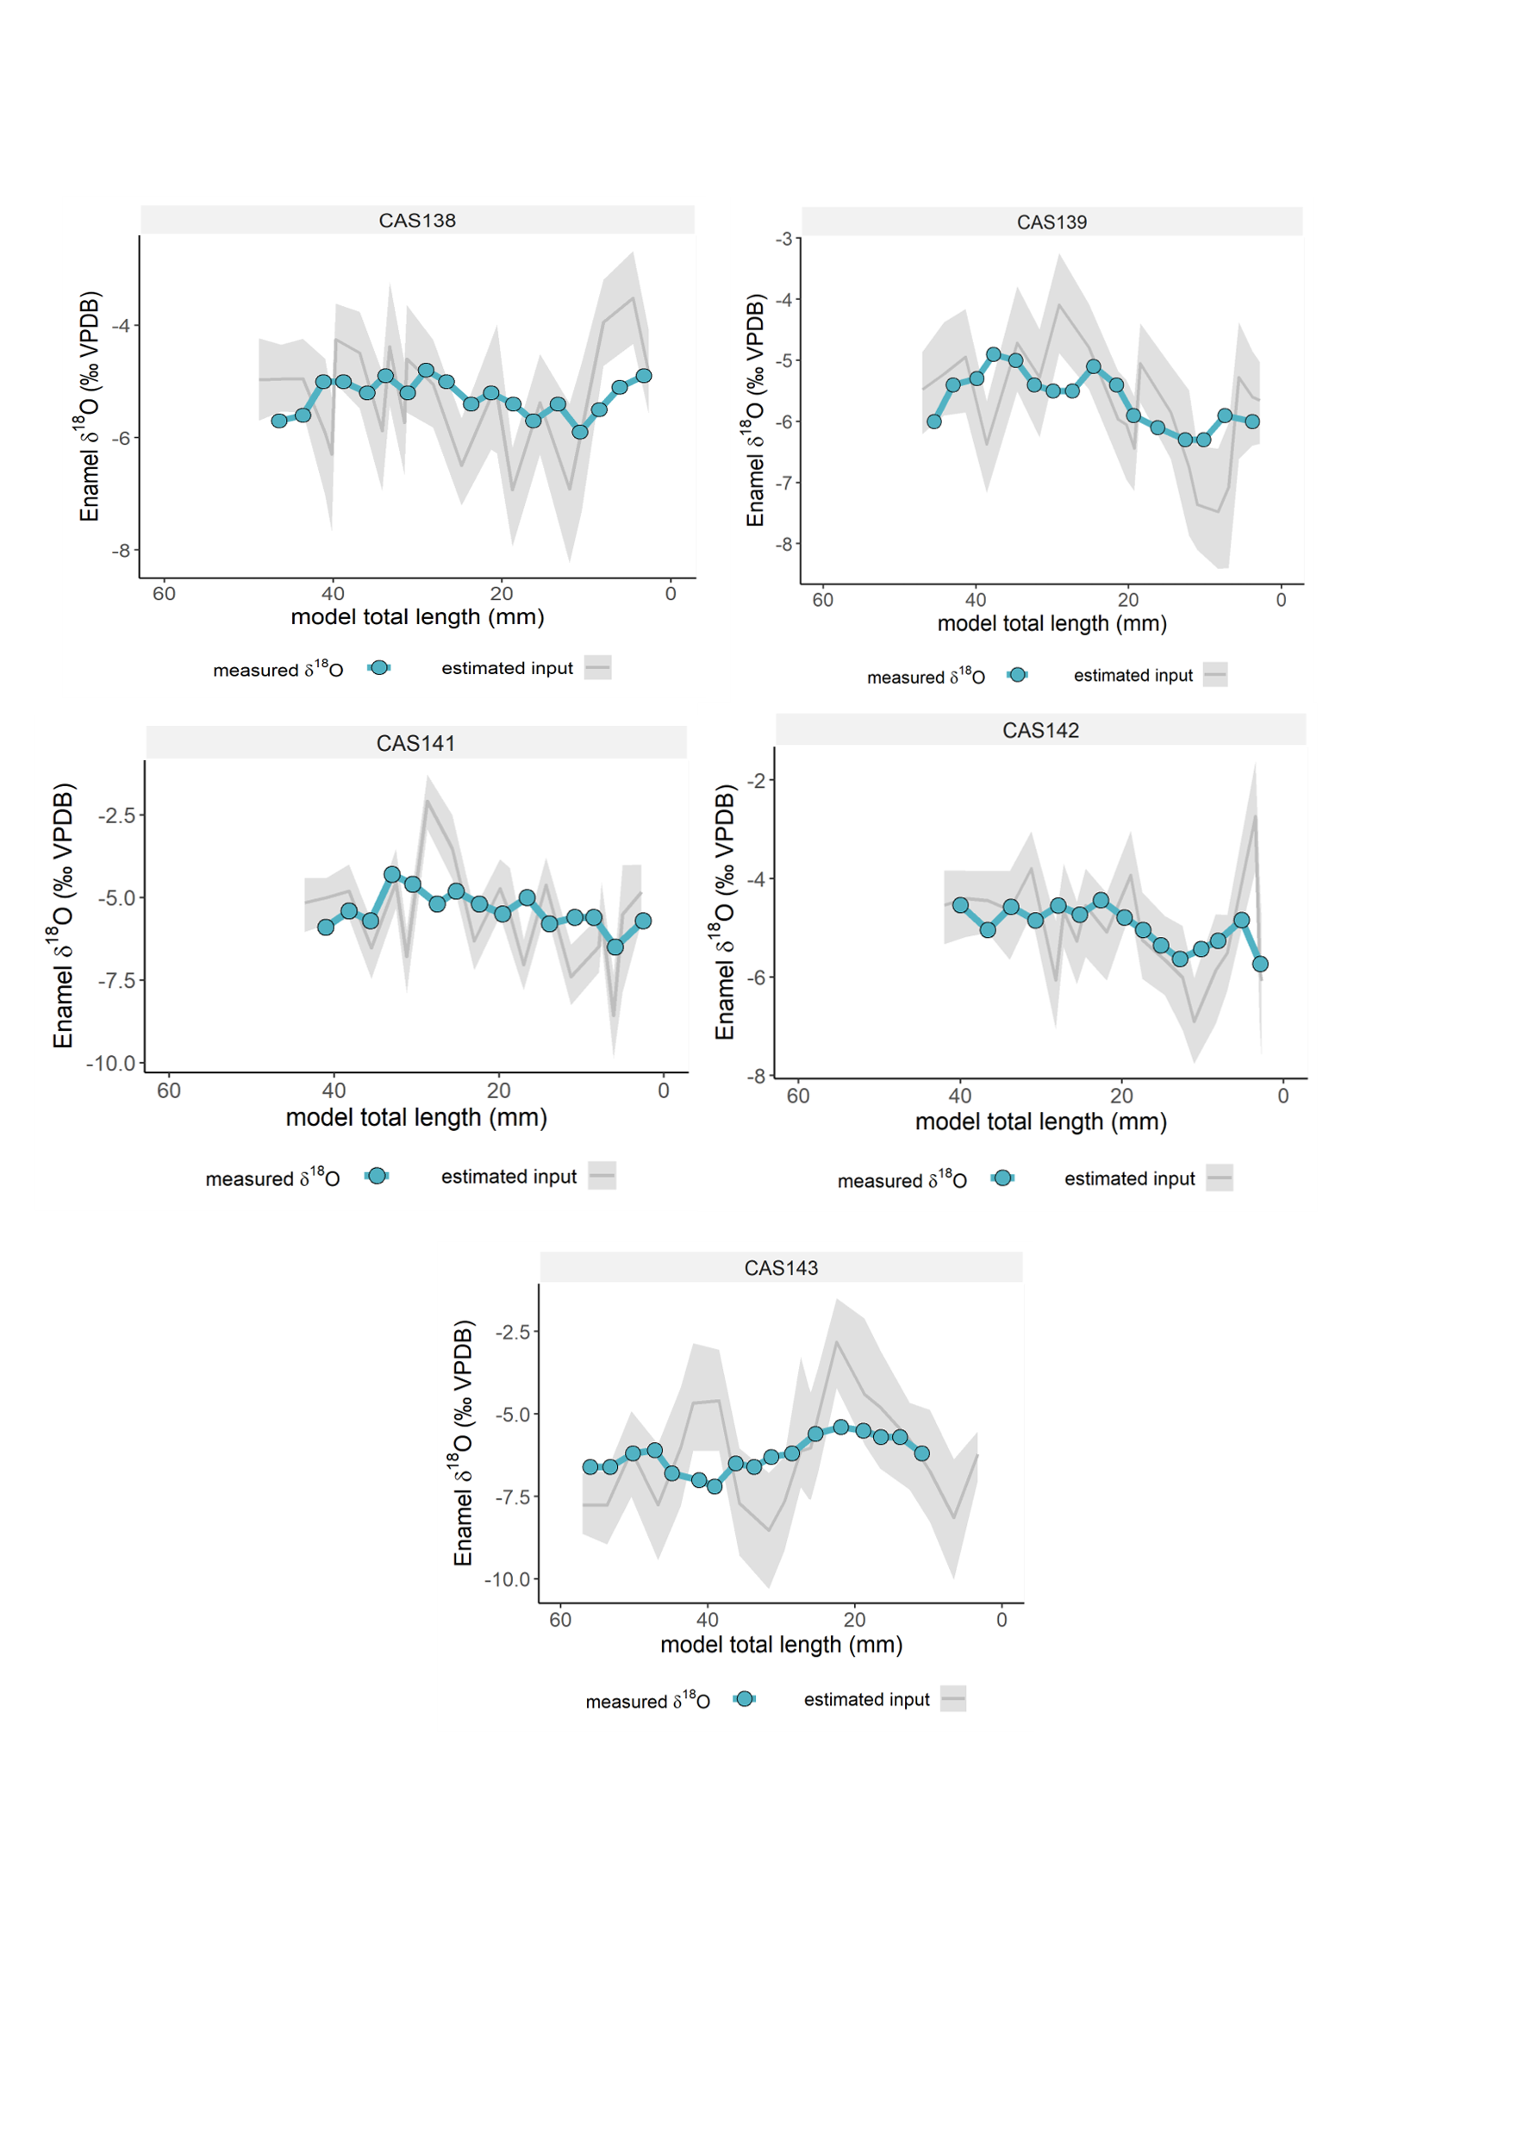

**Labeko Koba**

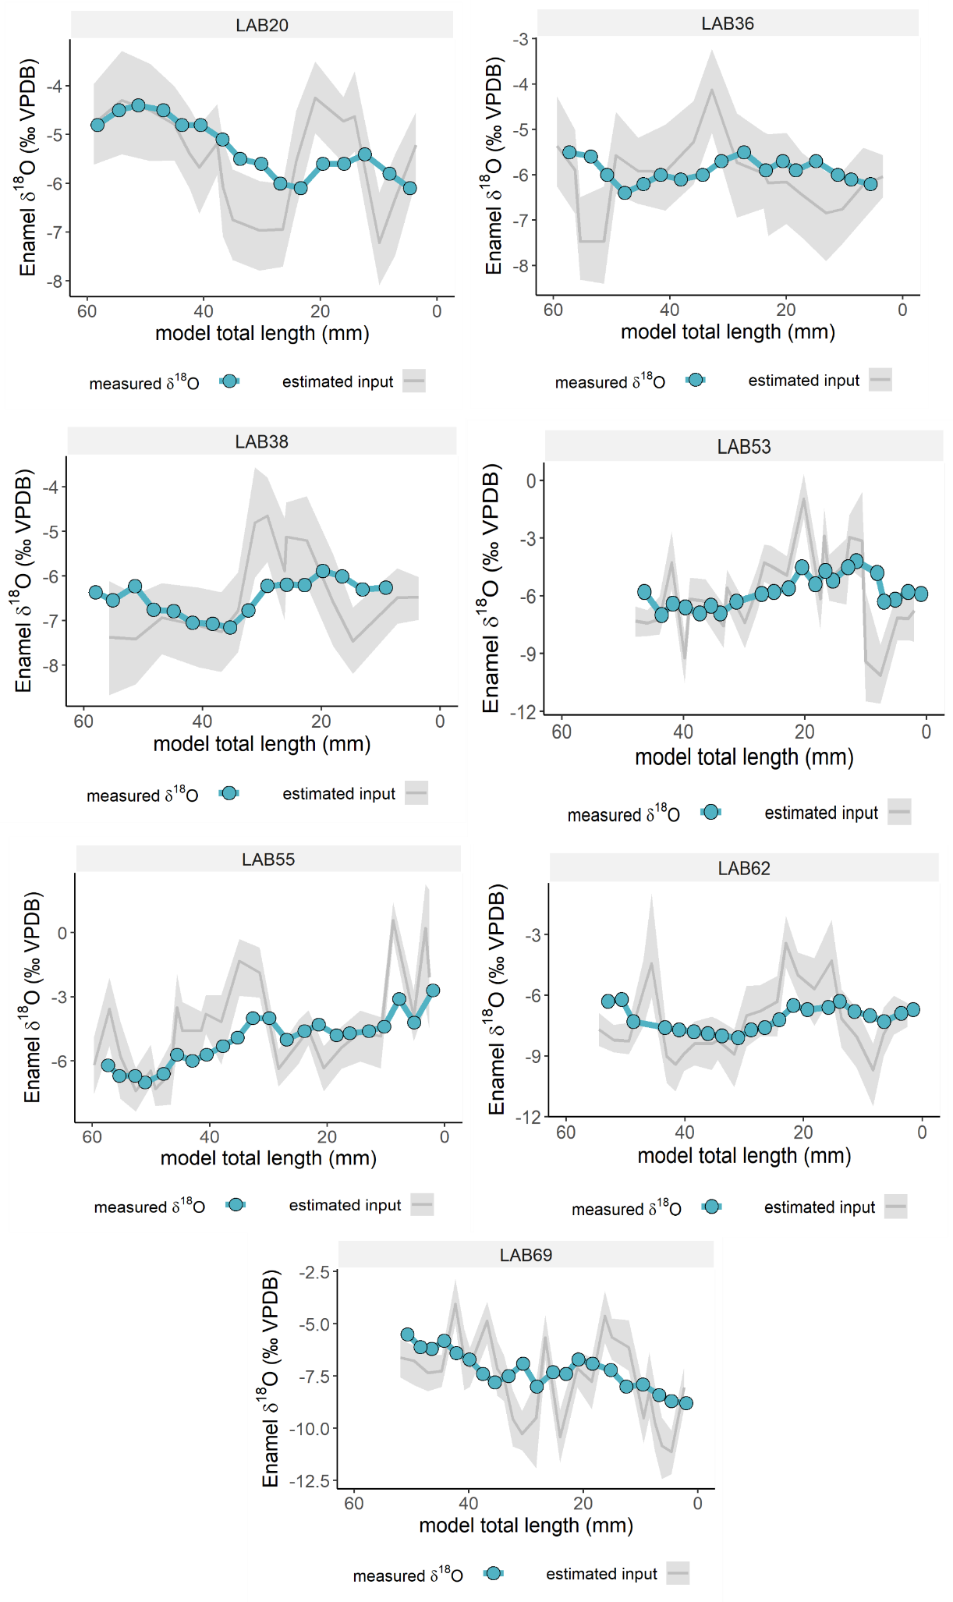

**Canyars**

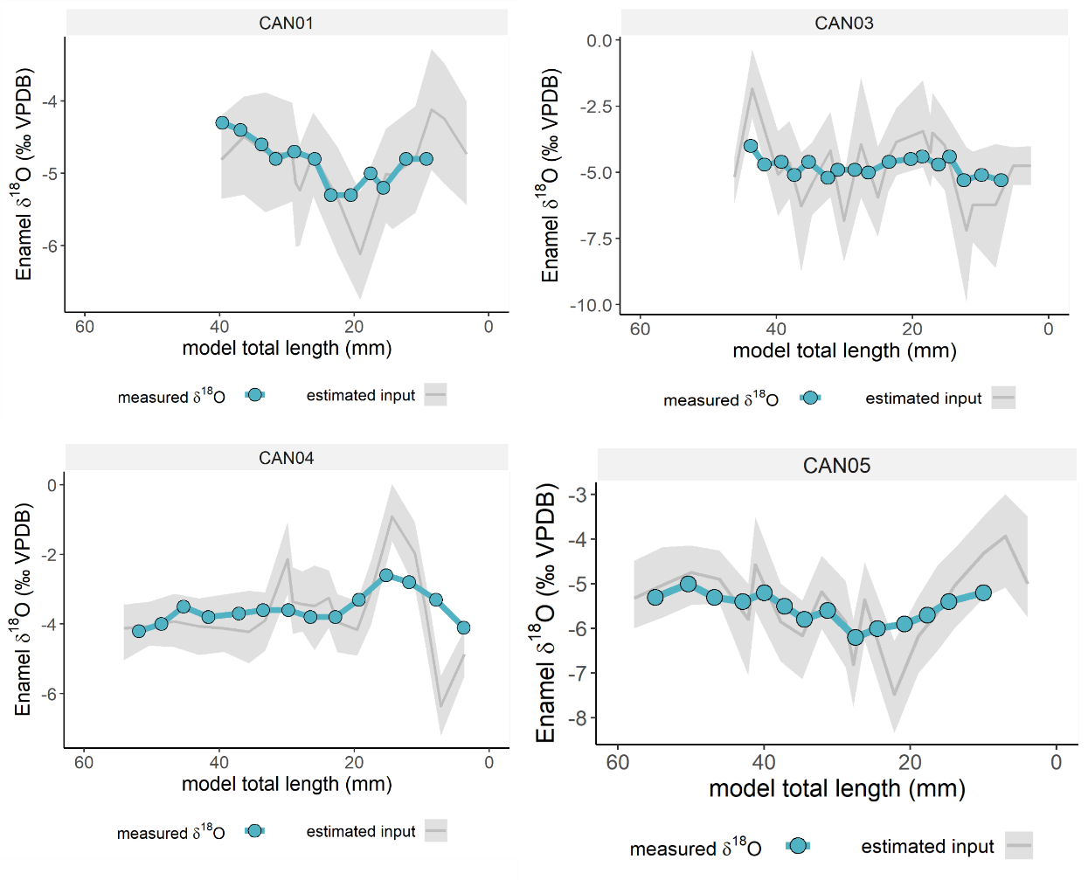

**El Otero**

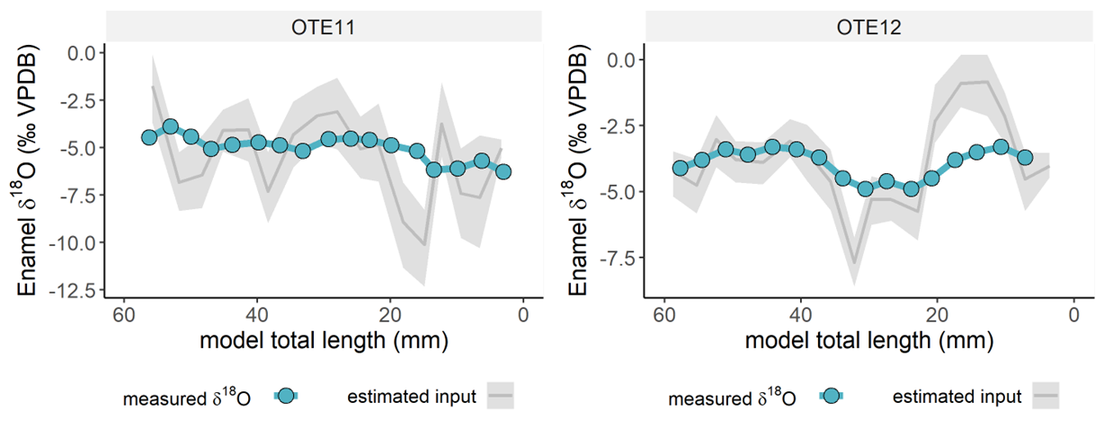

**Aitzbitarte III**

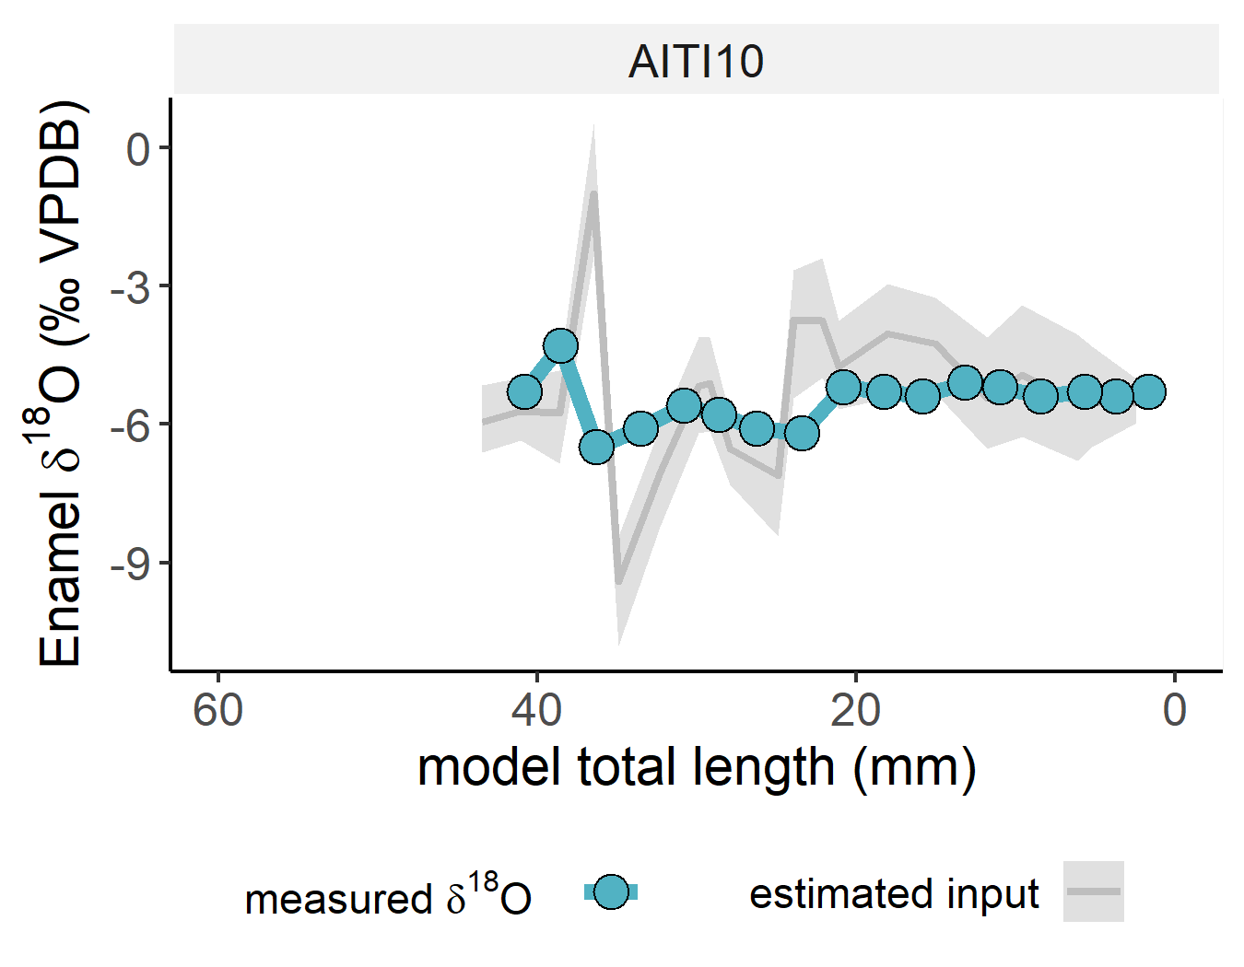

**References**

Bendrey, R., Vella, D., Zazzo, A., Balasse, M., Lepetz, S., 2015. Exponentially decreasing tooth growth rate in horse teeth: implications for isotopic analyses. Archaeometry 57, 1104–1124. https://doi.org/10.1111/arcm.12151

Blumenthal, S.A., Cerling, T.E., Chritz, K.L., Bromage, T.G., Kozdon, R., Valley, J.W., 2014. Stable isotope time-series in mammalian teeth: In situ δ18O from the innermost enamel layer. Geochim. Cosmochim. Acta 124, 223–236. https://doi.org/10.1016/j.gca.2013.09.032

Kohn, M.J., 2004. Comment: Tooth Enamel Mineralization in Ungulates: Implications for Recovering a Primary Isotopic Time-Series, by B. H. Passey and T. E. Cerling (2002). Geochim. Cosmochim. Acta 68, 403–405. https://doi.org/10.1016/S0016-7037(03)00443-5

Passey, B.H., Cerling, T.E., 2002. Tooth enamel mineralisation in ungulates: implications for recovering a primary isotopic time-series. Geochim. Cosmochim. Acta 66, 3225–3234. https://doi.org/10.1016/S0016-7037(02)00933-X

Passey, B.H., Robinson, T.F., Ayliffe, L.K., Cerling, T.E., Sponheimer, M., Dearing, M.D., Roeder, B.L., Ehleringer, J.R., 2005. Carbon isotope fractionation between diet, breath CO2, and bioapatite in different mammals. J. Archaeol. Sci. 32, 1459–1470. https://doi.org/10.1016/j.jas.2005.03.015

Zazzo, A., Bendrey, R., Vella, D., Moloney, A.P., Monahan, F.J., Schmidt, O., 2012. A refined sampling strategy for intra-tooth stable isotope analysis of mammalian enamel. Geochim. Cosmochim. Acta 84, 1–13. https://doi.org/10.1016/j.gca.2012.01.012