Supplementary Materials for

Late Pleistocene Neanderthal exploitation of stable and mosaic ecosystems in northern Iberia shown by multi-isotope evidence

Sarah Pederzani1, Kate Britton, Jennifer Rose Jones, Lucía Agudo Perez, Jeanne Marie Geiling, Ana Belen Marín-Arroyo2 1Corresponding author; Email address: scpederz@ull.edu.es  
2Corresponding author; Email address: anabelen.marin@unican.es

**This PDF file includes:**

**Supplementary Figures S1 - S8**

Figure S1: Results of OxA-40151 radiocarbon date calibration.  
Figure S2: Cross validation of 18Ophos prediction.  
Figure S3: Alternative 18O time series with simulated 18Ophos prediction error.  
Figure S4: Inverse model outcomes for alternative 18O time series.  
Figure S5: Extracted summer peak and winter trough values from alternative 18O time series.  
Figure S6: Summer, mean and winter 18Odw estimates.  
Figure S7: Sequential 18Ocarb and 13Ccarb data.  
Figure S8: Correlation of 18Ocarb and 13Ccarb in annual means.

**Supplementary Tables S1 - S2**

Table S1: Quality control indicators for OxA-40151 collagen extract.  
Table S2: Results of 18Odw and palaeotemperature estimation.

**Other Supplementary Material for this manuscript includes the following:**

Data and code to reproduce the manuscript files, figures and analyses are available at <https://github.com/ERC-Subsilience>.

**Supplementary Text**

# Assumptions and basis of the oxygen isotope palaeothermometer

Palaeotemperature reconstructions based on 18O of ungulate dental enamel have their basis in the linear relationships between 18Oenamel and 18O of drinking water (18Odw), and between environmental water 18O and air temperature (see main text section ‘Oxygen isotope analyses as a proxy of seasonal climate’). These relationships are well documented in modern animals and waters, but their application to archaeological specimens to reconstruct past climates is predicated on a few inherent assumptions that we discuss briefly here. Firstly, the exact numerical relationship between environmental water 18O and air temperature is to a certain degree dependent on atmospheric circulation systems. A sufficient degree of stability in atmospheric circulation reaching back into the European Late Pleistocene to maintain a stable slope of the 18Oprecip - air temperature relationship has been shown using circulation models as well as by comparisons of palaeotemperature estimates with 18O measurements of Pleistocene groundwaters (Rozanski, 1985; Rozanski et al., 1992; Zuber et al., 2004; Kaspar et al., 2005; Tütken et al., 2007). The relationship between 18Oenamel and 18Odw is similarly thought to be robust on these time scales, as there is no evidence to suggest any pronounced metabolic differences that could cause changes in drinking requirements in species of interest such as horses or large bovids across the relatively short time scales since the Late Pleistocene (Winchester and Morris, 1956; McHugh, 1958; Maloiy, 1973; Hinton, 1978; Groenendyk et al., 1988; Scheibe et al., 1998; Houpt et al., 2000; Arias and Mader, 2011). Other palaeotemperature estimation prerequisites should be validated for each study area. This includes the assumption that drinking water sources that are used by study animals are predominantly fed by local precipitation and are isotopically closely tied to it. The role of aridity in affecting 18O of potential water sources should also be checked for each study setting.

# Silver phosphate preparation

Approximately 5 mg of tooth enamel powder of each sample were weighed into 2 mL Eppendorf microcentrifuge tubes. Samples were agitated in 0.4 mL of 2 M hydrofluoric acid (HF) for 24 hours to digest bioapatite and remove calcium from the solution as CaF2. After digestion, samples were centrifuged (12000 rpm for 5 Min) to separate the phosphate containing solution from CaF2 precipitate in the solution transferred to a clean microcentrifuge tube. To maximise phosphate recovery the CaF2 precipitate was washed once with 0.1 mL MilliQ ultra pure water and the wash added to the phosphate containing solution. The sample solution was then titrated to neutrality as indicated by the colour change point of Bromothymolblue indicator using 25% ammonia solution (NH4OH). 60 L of NH4OH were first added to each sample using an automatic pipette and each solution then slowly brought to the colour change point (yellow to green) using individual drops of NH4OH added with a 100 $μ$ L Hamilton Microliter fixed needle syringe (Hamilton Bonaduz AG, Switzerland). From the neutralised solutions, Ag3PO4 was crash precipitated by addition of 0.4 mL 2 M silver nitrate (AgNO3) solution. The resulting precipitate was separated from the supernatant solution by centrifugation (12000 rpm for 5 Min) and the remaining silver nitrate solution removed. The silver phosphate precipitate was then washed four times with MilliQ ultrapure water using centrifugation and vortex mixing steps between rinses to eliminate any silver nitrate from the sample. Silver phosphate samples were then dried overnight at 50 °C and stored over desiccant until further analysis.

# Extraction and stable isotope analysis of bone collagen

Bone sub-samples between 0.5-0.8 g were cleaned by mechanical abrasion to remove any possible surface contamination and starting weight of the samples were recorded. Cleaned specimens were then placed in 0.5 M HCL at 6–8 °C for between 3 and 14 days until the bone had fully demineralised. Samples were checked regularly, and acid was changed regularly every (typically every 48h) to maintain the reaction. When fully demineralised, samples were washed three times using Milli-Q ultrapure water to remove any residual acid. Samples were then gelatinised in a weak acidic solution (pH 3 HCL) at 70 °C for 48 h to allow the collagen to hydrolyse. The samples were then filtered using 5–8 μm Ezee biological filters, and were placed into a -20°C freezer for at least 24h prior to lyophilisation. Frozen collagen samples were then freeze-dried for approximately 56 h. The resulting collagen was weighed to calculate the collagen yield of each specimen as an indicator of preservation.

This method differs slightly from the collagen extraction method used for the Jones et al. (2018) study where an additional ultrafiltration step was used to the isolate the >30 ka collagen fraction. Studies have shown that there is no difference in 13C and 15N values achieved from bone collagen extracted using ultrafiltration versus non-ultrafiltered if bone specimens are well preserved (Sealy et al., 2014), such as those from Axlor. Ultrafiltration has the added limitation of reducing collagen yields, which may prevent sufficient collagen being available for 34S analysis which typically requires >5mg of collagen for analysis.

For carbon and nitrogen stable isotope analysis, samples were weighed into tin capsules and introduced into a Europa Scientific elemental analyser, where conversion to CO2 and N2 was achieved using a combustion reactor temperature of 1000 °C and a reduction reactor temperature of 600 °C. Gas separation was achieved using a packed GC column held at 65 °C, and separated gases introduced into a Europa Scientific 20-20 isotope ratio mass spectrometer. The calibration procedure and measures of analytical precision are described in the article main text.

For sulphur stable isotope analysis,samples were weighed into tin capsules together with vanadium pentoxide as a combustion catalyst and introduced into a Europa Scientific elemental analyser, where conversion to SO2 was achieved using a combustion reactor temperature of 1080 °C in the presence of Tungstic oxide and zirconium oxide followed by reduction over copper wires. Water was removed using a Nafion membrane and gas separation achieved using a packed GC column held at 32 °C. SO2 was then introduced into a Europa 20-20 isotope ratio mass spectrometer to obtain 34S measurements. The calibration procedure and measures of analytical precision are described in the article main text.

# Radiocarbon dating methodology

Collagen extraction was conducted following methods in Brock et al. (2010), using a drilled bone powder sample, which was demineralised over night using 0.5 M hydrochloric acid (HCl) at 5°C. Humic acids were removed using 0.1 M sodium hydroxide solution (NaOH) for 30 minutes at room temperature followed by a wash in 0.5 M HCl for 1 hour. Collagen was then gelatinised in 0.001 M HCl at 70°C for 20 hours and filtered using EZEE filter (45-90 $μ$ m) followed by ultrafiltration using cleaned 30 kDa MWCO Vivaspin 15 ultrafilters. Collagen was combusted using an elemental analyser (ANCA-GSL) coupled to a Sercon 20-20 isotope ratio mass spectrometer for carbon and nitrogen stable isotope analyses, and excess CO2 was graphitised in the presences of an iron catalyst and dated via Accelerator Mass Spectrometry.

# Supplementary Figures

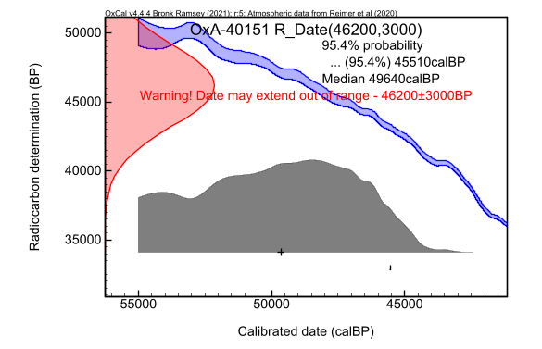

Figure S1: Calibrated age range of the newly dated bone specimen from Level III. Calibration was performed using OxCal version 4.4 (Bronk Ramsey, 2009) and the IntCal20 data set (Reimer et al., 2020).

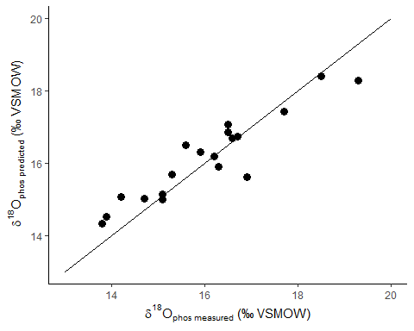

Figure S2: A comparison of directly measured $δ^{18}$ O $​_{\text{phos}}$ values with those predicted from bioapatite carbonate shows good correlation between the two, validating the possibility of the prediction with reasonable accuracy and precision.

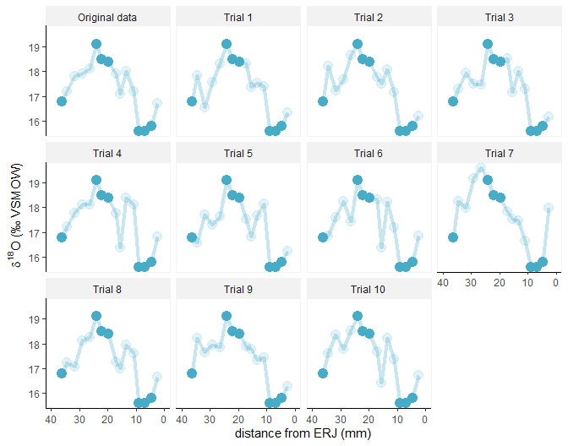

Figure S3: Different combined $δ^{18}$ O time series stitched from measured (solid symbols) and predicted (transparent symbols) $δ^{18}$ O $​_{\text{phos}}$ values that are possible within the uncertainty of the prediction (here called ‘Trials’) were generated by simulation using the addition of random errors on the predicted values.

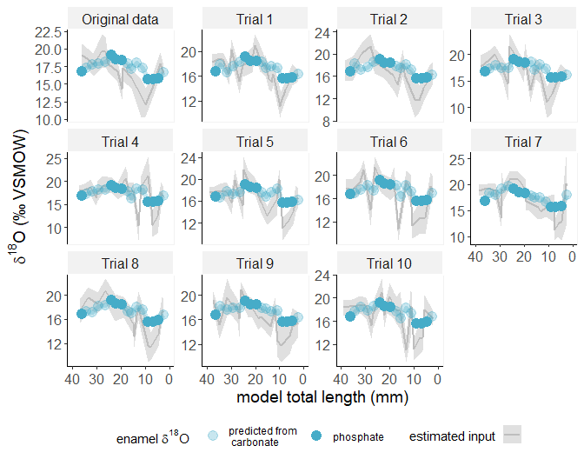

Figure S4: Inverse models were produced for all simulated $δ^{18}$ O time series (Trials) to explore the effect of the variability between oxygen isotope sequences introduced from $δ^{18}$ O $​_{\text{phos}}$ prediction uncertainty on the final $δ^{18}$ O summer and winter values extracted from the inverse model output (grey lines represent the most likely model solution, while shaded areas show the 95% confidence interval). Note that the y-axes are not the same in all plots to preserve visibility of seasonal oxygen isotope change.

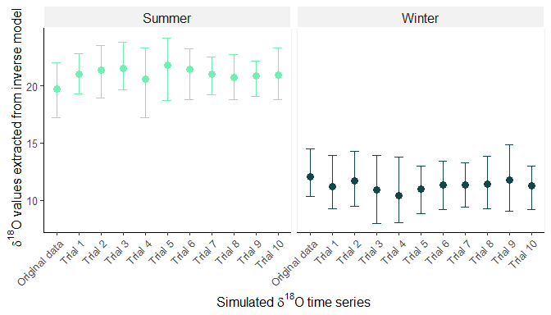

Figure S5: Summer peak and winter trough $δ^{18}$ O values extracted from the inverse models of simulated $δ^{18}$ O time series are extremely similar between simulations with between-trial variability much lower than inverse model uncertainty. This shows that palaeotemperature relevant outcomes of the prediction and modelling procedure are largely unaffected by the uncertainty introduced through predicting $δ^{18}$ O $​_{\text{phos}}$ from carbonate $δ^{18}$ O measurements in non-peak curve areas.

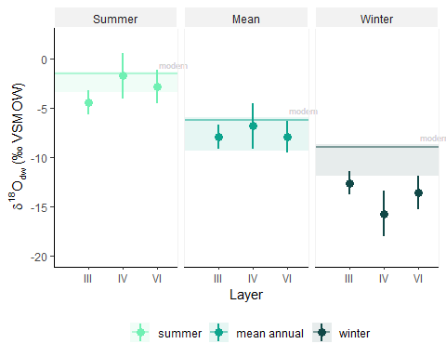

Figure S6: Reconstructed oxygen isotope composition of drinking water ($δ^{18}$ O $​_{\text{dw}}$) are similar to in summer and slightly lower in winter than estimates of modern day precipitation oxygen isotope values ($δ^{18}$ O $​_{\text{precip}}$) estimated for the location of the site (line) and a surrounding area of 50 km radius (shaded ribbon, estimates made using the OIPC (Bowen and Revenaugh, 2003)). Highest and lowest $δ^{18}$ O $​_{\text{precip}}$ values in a 50 km radius were approximated as the $δ^{18}$ O $​_{\text{precip}}$ values at highest and lowest elevation - Gorbeia Mountain (1,482 m a.s.l.) and Bilbao (19 m a.s.l.) respectively.

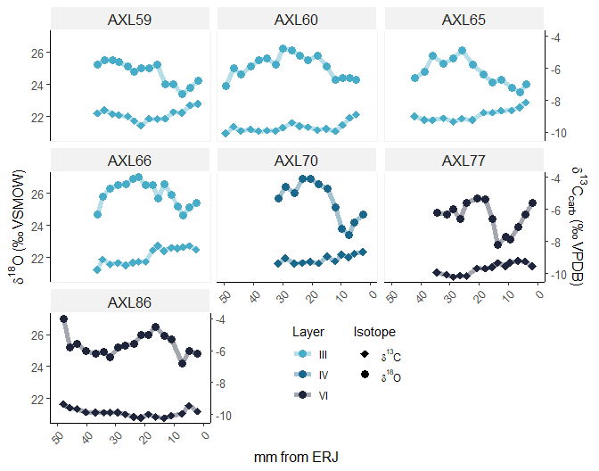

Figure S7: Sequential carbon (hollow symbols) and oxygen (filled symbols) isotope measurements of *Bos/Bison* tooth enamel bioapatite carbonate samples colored by Layer reveal little seasonal or inter-individual variability in carbon isotope values.

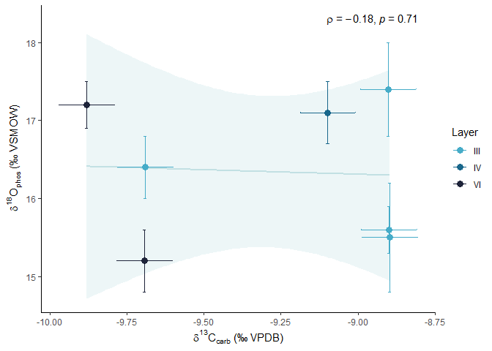

Figure S8: Annual means of bioapatite oxygen and carbon stable isotope delta values from *Bos/Bison* teeth do not show a detectable corrlation. Each point represents a single specimen, with an OLS linear model represented by a best-fit line and shaded 95% confidence interval to illustrate the lack of correlation. Spearman correlation shows a correlation coefficient ($ρ$) close to 0 and p = 0.71, indicating that no linear or monotic relationship is present. Error bars represent measurement precision.

# Supplementary Tables

Table S1: Quality indicators of collagen preservation for the radiocarbon dated specimen AXL55.

| OxA | Sample ID | Taxon | % yield | % C | % N | C/N | δ13C | δ15N |
| --- | --- | --- | --- | --- | --- | --- | --- | --- |
| OxA-40151 | AX.11E.255.128/AXL55 | *Bos/Bison* | 1.1 | 32.4 | 11.5 | 3.3 | -20.0 | 6.4 |

Table S2: Overview of estimates made for drinking water oxygen isotope values and palaeotemperatures for summer, winter and annual means of each studied archaeological layer.

| Layer | Record type | δ18Odw | δ18Odw error | Temperature | T error |
| --- | --- | --- | --- | --- | --- |
| III | Summer | -4.4 | 1.2 | 22.6 | 2.7 |
| IV | Summer | -1.7 | 2.3 | 28.5 | 5.1 |
| VI | Summer | -2.8 | 1.7 | 26.1 | 3.8 |
| III | Mean annual | -7.9 | 1.2 | 11.4 | 2.4 |
| IV | Mean annual | -6.8 | 2.3 | 13.6 | 4.6 |
| VI | Mean annual | -7.9 | 1.6 | 11.4 | 3.2 |
| III | Winter | -12.6 | 1.2 | -2.6 | 2.3 |
| IV | Winter | -15.7 | 2.3 | -8.5 | 4.5 |
| VI | Winter | -13.6 | 1.7 | -4.5 | 3.3 |

# References

Arias, R.A., Mader, T.L., 2011. Environmental factors affecting daily water intake on cattle finished in feedlots. *Journal of Animal Science* 89, 245–251. <https://doi.org/10.2527/jas.2010-3014>

Bowen, G.J., Revenaugh, J., 2003. Interpolating the isotopic composition of modern meteoric precipitation. *Water Resources Research* 39, 1–13. <https://doi.org/10.1029/2003WR002086>

Brock, F., Higham, T., Ramsey, C.B., 2010. Pre-screening techniques for identification of samples suitable for radiocarbon dating of poorly preserved bones. *Journal of Archaeological Science* 37, 855–865. <https://doi.org/10.1016/j.jas.2009.11.015>

Bronk Ramsey, C., 2009. Bayesian analysis of radiocarbon dates. *Radiocarbon* 51, 337–360.

Groenendyk, S., English, P.B., Abetz, I., 1988. External balance of water and electrolytes in the horse. *Equine Veterinary Journal* 20, 189–193. <https://doi.org/10.1111/j.2042-3306.1988.tb01497.x>

Hinton, M., 1978. On the Watering of Horses: A Review. *Equine Veterinary Journal* 10, 27–31. <https://doi.org/10.1111/j.2042-3306.1978.tb02210.x>

Houpt, K.A., Eggleston, A., Kunkle, K., Houpt, T.R., 2000. Effect of water restriction on equine behaviour and physiology. *Equine Veterinary Journal* 32, 341–344.

Jones, J.R., Richards, M.P., Straus, L.G., Reade, H., Altuna, J., Mariezkurrena, K., Marín-Arroyo, A.B., 2018. Changing environments during the Middle-Upper Palaeolithic transition in the eastern Cantabrian Region (Spain): direct evidence from stable isotope studies on ungulate bones. *Scientific Reports* 8. <https://doi.org/10.1038/s41598-018-32493-0>

Kaspar, F., Kühl, N., Cubasch, U., Litt, T., 2005. A model-data comparison of European temperatures in the Eemian interglacial. *Geophysical Research Letters* 32, 1–5. <https://doi.org/10.1029/2005GL022456>

Maloiy, G.M.O., 1973. Water metabolism of East African ruminants in arid and semi-arid regions. *Zeitschrift für Tierzüchtung und Züchtungsbiologie* 90, 219–228. <https://doi.org/10.1111/j.1439-0388.1973.tb01443.x>

McHugh, T., 1958. Social behavior of the American buffalo (Bison bison bison). *Zoologica* 43, 1–40.

Reimer, P., Austin, W.E.N., Bard, E., Bayliss, A., Blackwell, P.G., Bronk Ramsey, C., Butzin, M., Cheng, H., Edwards, R.L., Friedrich, M., 2020. The IntCal20 Northern Hemisphere radiocarbon age calibration curve (0-55 kcal BP). *Radiocarbon* 62, 725–757. <https://doi.org/doi:10.1017/RDC.2020.41>

Rozanski, K., 1985. Deuterium and oxygen-18 in European groundwaters - Links to atmospheric circulation in the past. *Chemical Geology: Isotope Geoscience section* 52, 349–363. <https://doi.org/10.1016/0168-9622(85)90045-4>

Rozanski, K., Araguás-Araguás, L., Gonfiantini, R., 1992. Relation Between Long-Term Trends of Oxygen-18 Isotope Composition of Precipitation and Climate. *Science* 258, 981–985. <https://doi.org/10.1126/science.258.5084.981>

Scheibe, K.M., Eichhorn, K., Kalz, B., Streich, W.J., Scheibe, A., 1998. Water consumption and watering behavior of Przewalski horses (Equus ferus przewalskii) in a semireserve. *Zoo Biology: Published in affiliation with the American Zoo and Aquarium Association* 17, 181–192.

Sealy, J., Johnson, M., Richards, M.P., Nehlich, O., 2014. Comparison of two methods of extracting bone collagen for stable carbon and nitrogen isotope analysis: Comparing whole bone demineralization with gelatinization and ultrafiltration. *Journal of Archaeological Science* 47, 64–69. <https://doi.org/10.1016/j.jas.2014.04.011>

Tütken, T., Furrer, H., Walter Vennemann, T., 2007. Stable isotope compositions of mammoth teeth from Niederweningen, Switzerland: Implications for the Late Pleistocene climate, environment, and diet. *Quaternary International* 164-165, 139–150. <https://doi.org/10.1016/j.quaint.2006.09.004>

Winchester, C.F., Morris, M.J., 1956. Water Intake Rates of Cattle. *Journal of Animal Science* 15, 722–740. <https://doi.org/10.2527/jas1956.153722x>

Zuber, A., Weise, S.M., Motyka, J., Osenbrück, K., Rózański, K., 2004. Age and flow pattern of groundwater in a Jurassic limestone aquifer and related Tertiary sands derived from combined isotope, noble gas and chemical data. *Journal of Hydrology* 286, 87–112. <https://doi.org/10.1016/j.jhydrol.2003.09.004>