Usability Guide

Contents

Site Navigation 2

Navigation using dropdown menu 3

Shopping Cart 4

Adding items to your cart 4

Navigating your shopping cart 5

Checkout process 6

# Site Navigation

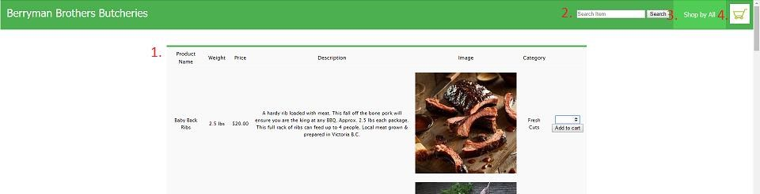

1. Product Display table
2. Search Bar
3. Site navigation Dropdown
4. Shopping Cart

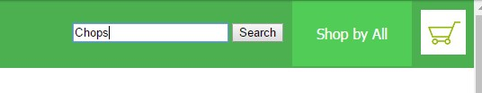

Using the Search bar

Select the form and fill out desired query and click on the *Search* button. All items matching your search will be returned.

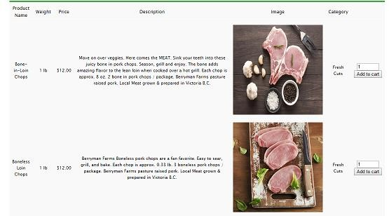

*A search for “chops” returns two items.*

## Navigation using dropdown menu

Mouse over the *Shop by All* button and the menu will appear. As you hover over each option they will be highlighted.

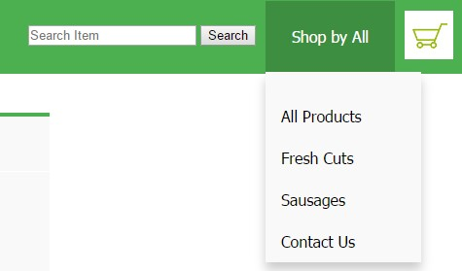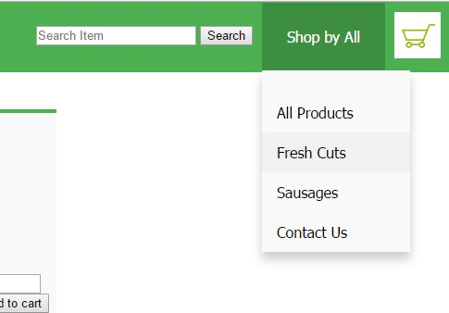

Select your preferred option and you will be redirected to that page.

# Shopping Cart

## Adding items to your cart

Once you’ve found the items that you are looking for, select the quantity you wish to purchase and select *Add to Cart*, once you’ve added items to your cart you will notice a number corresponding to the quantity of items you’ve added appear on top of the *Shopping Cart* icon.

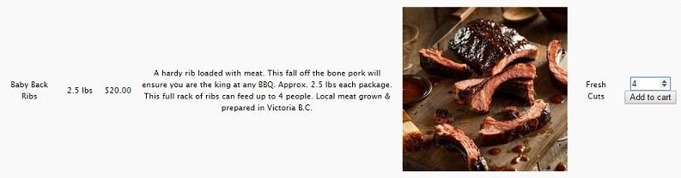

*Adding 4 Baby back Ribs to a cart*

## Navigating your shopping cart

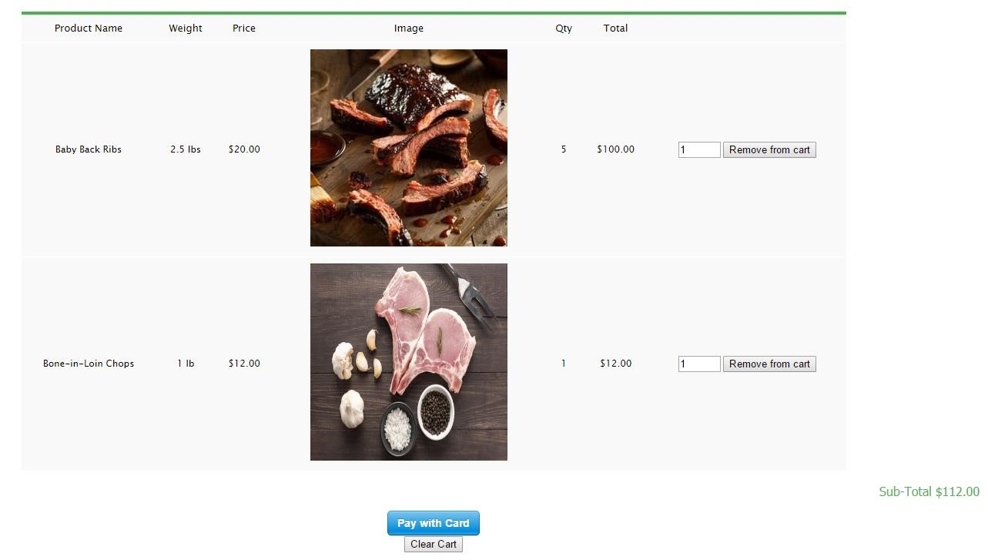After you have added items and moved to your shopping cart page, you will see the items, their quantities and a subtotal.

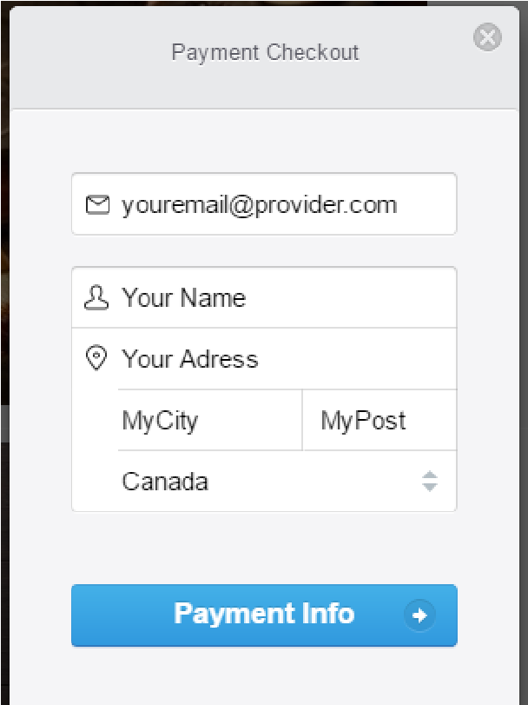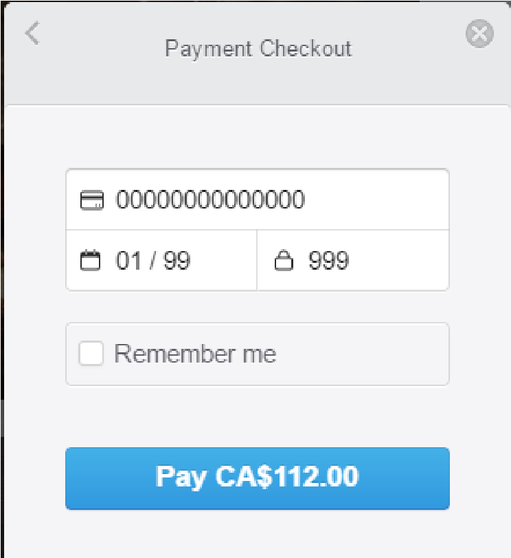

At this point you can remove one or more items from your cart before your checkout. If you wish to restart you can use the *Clear Cart* button to drop all items from your cart.

## Checkout process

Once you are happy with your selections, select the *Pay with Card* button and you will be prompted to enter your payment information. Once your information is entered continue to the Credit Card info prompt.

After your purchase is completed you will be redirected to the receipt splash page. Save this for your own records.

