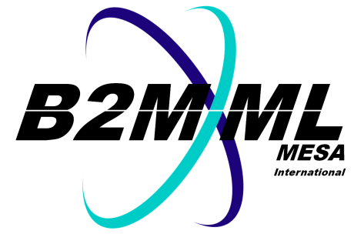

Business to Manufacturing   
Markup Language

B2MML-JSON V0700 Documentation

Version 0700 - November 2020

B2MML-JSON Doc

IMPORTANT: While the information, data, and standards provided in this publication were developed and are presented in good faith in accordance with a reasonable process that was subject to intellectual property and antitrust policies to benefit the industry as a whole, the publication is provided “as is” for information and guidance only, and there is no representation or warranty of any type or kind, including but not limited to warranties of merchantability or fitness for a particular purpose, and no warranty that use of the information, data, or standards will not infringe patent, copyright, trademark, trade secret, or other intellectual property rights of any party.

Copyright © 2020 MESA International

All Rights Reserved. http://www.mesa.org

This MESA Work (including specifications, documents, software, and related items) referred to as the Business To Manufacturing Markup Language (B2MML) is provided by the copyright holders under the following license.

Permission to use, copy, modify, or redistribute this Work and its documentation, with or without modification, for any purpose and without fee or royalty is hereby granted provided MESA International is acknowledged as the originator of this Work using the following statement:

"The Business To Manufacturing Markup Language (B2MML) is used courtesy of MESA International."

In no event shall MESA International, its members, or any third party be liable for any costs, expenses, losses, damages or injuries incurred by use of the Work or as a result of this agreement.

Material from ANSI/ISA-88 and ANSI/ISA-95 series of standards used with permission of ISA - The International Society of Automation, www.isa.org

Copyright © 2020 MESA International

All Rights Reserved. http://www.mesa.org

This MESA Work (including specifications, documents, software, and related items) referred to as the Business To Manufacturing Markup Language (B2MML) is provided by the copyright holders under the following license.

Permission to use, copy, modify, or redistribute this Work and its documentation, with or without modification, for any purpose and without fee or royalty is hereby granted provided MESA International is acknowledged as the originator of this Work using the following statement:

"The Business To Manufacturing Markup Language (B2MML) is used courtesy of MESA International."

In no event shall MESA International, its members, or any third party be liable for any costs, expenses, losses, damages or injuries incurred by use of the Work or as a result of this agreement.

Material from ANSI/ISA-88 and ANSI/ISA-95 series of standards used with permission of ISA - The International Society of Automation, [www.isa.org](http://www.isa.org)

# JSON Scema

The JSON schema (see [json-schema.org](http://www.json-schema.org) for a full definition of JSON schemas) of B2MML and BatchML was generated using XMLSpy-2021 from the AllSchemas.xsd file.

There has been no checking of this file. There has been no testing of this file. It is intended for distribution to aid in checking the use of JSON in place of XML for data exchanges.

If any errors or problems are discovered in the use or the format, then issues should be raised on the GitHub site.