THE POST-QUANTUM DIGITAL SIGNATURE SCHEME
Luu Hong Dung, Nguyen Kim Tuan, Nong Phuong Trang, Nguyen Thi Phuong Hang

Abstract: In this paper, the author proposes a post–quantum digital signature scheme based on a new of hard problem, which belongs to the group of unsolvable problems. Therefore, it can be resistant to quantum attacks based on the quantum algorithm proposed by P. Shor [1]. In addition to quantum resistance, the signature scheme proposed here can also be used as pre–quantum digital signature schemes that are widely used in current practical applications.
Keywords: Digital Signature, Digital Signature Scheme, Discrete Logarithm Problem, New Hard Problem, Post-quantum digital signature scheme, Quantum-resistant digital signature scheme.

1. INTRODUCTION
Digital signatures have now been widely applied in fields such as e-Government, e-Commerce, etc. or in telecommunications systems and computer networks. However, advances in quantum computing and quantum computers in recent years have threatened to undermine the security assumptions that underlie public-key cryptography algorithms in general and digital signature algorithms in use today.
The capabilities and operating mechanisms of quantum computers have become a direct impact on cryptography since P.Shor proposed efficient quantum algorithms to solve the prime factorization problem and the discrete logarithm problem in 1994 and later [1-3]. Therefore, quantum computers would render all public-key cryptography and digital signature algorithms based on the hard of these problems insecure. But from here also opens a new approach to the problem of construction post-quantum digital signature algorithms, that is, if using hard problems that have not been solved as the basis for construction post-quantum algorithms, these algorithms will be resistant to quantum attacks, because Shor's quantum algorithm has been disabled with hard problems belonging to the class of problems that have not been solved.
In this article, the author proposes a new type of hard problem on the finite field F_{p} and a quantum–resistant digital signature scheme based on this new type of hard problem. The scheme here, in addition to quantum attack resistance, can be used completely like the pre–quantum digital signature schemes (RSA, DSA,..) currently in use, suitable for many applications requiring high security in practice.
2. THE NEW HARD PROBLEMS ON THE FINITE FIELD
  - The Discrete logarithm problem on the finite field
The Discrete Logarithm Problem (DLP) is described as follows: Given a prime p, a generator g of 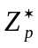 and an element y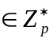, find the integer x, 0 ≤ x ≤ p – 2, such that:
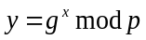
  - The new hard problems
From the Discrete logarithm problem on the finite field F_{p}, we see that if the parameter g is also kept secret, then the discrete logarithm problem on F_{p} will become an unsolvable problem. In the simplest case, it is possible to choose the secret key x itself for the role of the parameter g, the new hard problem is stated in the forms as follows:
Form 1: Given p is a prime number, for each pair of positive integers y₁ and y₂ in F_{p}, find the pair of numbers x₁ and x₂ that satisfies the following equation:
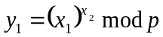
and:
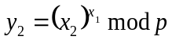
Form 2: Given p is a prime number and (a,b) are positive integers in F_{p}, find the number x that satisfies the following equation:
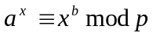
It is easy to see those existing algorithms for the Discrete logarithm problem on F_{p} [4-9] cannot be used to solve this problem. At present, there is no other solution to this problem other than the“brute force attack”method with computational complexity of about O(2^{n}), where: n = |p|.
In the proposed digital signature scheme, the first form of the hard problem is used to generate the public and private key pairs of the signer in the Key Generation algorithm, it is also used to generate signature in the Signature Generation algorithm, while the second form of this hard problem is used as the basis for construction the Signature Verification algorithm.
3. THE POST-QUANTUM DIGITAL SIGNATURE SCHEME BASED ON THE NEW HARD PROBLEMS
This section will present the construction of a quantum–resistant digital signature scheme based on the new hard problems mentioned in Section 2.
3.1. The proposed scheme

The proposed scheme here includes the Key Generation algorithm (Algorithm 25.1), the Signature Generation algorithm (Algorithm 25.2) and the Signature Verification algorithm (Algorithm 25.3). These algorithms are presented in the following sections 3.1.1, 3.1.2 and 3.1.3. The proof of the correctness is presented in sections 3.1.4.

3.1.1. The Key Generation algorithm
The End–User's public/private key pair is generated by the Key Generation algorithm based on the set of domain parameters, including a pair of prime numbers p,q satisfy: q|(p - 1). The domain parameters here can be generated as specified in ISO/IEC 14888-3[10], FIPS 186 – 4 [11] or GOST R34.10 – 94 [12].
To generate a private and public key pair, each signer first needs to choose 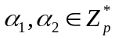, then compute the secret keys x₁,x₂ according to the formula:
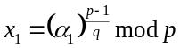
and:
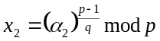
The public keys y₁ and y₂ are generated from x₁,x₂ and p,q according to the formula:
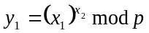 (25.1)
and:
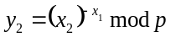 (25.2)
The Key Generation algorithm (Algorithm 25.1) of the proposed scheme is described as follows:

Algorithm 25.1:
input: L_{p},L_{q}.
output: p,q,x₁,x₂,y₁,y₂.
[1]. generate p,q: len(p)= L_{p}, len(q) = L_{q}, q|(p–1)
[2]. select α₁: 1<α₁ <p
[3]. 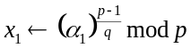 if (x₁ = 1) then goto [2]
[4]. select α₂: 1<α₂ <p
[5]. 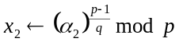 if (x₂ = 1) then goto [4]
[6]. 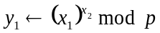 if (y₁ = 1) then goto [2]
[7]. 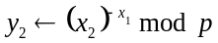 if (y₂ = 1) then goto [2]
[8]. return (p,q,x₁,x₂,y₁,y₂)
Note:
– len(.): function to calculate length (in bits) of an integer.
– L_{p}, L_{q}: length (in bits) of prime numbers p and q.
– p, q: system parameter/domain parameters.
– x₁,x₂,y₁,y₂: private and public keys of the signer.

3.1.2. The Signature Generation algorithm
Assuming (r,s) is the signature on the message to be signed M. The first component of the signature r is calculated according to the following formula:
(25.3)
Here: the k is a randomly chosen value in the range (1,q) and h is the representative value (hash value) of the message to be signed M: h = H(M).
The second component s of the signature is calculated according to the following formula:
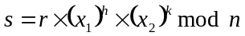 (25.4)
Here: 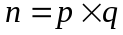.
The Signature Generation algorithm (Algorithm 25.2) of the proposed scheme is described as follows:

Algorithm 25.2:
input: p,q,x₁,x₂,M.
output:(r,s).
[1]. select k: 1 <k < p
[2]. 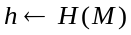
[3].
[4]. 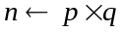
[5]. 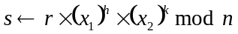
[6]. return (r,s)
Note:
- M: message to be signed, with: 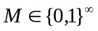.
- H(.): hash function, with 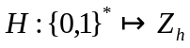, q < h < p.

3.1.3. The Signature Verification algorithm
The Signature Verification algorithm of the scheme is construction on the assumption:
(25.5)
That is, if M and the signature (r,s) satisfy the equality (25.5), then the signature is considered valid, and the message is verified for origin and integrity. Otherwise, the signature is considered forged, and the message to be verified is denied in terms of origin and integrity.
The Signature Verification algorithm (Algorithm 25.3) of the proposed scheme is described as follows:

Algorithm 25.3:
input: p,q,y₁,y₂,M,(r,s).
output: TRUE/FALSE.
[1]. 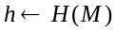
[2]. 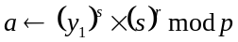
[3]. 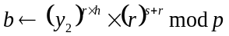
[4]. if (a = b) then return (TRUE)
else return (FALSE)
Note:
– M,(r,s): message and signature to be verified.
– If the result is TRUE, then the integrity and origin of M are asserted. Otherwise, if the result is FALSE, then M is denied for origin and integrity.

3.1.4. The correctness of the proposed scheme
What needs to be proved here is: if 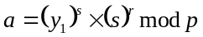 (25.6) and 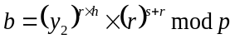 (25.7) then: a = b.
Indeed, if the signature and message to be verified are not forged, from (25.1),(25.4) and (25.6) we will have:
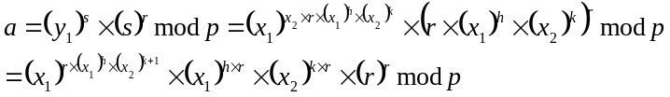 (25.8)
From (25.2),(25.3),(25.4) and (25.7) we get:
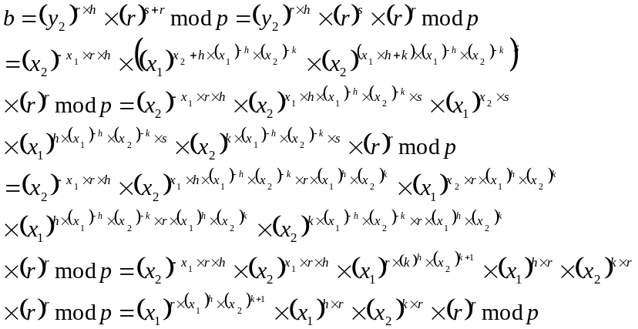 (25.9)
From (25.8) and (25.9) we have: 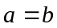.
Thus, the correctness of the scheme has been proved.

3.2. Some assessments of the secure of the proposed scheme
As mentioned in the INTRODUCTION section, the type of hard problem used here belongs to the class of hard problems with no solution, so for this type of hard problem, Shor's quantum algorithm is not effective. The secure of the signature scheme constructed based on the proposed solution can be evaluated through its ability to resist some types of attacks which will be considered below.
3.2.1. Secret key attack
In proposed scheme, attacking the secret key can be done at the Key Generation algorithm (Algorithm 25.1) and the Signature Generation algorithm (Algorithm 25.2), however the attacker will encounter the first form of the hard problem mentioned in section 2. Thus, to find the secret key, the attacker is forced to solve the above hard problem by the “brute force attack”method with computational complexity of about O(2^{n}), where n = |p|.

3.2.2. Signature forgery attack
From the Signature Verification algorithm (Algorithm 25.3) of the proposed scheme, a set of 2 values (r,s) will be recognized as a valid signature with the message to be verified M if the condition is satisfied:
(25.5)
It can be seen that, the condition (25.5) is essentially the second form of the hard problem mentioned in Section 2, as it is known this is a type of hard problem that currently in mathematics there is no other solution than the“brute force attack” method.
4. CONCLUSION
In this article, the author proposes a post–quantum digital signature scheme based on a new type of hard problem. Currently, this type of hard problem belongs to the group of unsolvable problems, which is an important factor that creates the quantum–resistant mechanism of the proposed digital signature scheme. In addition to the quantum–resistant ability, the proposed signature scheme here can also be used as pre–quantum digital signature schemes that are widely used in current practical applications.

REFERENCES
- P. W. Shor. “Algorithms for quantum computation: Discrete logarithms and factoring”. In Proceedings of the 35th Symposium on Foundations of Computer Science, pages 124–134, 1994.
- P. W. Shor. “Polynomial-time algorithms for prime factorization and discrete logarithms on a quantum computer”, in SIAM Journal of Computing, volume 26, no 5, 1997, pp. 1484-1509.
- M. Eker. “Modifying Shor's algorithm to compute short discrete logarithms”. In IACR ePrint Archive, report 2016/1128, 2016.
- L.C. WASHINGTON. Elliptic Curves. Number Theory and Cryptography. Chapman & Hall/CRC 2008..
- Jeffrey Hoffstein, Jill Pipher and Joseph H. Silverman. An Introduction to Mathematical Cryptography. ISBN 978-0-387-77993-5. Springer - Verlag 2008.
- D.R. STINSON. Cryptography. Theory and Practice. Chapman & Hall/CRC 2006.
- J. Talbot and D. Welsh. Complexity and Cryptography: An Introduction. Cambridge University Press, 2006.
- I. SHPARLINSKI. Cryptographic Applications of Analytic Number Theory. Complexity Lower Bounds and Pseurandomness. Birkhäuser 2003.
- S.S. WAGSTAFF. Cryptanalysis of Number Theoretic Ciphers. Chapman & Hall /CRC 2003.
- ISO/IEC 14888-3: Information technology – Security techniques – Digital signatures with appendix. Second edition 2006-11-15.
- National Institute of Standards and Technology, NIST FIPS PUB 186-4. Digital Signature Standard, U.S. Department of Commerce, 2013.
- GOST R 34.10-94. Russian Federation Standard. Information Technology. Cryptographic Data security. Produce and check procedures of Electronic Digital Signature based on Asymmetric Cryptographic Algorithm. Government Committee of the Russia for Standards, 1994 (in Russian).

