**LymeApp Cumulative Temperature Mask Data Processing Chain**

This section documents the production cumulative temperature masks which identify areas that are warm enough to stimulate tick questing activity, using a temperature threshold of 6oC. A series of scripts download and process MODIS EO imagery of Land Surface Temperature to create temperature masks every 8 days using a combination of decadel (8-day) and daily satellite data.

These result in Boolean masks where suitable areas according to temperature limits on I. ricinus are identified as 1 and unsuitable areas as 0. This mask can then be applied to the existing seasonal Tick model to make a more timely prediction of tick activity based on recent temperatures.

## Image acquisition and processing

The cumulative temperature mask is processed in two steps through two separate scripts:

1. Acquisition of 1km MODIS Land Surface Temeperature imagery from NASA’s data repository.
2. Importing of the imagery into a Suitable format from which regularly updated masks are calculated.

### Image Acquisition

For the current calendar year 1 km spatial resolution MODIS Land surface Temperature (LST) data from the NASA Terra satellite are downloaded from NASA’s [Land Processes Distributed Active Archive Center (LP DAAC) Data Repository](https://lpdaac.usgs.gov/). Two different products are downloaded MODIS/Terra Land Surface Temperature/Emissivity 8-day L3 Global 1 km SIN grid (MOD11A2, version 6) and MODIS/Terra Land Surface Temperature/Emissivity Daily L3 Global 1 km SIN grid (MOD11A1, version 6). A combination of both products are utilised as the 8-day product provides a close to complete coverage of the study area for each week. While the daily data is released closer to real time however has restricted coverage of the study area reliant on the environmental conditions at the time.

MODIS data are produced in the Sinusoidal projection (MODLAND Sinusoidal Grid) and made available as 460 tiles covering the Earth, each tile measuring 10° x 10° and consisting of 1200 x 1200, 0.859 km2 (926.63 m x 926.63 m) pixels

All available images per time interval, called granules, are acquired for the two tiles encompassing Scotland for. MODIS data sets are provided in Hierarchical Data Format (HDF), and are imported to OGC GeoTIFF standard format for further processing.

Both MOD11 datasets comprises composited land surface temperature (LST) for daytime (dLST) and night-time (nLST) overpasses. A complete time series for each tile of the MOD11A2 data therefore consists of 46 granules at 8-day intervals for each year, while the daily MOD11A1 data consists of 335(6) granules each year. For the LymeApp cumulative mask purposes only the dLST data is utilised in this process.

A python download script developed following protocols recommended by NASA [outlined here](https://lpdaac.usgs.gov/resources/e-learning/how-access-lp-daac-data-command-line/) download data for the current year to a fixed directory structure in a stepwise manner and works with the following logic (detailes steps are outlined in Table 1:

1. If there is no data currently downloaded it will download all the data for MOD11A1 & MOD11A2 from January the 1st through to the latest data available.
2. If previous downloads are located the script is designed to download data updates only, comparing the latest data available data on the LP DAAC platform with the latest data previously downloaded and processed. Any new data made available since the last run will then be downloaded.

Table 1: Data Downloading steps in cumulative temperature mask data download script temporalTickMask-downloadv02.py

|  |  |
| --- | --- |
| Step | Description |
| 1.1 | Identify begin and end date for download |
| 1.1.1 | Identify today |
| 1.1.2 | Identify last processed file datestamp if exists in /Downloads/MOD11A2/Processed or select 1st Jan this year if not |
| 1.2 | Connect with LP DAAC repository |
| 1.2.1 | List MOD11A2 HDF files within date range |
| 1.2.2 | Download and save HDF files to /Downloads/MOD11A2 |
| 1.2.3 | List MOD11A1 HDF files within date range |
| 1.2.4 | Download and save HDF files to /Downloads/MOD11A1 |

### Mask Processing

The full process from download to mask involves two scripts that can be scheduled separately to allow for completion and checking of the downloaded data before the importing and processing of the data into a Boolean mask. Figure 1 below presents the required directory structure for the scripts along with the data process flow which is described in greater detail below. The download script is outlined in section 1.1.1 above and its data process flow is presented in green in Figure 1.

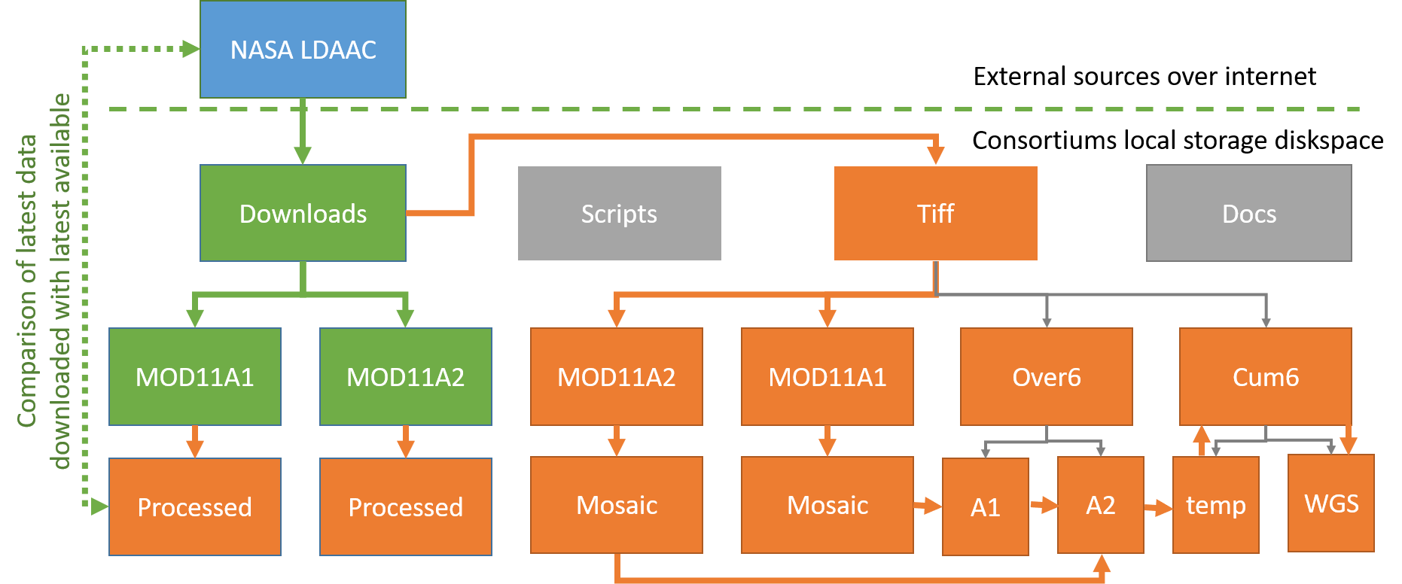

Figure 1: Presents the required directory structure for the scripts along with the data process flow for the download script (green) and the data processing script in orange.

The second python script extracts the dLST data from HDF file into a suitable format for processing (GeoTIFF), combines the tiles for each product per date into one image and then using a series of arithmetic and logical functions utilising the Geospatial Data Abstraction Library (GDAL). A mask is created where the temperature is shown to be above 6oC consistently for over a period of a week or more. The detailed processing chain is outlined in Table 2 below and results in an updated cumulative temperature mask every 8 days throughout the season. The corresponding data process flow is presented in orange in Figure 1.

Table 2: Data Processing steps in creating the cumulative temperature mask script temporalTickMask-processv02.py

|  |  |
| --- | --- |
| Step | Description |
| 2.1 | Import data downloaded to ../Downloads/MOD11A2 into GeoTIFF |
| 2.1.1 | Extract dLST data from HDF format into OGC GeoTIFF format Save to ../Tiff/MOD11A2 |
| 2.1.2 | Move extracted HDFs to ../Downloads/MOD11A2/Processed folder |
| 2.2 | Import data downloaded to ../Downloads/MOD11A1 into GeoTIFF |
| 2.2.1 | Extract dLST data from HDF format into OGC GeoTIFF format Save to ../Tiff/MOD11A1 |
| 2.2.2 | Move extracted HDFs to ../Downloads/MOD11A1/Processed folder |
| 2.3 | MOD11A2: Mosaic H2 & H3 tile for each date to ../Tiff/MOD11A2/Mosaic |
| 2.4 | MOD11A1: Mosaic H2 & H3 tile for each date to ../Tiff/MOD11A2/Mosaic |
| 2.5 | MOD11A2: Recode values over 6 oC =1 and 6 oC and below =1 (values are in kelvin * 0.02 so calculation is >13957=1; <=13957=1). Save to ../Tiff/Over6/A2 |
| 2.6 | MOD11A1: Recode values over 6oC =1 and 6oC and below =1 (values are in kelvin * 0.02 so calculation is >13957=1; <=13957=1). Save to ../Tiff/Over6/A1 |
| 2.7 | MOD11A2: If two consecutive 8-day product pixels are over 6oC mask value =1 otherwise value = 0. |
| 2.8 | MOD11A1: If four out of 8 of a 1-day product pixels are over 6oC mask value =1 otherwise value = 0. |
| 2.9 | Calculate maximum pixel value from step 2.7 and 2.9 and save to ../Tiff/Cum6/temp |
| 2.10 | If date is before June move 2.9 to ../Tiff/Cum6/ |
| 2.11 | If date is in July or later calculate MOD11A2: If three consecutive 8-day product pixels are under or equal 6oC mask value =0 otherwise value remains as is. Save to ../Tiff/Cum6/ |
| 2.12 | Reproject all masks to from MODLAND Sinusoidal Grid to WGS84. Save to ../Tiff/Cum6/WGS |

### Verification of results.

**Selection of temperature threshold**

A temperature of around 7oC is generally accepted as the temperature at which nymphs and adults become active, although it is accepted there will be some variation over different regions. This is described in more detail by Dobson et al 2011. Consortium members have regularly used this value as a masking value to continental European models after canvassing expert opinions from respected networks such as the ECDC/EFSA VectorNet network of vector-borne experts. Local calibration was considered within the LymeApp team and after comparing masks with survey data the above method was preferred.

**Visual and numerical examples of the processed data and final masks**

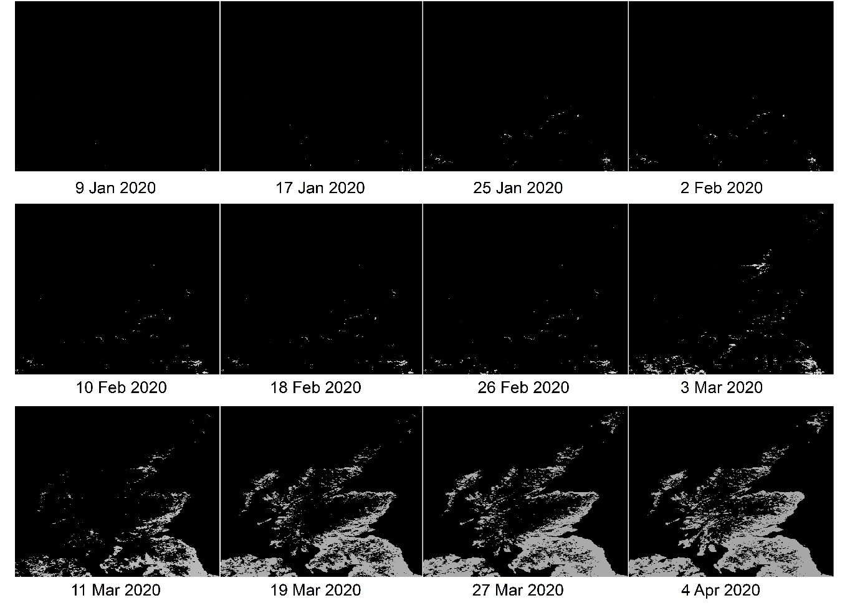 Figure 2: Displaying a time series of the cumulative temperature mask from January through to April. Black showing unsuitable and grey showing suitable according to species temperature limits.

Table 3:Checking the calculations

|  |  |  |  |
| --- | --- | --- | --- |
| Image | Created | Value | Expected |
| Tiff/MOD11A2 |  |  |  |
| Tiff/MOD11A2/Mosaic |  |  |  |
| Tiff/Over6/A2 |  |  |  |
| Tiff/Over6/A2(previous) |  |  |  |
| Tiff/MOD11A2 |  |  |  |
| Tiff/MOD11A2/Mosaic |  |  |  |
| Tiff/Over6/A2 |  |  |  |
| Tiff/Over6/A2(previous1) |  |  |  |
| Tiff/Over6/A2(previous2) |  |  |  |
| Tiff/Over6/A2(previous3) |  |  |  |
| Tiff/Over6/A2(previous4) |  |  |  |
| Tiff/Over6/A2(previous5) |  |  |  |
| Tiff/Over6/A2(previous6) |  |  |  |
| Tiff/Over6/A2(previous7) |  |  |  |
| Tiff/Over6/temp |  |  |  |
| Tiff/Over6 |  |  |  |
| Tiff/Over6/WGS |  |  |  |

Figure 3: Overlaying survey data on the cumulative temperature mask.

**Bibliography**

Dobson ADM, Finnie TJR, Randolph SE: A modified matrix model to describe the seasonal population ecology of the European tick *Ixodes ricinus*. J Appl Ecol. 2011, 48: 1017-1028. 10.1111/j.1365-2664.2011.02003.x.