**Cumulative Temperature Mask Data Processing Chain**

This section documents the production cumulative temperature masks which identify areas that are warm enough to stimulate tick questing activity, using a temperature threshold of 6oC. A series of scripts download and process VIIRS EO imagery of Land Surface Temperature to create temperature masks every 8 days using a combination of decadal (8-day) and daily satellite data. This is an update for the previous version of MODIS EO imagery. Since MODIS was not produced anymore, VIIRS was replaced by.

These result in Boolean masks where suitable areas according to temperature limits on I. ricinus are identified as 1 and unsuitable areas as 0. This mask can then be applied to the existing seasonal Tick model to make a more timely prediction of tick activity based on recent temperatures.

## Image acquisition and processing

The cumulative temperature mask is processed two separate steps:

1. Acquisition of 1km VIIRS Land Surface Temperature imagery from NASA’s data repository: https://appeears.earthdatacloud.nasa.gov/
2. Importing of the imagery into a Suitable format from which regularly updated masks are calculated.

### Image Acquisition

For the current calendar year 1 km spatial resolution VIIRS Land surface Temperature (LST) data from the NASA Terra satellite are downloaded from NASA’s AppEEARS: https://appeears.earthdatacloud.nasa.gov/. Two different products are downloaded VIIRS/Terra Land Surface Temperature/Emissivity 8-day L3 Global 1 km SIN grid VNP21A2, version 1) and VIIRS/Terra Land Surface Temperature/Emissivity Daily L3 Global 1 km SIN grid (VNP21A1D, version 1). A combination of both products is utilised as the 8-day product provides a close to complete coverage of the study area for each week. While the daily data is released closer to real time however has restricted coverage of the study area reliant on the environmental conditions at the time.

VIIRS data are downloaded as TIF in the Sinusoidal projection (Modis Sinusoidal PROJ.4:

+proj=sinu +lon_0=0 +x_0=0 +y_0=0 +R=6371007.181 +units=m +no_defs=True) and made as a mosaic directly in the website by selecting specific extent ( EuropeExtentMOOD.Geojson)

Both VNP21 datasets comprises composited land surface temperature (LST) for daytime (dLST) and night-time (nLST) overpasses. Make sure dLST is selected when downloading the data.

Table 1: Data Downloading steps in cumulative temperature mask data download script temporalTickMask-downloadv02.py

|  |  |
| --- | --- |
| Step | Description |
| 1.1 | Login or create an account in <https://appeears.earthdatacloud.nasa.gov/> |
| 1.1.1 | Choose extract Area |
| 1.1.2 | Name the area and select the area (EuropeExtentMOOD.Geojson) |
| 1.2 | Select dates |
| 1.2.1 | Type the name of product VNP21A2.001 then select LST_Day_1 |
| 1.2.2 | Select MODIS Sinusoidal as projection and GEOTIFF as format |
| 1.2.3 | Download and save TIF files to /Downloads/VNP21A2 |
| 1.2.4 | Repeat all steps for VNP21A1D |

### Mask Processing

The full process to mask involves a script that can be scheduled separately to allow for completion and checking of the downloaded data before the importing and processing of the data into a Boolean mask. Figure 1 below presents the required directory structure for the scripts along with the data process flow which is described in greater detail below. The download script is outlined in section 1.1.1 above and its data process flow is presented in green in Figure 1.

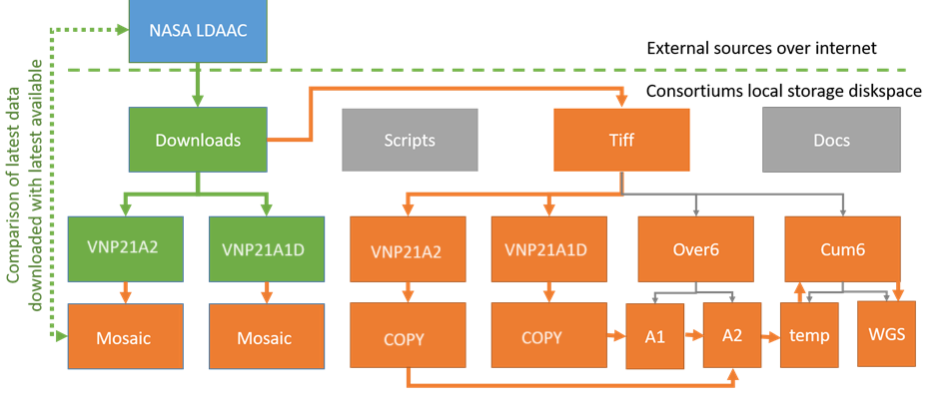

Figure 1: Presents the required directory structure for the scripts along with the data process flow for the download script (green) and the data processing script in orange.

The second python script extracts the Day LST data from HDF file into a suitable format for processing (GeoTIFF), combines the tiles for each product per date into one image and then using a series of arithmetic and logical functions utilising the Geospatial Data Abstraction Library (GDAL). A mask is created where the temperature is shown to be above 6oC consistently for over a period of a week or more. The detailed processing chain is outlined in Table 2 below and results in an updated cumulative temperature mask every 8 days throughout the season. The corresponding data process flow is presented in orange in Figure 1.

Table 2: Data Processing steps in creating the cumulative temperature mask script temporalTickMask-processv09.py

|  |  |
| --- | --- |
| Step | Description |
| 2.1 | Data data downloaded to … /cumtemp/downloads/appeears/VIIRS/ER/VNP21A2 |
| 2.1.1 | Data data downloaded to … /cumtemp/downloads/appeears/VIIRS/ER/VNP21A1D |
| 2.1.2 | Create folder TIF in here: … /cumtemp/downloads/appeears/VIIRS/TIF |
| 2.1.3 | Create Folders … /cumtemp/downloads/appeears/VIIRS/TIF/vo68/A2 |
| 2.1.4 | Create Folders … /cumtemp/downloads/appeears/VIIRS/TIF/vo68/A1 |
| 2.1.5 | Create Folders … /cumtemp/downloads/appeears/VIIRS/TIF/vc68 |
| 2.2 | For each year, create another folder under 2.1.3 to 2.1.5 for example:  … /cumtemp/downloads/appeears/VIIRS/TIF/vo68/A2/2024  … /cumtemp/downloads/appeears/VIIRS/TIF/vo68/A1/2024  … /cumtemp/downloads/appeears/VIIRS/TIF/vc68/2024 |
| 2.3 | For vc68 create folders fin,temp, wgs :  … /cumtemp/downloads/appeears/VIIRS/TIF/vc68/2024/fin  … /cumtemp/downloads/appeears/VIIRS/TIF/vc68/2024/WGS  … /cumtemp/downloads/appeears/VIIRS/TIF/vc68/2024/temp |
| 2.4 | Run python code: temporalTickmaskProcessv09.py |
| 2.5 | VNP21A2: Recode values over 6 oC =1 and 6 oC and below =1 (values are in kelvin * 0.02 so calculation is >13957=1; <=13957=1). Save to ../Tiff/Over6/A2 |
| 2.6 | VNP21A1D: Recode values over 6oC =1 and 6oC and below =1 (values are in kelvin * 0.02 so calculation is >13957=1; <=13957=1). Save to ../Tiff/Over6/A1 |
| 2.7 | VNP21A2: If two consecutive 8-day product pixels are over 6oC mask value =1 otherwise value = 0. |
| 2.8 | VNP12A1D: If four out of 8 of a 1-day product pixels are over 6oC mask value =1 otherwise value = 0. |
| 2.9 | Calculate maximum pixel value from step 2.7 and 2.9 and save to ../Tiff/Cum6/temp |
| 2.12 | Reproject all masks to from Modis Sinusoidal Projection to WGS84. Save to ../Tiff/Cum6/WGS |

### Verification of results.

**Selection of temperature threshold**

A temperature of around 7oC is generally accepted as the temperature at which nymphs and adults become active, although it is accepted there will be some variation over different regions. This is described in more detail by Dobson et al 2011. Consortium members have regularly used this value as a masking value to continental European models after canvassing expert opinions from respected networks such as the ECDC/EFSA VectorNet network of vector-borne experts. Local calibration was considered within the LymeApp team and after comparing masks with survey data the above method was preferred.

**Visual and numerical examples of the processed data and final masks**

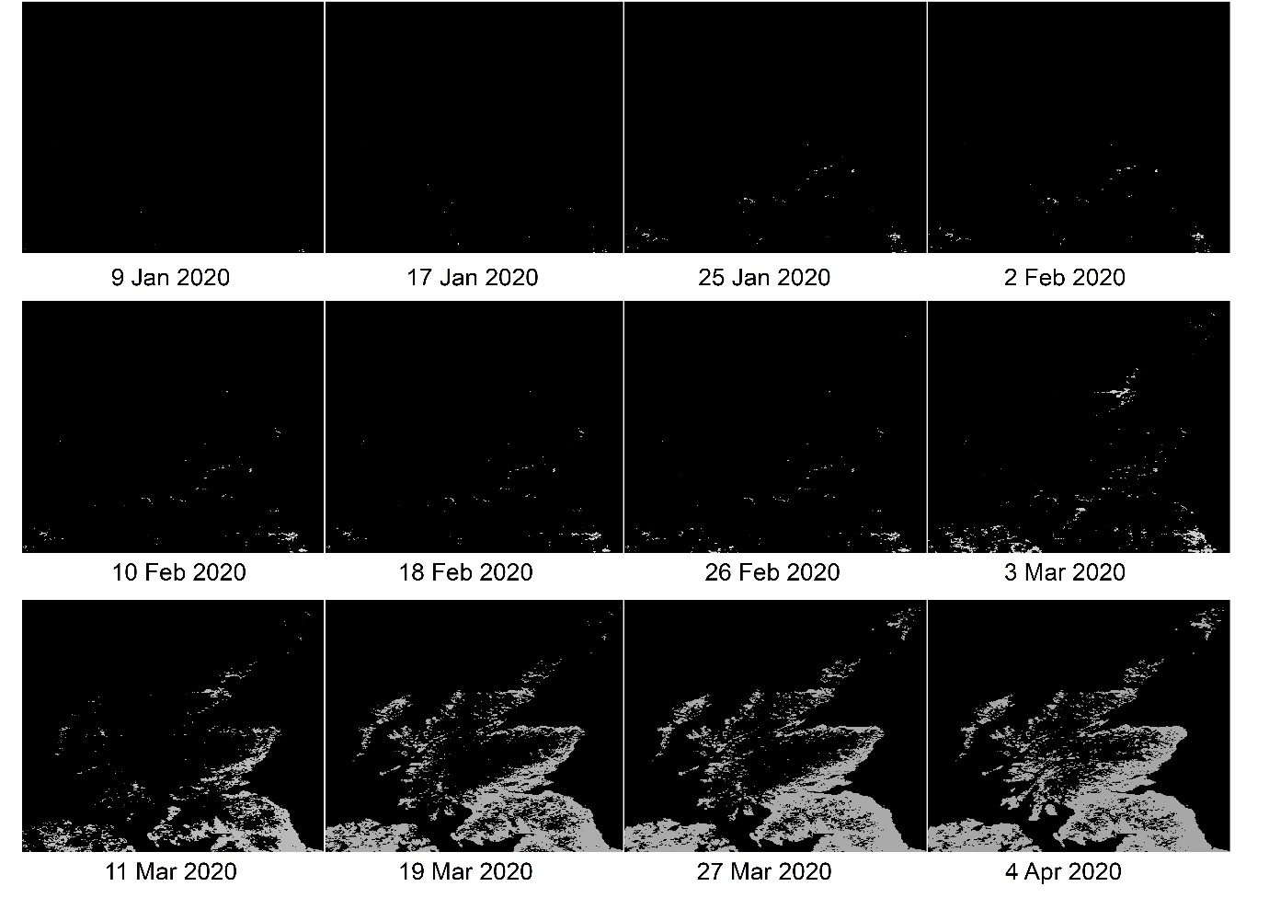 Figure 2: Displaying a time series of the cumulative temperature mask from January through to April. Black showing unsuitable and grey showing suitable according to species temperature limits.

Table 3:Checking the calculations

|  |  |  |  |
| --- | --- | --- | --- |
| Image | Created | Value | Expected |
| Tiff/MOD11A2 |  |  |  |
| Tiff/MOD11A2/Mosaic |  |  |  |
| Tiff/Over6/A2 |  |  |  |
| Tiff/Over6/A2(previous) |  |  |  |
| Tiff/MOD11A2 |  |  |  |
| Tiff/MOD11A2/Mosaic |  |  |  |
| Tiff/Over6/A2 |  |  |  |
| Tiff/Over6/A2(previous1) |  |  |  |
| Tiff/Over6/A2(previous2) |  |  |  |
| Tiff/Over6/A2(previous3) |  |  |  |
| Tiff/Over6/A2(previous4) |  |  |  |
| Tiff/Over6/A2(previous5) |  |  |  |
| Tiff/Over6/A2(previous6) |  |  |  |
| Tiff/Over6/A2(previous7) |  |  |  |
| Tiff/Over6/temp |  |  |  |
| Tiff/Over6 |  |  |  |
| Tiff/Over6/WGS |  |  |  |

Figure 3: Overlaying survey data on the cumulative temperature mask.

**Bibliography**

Dobson ADM, Finnie TJR, Randolph SE: A modified matrix model to describe the seasonal population ecology of the European tick *Ixodes ricinus*. J Appl Ecol. 2011, 48: 1017-1028. 10.1111/j.1365-2664.2011.02003.x.