**Tutorial on Azure SQL Database Creation**

1. To start this process first you will have to log into your email account with the university, since the email that is required to do this should be in that emails inbox.

2. Once in your university email look for an email in your inbox called “School of Computing, Electronics and Mathematics – Microsoft Imagine” this is the email that is required.

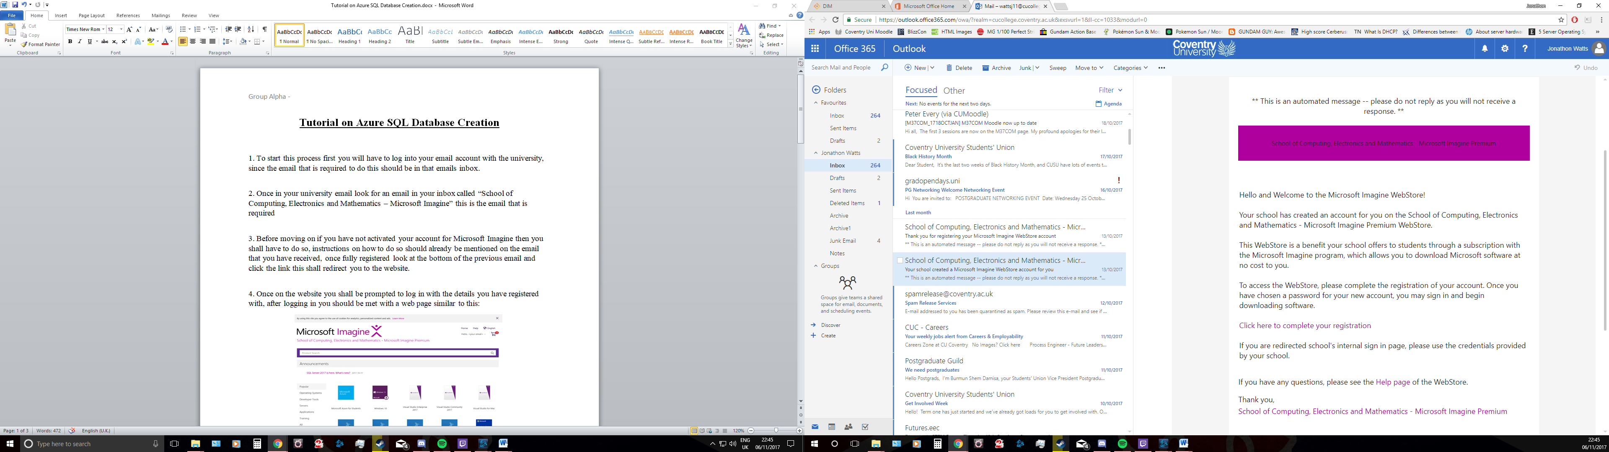

3. Before moving on if you have not activated your account for Microsoft Imagine then you shall have to do so, instructions on how to do so should already be mentioned on the email that you have received, once fully registered look at the bottom of the previous email and click the link this shall redirect you to the website.

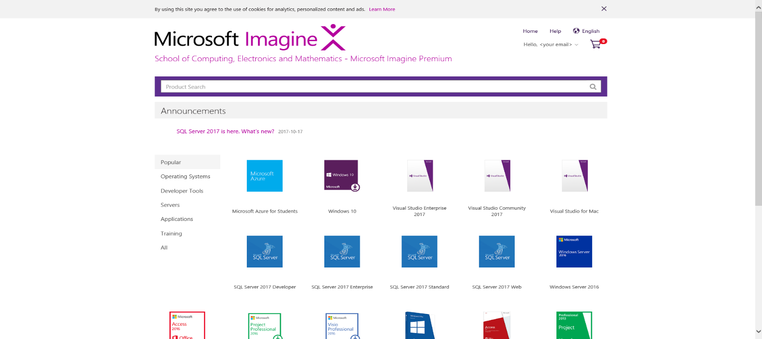4. Once on the website you shall be prompted to log in with the details you have registered with, after logging in you should be met with a web page similar to this:

5. On this page you can see that there is a lot of different Microsoft packages available to you, Microsoft Azure is required so click on Microsoft Azure for Students and click “Add to Cart” and finalise the purchase even though it’s free because of you being a student.

6. Once you have “purchased” the software package access your orders, this can be done by using the drop down menu in the top right corner near the shopping cart icon:

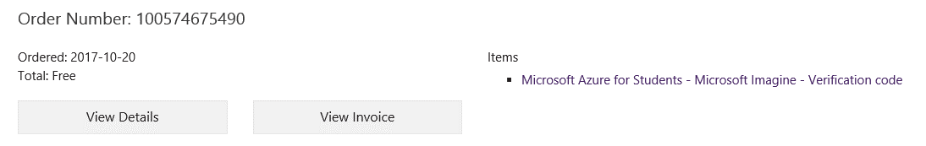Once in your orders look for the following order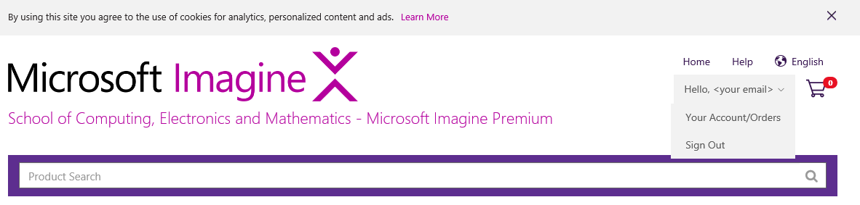:

Once the order has been found then click to view the details, in there you’ll find the Verification Code and a Tutorial for Microsoft Azure, look at the tutorial before moving on.  
  
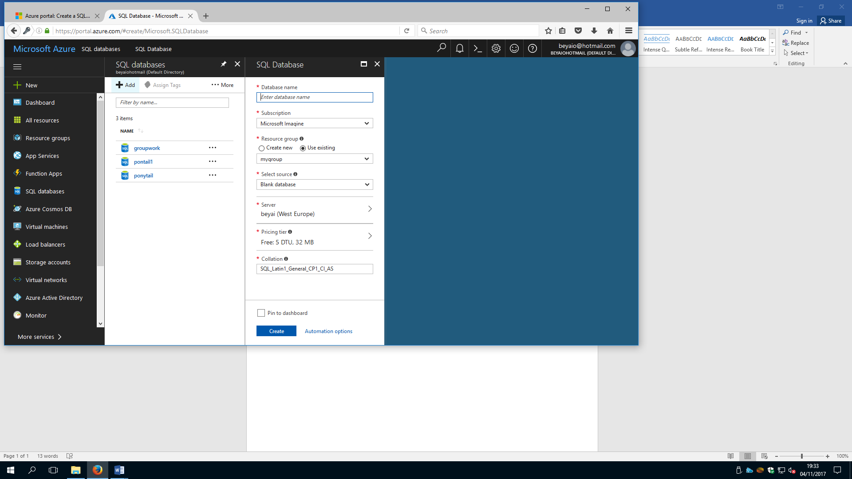7. After looking at the tutorial log into Microsoft Azure, make sure to use the correct email address and password used for the sign up and proceed to create a new SQL database by looking on the side panel of the azure dashboard.

8. When creating the Database it will ask for a Database Name, Subscription, Resource group, select source, server, pricing tier and collation.  
  
9. First give the database a name, this could be MyFirstDatabase, it will show a green tick in the box if the database name is available. In the Subscription drop down select Microsoft Imagine, in the resource group select create new then put in the name of the database again, under server put it as groupwork and with area set it to West UK. After all of this select create which should be located at the bottom, and after clicking create the system will start deploying the SQL database.

Screenshot below:



10. After the database has been deployed after a few minutes you’ll come up with a screen like the screenshot down below showing the performance of the SQL Database is currently:

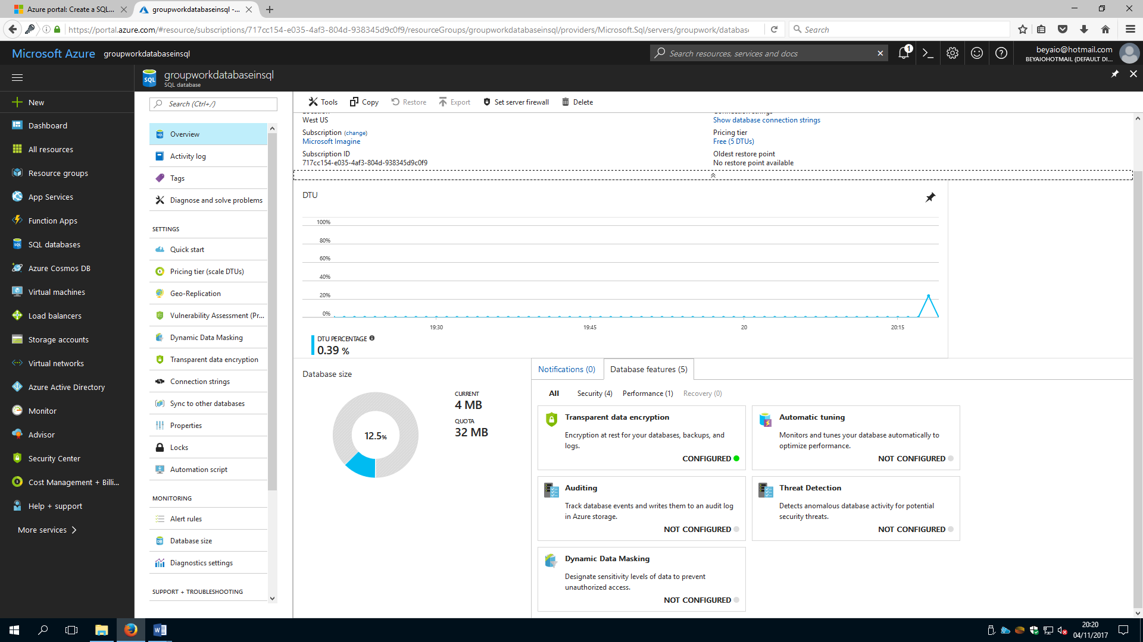

11. After the deployment of the SQL Database a firewall rule will have to be setup so it’s possible to access the database from where ever you are, to do so go to the SQL databases tab on the left and look for your database, on the overview page you should see a fully qualified server name this could be “**mynewserver-20170824.database.windows.net” and will provide further configurations.**

**12. Copy the fully qualified server name for the use of connecting to your server and the databases linked to it will do a quick start, once that’s done click on set server firewall on the toolbar, once there click add client IP on the toolbar and add the current IP address you are currently using for the new firewall rule, make sure to open the correct amount of ports you shall need.**

**13. Save the changes and a server level firewall rule should be created under your current IP address and with the allowed ports you have specified, click ok and then close the firewall settings page.**

14. Now to access the database you must select SQL Databases on the menu on the left side of the screen then click on the database you’ve created on the SQL Databases page.  
  
15. Look at the overview page for your database and look at the fully qualified server name which can be found in the top right of the screen, if needed you can hover over it and from there you can get the click to copy option.

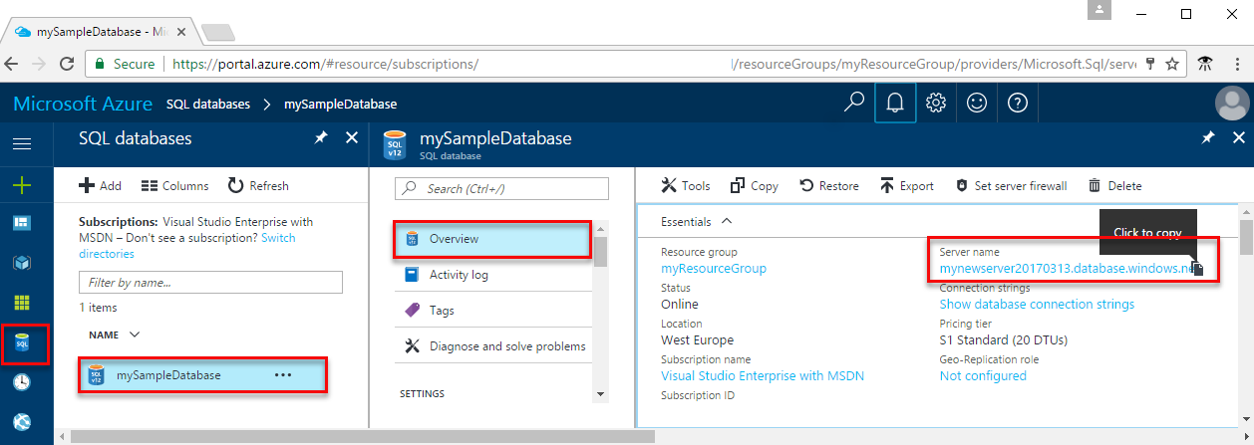  
16. If you have potentially forgotten or lost the login information to access your database you can navigate to the SQL database server page and from there you will be able to view the admin name and if necessary will be able to reset the password, after that click on show database connection strings.

17. Once at looking at the strings just review the ADO.NET connection string like so:

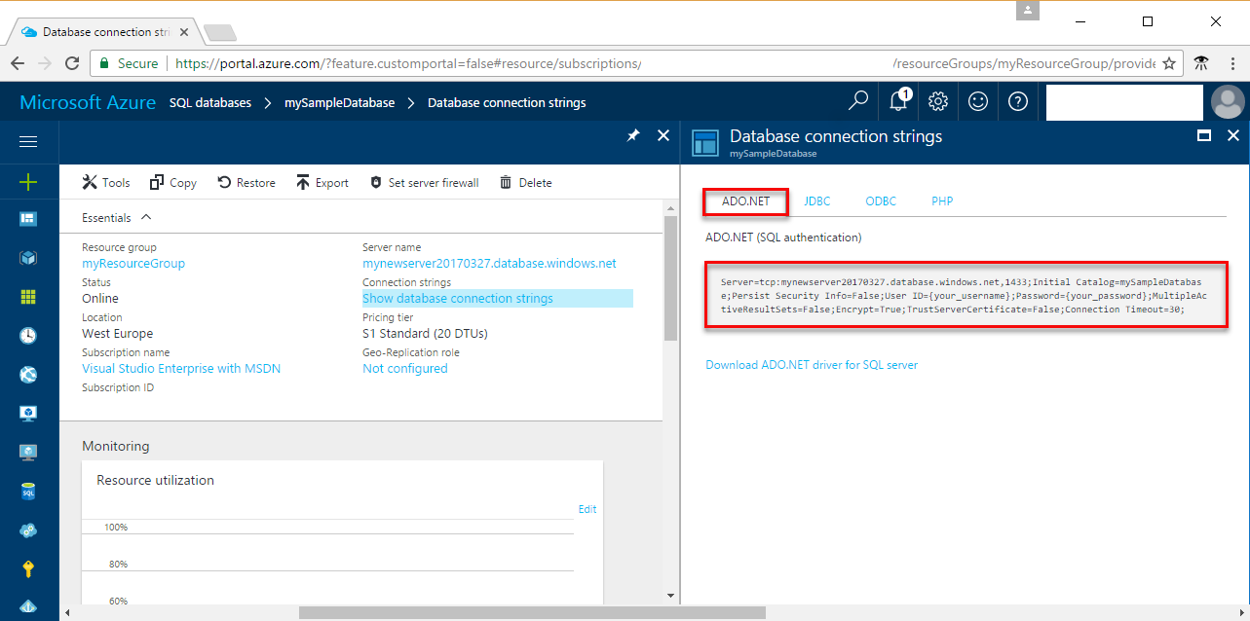

18. Now that is done you’ll want to follow the list below to create a new Visual Studio Project.

* In Visual Studio, choose File then New Project
* In the New Project Dialog, and expand Visual C**#**
* **Select Console App and enter sqltest for the project name**
* **Click OK to create and open the new project**
* **In the Solution Explorer, right click sqltest and click Manage NuGet Packages**
* **On the Browse, search for System.Data.SqlClient and, when found select it**
* **In the System.Data.SqlClient page click install**
* **When this installation is complete review the changes and click OK to close the preview window**
* **If a License Acceptance window appears click accept**

19. Once the above set has been done then switch to or even open if necessary Program.cs and in Program.cs replace the contents with the following code and add the appropriate values for your server, database, user and password.

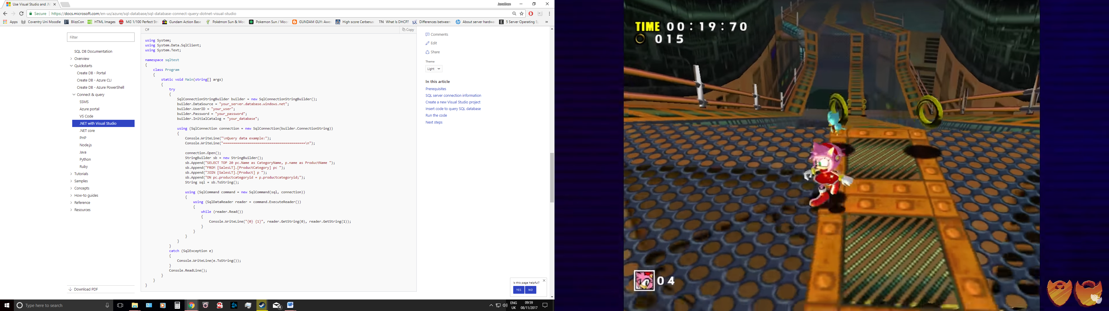

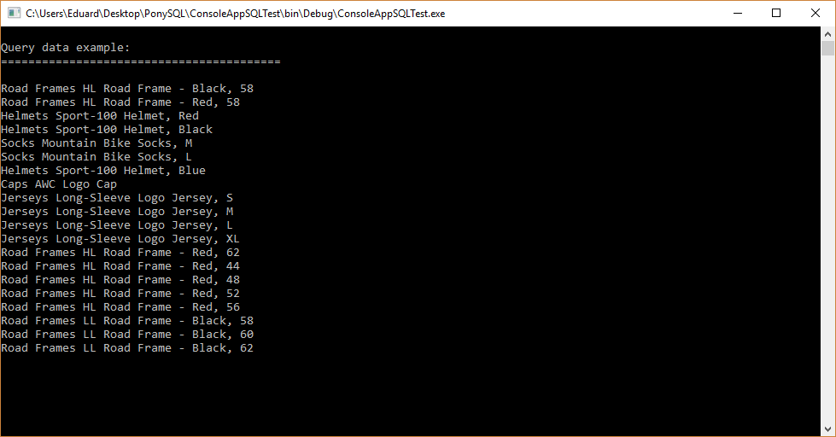20. Once the code has been input press F5 which will run the application and you should get a screen similar to this:

You’ve completely setup an Azure SQL Database and it is currently working!

**References**Microsoft Azure (2017) *Use .NET (C#) with Visual Studio to connect and query an Azure SQL database*[online] Available from<<https://docs.microsoft.com/en-us/azure/sql-database/sql-database-connect-query-dotnet-visual-studio>> [7th November 2017]

Microsoft Azure (2017) *Create an Azure SQL database in the Azure portal*[online] Available from<<https://docs.microsoft.com/en-us/azure/sql-database/sql-database-get-started-portal>> [7th November 2017]