Deep Learning (Fall 2025)
Homework 1

系所:人工智慧/AIG
學號:
姓名:
- Regression
Network Architecture | 16- 64- 32- 1
Learning Curve | 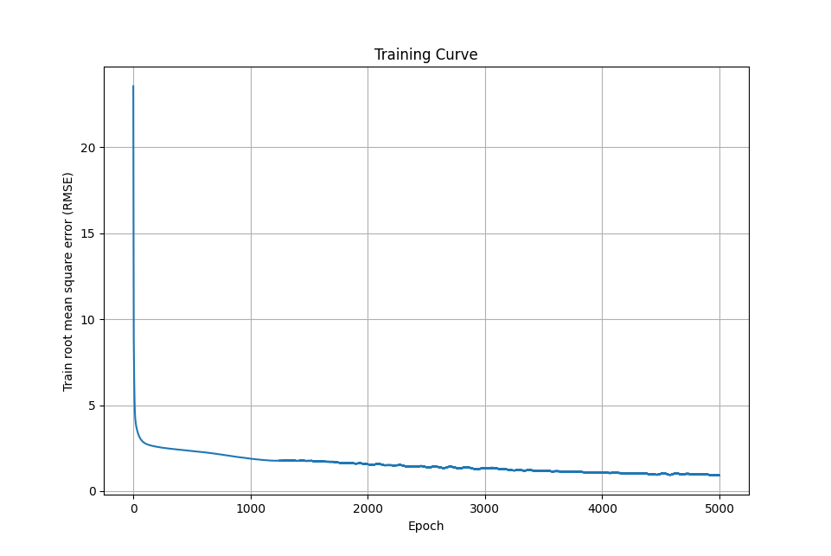
Training RMSE | 0.9253
Test RMSE | 1.6272
Learning Rate | 0.003
Epoch | 5000
Batch | Full batch
Activation Function | ReLU
Regression Result with Training Labels | 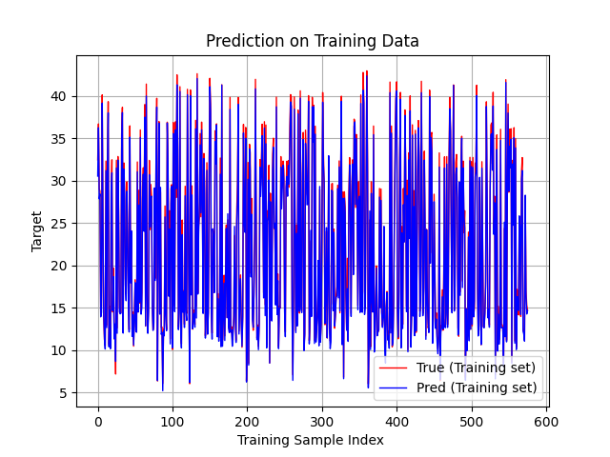
Regression Result with Test Labels | 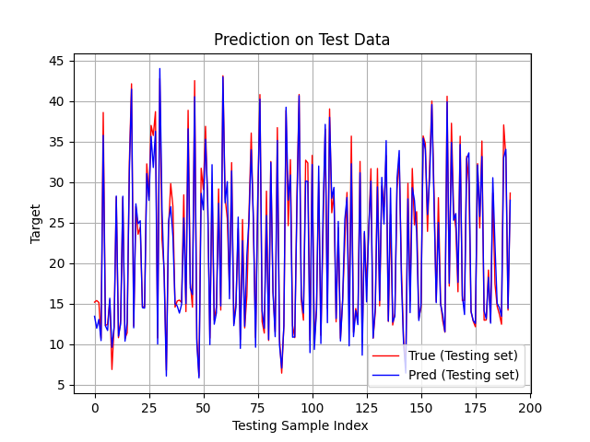

Methods of choosing the most important features:
Leave-One-Feature-Out:
Calculate the importances of a set of features based on a metric of choice, for a model of choice, by iteratively removing each feature from the set, and evaluating the performance of the model, with a validation scheme of choice, based on the chosen metric (refers to ΔTest_RMSE in this section). The formula of ΔTest_RMSE is given below. The metric tells us that if a feature is essential, the removal will increase ΔTest_RMSE. On the other hand, if the feature isn’t crucial, the removal may make ΔTest_RMSE decrease.
ΔTest_RMSE = RMSEremove feature ​−RMSEall​
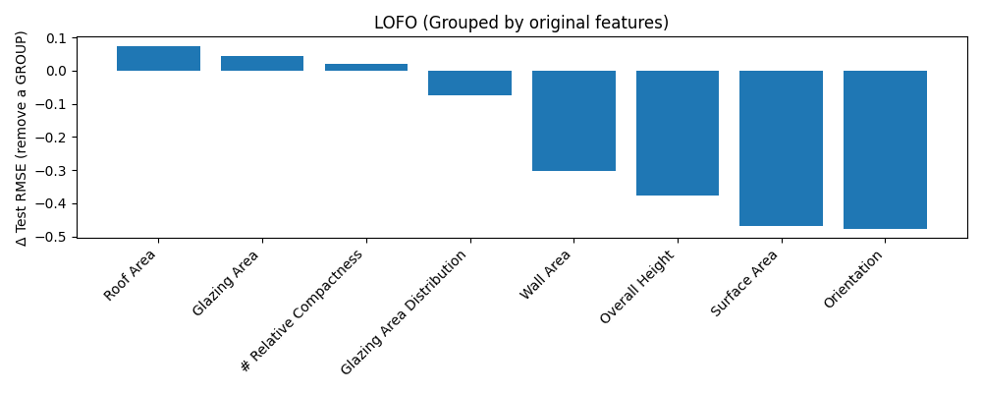
From the diagram, we can see that the removal of “Roof Area”, “Glazing Area”, and “Relative Compactness” are the top three causes of increment in the error rate.
Permutation Feature Importance:
Measures the increase in the prediction error (referred to as ΔRMSE in this section) of the model after permuting the feature values, which breaks the relationship between the feature and the actual outcome. The formula of the ΔRMSE is given below. The metric tells how the performance is after a feature has been permuted. The higher ΔRMSE, the more critical the feature is for the model.
ΔRMSE =RMSEpermuted – RMSEbaseline
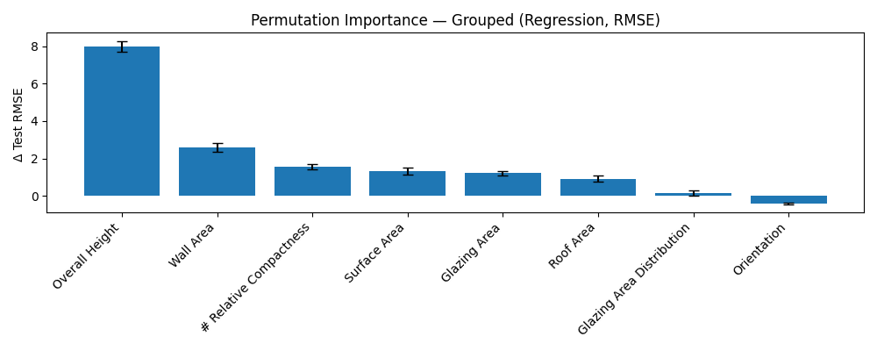
From the diagram, we can tell that the removal of “Overall Height”, “Wall Area”, and “Relative Compactness” are the top three causes of increment in the error rate, not to mention the fact that the error between different measurements (the black bar) exists.
- Classification
Network Architecture | 34 - 128- 32- 2- 4- 1
Learning Curve | 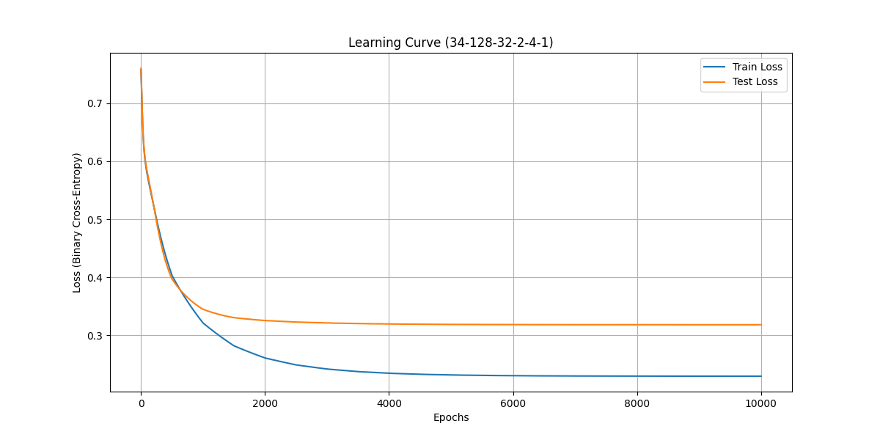
Training Error Rate | 0.0500
Test Error Rate | 0.1408
Learning Rate | 0.004(multiply by 0.65 for each 500 epoch)
Epoch | 10000
Batch | Full Batch
Activation Function | tanh (for hidden layer)  sigmoid (for output layer)

Compare the results of choosing different numbers of nodes in the layer:
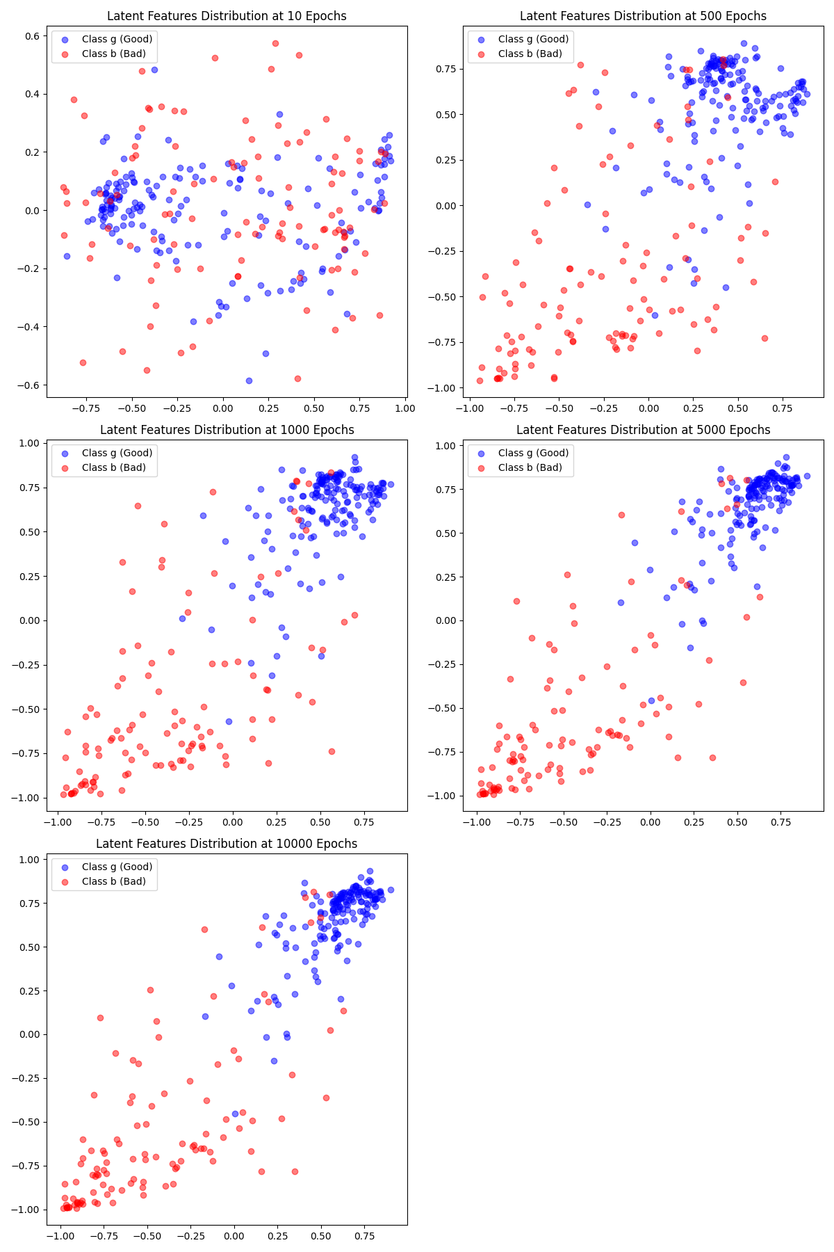
Network Architecture: 34- 128- 32- 2- 4- 1
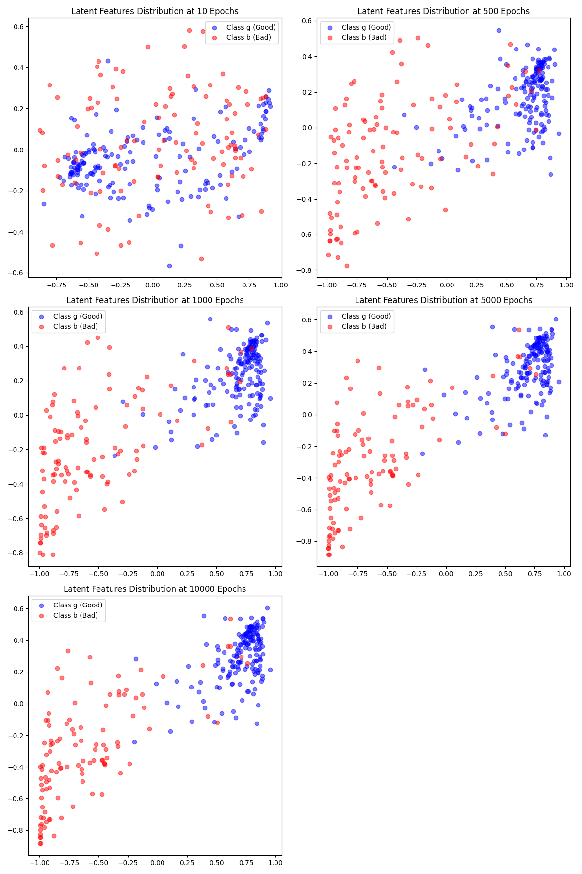
Network Architecture: 34- 128- 32- 2- 8- 1

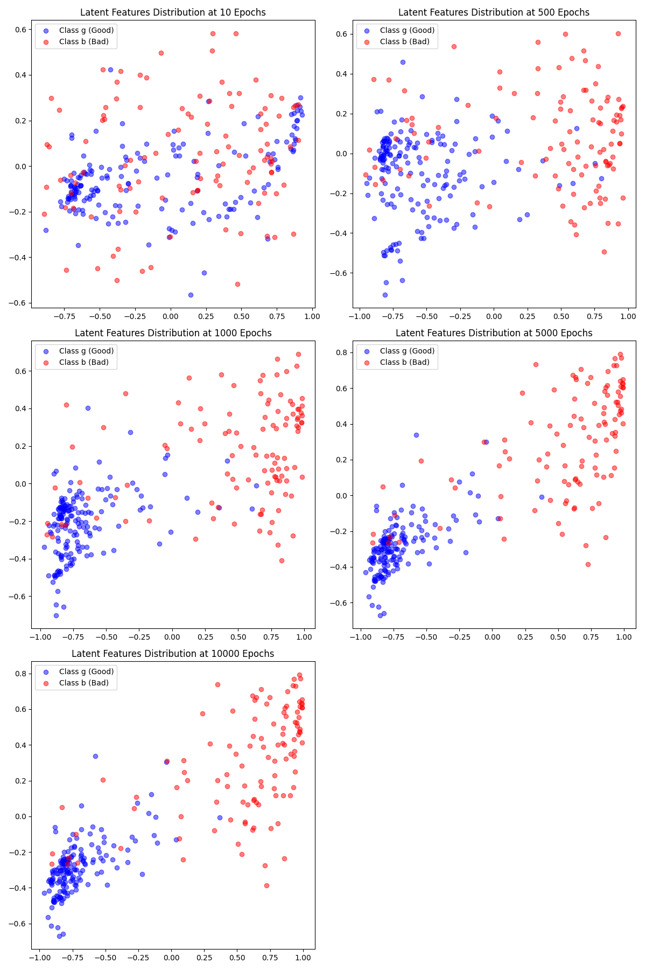
Network Architecture: 34- 128- 32- 2- 16- 1

