Deep Learning (Fall 2025)
Homework 3

Student ID:
Name:

- RNN:
  - Architecture, Learning Curve, and Error Rate:
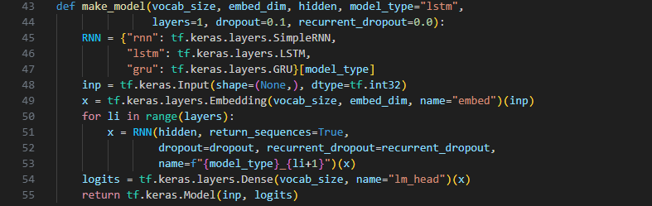
Architecture: Embedding → 1/2× SimpleRNN(tanh) → Dense softmax (CE in BPC), optimizer = Adam

Hyperparameter/ Setup | Value
*Embedding dimension | 64
Hidden layer dimension | 224
Sequence length | 140
Layer of the Network | 2
Dropout | 0.1
Batch Size | 64
Epoch | 15
Learning Rate | 0.0025
Weight Decay | 0 (No weight decay)
Global Clipping norm | 0.75
*Using embedding to replace one-hot encoding to retain the relationship between the vocabulary.
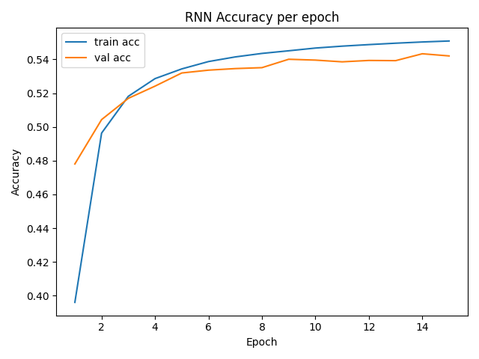
Learning Curve (accuracy per epoch):
Training Accuracy at epoch = 15: 0.547 Validation Accuracy at epoch = 15: 0.543
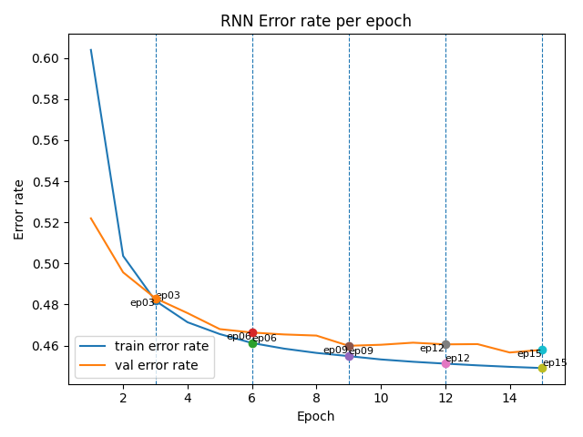
Error rate for Training Set and Validation Set per epoch (marking breaking point):
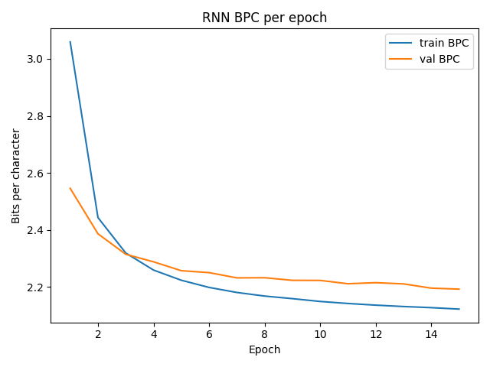
Training and Validation BPC (Bits per Character) vs Epoch (lower is better)
Training BPC at epoch = 15: 2.1228 Validation BPC at epoch = 15: 2.1928
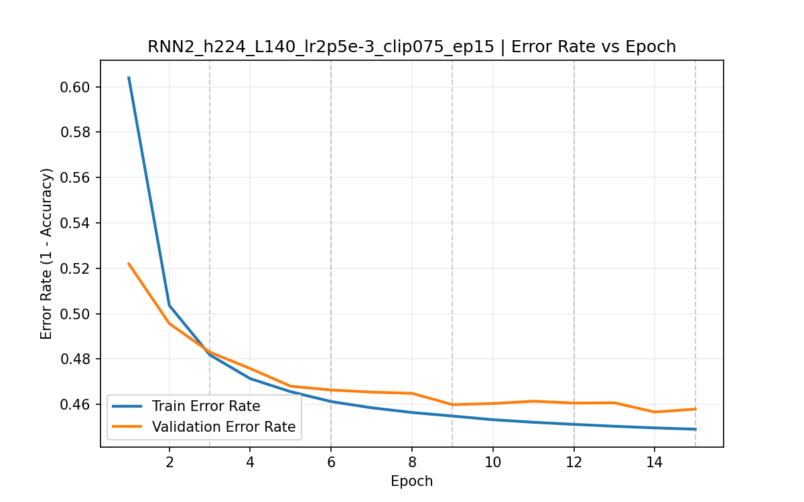
Training/Validation error rate (Error Rate = 1 – Accuracy)
Training Error Rate at epoch = 15: 0.453 Validation Error Rate at epoch = 15: 0.457
  - 5 Training Checkpoints (Epochs) – Text Samples:
Breaking Points | Text Outputs
Epoch 3 | JULIET:  The assiato, and fool my look athel.  BEATRICE:  Your valain the coluse  With her fair noble love,  A maning ear with drips all take a whiless like hang blught she less and  her quick us our days,  Good madmed o' the peersion in your highne pattle  sitse is boying yet, presently spitolable limaes and of my purle;  A word before.  LEONTES:  What is it Were peace, let my woo back high and stear;' but, goo
Epoch 6 | JULIET:  My skave world done, has the rheasder  At it:' have we,  I begins himsard; yet, my lord, which he wronger vow:  Indeapound's some tozplesh men's neck, it must  his cannot dismout what, but I can from fair act.  OARO:  We would not actrised for her unmnedged amay,  so add chardeded word such part,  And blood away speak with we should be men the forch.  No, no, now, beike. If we that princes.  THERSETER:
Epoch 9 | JULIET:  No. Willingry of hie got him in my flock weakthed-burial as more cry but  His defacler and the frail bring him of laws this acreafful father's calour's thing the gods mendon  Follow, I know you, Ourselves, pray you. Come, would do  be and ackillen as whose skilly head heard  wherein itselfolting beautestive speech, masters: or is so did.  MORTIMOM:  Why, no rubs it to Bartianar's very uncle of Grutt.
Epoch 12 | JULIET:  FRIAR YORK:  Farewell; no, it in his courtesiar, had he be she  Hath reserves me, 'ough I become to warrona; I'll not  Englase to muctor scands, forth.  PISTOL:  For I were their gract of at each sight barm?  But I am I it madough upon fair oweld:  Spirits at report,--whom the prover o' the impeared him,  He not spoil stay wish his fire all presently  Us to common thing of all bark, forth,  If you no br
Epoch 15 | JULIET:  Fie, they of swigned which knows.  Courtes may pario-will not worthy tongue,  Thy service no labethter, and seem away?  BEGOLYTO:  Sir, hast that I say 'ayard of Thanks in this interishment.  But I am vile stale. Gees: refeller your mother?  IAGO:  Does use this parts begraction!  PRINCE HENRY:  Not his sapes heavy little Brother:  Sir, this all'st for forwing them on it  As now it come and speech'l al

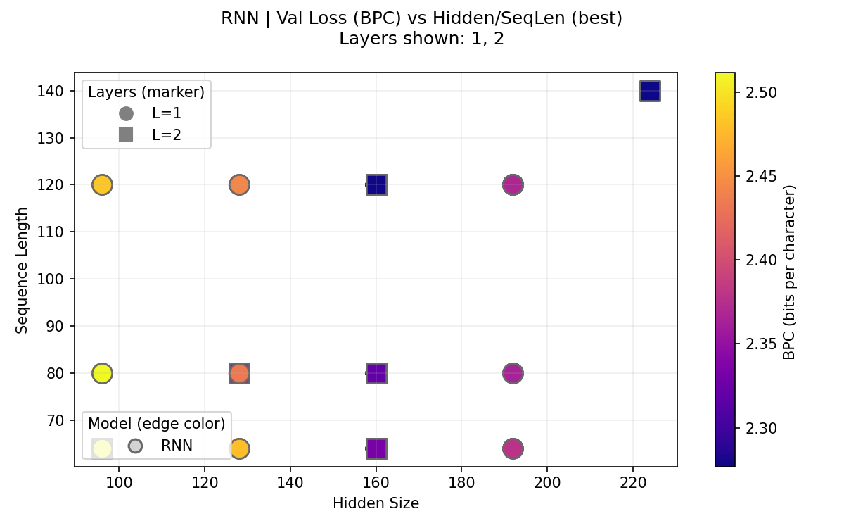
  - Compare the Impact of Different Hidden State Sizes and Sequence Lengths on Training (Including the effect of different layers of the network)
*Color = validation BPC (lower is better); circle = 1 layer, square = 2 layers
Analysis: Two-layer RNNs consistently outperform single-layer ones in validation BPC (lower is better, and further proof will be shown below). From the graph, we can see that increasing both the hidden size and sequence can improve the model's performance. The best region appears at roughly hidden = 224 and seq_len = 140 (square markers), with strong blue tones. However, the region of hidden = 160 and seq_len = 120 has similar performance to the best region. As a result, it can be concluded that the gain of increasing the hidden size and sequence length has begun to decrease, starting from a hidden size of 160 and a sequence length of 120.

Comparison of different layers of the network
The setup of the network:
Hyperparameter/ Setup | Value
*Embedding dimension | 64
Hidden layer dimension | 128
Sequence length | 80
Batch Size | 64
Learning Rate | 0.002

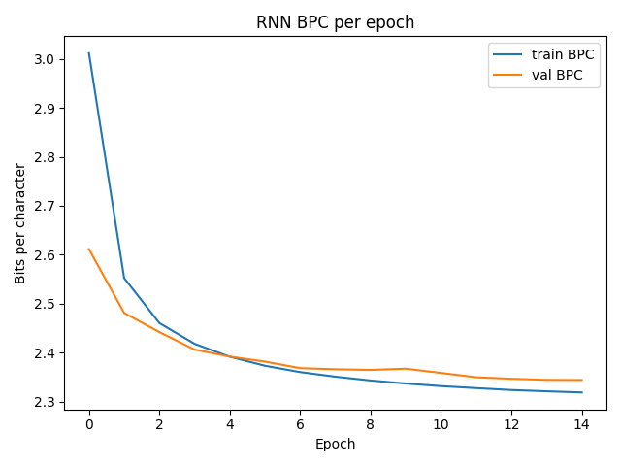
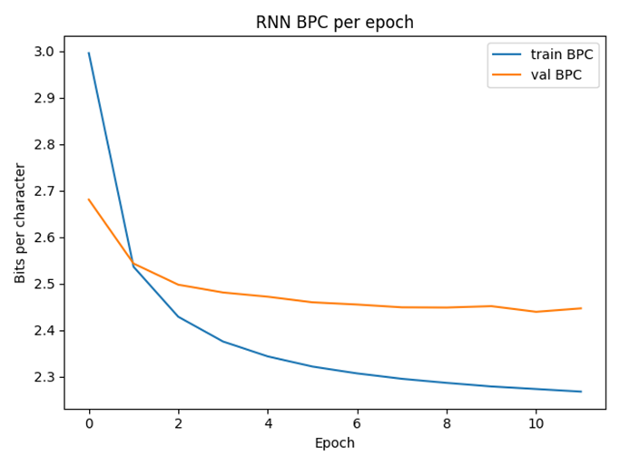
Layer = 1 (epoch = 12) Layer = 2 (epoch = 15)
Analysis: From the graphs above, it is evident that setting up a two-layer network decreased validation BPC more rapidly. Even though the curve of the train BPC of the two graphs is similar, the validation BPC of Layer = 2 decreases more and even holds a better performance (lower BPC) than the other one at the same epoch.
- LSTM
2-1. Architecture, Learning Curve, and Error Rate:

Architecture: Embedding → 1/2×LSTM(tanh) → Dense softmax (CE in BPC), optimizer=Adam
Hyperparameter/ Setup | Value
Embedding dimension | 64
Hidden layer dimension | 224
Sequence length | 140
Layer of the Network | 2
Dropout | 0.1
Batch Size | 64
Epoch | 15
Learning Rate | 0.0025
Weight Decay | 0 (No weight decay)
Global Clipping norm | 0.75
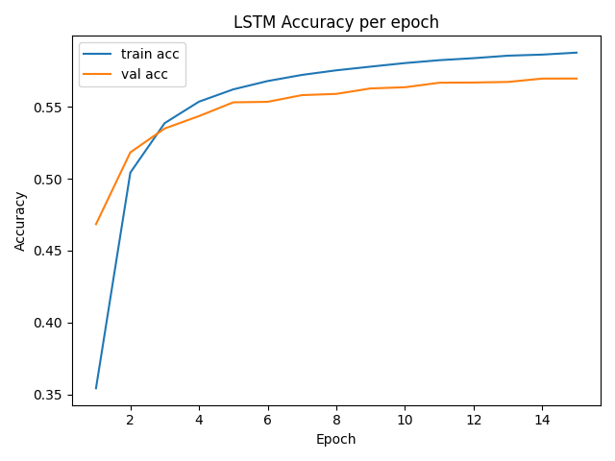
Learning Curve (accuracy per epoch):
Training Accuracy at epoch = 15: 0.5878 Validation Accuracy at epoch = 15: 0.5697
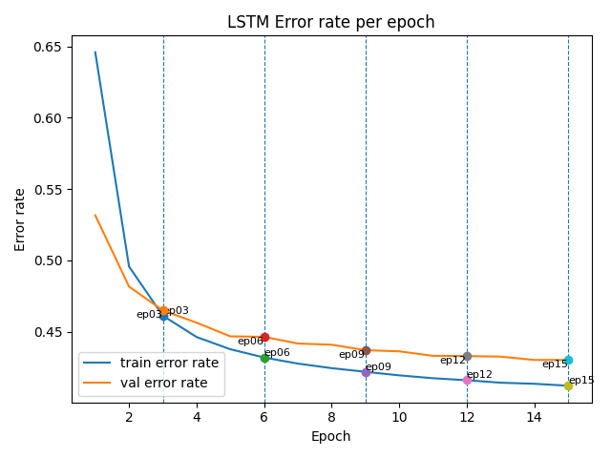
Error rate for Training Set and Validation Set per epoch (marking breaking point):
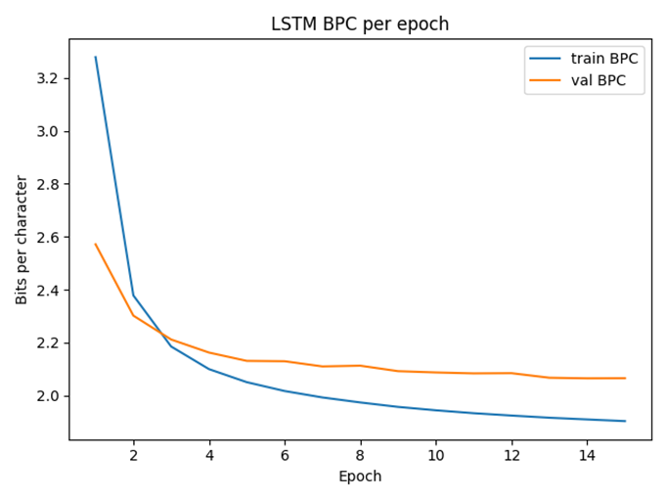
Training and Validation BPC (Bits per Character) vs Epoch (lower is better)
Training BPC at epoch = 15:1.9034 Validation BPC at epoch = 15: 2.0753
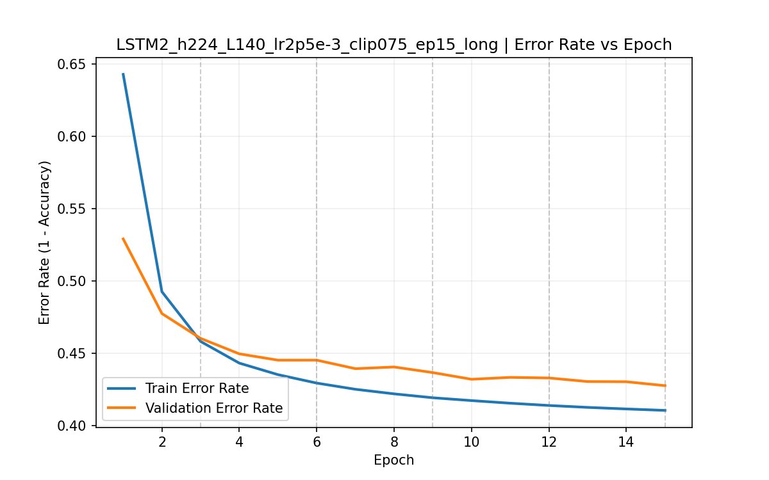
Training/Validation error rate (Error Rate = 1 – Accuracy)
Training Error Rate at epoch = 15: 0.4122 Validation Error Rate at epoch = 15: 0.4303

2-2. 5 Training Checkpoints (Epochs) – Text Samples:
Breaking Points | Text Outputs
Epoch 3 | JULIET:  The arms win good man is my lidst:  And new reportly, we are the colse Brotoal  head his impossion a nettent and thou thou,  Dist, had we show me and friend.  CORIOLANUS:  Say this; between shall distress up  An answer it upon his toobs,  That would how fish out any most gives;  In thou art of Earl is of my purise.  TURIA:  My great bird Hasteant hath good car.  Prithee, velb'd'd thou powern stuke--stast
Epoch 6 | JULIET:  My reasons.  HELENA:  Jascle and Londo Julius?  BOULT:  HAMLET:  I will, thy lord: now drown for authority;  You won hither? he hathst thou by his corround;  A quick esperies one will; and a day greed  Again, and I officers be pleased:  Make he has the large and mething'd feoling  Quite or night made neir he were remembricite  Who that she has let him to vile's to feecent things  For so have long marthou
Epoch 9 | JULIET:  No, to buy vound it in the impain, conceive away  You bade the health come to denger peace;  For wake him, charge so women. I enter, let  you most crown.  Come by the fool, when sent that recover'd  pitience: stands, such adigute. Ho, call thee,  Till watch't the tyrant and dags he worls: may which  This worthy return, Tumbly, or he's a passion!  Fiterous, reserved him. K'll, but I must bring but I woul
Epoch 12 | JULIET:  'Tis now in the perfections under whole?  This wine and lands iccorgentable weeds,  He had been belodicious.  BUCKINGHAM:  Were we much; and for the way of tricks  To beg home from ordiners with me; and  O sorrow.  EARL OF DORFWOBUS:  Most grait pleasure, that she of your soul,  To shop--I have given me on in possible English Warwick,  That she clessing with him: chief, I have called  These heart and a t
Epoch 15 | JULIET:  Go thy mother,--Pool was never such worthiest.  A gifts! Where's My master Richard?  TIMON:  Bol, you have confess your daughter; but My good queen see  Antony of Rome: enough, recoloured, I could  ne'er have been damn'd in such villainments for you.  ESCALUS:  The mute bpoken not one than twenty soldiers  Unto fity's tongue.  BOTTOM:  O, god I think it hats; for it is he as mercy;  But being sendent al

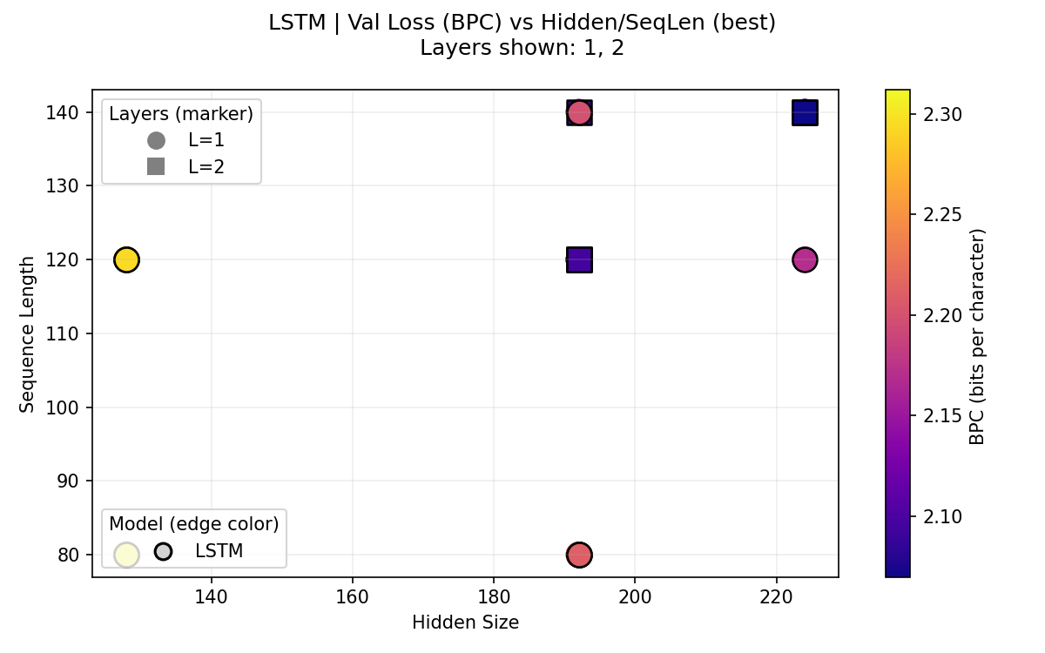
  - Compare the Impact of Different Hidden State Sizes and Sequence Lengths on Training (Including the effect of different layers of the network)
*Color = validation BPC (lower is better); circle = 1 layer, square = 2 layers

Comparison of different layers of the network
The setup of the network:
Hyperparameter/ Setup | Value
*Embedding dimension | 64
Hidden layer dimension | 192
Sequence length | 120
Batch Size | 64
Learning Rate | 0.003
Epoch | 15
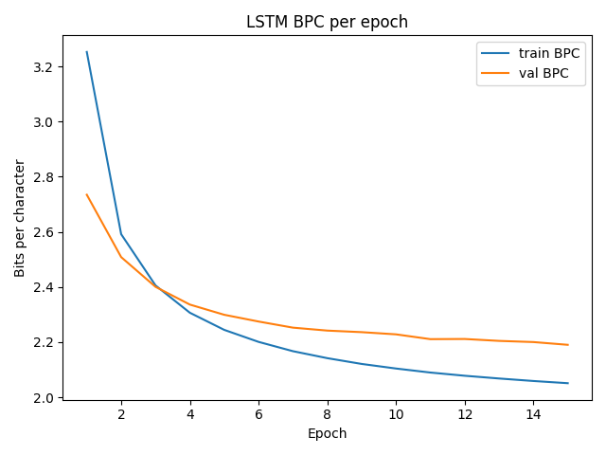
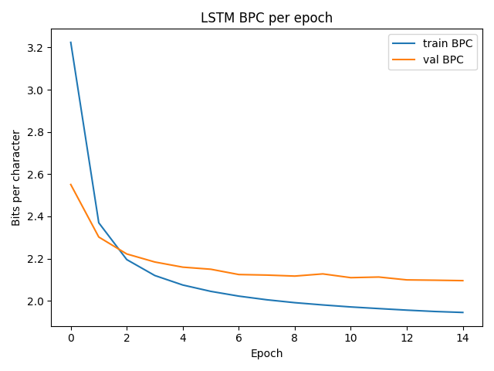
Layer = 1 Layer = 2
Analysis: For starters, the curves of the single-layer model drop steeply in the first 2 ~3 epochs, then plateau but plateau near epoch ~10. The curve that follows indicates that the model has reached its capacity under this configuration. In comparison, the curve of the two-layer model continues to trend downward. The continued descent indicates that the model has not yet saturated. In conclusion, the single-layer model has plateaued, indicating limited capacity under the current setup, whereas the two-layer model exhibits a continuing downward trend in validation BPC and thus shows better potential.

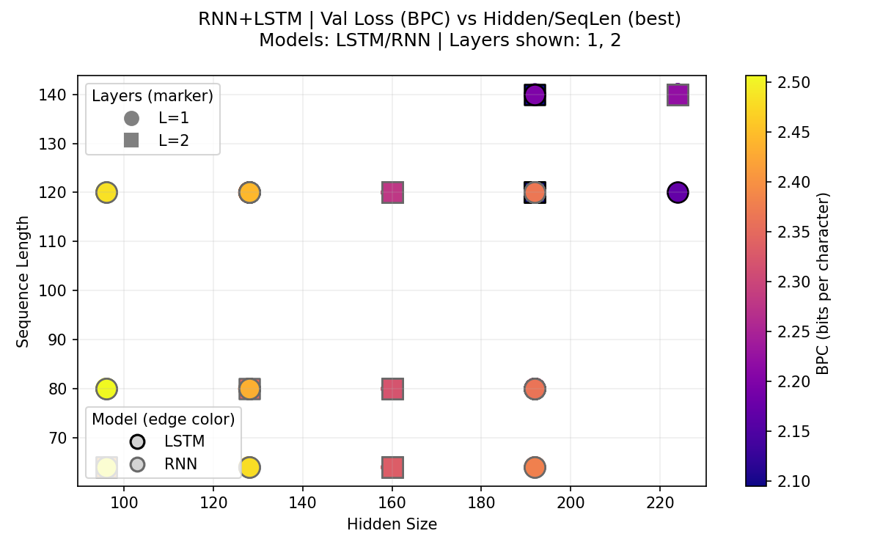
- Discussion of the difference between RNN and LSTM
*The graph compares the performance of the RNN and LSTM with different layers :
Color = validation BPC (lower is better); circle = 1 layer, square = 2 layers; black edge = LSTM / gray edge = RNN
Analysis: Across the runs, the best validation BPC consistently improves when moving from one layer to two layers. Points (squares) are generally darker than 1-layer points at the same hidden/sequence settings, matching earlier learning curves where the 1-layer model had already plateaued while the 2-layer model kept descending. Comparing architectures, LSTMs outperform vanilla RNNs at matched capacity, with the gap widening at larger hidden sizes (190~225) and longer sequences (120~140), where LSTM results cluster near 2.07~2.15 BPC while RNNs remain around 2.20~2.45. When it comes to the text generated, LSTM preserves local word order more faithfully. On the other hand, RNN samples more often show scrambled ordering that violates grammar, although both models still exhibit misspellings and occasional awkward spacing or blank lines.
- Generate Text Using the RNN and LSTM Model
*To achieve enough content change the setting: prime = “JULIET:”, temperature = 0.9, gen_len = 400, seed = 42
RNN | JULIET:  What tell you hoars weepion, my lord,  Which I may brought alone.  CLOTEN:  Gove already, to make thrice, to you will assives,  And Henry thou shalt more than my only?  ORLANDO:  So fearest they parson you to thou:  Your tent daughter with dangery:  And at the king's other bigetful air,  And never Galance, by all stooved inquieting and seeming a hune,  And will no mine bold, sir, this wearing hardly  And
LSTM | JULIET:  I never stir mad: and God the world, master,  Farewell, how dare she would chain on Plantagenet,  That you do be so cardied.  POSTHUMUS LEONATUS:  Therefore, below, ho! The coming of it ones and  vessing chamber out of men of familiar together,  Lest to see you then, the fines their gossbellow!  MESSALA:  Ay, though I know not for my lamber: the prince,  This shame. Was not what I should before thee.  JESSICA:  Nay, by the closes the boon hearts, and my vows  Did metaff his state and precies,  A father a book of day is not one more:  Thou endem proves, and pride who ebsurrets house  Why might be inform the very root of us  And trouble the wirteness are: who greets at on  That callour my place?  BUCKINGHAM:  Yes, mine, was I parted in his father that would look  You have made the Diomement: a piton can say,  You have angry enough of the gift, or honesty;  I not say you are in speech'd--  LUCENTIO:  I beg it so.  GRAMIO:  A little shoulder that I more thint that he was  buried it so villain, a brother, where lies the pursuit will go  fram, to't withal, I had revenged at Geard;  What is true slippish figures to this night?  This glony have been thy three eye of thy mind?  KENT:  Truth, rather!'  First Citizen:  To-morrow, sir.  BENVOLIO:  That is more man's sons; we will go.  THERSITES:  They tender in Marcius in Publio.  TROILUS:  Ay, as thou hast hammers by Caesar: my master to  thy place, she use his eyes and the lady and honour'd an house:  Is the intended Fruitful Julia paties,  And then against our blown reproach of steel?  DESDEMONA:  And now, sir, you shall say as that the fools see;  Pride my fortune, with a knave that lead as good the night,  Because I will down them all the night.  There, my lord; Jehn, write the applause,  And see not the furn and time to mine eye  A bag-years for thy houng is in blows of  Husband, thou simple love, no harm: I'll exply  The vapour I my father's daar'd limb,  Did paise the hate too,--to busie me, I have  fainting orleans. Why, he, there is some case, and a way  aite

