**ANGULAR**

**INSTALL NODE JS**

[opc@jenkins-master ~]$ **sudo dnf module reset nodejs:10/common**

Last metadata expiration check: 0:03:21 ago on Thu 22 Dec 2022 12:35:41 AM GMT.

Only module name is required. Ignoring unneeded information in argument: 'nodejs:10/common'

Dependencies resolved.

======================================================================================================================================================================================

Package Architecture Version Repository Size

======================================================================================================================================================================================

Resetting modules:

nodejs

Transaction Summary

======================================================================================================================================================================================

Is this ok [y/N]: y

Complete!

[opc@jenkins-master ~]$ sudo dnf module install nodejs:18/common

Last metadata expiration check: 0:04:00 ago on Thu 22 Dec 2022 12:35:41 AM GMT.

Dependencies resolved.

======================================================================================================================================================================================

Package Architecture Version Repository Size

======================================================================================================================================================================================

Upgrading:

nodejs x86_64 1:18.12.1-2.module+el8.7.0+20890+579912a9 ol8_appstream 13 M

npm x86_64 1:8.19.2-1.18.12.1.2.module+el8.7.0+20890+579912a9 ol8_appstream 2.0 M

Installing module profiles:

nodejs/common

Enabling module streams:

nodejs 18

Transaction Summary

======================================================================================================================================================================================

Upgrade 2 Packages

Total download size: 15 M

Is this ok [y/N]: y

Downloading Packages:

(1/2): npm-8.19.2-1.18.12.1.2.module+el8.7.0+20890+579912a9.x86_64.rpm 4.0 MB/s | 2.0 MB 00:00

(2/2): nodejs-18.12.1-2.module+el8.7.0+20890+579912a9.x86_64.rpm 15 MB/s | 13 MB 00:00

--------------------------------------------------------------------------------------------------------------------------------------------------------------------------------------

Total 17 MB/s | 15 MB 00:00

Running transaction check

Transaction check succeeded.

Running transaction test

Transaction test succeeded.

Running transaction

Running scriptlet: npm-1:8.19.2-1.18.12.1.2.module+el8.7.0+20890+579912a9.x86_64 1/1

Preparing : 1/1

Upgrading : npm-1:8.19.2-1.18.12.1.2.module+el8.7.0+20890+579912a9.x86_64 1/4

Upgrading : nodejs-1:18.12.1-2.module+el8.7.0+20890+579912a9.x86_64 2/4

Cleanup : nodejs-1:10.24.0-1.module+el8.3.0+9671+154373c8.x86_64 3/4

Cleanup : npm-1:6.14.11-1.10.24.0.1.module+el8.3.0+9671+154373c8.x86_64 4/4

Running scriptlet: npm-1:6.14.11-1.10.24.0.1.module+el8.3.0+9671+154373c8.x86_64 4/4

Verifying : nodejs-1:18.12.1-2.module+el8.7.0+20890+579912a9.x86_64 1/4

Verifying : nodejs-1:10.24.0-1.module+el8.3.0+9671+154373c8.x86_64 2/4

Verifying : npm-1:8.19.2-1.18.12.1.2.module+el8.7.0+20890+579912a9.x86_64 3/4

Verifying : npm-1:6.14.11-1.10.24.0.1.module+el8.3.0+9671+154373c8.x86_64 4/4

Upgraded:

nodejs-1:18.12.1-2.module+el8.7.0+20890+579912a9.x86_64 npm-1:8.19.2-1.18.12.1.2.module+el8.7.0+20890+579912a9.x86_64

Complete!

################################################################################

**ANGULAR CLI – COMMAND LINE INTERFACE**

opc@jenkins-master ~]$ ls

aws awscliv2.zip Birthday cs50p demo easy-rsa kali loc-nmap openvpn-install output Python-3.10.2 Python-3.10.2.tgz webex-api webex-websoket

[opc@jenkins-master ~]$ sudo npm install -g @angular/cli

npm WARN deprecated @npmcli/move-file@2.0.1: This functionality has been moved to @npmcli/fs

npm WARN deprecated sourcemap-codec@1.4.8: Please use @jridgewell/sourcemap-codec instead

changed 232 packages, and audited 233 packages in 40s

26 packages are looking for funding

run `npm fund` for details

found 0 vulnerabilities

[opc@jenkins-master ~]$ ng --version

Error: You need to specify a command before moving on. Use '--help' to view the available commands.

[opc@jenkins-master ~]$ ng --help

ng <command>

Commands:

ng add <collection> Adds support for an external library to your project.

ng analytics Configures the gathering of Angular CLI usage metrics.

ng build [project] Compiles an Angular application or library into an output directory named dist/ at the given output path. [aliases: b]

ng cache Configure persistent disk cache and retrieve cache statistics.

ng completion Set up Angular CLI autocompletion for your terminal.

ng config [json-path] [value] Retrieves or sets Angular configuration values in the angular.json file for the workspace.

ng deploy [project] Invokes the deploy builder for a specified project or for the default project in the workspace.

ng doc <keyword> Opens the official Angular documentation (angular.io) in a browser, and searches for a given keyword. [aliases: d]

ng e2e [project] Builds and serves an Angular application, then runs end-to-end tests. [aliases: e]

ng extract-i18n [project] Extracts i18n messages from source code.

ng generate Generates and/or modifies files based on a schematic. [aliases: g]

ng lint [project] Runs linting tools on Angular application code in a given project folder.

ng new [name] Creates a new Angular workspace. [aliases: n]

ng run <target> Runs an Architect target with an optional custom builder configuration defined in your project.

ng serve [project] Builds and serves your application, rebuilding on file changes. [aliases: s]

ng test [project] Runs unit tests in a project. [aliases: t]

ng update [packages..] Updates your workspace and its dependencies. See https://update.angular.io/.

ng version Outputs Angular CLI version. [aliases: v]

Options:

--help Shows a help message for this command in the console. [boolean]

For more information, see https://angular.io/cli/.

[opc@jenkins-master ~]$ ng version

? Would you like to enable autocompletion? This will set up your terminal so pressing TAB while typing Angular CLI commands will show possible options and autocomplete arguments.

(Enabling autocompletion will modify configuration files in your home directory.) Yes

Appended `source <(ng completion script)` to `/home/opc/.bashrc`. Restart your terminal or run the following to autocomplete `ng` commands:

source <(ng completion script)

? Would you like to share pseudonymous usage data about this project with the Angular Team

at Google under Google's Privacy Policy at https://policies.google.com/privacy. For more

details and how to change this setting, see https://angular.io/analytics. Yes

Thank you for sharing pseudonymous usage data. Should you change your mind, the following

command will disable this feature entirely:

ng analytics disable --global

Global setting: enabled

Local setting: No local workspace configuration file.

Effective status: enabled

_ _ ____ _ ___

/ \ _ __ __ _ _ _| | __ _ _ __ / ___| | |_ _|

/ △ \ | '_ \ / _` | | | | |/ _` | '__| | | | | | |

/ ___ \| | | | (_| | |_| | | (_| | | | |___| |___ | |

/_/ \_\_| |_|\__, |\__,_|_|\__,_|_| \____|_____|___|

|___/

Angular CLI: 15.0.4

Node: 18.12.1

Package Manager: npm 8.19.2

OS: linux x64

Angular:

Package Version

------------------------------------------------------

@angular-devkit/architect 0.1500.4 (cli-only)

@angular-devkit/core 15.0.4 (cli-only)

@angular-devkit/schematics 15.0.4 (cli-only)

@schematics/angular 15.0.4 (cli-only)

**CREATE A PROJECT**

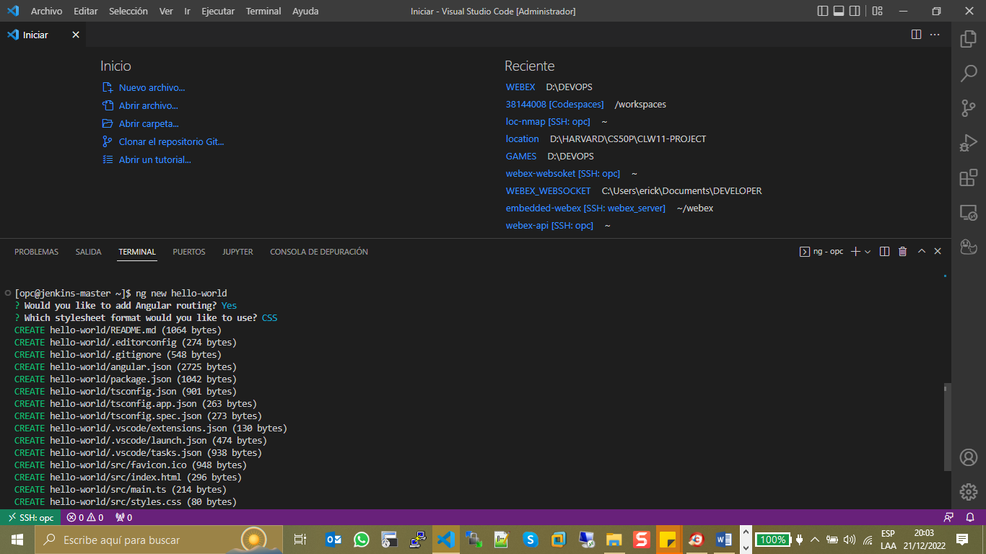

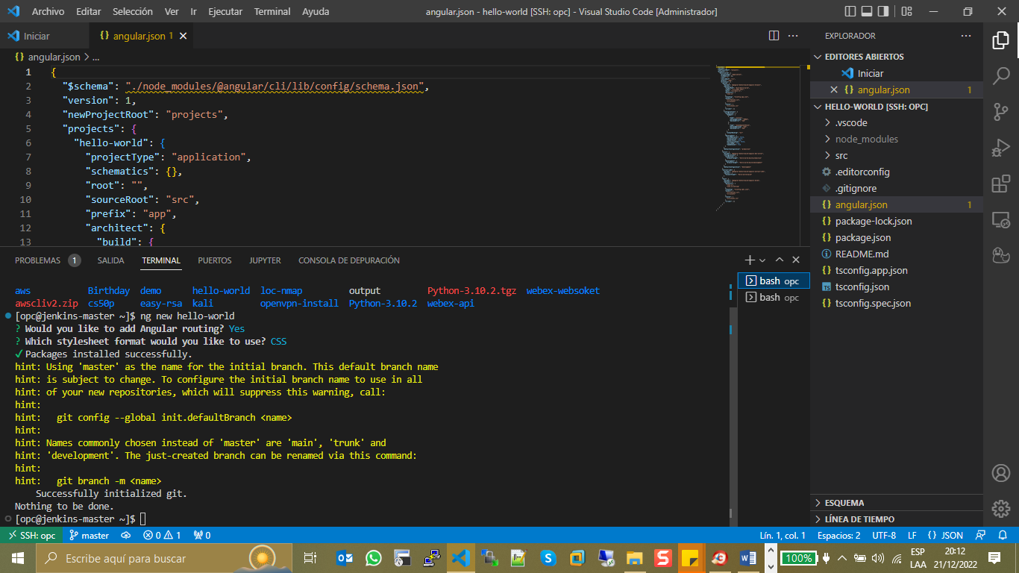

[opc@jenkins-master ~]$ ng new hello-world

[opc@jenkins-master ~]$ ng serve

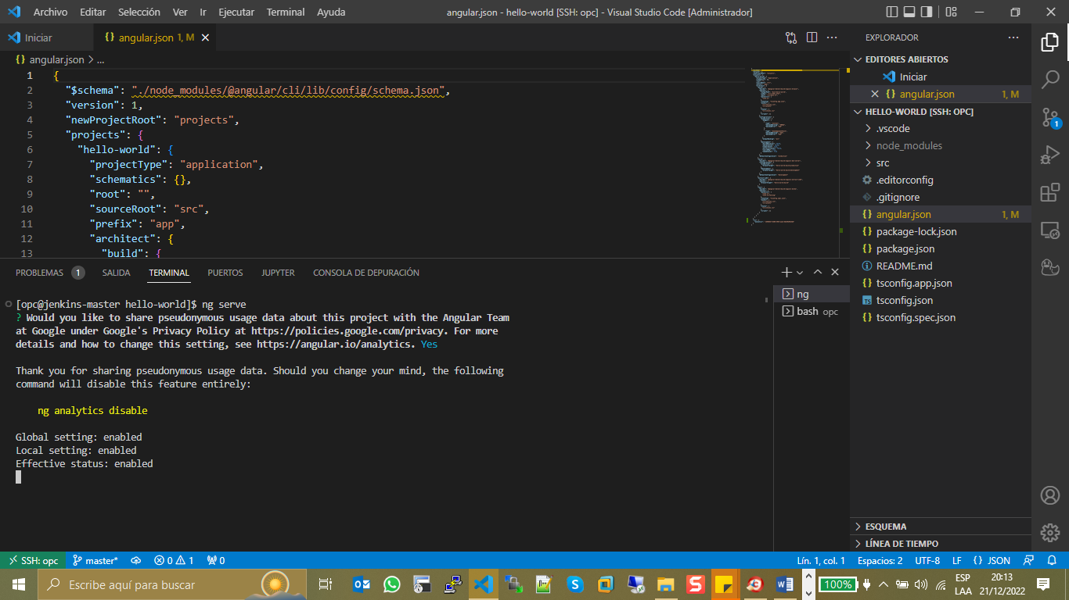

**DEFAULT VALUES IN FILE >>> package.json**

"start": "ng serve",

    "build": "ng build",

**Error:** FATAL ERROR: Ineffective mark-compacts near heap limit Allocation failed - JavaScript heap out of memory.

[opc@jenkins-master hello-world]$ ng serve

⠴ Generating browser application bundles (phase: sealing)...

<--- Last few GCs --->

[244561:0x55c2a95a1550] 141217 ms: Mark-sweep (reduce) 338.2 (346.3) -> 337.6 (346.8) MB, 1406.9 / 0.0 ms (average mu = 0.139, current mu = 0.066) allocation failure; scavenge might not succeed

[244561:0x55c2a95a1550] 143512 ms: Mark-sweep (reduce) 338.6 (346.8) -> 337.9 (347.1) MB, 2293.5 / 0.0 ms (average mu = 0.064, current mu = 0.001) allocation failure; scavenge might not succeed

<--- JS stacktrace --->

FATAL ERROR: Ineffective mark-compacts near heap limit Allocation failed - JavaScript heap out of memory

1: 0x55c2a6664174 node::Abort() [ng serve]

2: 0x55c2a6504c16 node::OOMErrorHandler(char const*, bool) [ng serve]

3: 0x55c2a6853574 v8::Utils::ReportOOMFailure(v8::internal::Isolate*, char const*, bool) [ng serve]

4: 0x55c2a6853837 v8::internal::V8::FatalProcessOutOfMemory(v8::internal::Isolate*, char const*, bool) [ng serve]

5: 0x55c2a6a1c1b9 [ng serve]

6: 0x55c2a6a233dc [ng serve]

7: 0x55c2a6a33fc3 v8::internal::Heap::PerformGarbageCollection(v8::internal::GarbageCollector, v8::internal::GarbageCollectionReason, char const*, v8::GCCallbackFlags) [ng serve]

8: 0x55c2a6a34987 v8::internal::Heap::CollectGarbage(v8::internal::AllocationSpace, v8::internal::GarbageCollectionReason, v8::GCCallbackFlags) [ng serve]

9: 0x55c2a6a10716 v8::internal::HeapAllocator::AllocateRawWithLightRetrySlowPath(int, v8::internal::AllocationType, v8::internal::AllocationOrigin, v8::internal::AllocationAlignment) [ng serve]

10: 0x55c2a6a11b0c v8::internal::HeapAllocator::AllocateRawWithRetryOrFailSlowPath(int, v8::internal::AllocationType, v8::internal::AllocationOrigin, v8::internal::AllocationAlignment) [ng serve]

11: 0x55c2a69f4f82 v8::internal::Factory::NewFillerObject(int, v8::internal::AllocationAlignment, v8::internal::AllocationType, v8::internal::AllocationOrigin) [ng serve]

12: 0x55c2a6d91ac9 v8::internal::Runtime_AllocateInYoungGeneration(int, unsigned long*, v8::internal::Isolate*) [ng serve]

13: 0x55c2a71ac1b9 [ng serve]

Aborted (core dumped)

############ Fixed ng Serve ------NG SERVE #####################

CHANGE VALUES IN FILE >>> package.json

"scripts": {

    "ng": "ng",

    "build": "node --max_old_space_size=1024 ./node_modules/@angular/cli/bin/ng build",

    "serve": "node --max_old_space_size=1024 ./node_modules/@angular/cli/bin/ng serve",

    "watch": "ng build --watch --configuration development",

    "test": "ng test"

  },

[opc@jenkins-master hello-world]$ node -e 'console.log(v8.getHeapStatistics().heap_size_limit/(1024*1024))'

352.5 >>>> default status

[opc@jenkins-master hello-world]$ export NODE_OPTIONS="--max-old-space-size=1024"

[opc@jenkins-master hello-world]$ node -e 'console.log(v8.getHeapStatistics().heap_size_limit/(1024*1024))'

**1036**

[opc@jenkins-master hello-world]$ ng serve

✔ Browser application bundle generation complete.

Initial Chunk Files | Names | Raw Size

vendor.js | vendor | 2.09 MB |

polyfills.js | polyfills | 314.28 kB |

styles.css, styles.js | styles | 209.40 kB |

main.js | main | 48.10 kB |

runtime.js | runtime | 6.52 kB |

| Initial Total | 2.66 MB

Build at: 2022-12-22T04:00:39.154Z - Hash: f28b5839d9ccdc54 - Time: 83397ms

** Angular Live Development Server is listening on localhost:4200, open your browser on http://localhost:4200/ **

✔ Compiled successfully

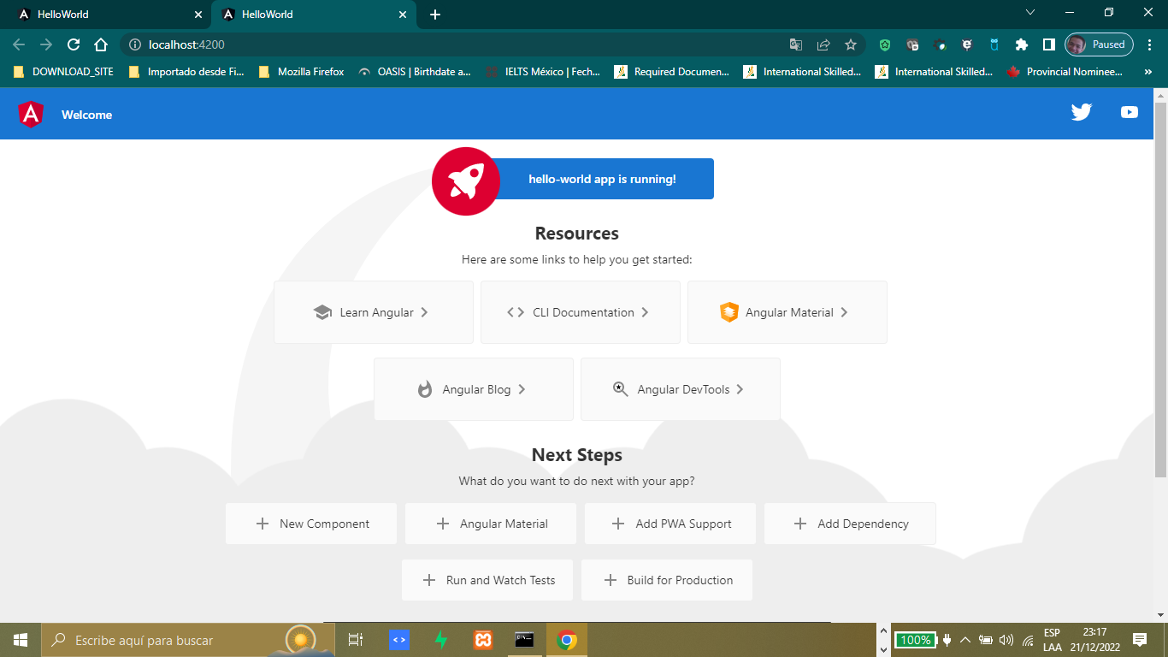

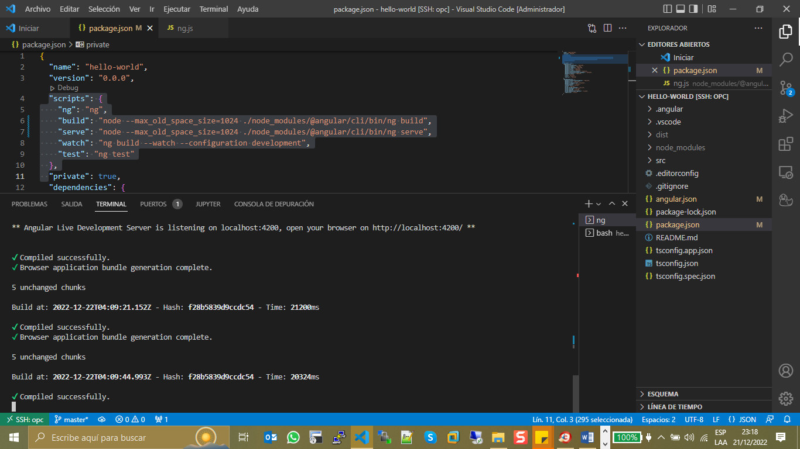

At this part the server is active in https://localhost:4200

Check variable environment in linux: export -p

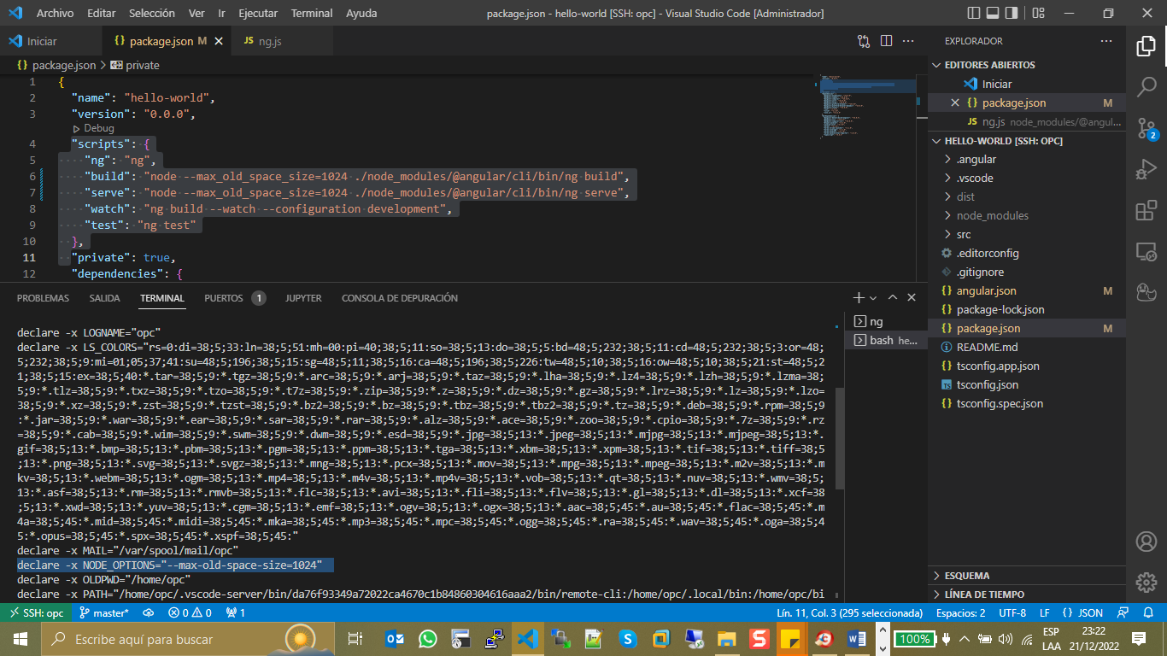

<https://www.javatpoint.com/linux-export-command#:~:text=To%20display%20all%20the%20exported,export%20%2Dp>

<https://sebhastian.com/javascript-heap-out-of-memory/>

<https://stackoverflow.com/questions/53230823/fatal-error-ineffective-mark-compacts-near-heap-limit-allocation-failed-javas>

