1. The total amount that Mary paid for a book was equal to the price of the book plus a sales tax

that was 4 percent of the price of the book. Mary paid for the book with a $10 bill and received the correct change, which was less than $3.00. Which of the following statements must be true?

Indicate all such statements.

A. The price of the book was less than $9.50.

B. The price of the book was greater than $6.90.

C. The sales tax was less than $0.45.

2. Let S be the set of all positive integers n such that n2 is a multiple of both 24 and 108. Which of

the following integers are divisors of every integer n in S ?

Indicate all such integers.

A. 12

B. 24

C. 36

D. 72

20. xy＞0，xy2＜0

Quantity A：x

Quantity B：y

A. Quantity A is greater.

B. Quantity B is greater.

C. The two quantities are equal.

D. The relationship cannot be determined from the information given.

29. The figure above represents a rectangular garden with a walkway around it. The garden is 18

feet long and 12 feet wide. The walkway is uniformly 3 feet wide, and its edges meet at right

angles. What is the area of the walkway?

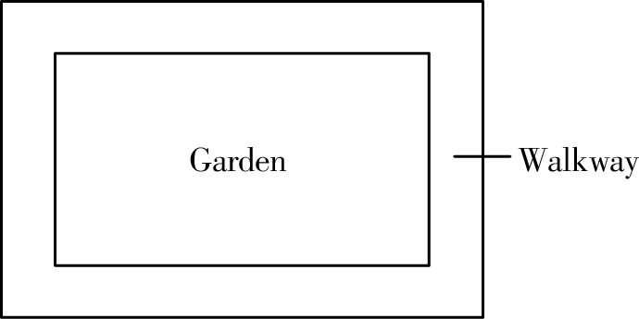

38. In a probability experiment, G and H are independent events. The probability that G will occur

is r, and the probability that H will occur is s, where both r and s are greater than 0.

Quantity A：the probability that either G will occur or H will occur,but not both

Quantity B：r+s-r×s

A. Quantity A is greater.

B. Quantity B is greater.

C. The two quantities are equal.

D. The relationship cannot be determined from the information given.

43. N=824x，where x is a positive integer

Quantity A：the number of possible values the units digit of N

Quantity B：4

A. Quantity A is greater.

B. Quantity B is greater.

C. The two quantities are equal.

D. The relationship cannot be determined from the information given.

46. A manufacturing company has plants in three locations: Indonesia, Mexico, and Pakistan. The

company has 6,000 employees, and each of the employees works at only one of the plants. If 3/8

of the employees work at the plant in Indonesia and if twice as many employees work at the plant in Mexico as work at the plant in Pakistan, how many employees work at the plant in Mexico?

68. For a certain probability experiment, the probability that event A will occur is 1/2 and the

probability that event B will occur is 1/3. Which of the following values could be the probability that the event A∪B (that is, the event A or B, or both) will occur?

Indicate all such values.

A. 1/3

B. 1/2

C. 3/4

69. In a factory, machine A operates on a cycle of 20 hours of work followed by 4 hours of rest, and machine B operates on a cycle of 40 hours of work followed by 8 hours of rest. Last week, the two machines began their respective cycles at 12 noon on Monday and continued until 12 noon on the following Saturday. On which days during that time period was there a time when both machines

were at rest?

Indicate all such days.

A. Monday

B. Tuesday

C. Wednesday

D. Thursday

E. Friday

76. If a, b, x, and y are positive integers, and13a×13b=(13x)y=1313, what is the average (arithmetic mean) of a, b, x, and y?

90. If x + y ≠ 0, which of the following is a solution to the inequality below？

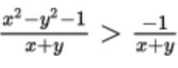

A. x=3 and y =7

B. x=-3 and y =7

C. x=-11 and y =-9

D. x=9 and y =-6

E. x=-20 and y =-24

F. x=12 and y =9

G. x=-2 and y =16

99.

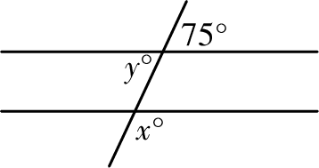

Quantity A：x

Quantity B：y

A. Quantity A is greater.

B. Quantity B is greater.

C. The two quantities are equal.

D. The relationship cannot be determined from the information given.

100. 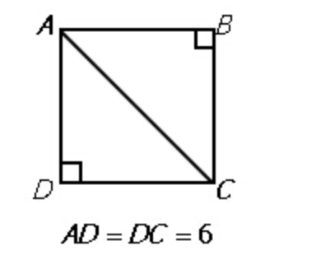

Quantity A：AB

Quantity B：BC

A. Quantity A is greater.

B. Quantity B is greater.

C. The two quantities are equal.

D. The relationship cannot be determined from the information given.

107. If x>0, which of the following expressions are equal to 3.6 percent of 5x/12?

Indicate all such expressions.

A. 3 percent of 20x

B. x percent of 3/2

C. 3x percent of 0.2

D. 0.05 percent of 3x

E. 3x/200

110. Anne pays 150 percent more for a wholesale widget than Bart pays. Anne’s retail price per

widget is 15 percent greater than the wholesale price she paid. Bart’s retail price per widget is 185 percent greater than the wholesale price he paid.

Quantity A：Anne's retail price

Quantity B：Bart's retail price

A. Quantity A is greater.

B. Quantity B is greater.

C. The two quantities are equal.

D. The relationship cannot be determined from the information given.

111. Diana invested $61,293 in an account with a fixed annual percent of interest, compounding

quarterly. At the end of five full years, she had $76,662.25 in principal plus interest. Approximately what was the annual percent rate of interest for this account?

A. 1.2%

B. 4.5%

C. 10%

D. 18%

E. 25.2%

113. A box contains 10 balls numbered from 1 to 10 inclusive. If Ann removes a ball at random and replaces it, and then Jane removes a ball at random, what is the probability that both women

removed the same ball?

A. 1/100

B. 1/90

C. 1/45

D. 1/10

E. 41/45

114. A: {71,73,79,83,87} B: {57,59,61,67}

If one number is selected at random from set A, and one number is selected at random from set B, what is the probability that both numbers are prime?

A. 9/20

B. 3/5

C. 3/4

D. 4/5

E. 1

117. In a certain sock drawer, there are 4 pairs of black socks, 3 pairs of gray socks and 2 pairs of

orange socks. If socks are removed at random without replacement, what is the minimum number of socks that must be removed in order to ensure that two socks of the same color have been removed?

A. 4

B. 7

C. 9

D. 10

E. 11

121. From a group of 8 people, it is possible to create exactly 56 different k-person committees.

Which of the following could be the value of k ?

Indicate all such values.

A. 1

B. 2

C. 3

D. 4

E. 5

F. 6

G. 7

122. A knockoff website requires users to create a password using letters from the word MAGOSH. If each password must have at least 4 letters and no repeated letters are allowed, how many different passwords are possible?

124. How many integers between 1 and 1021are such that the sum of their digits is 2?

A. 190

B. 210

C. 211

D. 230

E. 231

125. There are 10 people in a room. If each person shakes hands with exactly 3 other people, what is the total number of handshakes?

A. 15

B. 30

C. 45

D. 60

E. 120

126. How many positive integers less than 10,000 are such that the product of their digits is 210?

A. 24

B. 30

C. 48

D. 54

E. 72

128. In a group of 200 workers, 10 percent of the males smoke, and 49 percent of the females

smoke.

Quantity A：Total number of workers who smoke

Quantity B：59

A. Quantity A is greater.

B. Quantity B is greater.

C. The two quantities are equal.

D. The relationship cannot be determined from the information given.

131.

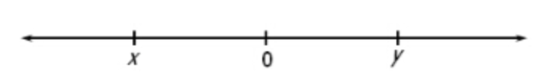

Note: Figure not drawn to scale

If x and y are numbers on the number line above, which of the following statements must be true?

I. |x+y| < y

II. x + y < 0

III. xy < 0

A. I only

B. III only

C. I and II

D. I and III

E. II and III

135. x is a positive integer. k is the remainder when x3-x is divided by 3.

Quantity A：k

Quantity B：1

A. Quantity A is greater.

B. Quantity B is greater.

C. The two quantities are equal.

D. The relationship cannot be determined from the information given.

136. x and y are integers greater than 5. x is y percent of x2.

Quantity A：x

Quantity B：10

A. Quantity A is greater.

B. Quantity B is greater.

C. The two quantities are equal.

D. The relationship cannot be determined from the information given.

143. If x is an odd negative integer and y is an even integer, which of the following statements must be true?

I. (3x - 2y) is odd

II. xy2 is an even negative integer

III. (y2-x) is an odd negative integer

A. I only

B. II only

C. I and II

D. I and III

E. II and III

149. The 20 people at a party are divided into n mutually exclusive groups in such a way that the

number of people in any group does not exceed the number in any other group by more than 1.

Quantity A：The value of n if at least one of the groups consists of 3 people

Quantity B：6

A. Quantity A is greater.

B. Quantity B is greater.

C. The two quantities are equal.

D. The relationship cannot be determined from the information given.

152. If n is any prime number greater than 2, which of the following CANNOT be a prime number ?

A. n-4

B. n-3

C. n-1

D. n+2

E. n+5