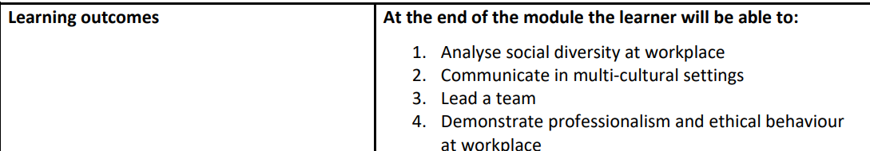

# Identification of social diversity and differences

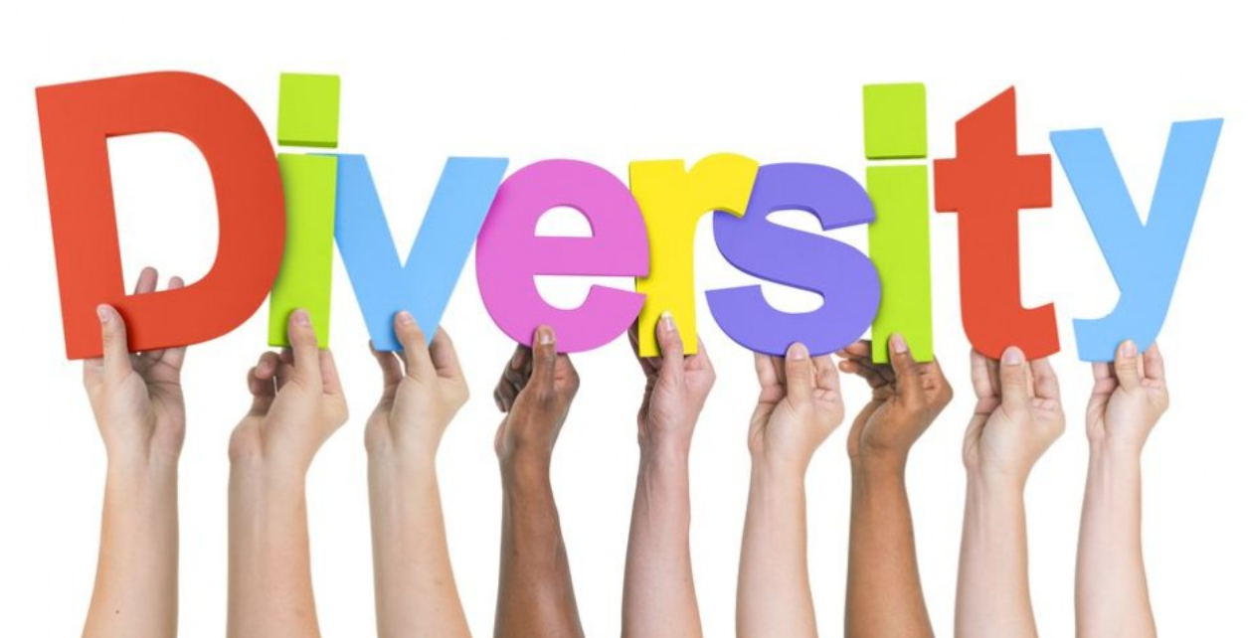

## ✓ Definition of key terms

**Social diversity:**

refers to the **variety of identities and characteristics** within a society or group. It encompasses the wide range of attributes such as race, ethnicity, gender, religion, age, sexual orientation, and socioeconomic status. Social diversity highlights the **presence of multiple distinct groups or categories** within a community or workplace.

According to Dania Santana, a multiculturalism, diversity, and inclusion expert, social diversity is defined as a successful community which includes individuals from diverse backgrounds who all contribute to the success of the community by practicing understanding and respect of different ideas and perspectives

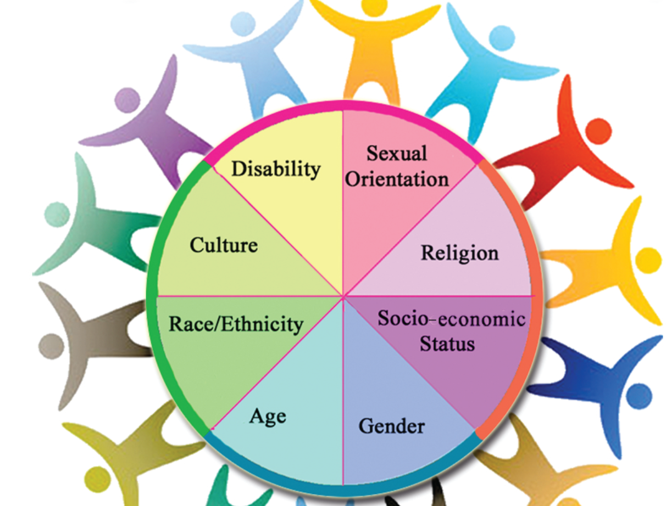

**Social differences:**

Refers to the **specific distinctions or variations** that exist between individuals or groups within society. These can include differences in culture, values, beliefs, and behaviors. Social differences are more about the **comparative aspects** between individuals or groups, such as how one group may differ from another in terms of traditions, norms, or social roles.

## ✓ Types of workplace diversity

1. **Ethnicity**: Refers to a group of people who share a common cultural heritage, traditions, and social customs. Ethnic diversity focuses on differences in cultural backgrounds, including shared history and practices, without considering language as a factor.

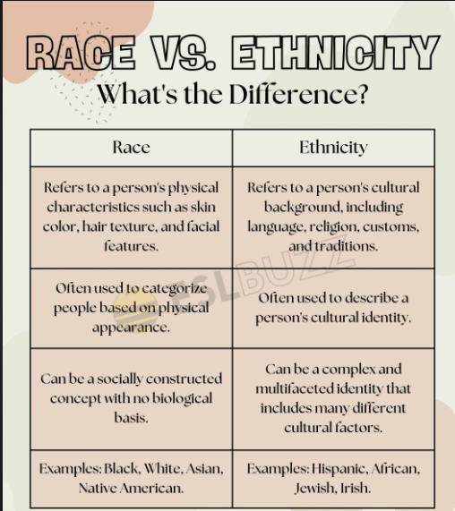

1. **Lifestyle**: Involves the individual choices people make in how they live their lives, including their daily habits, recreational activities, and personal values. Lifestyle diversity highlights variations in work-life balance, diet, hobbies, and approaches to personal well-being.

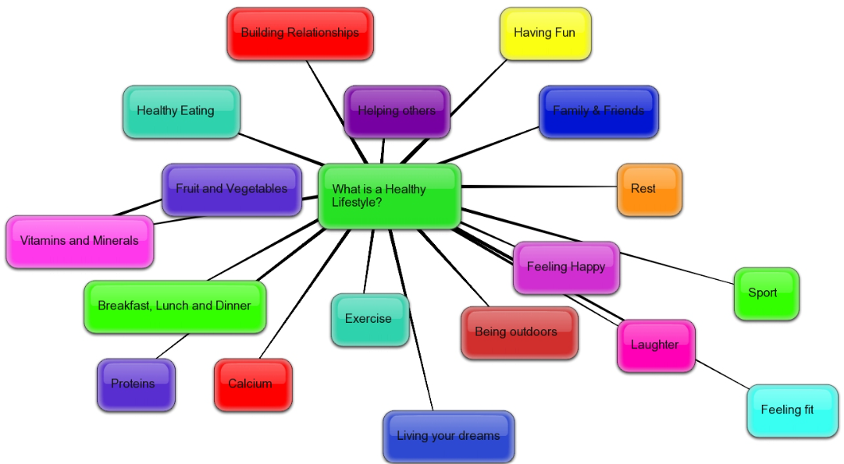

1. **Religion**: Refers to the spiritual beliefs, rituals, and practices that individuals follow as part of their faith. Religious diversity addresses differences in belief systems, worship practices, observances, and holidays.

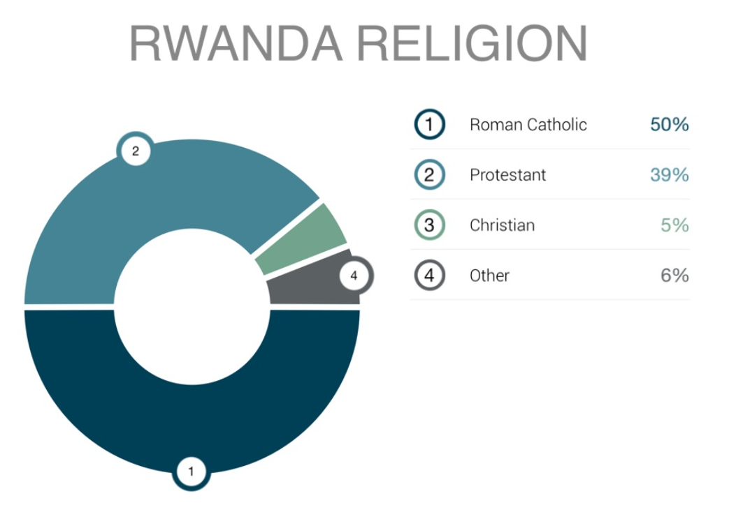

1. **Beliefs**: Relates to a person's personal convictions, values, or ideologies that guide their actions and decisions. This includes ethical, political, and philosophical views, which can influence decision-making and interactions in the workplace.

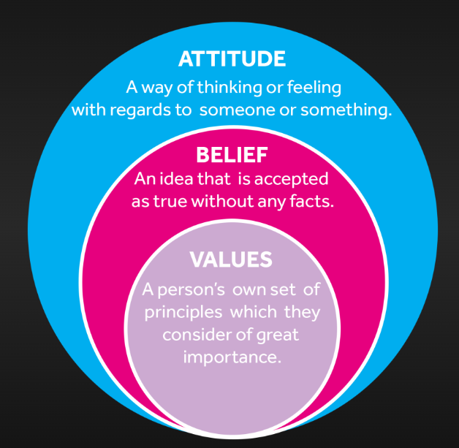

1. **Taste and Preferences**: Refers to individual choices and inclinations related to personal likes and dislikes, such as food, fashion, music, and entertainment. Diversity in taste and preferences affects social interactions and group dynamics based on differing personal interests.
2. **Language**: Focuses on the different languages or dialects spoken by employees in the workplace. Language diversity highlights variations in communication styles, which may create challenges or opportunities for collaboration and understanding.

**DISTINCTION OF SOCIAL DIVERSITY ISSUES IN THE WORKPLACE**

Social diversity in the workplace refers to the presence of employees from various cultural, ethnic, gender, generational, and socioeconomic backgrounds. While diversity offers numerous benefits, it can also give rise to several issues that need to be managed carefully to ensure a harmonious and productive work environment. Below are explanations of key **categories of social diversity issues** that can arise in the workplace.

**1. Communication Issues:**

Communication is a central part of any workplace, but when employees come from different cultural or linguistic backgrounds, misunderstandings can occur. These may be due to differences in language proficiency, communication styles, or interpretations of non-verbal cues (such as body language or tone).

**Examples**:

* A team where employees speak different native languages might experience difficulties understanding each other, which can affect teamwork and efficiency.
* Cultural norms regarding how direct or indirect communication should be can cause misunderstandings. For example, employees from a culture where indirect communication is preferred may perceive direct criticism as rude, while others may find indirect feedback unclear.

**2. Workplace Conflicts**

Conflicts can arise when employees with different backgrounds, values, or beliefs interact. Workplace diversity can lead to differing opinions on work ethics, problem-solving approaches, or interpersonal relations, which may result in disagreements.

**Examples**:

* A conflict might occur when younger employees prefer a more casual work environment, while older employees expect a more formal one.
* Religious differences, such as how and when people observe holidays or dress, can also lead to misunderstandings or disagreements.

**Impact**:  
Unresolved conflicts can create a toxic work environment, reduce collaboration, and increase stress. Mediation and conflict resolution strategies tailored to diverse workforces can help manage these situations effectively.

**3. Harassment**

Workplace harassment occurs when employees face unwelcome and inappropriate behavior based on their race, gender, ethnicity, age, or other diverse characteristics. Harassment can take many forms, including verbal abuse, physical intimidation, or subtle exclusion.

**Examples**:

* Racial or gender-based jokes or derogatory comments can create a hostile work environment.
* A female employee might face sexual harassment or discrimination from male colleagues in a male-dominated workplace.

Harassment can lead to severe emotional distress, decreased job satisfaction, and high turnover rates. Implementing strict anti-harassment policies, offering training, and encouraging employees to report incidents can help prevent and address such issues.

**4. Diversity Without Inclusion**

Diversity means having a mix of people from different backgrounds, but without **inclusion**, diverse employees may not feel valued or have equal opportunities to participate. Inclusion ensures that all employees, regardless of their background, feel accepted, respected, and involved in decision-making processes.

**Examples**:

* A company might hire employees from various backgrounds but fail to provide them with the same opportunities for leadership roles or professional growth.
* Minority employees may feel their voices are ignored in meetings, or they might not be invited to participate in key projects.

When diversity exists without inclusion, it can lead to disengagement, frustration, and higher turnover rates, particularly among underrepresented groups. Building an inclusive culture where all employees feel empowered to contribute is crucial for maximizing the benefits of diversity.

**5. Generation Gaps**

With multiple generations working together, from Baby Boomers to Gen Z, differences in work styles, communication preferences, and expectations can cause friction. Each generation may have its own values, goals, and approaches to work, which can lead to misunderstandings.

**Examples**:

* Older employees may prefer traditional work hours, while younger employees might value flexibility and remote work.
* Communication preferences can differ: Baby Boomers may prefer face-to-face meetings, while Millennials and Gen Z might favor digital communication like emails or instant messaging.

If not managed well, generational differences can create misunderstandings, resentment, and reduced collaboration. Offering intergenerational training and encouraging mentorship between generations can help bridge these gaps.

**6. Unconscious Biases**

Unconscious biases are the automatic judgments or stereotypes people hold about others based on race, gender, age, or other characteristics without being aware of them. These biases can influence hiring decisions, promotions, project assignments, or evaluations in unfair ways.

**Examples**:

* A manager might unconsciously favor male candidates for leadership roles, believing they are more assertive, even though female candidates are equally qualified.
* An employee might assume that a younger colleague is more tech-savvy than an older one, despite both having the same experience with technology.

Unconscious biases can lead to inequality, frustration, and missed opportunities for talented employees. Bias training, inclusive hiring practices, and promoting awareness of unconscious biases can help create a fairer and more equal workplace.

**IMPACTS OF SOCIAL DIVERSITY AT THE WORKPLACE**

Social diversity in the workplace has both positive and negative impacts, depending on how well it is managed. Organizations that embrace diversity and inclusion can unlock great potential, but if mismanaged, social diversity can also lead to challenges.

**Negative Impacts of Social Diversity**

**1. Communication Barriers:** Employees from diverse backgrounds may have different languages, communication styles, or cultural norms, which can lead to misunderstandings or ineffective communication.Poor communication can cause confusion, decrease productivity, and lead to errors in team-based tasks.

**2. Increased Workplace Conflict:** Differing values, beliefs, or work ethics among a diverse workforce can sometimes lead to clashes or disagreements. These conflicts, if left unresolved, can result in a toxic work environment, stress, and decreased collaboration among employees.

**3. Exclusion and Alienation:** When diversity exists without inclusion, minority employees may feel left out of decision-making processes, social networks, or opportunities for growth.This can lead to disengagement, lower job satisfaction, and higher turnover rates, especially among underrepresented groups.

**4. Unconscious Bias and Discrimination:** Unconscious biases can lead to unfair treatment, where individuals are judged based on stereotypes or assumptions rather than their actual performance or potential.This can create unequal opportunities in hiring, promotions, or project assignments, and contribute to a lack of trust and resentment within the workplace.

**5. Challenges in Change Management:** Diverse workforces may have differing attitudes toward organizational change. What works for one group might be resisted by another.This resistance can slow down the implementation of new policies or initiatives and reduce overall adaptability within the organization.

**Positive Impacts of Social Diversity**

**1. Increased Innovation and Creativity:** A diverse workforce brings together different perspectives, ideas, and problem-solving approaches, leading to more creative solutions.This diversity of thought can drive innovation, helping companies to better adapt to changing markets and create new products or services.

**2. Enhanced Decision-Making:** Teams with members from diverse backgrounds are better equipped to consider multiple viewpoints, leading to more informed and well-rounded decisions. This reduces the risk of groupthink and leads to decisions that consider a broader range of potential outcomes and risks.

**3. Improved Employee Engagement and Retention:** When employees feel that their diverse backgrounds are respected and valued, they are more likely to feel engaged, satisfied, and committed to their jobs.This leads to higher retention rates, as employees who feel included and appreciated are less likely to leave the company.

**4. Better Understanding of a Diverse Customer Base:** A diverse workforce can better understand the needs, preferences, and challenges of a diverse customer base.This insight allows companies to tailor products, services, and customer service strategies to meet the expectations of a broader audience, improving customer satisfaction and loyalty.

**5. Broader Talent Pool:** By embracing social diversity, companies can attract talent from a wider range of backgrounds, bringing in individuals with unique skills and experiences.This not only strengthens the company’s ability to innovate but also improves its competitive edge in attracting top talent.

**6. Positive Workplace Culture:** A focus on diversity and inclusion helps foster a positive, respectful, and open workplace culture where employees feel safe and supported.A positive culture increases collaboration, reduces conflict, and improves overall job satisfaction for employees.

**Conclusion**

**Negative Impacts**: If diversity is poorly managed, it can result in communication barriers, workplace conflicts, exclusion, and unconscious bias, which can negatively affect productivity, employee morale, and retention.

**Positive Impacts**: When managed effectively, diversity can lead to increased innovation, better decision-making, higher employee engagement, a better understanding of diverse markets, and a more positive workplace culture, providing significant benefits to organizations.

**Evaluation of Factors Influencing Social Diversity and Differences**

Social diversity and differences are shaped by various factors that affect how individuals and groups interact, perceive each other, and live together. These factors can be demographic, socio-economic, geographical, and political, all of which contribute to the overall complexity of social dynamics in different settings, including workplaces and communities.

**1. Demographic Factors**

Demographic factors relate to the characteristics of a population and have a significant impact on social diversity.

* **Age**: Different generations have distinct experiences, values, and expectations. For example, Baby Boomers, Millennials, and Gen Z may have different work preferences, communication styles, and approaches to technology.
* **Gender**: Gender diversity includes men, women, and non-binary individuals, contributing to different perspectives and experiences within society or the workplace.
* **Ethnicity and Race**: Ethnic and racial diversity can influence language, cultural practices, traditions, and social interactions. People from different racial backgrounds bring a wide array of cultural viewpoints and values.
* **Religion**: Religious diversity introduces different belief systems, practices, and moral values. It can influence holidays, workplace accommodations (such as prayer spaces), and dietary restrictions.
* **Disability**: People with disabilities may have unique needs and experiences, requiring inclusivity in accessibility, communication, and policies.

**Impact**: Demographic factors contribute to the variety of perspectives, values, and needs in a diverse society. Organizations that consider these factors when shaping policies and practices are more likely to foster inclusivity and benefit from diverse talent.

**2. Socio-Economic Factors**

Socio-economic factors refer to the social and economic conditions that affect people's lives and opportunities.

* **Income and Wealth**: People from different income brackets have varying levels of access to education, healthcare, and resources. Socio-economic disparities can create divisions between wealthier and less privileged groups.
* **Education**: Educational background influences skills, knowledge, and opportunities. Those with higher levels of education may have different perspectives on work, problem-solving, and career advancement compared to those with less formal education.
* **Occupation**: Occupational diversity brings different skills and work experiences to the workplace. For example, blue-collar workers may have different values or expectations compared to white-collar professionals.
* **Social Class**: Social class can affect access to opportunities, social networks, and lifestyle choices, contributing to differences in social behavior and expectations.
* **Access to Technology**: The digital divide, where some have greater access to technology than others, can influence job opportunities, education, and access to information.

**Impact**: Socio-economic factors influence people's life choices, opportunities, and interactions with others. Inequality in socio-economic conditions can lead to disparities in access to resources and opportunities, perpetuating social divisions.

**3. Geographical Factors**

Geographical factors encompass the physical location and regional characteristics that influence social diversity.

* **Urban vs. Rural**: Urban areas tend to be more diverse, with a concentration of people from different backgrounds, while rural areas may have less diversity due to geographical isolation and smaller populations.
* **Climate and Environment**: Geographic features, such as climate, natural resources, and environmental conditions, shape the lifestyle, economy, and culture of a region. For example, coastal regions may have different livelihoods (fishing, tourism) compared to mountainous or desert areas.
* **Migration and Immigration**: Regions with higher rates of immigration tend to have more ethnic and cultural diversity. Migrant populations bring their own traditions, languages, and practices, enriching the social fabric.
* **Proximity to Borders**: Regions near national borders may experience cross-cultural interactions and influences, leading to a blending of languages, foods, and customs from neighboring countries.

**Impact**: Geographic factors influence the concentration of diverse populations and the level of interaction between different groups. Areas with high migration or urbanization tend to be more socially diverse, while remote or rural areas may be more homogenous.

**4. Political Factors**

Political factors refer to government policies, laws, and leadership, which shape the way diversity is managed and addressed in society.

* **Government Policies on Immigration**: Immigration policies determine how easily people from different countries can enter and live in a nation. Countries with open immigration policies tend to be more ethnically diverse.
* **Anti-discrimination Laws**: Political frameworks that enforce anti-discrimination laws promote equality and prevent marginalization of minorities based on race, gender, religion, or sexual orientation.
* **Affirmative Action Programs**: Some governments implement affirmative action policies to promote diversity in education, employment, and business by giving opportunities to historically marginalized groups.
* **Human Rights and Civil Liberties**: Political regimes that prioritize human rights and civil liberties tend to create environments that encourage freedom of expression, cultural diversity, and equal treatment for all.
* **Nationalism and Political Ideologies**: Nationalist or conservative ideologies may prioritize homogeneity and restrict diversity, while liberal political environments may encourage inclusivity and multiculturalism.

**Impact**: Political factors play a crucial role in shaping societal attitudes toward diversity and inclusion. Governments that promote diversity through laws and policies help reduce inequality and discrimination, fostering a more inclusive society.