 | 

Holistic Test Description
- Guidelines and Annotated Template -

Contents

Terminology
- Holistic testing is the process and methodology for the evaluation of a concrete function, system or component (object under investigation) within its relevant operational context (system under test), corresponding to the purpose of investigation

- Test objective: The purpose for carrying out the test. These can be divided into three categories:
  - Characterization test: a measure is given without specific requirements for passing the test.
Examples: characterizing performance of a system; developing a simulation model.
  - Validation test: functional requirements and abstract measures are provided, but are subject to interpretation; qualitative test criteria. Example: is a controller ready for deployment?
  - Verification test: Tests where requirements are formulated as quantitative measures and thresholds of acceptable values are quantified. Example: Testing if a component conforms to a standard.
- Remark: Test objectives can be characterized by the context provided by development process in of a given Test object (e.g. development vs. certification)
- A test case provides a set of conditions under which a test can determine whether or how well a system, component or one of its aspects is working given its expected function.
- A test specification defines the test system (i.e. how the object under investigation is to be embedded in a specific system under test), which parameters of the system will be varied and observed for the evaluation of the test objective, and in what manner the test is to be carried out (test design).
- The experiment specification defines by what exact means a given test specification is to be realized in a given laboratory infrastructure.

- Use case: Specification of a set of actions performed by a system, which yields an observable result that is, typically, of value for one or more actors or other stakeholders of the system.

- Component: constituent part of a system which cannot be divided into smaller parts without losing its particular function for the purpose of investigation.
  - Remark: In a system configuration, components cannot further be divided; connections are established between components.
- System (generic): Set of interrelated elements considered in a defined context as a whole and separated from their environment.
  - Remark: In a system configuration, a system represents a grouping of components, which may be divided into sub-systems; interfaces between systems are called connections.
- Domain: An area of knowledge or activity in the context of smart grids characterized by a set of concepts and terminology understood by practitioners in that area.
  - Remark: In a system configuration, domains represent a categorization of the connections between systems; a domain can be divided into sub-domains; domains interface with other domains via components.
- System(s) configuration: an assembly of (sub-)systems, components, connections, domains, and attributes relevant to a particular test case.

Step-by-Step Approach for completing the Holistic Test Case

The definition of a holistic test case entails the following steps:

- Motivation and context of Test case: Set scope and goal:

  - Formulate the narrative in one sentence or paragraph:
    - What is the test objective?
    - What use case/function is investigated? in context of what system configuration?
  - Define a unique test case identifier.
  - Identify related Generic System Configuration (GSC) (e.g. in SGAM) and Use Cases (UC).
  - Revisit the test objective to ensure it is stated in relation to the GSC and UC elements.

- Identify Holistic test components:

  - Identify the generic System under Test (SuT) within the Generic System Configuration
    - If not explicitly identified here, any component of the SuT may become OuI in the following specification steps
    - The domains identified in the SuT are all possible Domains under Investigation, unless the DuIs are identified further here.

  - List the functions:
    - FuT: functions required to be operational in the SuT
    - FuI: functions for which test criteria have to be defined.

  - Purpose of Investigation (PoI):
    - Reformulate test objective into a numbered list (PoIs) so that at least one objective is specified per expected test.
    - Ensure that each PoI is formulated wrt. A specific OuI and/or FuI
    - Ensure that each PoI is qualified as either characterization, validation or verification.
    - Reflect on the relationship between PoI and SuT: are all aspects reflected in the system configuration?

- Specify Test criteria for each PoI (reference PoI list items)

  - Formulate the target metric as a quantity to be derived from SuT and DuI related variable types.

  - Identify variability attributes qualitatively as ranges of relevant test parameters in terms of acceptable uncertainty and required variability (also) for non-OuI components of the SuT. In context of Design of Experiments (DoE), this field anticipates the required “test factors”.

  - Define the quality attributes, for assessing an acceptable test result. In case of a characterization PoI, here the remaining model uncertainty is stated; for verification PoI, the acceptance threshold (worst case for passing the test) is stated; for validation PoI another criterion for ending the test execution can be chosen. The quality attributes inform the choice of DoE “levels” in formulation of the test and experiment design.

Test Case

Name of the test case |  |  | Name, ID
Narrative and Test Objective  “a storyline summarizing motivation, scope and purpose of the test case.” |  |  | What is the subject of the test and is the purpose of the test? Formulate the test objective in terms of e.g. “function to be validated”; include context motivating test.
System under Test (SuT):  “a (specific) system configuration that includes all relevant properties, interactions and behaviours (closed loop I/O and electrical coupling), that are required for evaluating an OuI as specified by the test criteria. “  A list of systems, subsystems, components included in the test case or test setup. |  |  | What is the test system & the test system boundary? What is the system context and which interactions between your object under investigation and the surrounding system are relevant? What are the “external” interactions across the system boundary?  If possible, provide an illustration utilizing a system specification identifying the System/Component types as boxes and connections associated with a Domain.
 | Object under Investigation (OuI)  "the component(s) (1..n) that are to be characterized or validated” |  | Which is the actual subject of this test case? Identify the sub-system(s) or component(s) that is/are in focus for this test. It may be listed above or a part of the systems listed above.
 | Domain under Investigation (DuI):  “Identifies the relevant domains or sub-domains of test parameters and connectivity.” |  | Which interactions are part of the test case? Which domains of expertise needs to be included/emulated in a potential test setup? In a multi-domain system, not all interactions need to be reflected in a test; identify the domains and/or sub-domains that are relevant for this test case.
Functions under Test (FuT)  “the functions relevant to the operation of the system under test, as referenced by use cases” |  |  | Which use cases apply to this test case or which system functions are required for an operational FuI to be investigated? List all functions required to be operational in the final test setup.
 | Function(s) under Investigation (FuI)  “the referenced specification of a function realized (operationalized) by the object under investigation” |  | The function or sub-function that is operational in the OuI and subject to testing.
Purpose of Investigation (PoI)  “a formulation of the relevant interpretations of the test purpose (e.g. in terms of Characterization, Verification, or Validation)” |  |  | What information will be gained by a successfully carried out test? Use keywords such as Characterization, Verification, or Validation, as well as reference to properties of the OuI or FuI to be addressed. Number each PoI so that it can be referenced in the remainder of the test description.
Test criteria: “the measures of satisfaction that a need to be evaluated for a given test to be considered successful.” A formalization of the purpose of investigation wrt. SuT and FuT attributes. |  |  | Use this field for explanation on how each of the given PoIs is broken down into a quantifiable test criterion. Reference and extend PoI numbering hierarchically. Include “controls” to assure that validation results are not disqualified by neglected slack parameters (e.g. increased power losses when performing voltage control)
 |  | target metrics (quantify criteria)  A numbered list of measures to qualify (quantify) each identified Purpose of Investigation | Based on the PoI, formulate the central quantities which should be calculated and evaluated to determine the test outcome. What should be measured, and with what should it be compared?
 |  | variability attributes:  (“test factors” in DoE)  identification of the sets of attributes (controllable or uncontrollable parameters) and qualification of the required variability; includes reference to purpose of  investigation. | Which system (input, state) parameters should we varied in order to disturb the OuI?  What values should these parameters assume?  What kind of faults should the SuT be subjected to?
 |  | quality attributes: with  reference to purpose of investigation and/or target metrics; can be used to set a threshold level required to pass a test or the certainty, or a precision level  (e.g. probabilistic measure) required for the quality of a characterization | How good should the target metrics be quantified in order to decide the test outcome? This field identifies the stopping criteria of a test in terms of constraints or thresholds of the target metrics (e.g. actual acceptable minimum or maximum values). In case of characterization tests, here also the required range and statistical quality of the test outcome can be specified.

Qualification Strategy

[free text ]i.e. how are the PoI to be met by the different tests and how will the test results be combined to yield the desired PoI outcomes (see guideline)

In preparation of the next level of specifications, it is helpful to formulate a qualification strategy, which outlines the role of the different tests. The tests could be related in a sequence, aiming at a round-robin test, in a hierarchy (e.g. to resolve SuT-PoI dependencies), or may be simply addressing different PoIs in independent tests. This strategy also clarifies how the experiment results may be used across test specifications, e.g. to validate model characteristics against physical equipment. Based on this strategy, also the titles and breakdown into test specifications and their titles can be formulated.

1: Top-Down Approach
Given is a TC Case (incl. PoI, FuI, SuT, TCR). The goal would be to define the TSs and eventually experiments that will achieve qualification of the (OuI / FuI) according to your test objectives. This is a typical situation for testing whether some new device or configuration meets some established requirement or standard. The following questions should be answered:

1) Goal identification and sharpening
- What goals are achieved by the experiments?
- What is the final or main goal to address your research question?
- What goals are supporting what should be known about your object under investigation?
- Are some of the goals auxiliary to the main goal? (additional ‘nice to have’ information that will not contribute to the main goal)

2) Collection and Breakdown
- Identify SuT and Sub-SuTs
- Identify FuTs and clarify Sub-FuTs
- Associate PoIs with OuI and FuI
3) Precision and Refinement (1st iteration)
Do the PoIs and Test Criteria require different testing approaches?

→ formulate sub-sets of test objectives
Are the Test Criteria directly quantifiable?

→ refine TCR, create TCR-hierarchy
What factors would influence the test result?

→ consider characterization of test-bed properties

4) RI-Collection
- How do the experimental setups reflect a real-world situation? What is the actual object under test/investigation in each experiment? What part of the experiment is the “support structure” for testing that object?
- What can you measure about this object under test/investigation in general?
- What metrics could be quantified by the experiments and how? Which measurements would be needed from the experiments?
- If several experiments are planned with the same reference system, what factors vary between the experiments? (these variations may be interpreted as either test factors, or as nuisances)
5) Precision and Refinement (2nd iteration)
- Considering the applicable RI, how are SuT, OuI and FuTs / FuIs realizable?
- Revisit steps 2-4.

Situation 2: Bottom-Up Assembly
You have a concrete idea about what set of experiment setups you are planning to implement. All of these experiments are meant to contribute to qualification of a specific research question (e.g., “Validate CVC”). You want to build an analytical frame as a clear context to complement the experiments, so that you can show how the experiment qualifies the research question. This is a typical situation in research, where new requirements can be an outcome of a project. The following questions should be answered:
1) Collection
- How do the experimental setups reflect a real-world situation? What is the actual object under test/investigation in each experiment? What part of the experiment is the “support structure” for testing that object?
- What can you measure about this object under test/investigation in general?
- What metrics could be quantified by the experiments and how? Which measurements would be needed from the experiments?
- If several experiments are planned with the same reference system, what factors vary between the experiments? (these variations may be interpreted as either test factor, or as nuisance)

2) Goal identification and sharpening
- What goals are achieved by the experiments?
- What is the final or main goal to address your research question?
- What goals are supporting what should be known about your OuI?
- Are some of the goals auxiliary to the main goal? (additional ‘nice to have’ information that will not contribute to the main goal)

3) Compounding, Breakdown and Assembly:
Identify SuT and Sub-SuTs.
Identify FuTs and clarify Sub-FuTs.
Associate PoIs with OuI and FuI.
4) Precision and Refinement
Do the PoIs and Test Criteria require different testing approaches?
→ formulate sub-sets of test objectives
Are the Test Criteria directly quantifiable?

→ refine TCR, create TCR-hierarchy
What factors would influence the test result?

→ consider characterization of test-bed properties

Examples:
Example 1.
- [JRA3.3]
- [JRA3.2]

Test Specification
The definition of a test specification entails the following steps:
…

Title | Test specification title
Ref. Holistic test case | Reference to ID of test case
Test Rationale | Motivation and explanation for choice of test criteria and test system of the subtest specified here. If the test system and test criteria represent a specific subset of the referenced Test Case Objective, identify the test decomposition.
Test System | Graphical and textual description of the system under investigation and its components including interfaces between test setup and Object under investigation and type of those interfaces (e.g. electrical)
Target measures | Specification of the target metrics that will be derived from measured parameters in order to evaluate the test objectives. Which variables will be quantified by the test? (formula and explanation)
Input and output parameters | List of inputs for the system under test relevant to the object under investigation, inputs relevant to the object under investigation itself and outputs / measured parameters divided into:  - ‘Controllable input parameters’  - ‘Uncontrollable input parameters’  - ‘Measured parameters’
Test Design | The choice of mapping between required testing target and factors, and available test parameters: motive, test sequence, decision criteria and controlled parameters. Textual or graphical description of the sequence of steps carried out during the test including parameter ranges and variation of input parameter.
Initial system state | Description of conditions that are prerequisites to actually run the test and initial choices of parameters.
Evolution of system state and test signals | Quantitative characterization of the temporal evolution of test events and evolution of the relevant test parameters, as adjustable by the input parameters (e.g. opening breakers after a certain amount of seconds); incl. variability attributes
Other parameters | Information of data that should be tracked apart from the input and output parameters and system state, test signals
Temporal resolution | Discrete or continuous simulation and (if applicable) resolution of the discrete time steps
Source of uncertainty | In order to evaluate the quality of the test, the possible sources of uncertainties are given in how they can be quantified.
Suspension criteria / Stopping criteria | Under which conditions are the test results not valid or the test is interrupted

Mapping to Research Infrastructure – Experiment Realisation Plan
i.e. how is it planned to identify, distribute (map) and execute a specified test system in one of a set of given research infrastructures; this section can be used to list the intended Experiment specifications.

When preparing multiple experiment realizations for a single test specification, it can be helpful to also formulate a mapping strategy to express the motivation and roles of separate experiments.
The definition of an experiment specification entails the following steps:
…[see report – to summarise]

Experiment Specification
Whatever we want to say about this one…

Title | Experiment specification title
Ref. Test Specification | Reference to test specification document.
Research Infrastructure | Specify the RI where the experiment is carried out.
Experiment Realisation | The setup can be realised in different ways (e.g. simulation, hardware,…): give a brief description of the realization.
Experiment Setup  (concrete lab equipment) | Graphical and textual description of the concrete lab equipment and interconnections
Experimental Design and  Justification | For all parameters give a reason why it has been chosen that way  - concrete values, sequences of values of “variability attributes” and  - concrete combinations of different variability attributes  - number of repetitions for each combination
Precision of equipment | For the components of the lab equipment the precision is given such that the experiment’s uncertainty can be derived.
Uncertainty measurement | Based on the precision of equipment of the lab instrument and of measurement algorithms, the parameters to model the measured quantities’ errors are provided it is specified how experiment’s uncertainty can actually be measured.
Storage of data | In which format are the parameters stored?

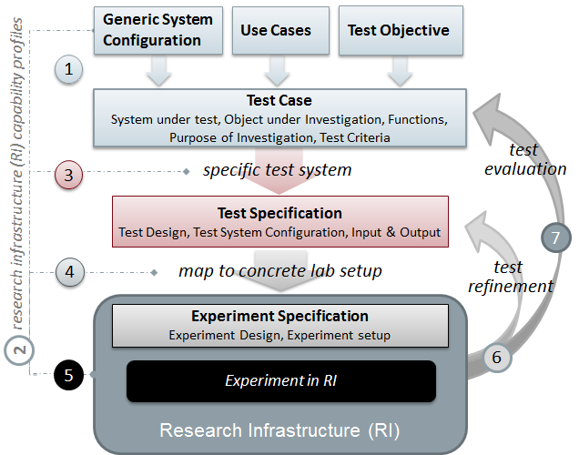

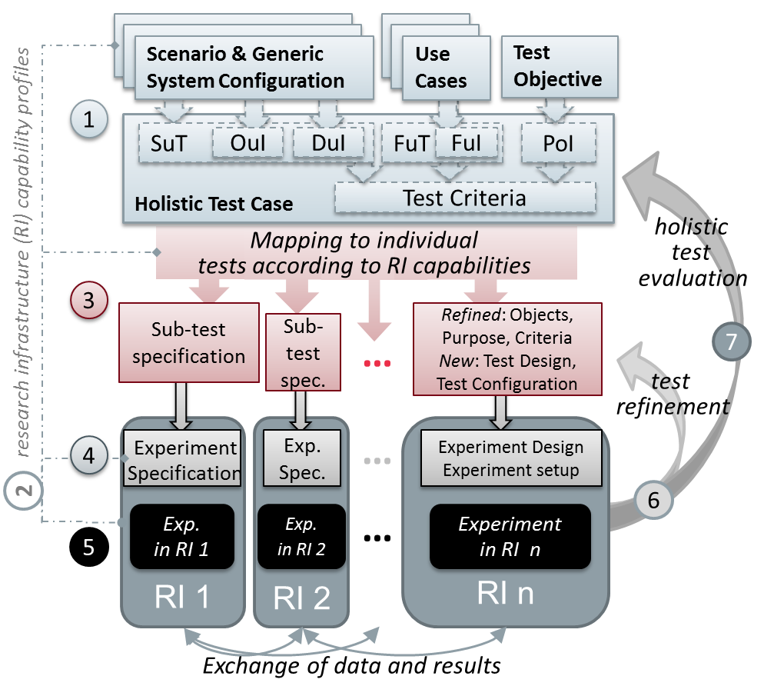
Figure 1: Holistic testing procedure outline

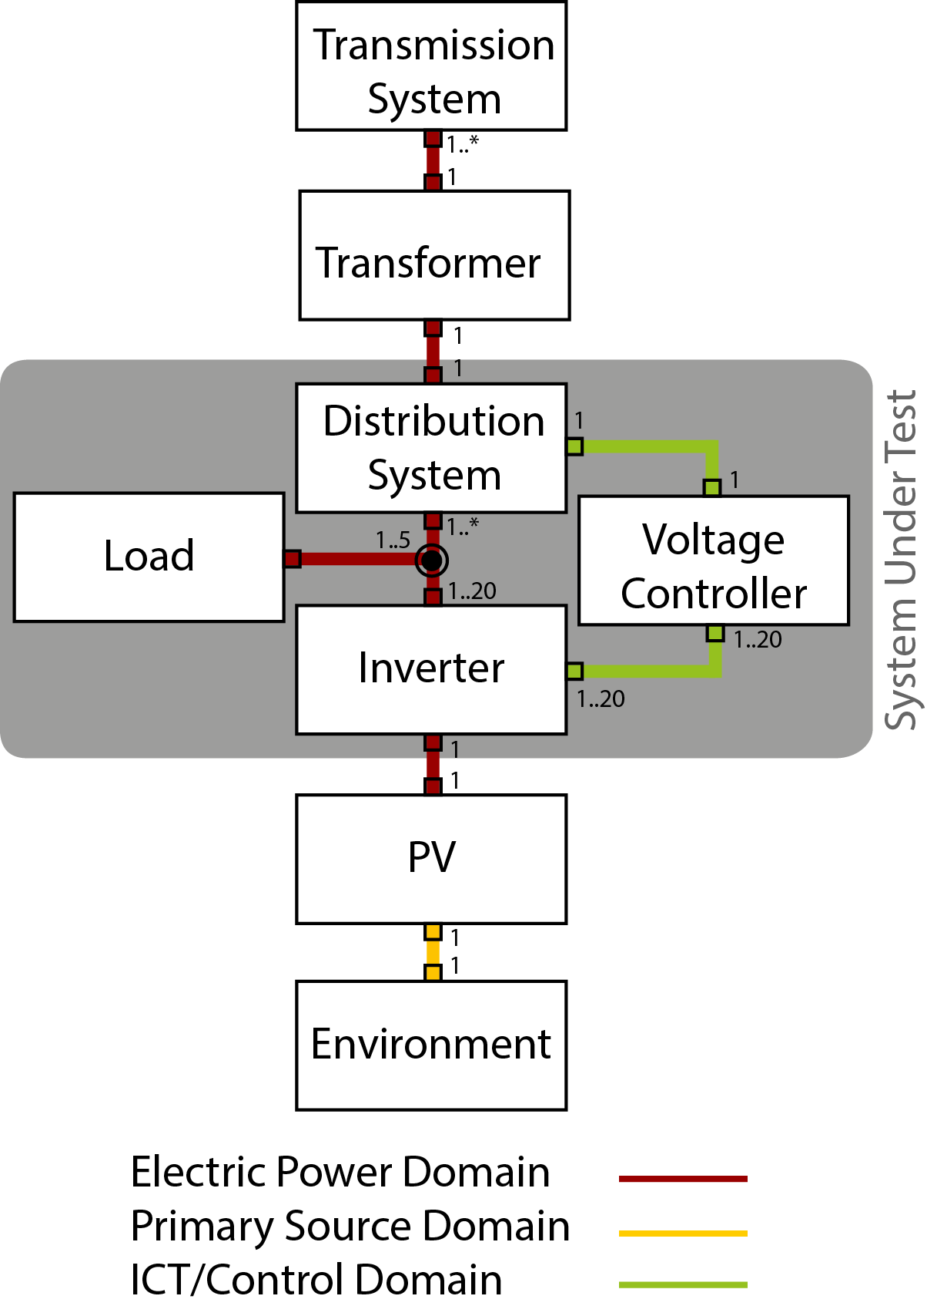

Figure 2: Test Case - Generic System Configuration Diagram
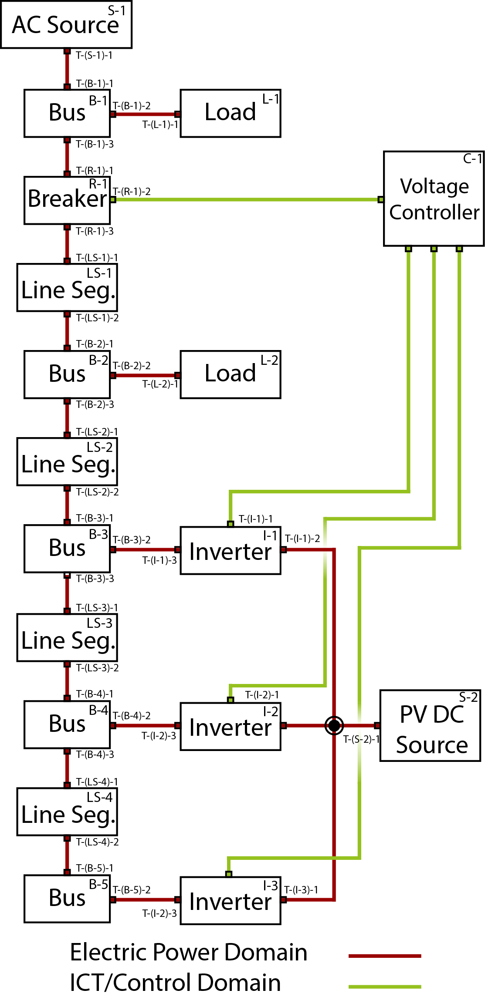
Figure 3: Test System - Specific System Configuration Diagram

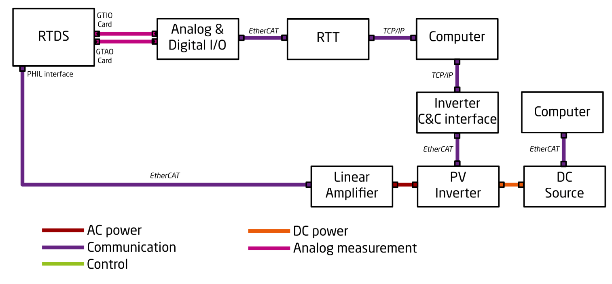
Figure 4: Lab Setup - Specific System Configuration Diagram (L-SC)

Figure 5: Illustration of Domain Hierarchy

