Test Case MENB
“Multi-Energy Networks” benchmark model
Author Version
Project Date

Name of the Test Case |  | Characterization of the improved self-consumption of RES in a coupled heat & power network due to a local voltage control, and of the improvement of operating parameters of local electrical network (reduced range of slow voltage variations)
Narrative |  | An electrical and a thermal network supply power and heat to their connected consumers. The networks are coupled through a power to heat facility comprising a heat pump connected to a thermal tank, which feeds into the thermal network’s supply line to support its operation.  The electrical energy generated by the PV systems connected to the electrical network and the operation of the heat pump for the conversion to thermal energy and storage to a hot water tank can be coordinated for a more efficient use of the networks. In periods of high PV generation and low load consumption, overvoltage and grid congestion may occur in the electrical network. In this case, the voltage controller will send a request to increase the heat pump’s power consumption, if possible. Moreover, in periods of high load (peak load) resulting in an undervoltage, the voltage controller sends a request to decrease the heat pump’s power consumption or even cease its operation. The hot water tank serves as a decentralized heat source for supporting the local district heating network. At the same time, this power-to-heat facility can be used to improve the stability of the electrical network. The operation of the overall system is determined by two controllers:  - A voltage controller monitors the voltage in the electrical network and proposes a power consumption setpoint for the heat pump (controllable/flexible load) to keep the voltage within acceptable limits.  - The heat controller (referred as flex heat controller) operates the power-to-heat facility and decides whether the power-to-heat facility supports the thermal network by discharging the tank (decentralized heat supply).
Function(s) under Investigation (FuI)  “the referenced specification of a function realized (operationalized) by the object under investigation” |  | The voltage control, its interaction to the local heat network control, and their combined effect on local networks  The voltage control is based on an active power-voltage characteristic (P(V)) relating the heat pump active power to the measured local voltage.
Object under Investigation (OuI)  "the component(s) (1..n) that are to be qualified by the test” |  | Voltage controller of the electrical LV local distribution network
Domain under Investigation (DuI):  “the relevant domains or sub-domains of test parameters and connectivity.” |  | Electrical  Heat  Control and ICT
Purpose of Investigation (PoI)  The test purpose in terms of Characterization, Verification, or Validation |  | Characterization of the effect of the voltage controller on the self-consumption of RES within the local network and on operating characteristics of the electrical network
System under Test (SuT):  Systems, subsystems, components included in the test case or test setup. |  | 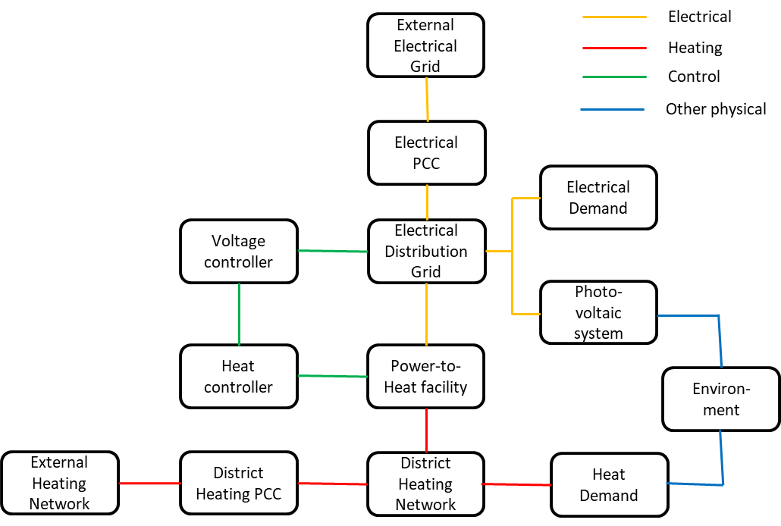  PCC denotes the point of common coupling for the district to the external networks
Functions under Test (FuT)  Functions relevant to the operation of the system under test, including FuI and relevant interactions btw. OuI and SuT. |  | The voltage control : active power-voltage characteristic (P(V)) relating the heat pump active power to the measured local voltage  Heat facility control : Activation of heat pump and thermal tank, to support thermal network supply
Test criteria: Formulation of criteria for each PoI based on properties of SuT; encompasses properties of test signals and output measures. |  | The TCR aim to quantify  -the export/import from the external networks  -the range of voltage at the consumer connection points
 | target metrics  Measures required to quantify each identified test criteria | Electrical and heat exchange at respective PCC (energy import/export)  Voltages at consumer connection points
 | variability attributes  controllable or uncontrollable factors and the required variability; ref. to PoI. | Controllable factors  Voltage controller settings  Heat facility controller settings, criteria for activation- deactivation of heat pump and thermal tank  Uncontrollable factors  PV generation  Demand (electrical and thermal)  Electrical PCC voltage  Ambient Temperature
quality attributes
threshold levels for test result quality as well as pass/fail criteria.

Qualification Strategy

i.e. how are the PoI to be met by the different tests and how will the test results be combined to yield the desired PoI outcomes (see guideline)

Test Specification MENB.01

Reference to Test Case | MENB
Title of Test | Characterization of the effect of the voltage controller on the self-consumption of RES and on operating characteristics of electrical network, of a coupled power and heat network
Test Rationale | This test addresses issues related to self-consumption of excess power generated from renewable (PV) power generators. The excess power is fed into the local heating network. The local use of excess power helps mitigate problems in the electric distribution network, such as high loading of equipment and voltage band violations.  The networks are coupled through a power to heat facility comprising a heat pump connected to a thermal tank, for the (short-term) storage of generated heat.  The operation of the overall system is determined by two controllers:  A voltage controller monitors the voltage in the electrical network and proposes a power consumption setpoint for the heat pump (controllable/flexible load) to keep the voltage within acceptable limits.  The flex heat controller decides whether the heat supply is covered entirely through the external grid or whether the power-to-heat facility supports the local thermal network by discharging the tank. If required, the heat pump is used to heat up the tank. The actual power consumption of the heat pump is determined by the operating conditions (mass flow rate through the heat pump’s condenser) always respecting the power consumption threshold from the voltage controller (i.e., the power consumption never exceeds the setpoint, but may be less).  The flex heat controller adjusts the power-to-heat facility’s electrical power consumption based on the input from the voltage controller.  Based on the measurement of the storage tank temperature and the power consumption threshold for the heat pump, the flex heat controller can switch between several modes of operation. The switching between these modes follows a simple set of rules, represented by a state machine, where each state corresponds to a specific operational mode.  This dependency of the sub-systems causes a complex interaction which can only be fully captured by assessing them simultaneously.
Specific Test System  (graphical) | 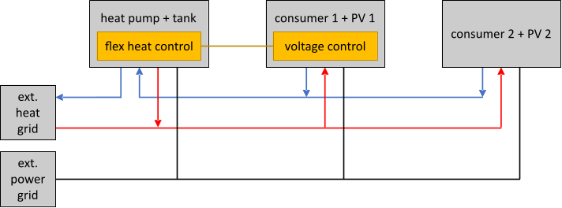  Overview of the overall system configuration used in the “Multi-Energy Networks” benchmark model.  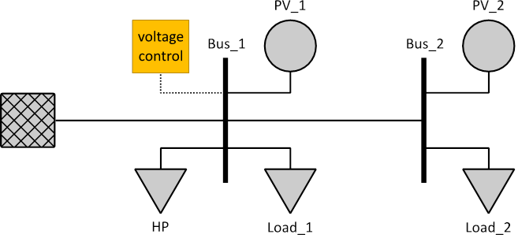  Detailed view of the components of the electrical sub-system used in the “Multi-Energy Networks” benchmark model.  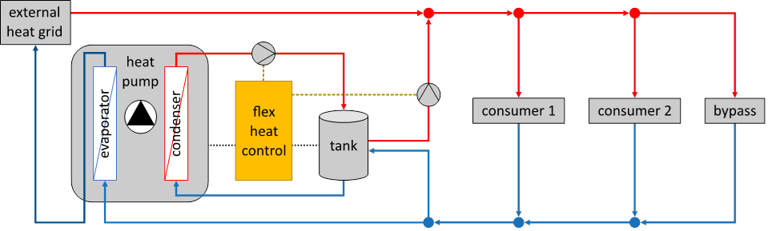  Detailed view of the components of the thermal sub-system used in the “Multi-Energy Networks” benchmark model.  The electrical network supplies power to its connected consumers.  The thermal network supplies heat to its connected consumers.  The power-to-heat facility comprises a heat pump connected to a thermal tank, which feeds into the thermal network’s supply line to support its operation.  The voltage controller monitors the voltage in the electrical network and the power consumption setpoint of the heat pump is adjusted to keep the voltage in the electrical network within acceptable limits. The specific control under test is a simple control with a dead-band and a part with proportional control, taking into account the operating limits of the controlled component.  The thermal sub-system uses a dedicated controller scheme – referred to as flex heat control – to operate the power-to-heat facility. It decides whether the heat supply is covered entirely through the external grid or whether the power-to-heat facility supports by discharging the tank. If required, the heat pump is used to heat up the tank, always respecting the power consumption threshold from the voltage controller (i.e., the power consumption never exceeds the setpoint, but may be less).  The flex heat controller can switch between several modes of operation. The operational modes of the specific controller and the rules for switching among the modes are shown the following diagram.  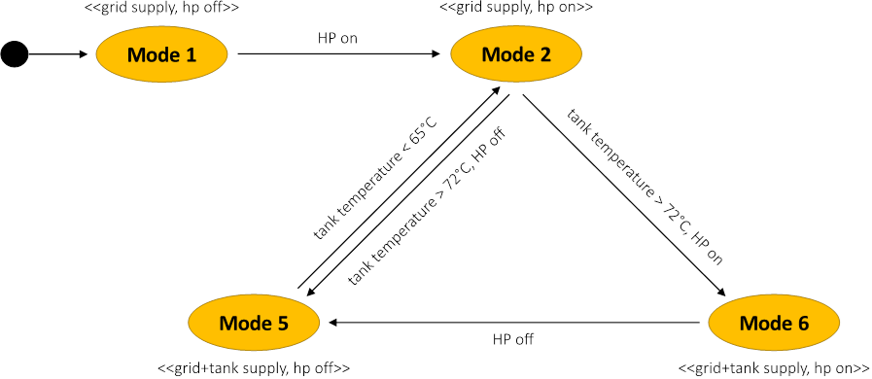  State machine representation of the operational modes implemented by the flex heat controller
Target measures | The test aims to assess if power flows to the external network are reduced compared to a scenario without the voltage controller. Moreover, relevant network parameters (range of voltages) need to be assessed also.
Input and output parameters | (Uncontrollable Input)  PV generation  Demand (electrical and thermal)  Electrical PCC voltage  Ambient Temperature  (Controllable Input)  Parameters of components (capacity, size, efficiency etc.)  Parameters of controllers  (Output)  Energy flows (in and out of the networks)  Voltages at consumer connection points  Total energy consumption of heat pump
Test Design | This test involves the running of the test system for at least an entire week to cover the daily variations of loads/generators and the impact of the corresponding controllers. It involves also an additional run with the voltage controller not enabled.  Repetitions of the test may be required to account for seasonal variations and to cover a wide range of environmental conditions.
Initial system state | Initial state of flex heat controller: Mode 2 (network supplies, heat pump charges the hot water tank)  Initial storage tank temperature: 70 °C
Evolution of system state and test signals
Other parameters
Temporal resolution | Update of input values (PV production, demand, temperature etc.), as well as setpoints, in the range of minutes.
Source of uncertainty | - The supply voltage at the point of common coupling to external grid (normal distribution, mean equal to nominal magnitude of voltage, standard deviation 5% of mean)  - Variability of load (normal distribution, mean equal to the mean value of load over the reference period, standard deviation 5% of mean value of load )  - Variability of PV generation (Beta distribution with shape parameters 2.06 and 2.5, based on nominal output of PV plant)  - Variability of heat demand (uniform distribution in the interval from 0 to maximum value of heat demand of heat exchanger)  - Ambient Temperature (interval [-10ºC,25ºC] )
Suspension criteria / Stopping criteria

Mapping to Research Infrastructure
i.e. how is it planned to distribute (map) and execute the specified test system in a given research infrastructure (free text); this section can be used to list the intended Experiment specifications.

Experiment Specification MENB.01.01
Ref. Test Specification | TC MENB.TS01
Research Infrastructure
Experiment Realisation | The experiment is implemented as co-simulation using mosaic in a single RI
Experiment Setup  (concrete lab equipment) | Simulation components:  Power system simulation : pandapower model  Thermal network simulation : Modelica/Dymola
Experimental Design and  Justification | This is a basic co-simulation setup using the mosaic environment
Experimental Setup uncertainties | Model accuracy  Type of simulation (EMT vs RMS vs Power Flow)  Synchronization and interface between multi-vendor simulation platforms with different time scales  Synchronization and interface between multiple domain simulations at different time scales  Computational capacity
Uncertainty Management
Precision of equipment | N/A
Measurement Uncertainty | N/A
Storage of data | Time series data

