ICONS

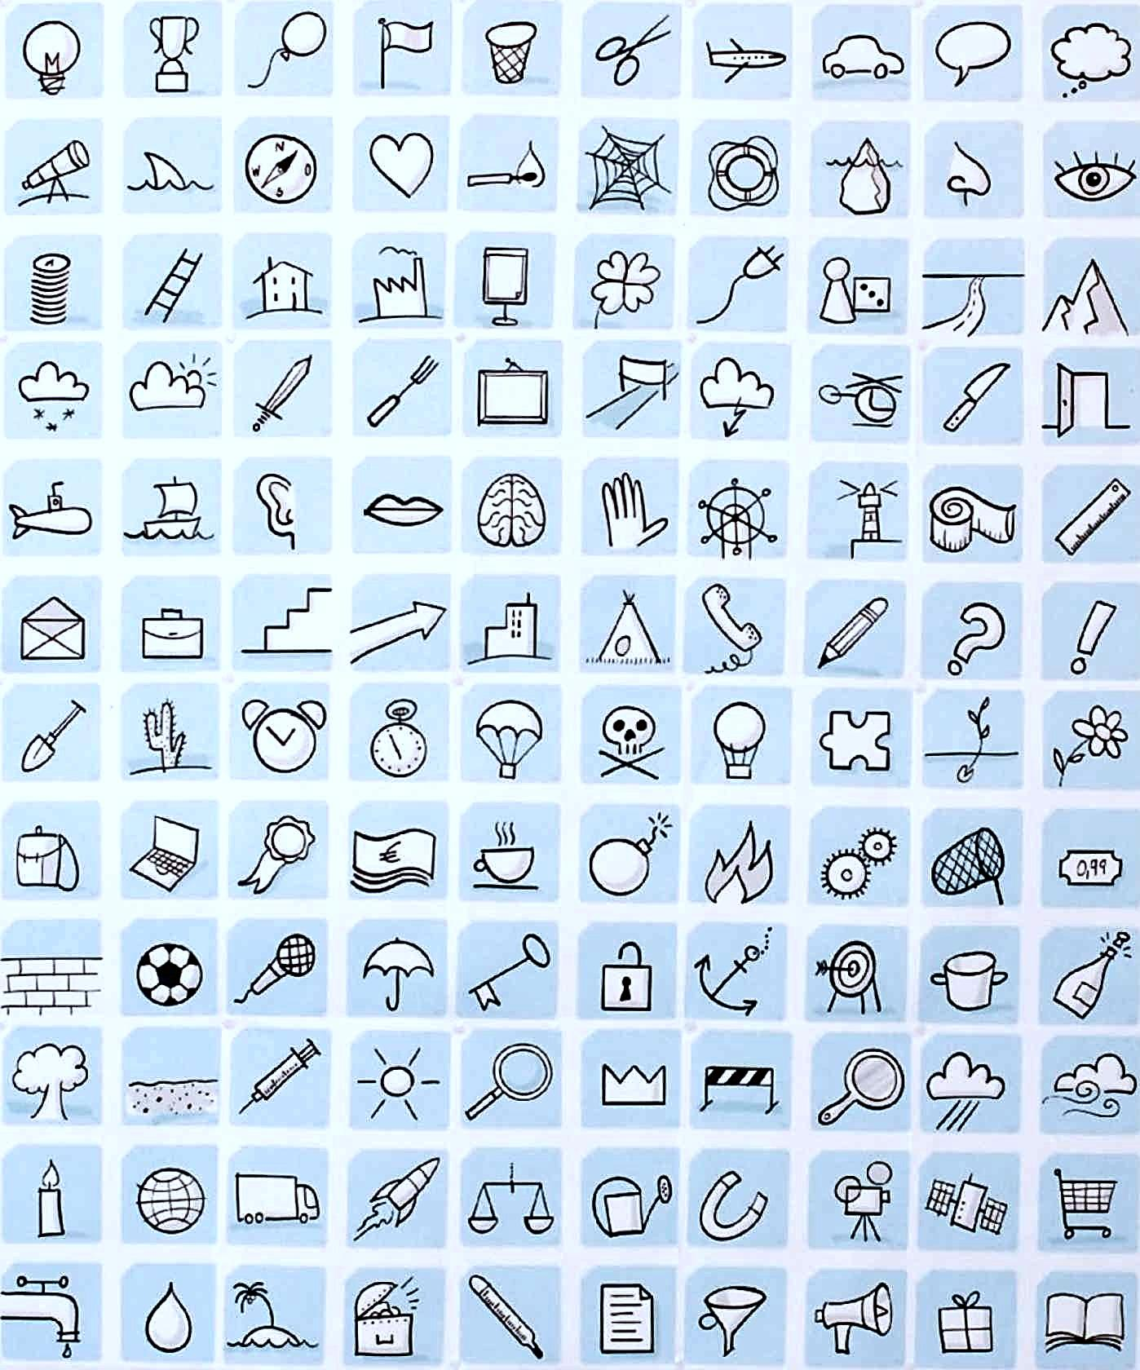 **bulb**, idea

 **plane, …**

 **car, …**

 comment, …

 sissors

 trash

 flag

 balloon

 **trophy**, cup, win



