**PROJECT REPORT ON**

**FACE RECOGNITION ATTENDANCE SYSTEM**

SUBMITTED TO THE SAVITRIBAI PHULE PUNE UNIVERSITY, PUNE

##### SUBMITTED BY

|  |  |
| --- | --- |
| Piyush Agrawal | Roll No: 4105 |
| Apurva Joshi | Roll No: 4145 |
|  |  |
|  |  |



## DEPARTMENT OF COMPUTER ENGINEERING

## NBN SINHGAD SCHOOL OF ENGINEERING, PUNE-41

## SAVITRIBAI PHULE PUNE UNIVERSITY

## 2020 - 21



**CERTIFICATE**

This is to certify that the project report entitles

**“FACE RECOGNITION ATTENDANCE SYSTEM”**

Submitted by

**Piyush Agrawal Exam No : 71804201J**

**Apurva Joshi Exam No : 71803985J**

is a bonafide work carried out by her/him under the supervision of **Prof. A. B. C** and it is approved for the partial fulfillment of the requirement of University of Pune as a part of Laboratory Practice II work syllabus (Final year Computer Engineering). (12, Sentence case)

|  |  |
| --- | --- |
| **( MR. Shailesh Bendale )** | **( DR. A. V. Dhumane )** |
| Subject In-charge | Head, Department of Computer Engineering |

**ACKNOWLEDGEMENT**

It is indeed a great pleasure and moment of immense satisfaction for we to present a project report on “FACE RECOGNITION ATTENDANCE SYSTEM “amongst a wide panorama that provided us inspiring guidance and encouragement, we take the opportunity to thanks those who gave us their indebted assistance. We wish to extend our cordial gratitude with profound thanks to our internal guide **Mr. Shailesh Bendale** for his\her everlasting guidance. It was his/her inspiration and encouragement which helped us in completing our project.

Our sincere thanks and deep gratitude to Head of Department, Prof. A. V. Dhumane and other faculty member; but also to all those individuals involved both directly and indirectly for their help in all aspect of the project.

At last but not least we express our sincere thanks to our Institute’s Principal Dr. S. D. Markande, for providing us infrastructure and technical environment.

**NAME OF THE STUDENTS**

**PIYUSH AGRAWAL**

**APURVA JOSHI**

**ABSTRACT**

Face recognition is a biometric system used to identify or verify a person from a digital image. Face Recognition system is used in security. Face recognition system should be able to automatically detect a face in an image. This involves extracts its features and then recognize it, regardless of lighting, expression, illumination, ageing, transformations (translate, rotate and scale image) and pose, which is a difficult task. In this project, we implemented a facial recognition based attendance system to solve the time required by the manual process of taking attendance at schools, colleges etc. We use open-source libraries for computer vision and machine learning tools to train and recognize faces to be able to mark the attendance automatically.

**CONTENTS**

**LIST OF FIGURES I**

|  |  |  |  |
| --- | --- | --- | --- |
| **CHAPTER** | | **TITLE** | **PAGE NO** |
| **01** | | Problem Statement Definition | **7** |
| **02** | | Software Requirements Specification | **7** |
|  | **2.1** | **Introduction** | **7** |
|  | **2.2** | **Scope** | **8** |
|  | **2.3** | **Requirements** | **8** |
| **03** | | **System Implementation** | **8-9** |
| **04** | | **GUI / Snapshots** | **10-11** |
| **05** | | Conclusion | **12** |
| **06** | | References | **12** |

**LIST OF FIGURES**

|  |  |  |
| --- | --- | --- |
| **Figure** | **Illustration** | **Page No.** |
| 1 | Implementation Flow Chart | 8 |
| 2 | Google Colab | 10 |
| 3 | Colab with GPU acceleration for training | 10 |
| 4 | Image of Tom used for training. | 11 |
| 5 | Image of Tom used for testing. | 11 |
| 6 | Image of Steve used for training. | 11 |
| 7 | Image of Steve used for testing. | 11 |

**CHAPTER 1: PROBLEM STATEMENT DEFINITION**

Automating attendance is a task that is generally overlooked. Biometrics based attendance system produced approximately 3.8 seconds of execution time on average while the manual method of attendance produced approximately 17.8 seconds of execution time on average [1]. The amount of time it takes to complete the attendance of 200 students may take more than 20 minutes.

That is about 33% of the lecture time. We hope to reduce this time by implementing a face recognition attendance system using which, the students give their attendance through facial recognition. This is not only scalable to detect all faces at once, but it reduces the time significantly.

**CHAPTER 2: SOFTWARE REQUIREMENT SPECIFICATION**

* 1. **INTRODUCTION:**

The purpose of this document is to build a face recognition system to manage the attendance of students automatically to reduce the time taken by the manual process.

A facial recognition system is a technology capable of matching a human face from a digital image or a video frame against a database of faces. Researchers are currently developing multiple methods in which facial recognition systems work. The most advanced face recognition method, which is also employed to authenticate users through ID verification services, works by pinpointing and measuring facial features from a given image [2].

Time and attendance systems (TNA) are used to track and monitor when employees start and stop work. A time and attendance system enable an employer to monitor their employee’s working hours and late arrivals, early departures, time taken on breaks, and absenteeism. It also helps to control labor costs by reducing over-payments, which are often caused by paying employees for time that is not working and eliminates transcription error, interpretation error, and intentional error. TNA systems can also be used to ensure compliance with labor regulations regarding proof of attendance [3].

OpenCV (Open Source Computer Vision Library) is a library of programming functions mainly aimed at real-time computer vision. Originally developed by Intel, it was later supported by Willow Garage and then Itseez (which was later acquired by Intel). The library is cross-platform and free for use under the open-source Apache 2 License. Starting in 2011, OpenCV features GPU acceleration for real-time operations [4].

An artificial neural network (ANN) is a collection of connected units called artificial neurons that is inspired by the architecture of a human brain. Deep learning is a subfield of machine learning using neural networks. Together, they are responsible for many of the dramatic improvements in perception used by face recognition. While we can use machine learning to feed data to a face recognition algorithm to help it recognize people wearing hats, for example, the AI itself is too complex for humans to fully understand.

* 1. **SCOPE:**

The purpose of the facial recognition attendance management system is to ease the management and to create a convenient and easy-to-use application for teachers, trying to mark the attendance of the students. The system is based on a database of the faces of students which the system is trained and the function of identifying students and marking attendance when they come to the lectures. We will have a database server that can support hundreds. Above all, we hope to provide a comfortable user experience along with a reduction in the processing time as much as possible.

* 1. **REQUIREMENTS:**

User Interface:

Front-end software: (.NET/Java, HTML, JavaScript) - Future, Google Colab (Current)

Back-end software: RDBMS - Future, OpenCV, dlib

Hardware Interface:

For training: Min GPU 1050ti (To train the model), CPU (Min i5 5300H Base clock-2.40Ghz), Ram - 8GB

For running: Min integrated GPU, CPU (Min Core 2 duo), Ram - 4GB

For image capture: any RGB camera.

**CHAPTER 3: SYSTEM IMPLEMENTATION**

Jupyter Notebook

OpenCV

Dlib

Oslib

Read Image

Test Encodings

Train Encodings

**Fig 1: Implementation Flow Chart**

We use Google Colab as the main system requirement. Three main libraries namely OpenCV, Dlib and OSlib are used.

OpenCV: Is an open-source computer vision library which is used for facial recognition purpose in our project. It is used to train and test encodings of the trained faces.

Dlib: is a complimentary library for OpenCV which consists of machine learning tools for optimization and training.

* The Colab notebook is initialized.
* A face recognition library based on OpenCV and Dlib is imported.
* Cv2 library of OpenCV is separately imported.
* A read image function is implemented.
* Cv2 is used for image reading and resizing.
* Known encodings are generated and saved from the faces read using the face recognition library.
* New pictures are given as input and tested against the known encodings.
* If the encodings match, attendance is marked. Else the attendance is not marked and “No face detected” is printed.

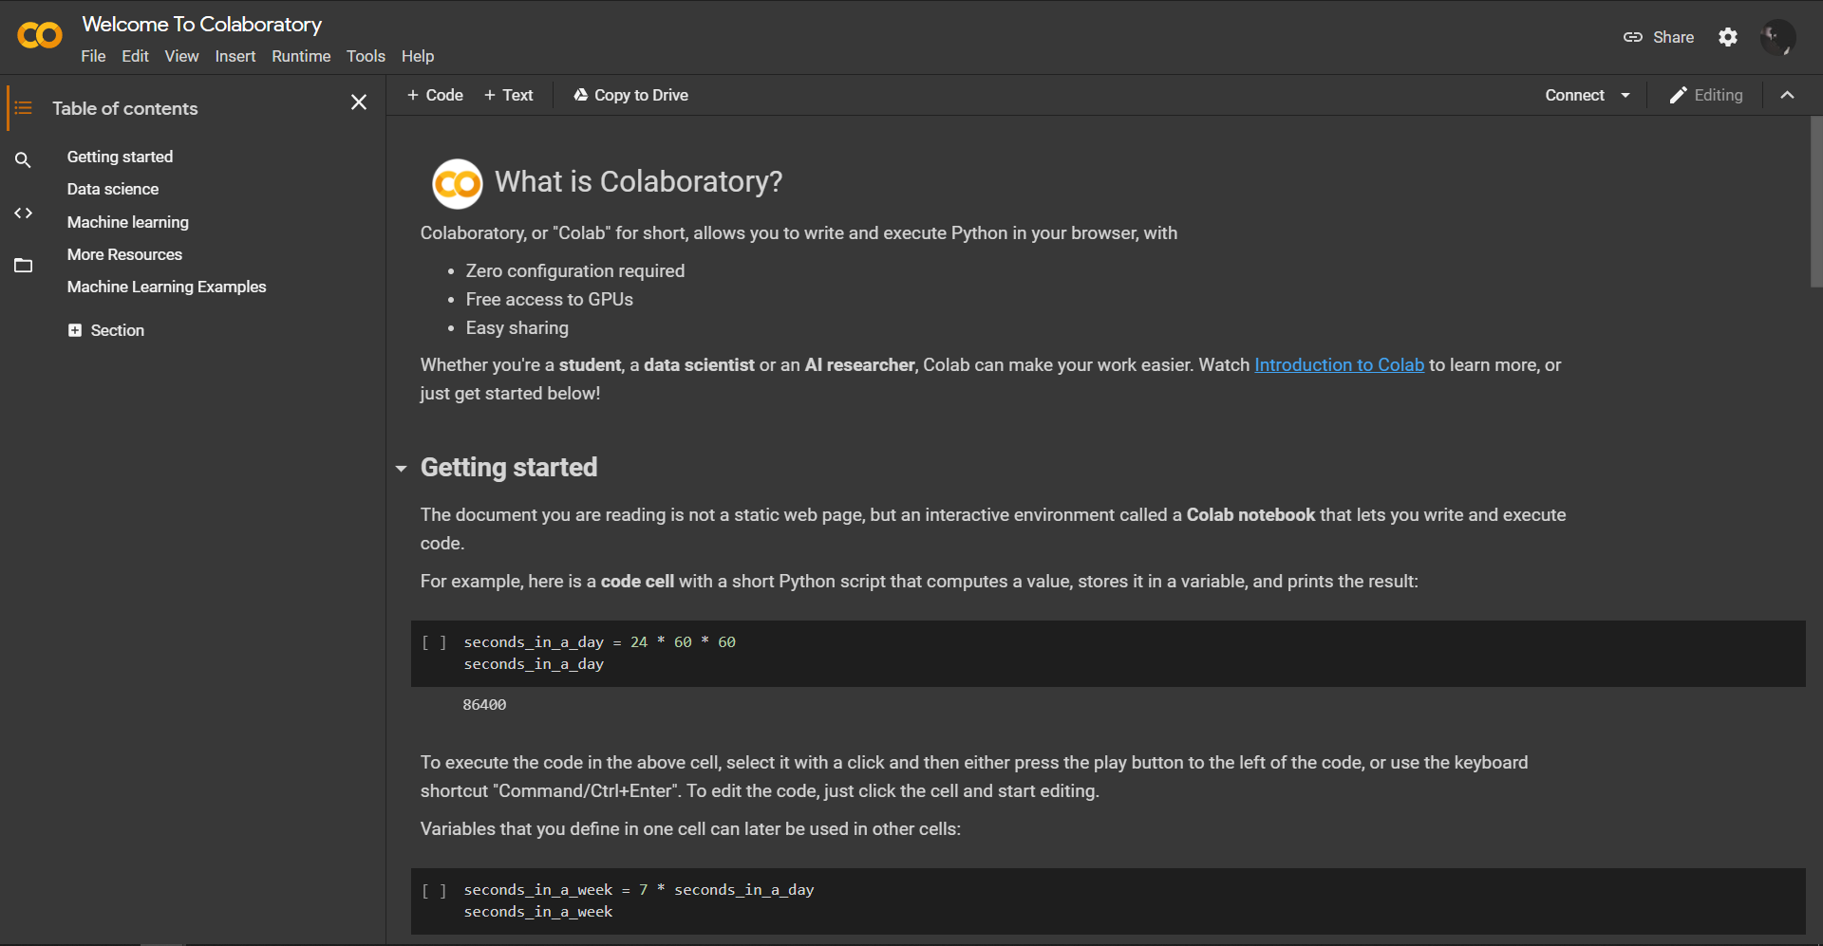**CHAPTER 4: SCREENSHOTS**

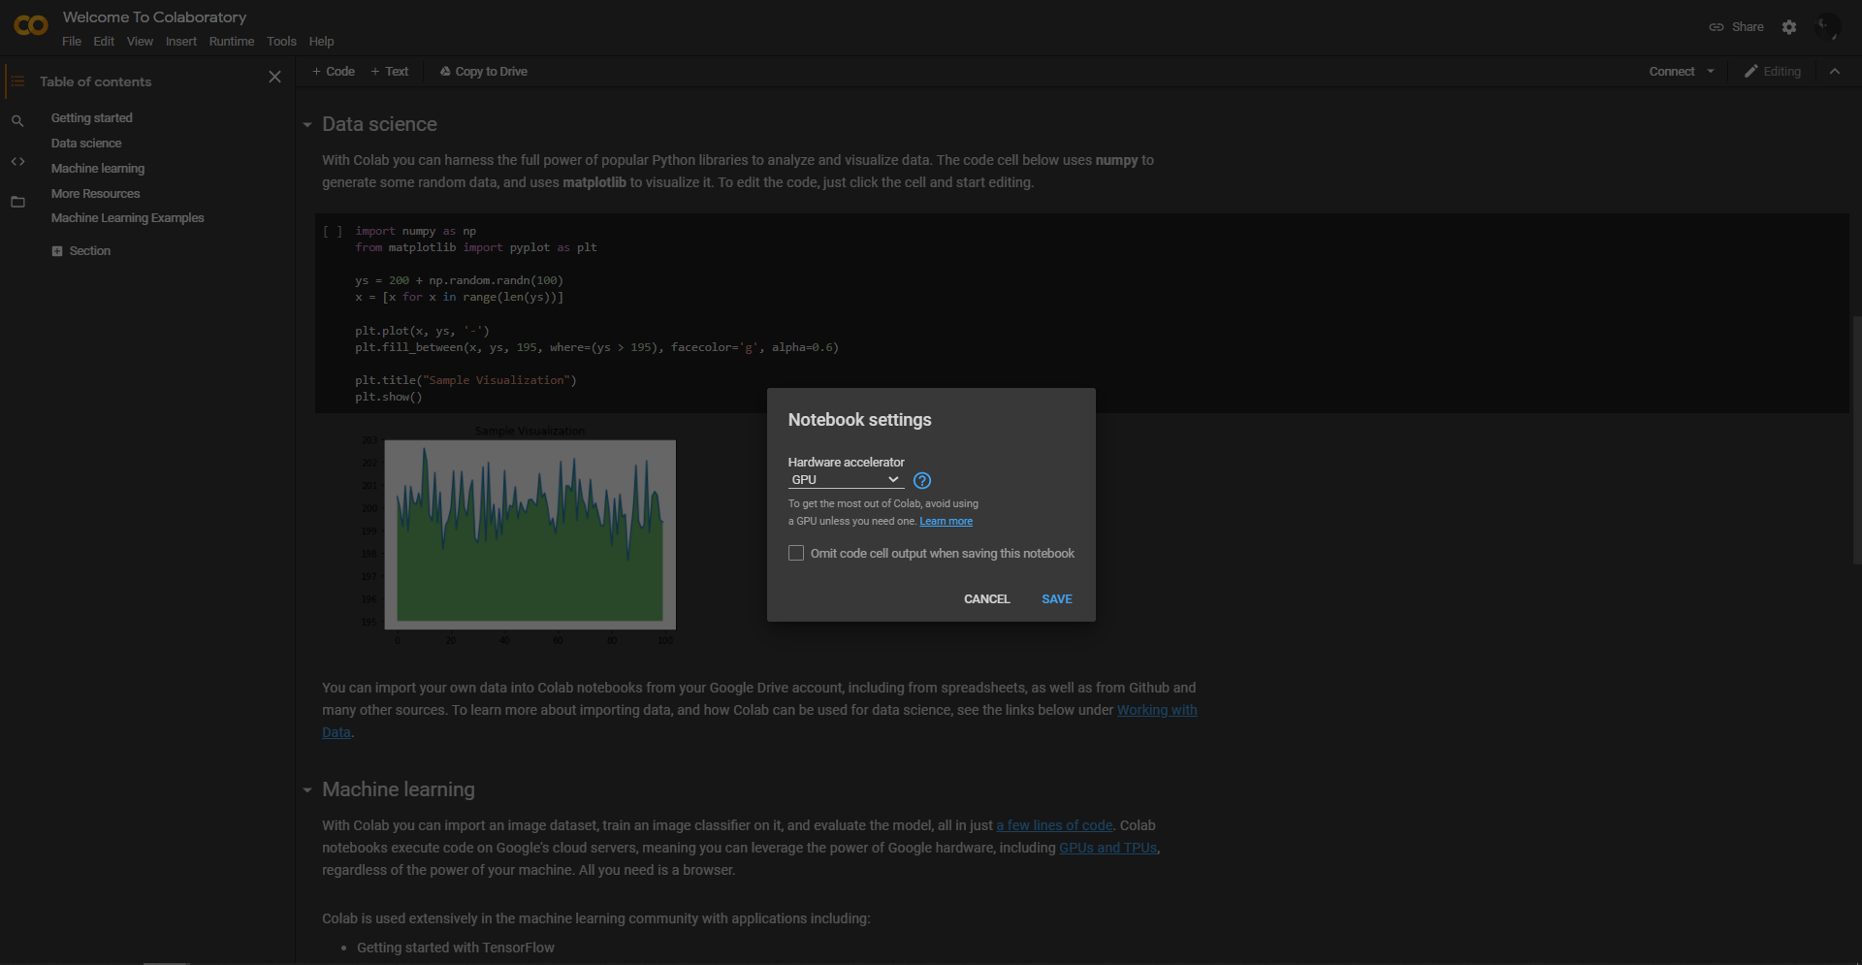**Fig 2: Google Colab**

**Fig 3: Colab with GPU acceleration for training**

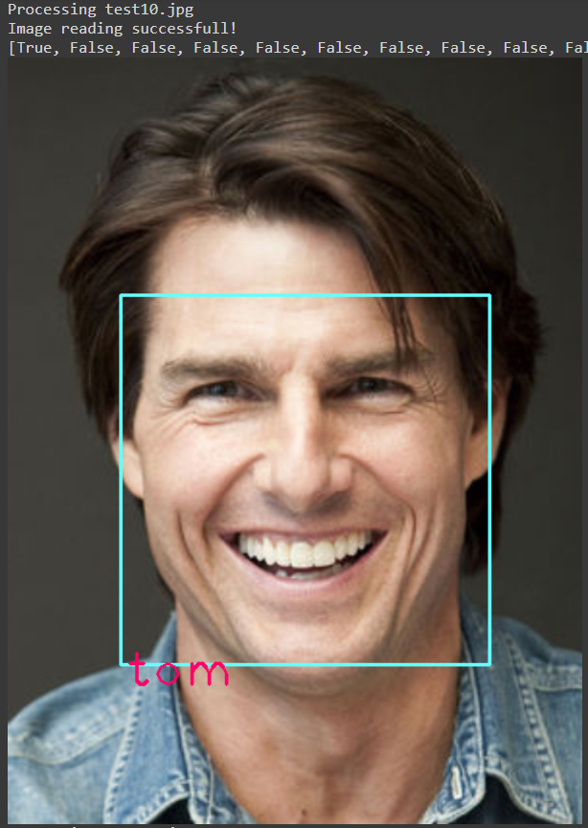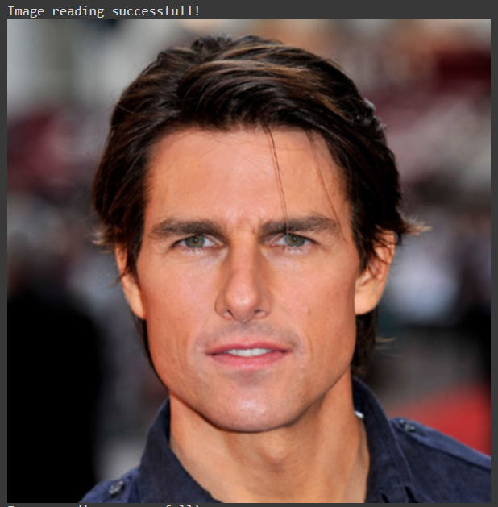

**Fig 4: Image of Tom used for training Fig 5: Image of Tom used for verification**

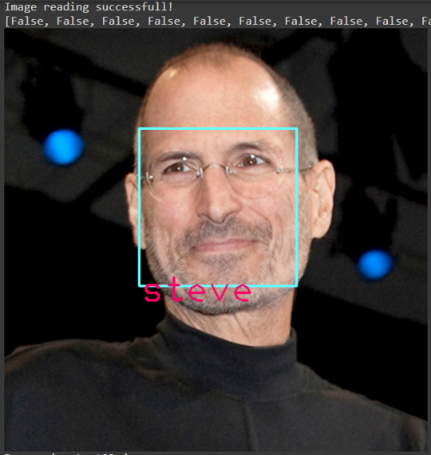

**Fig 6: Image of Steve used for training Fig 7: Image of Steve used for verification**

**CHAPTER 5: CONCLUSION**

In this project, we tackle the efficiency problem of manual attendance marking for students in schools and colleges and we see how a system can be implemented using facial recognition system with artificial intelligence and machine learning which can automate the process and reduce the time significantly. This project is very scalable as it only requires a decent system to run on and a normal camera which can capture faces of the students.

**CHAPTER 6: REFERENCES**

**[1]** O. Shoewu, N.T. Makanjuola and S.O. Olatinwo. Biometric-based Attendance System: LASU Epe Campus as Case Study. American Journal of Computing Research Repository. 2014; 2(1):8-14. doi: 10.12691/ajcrr-2-1-2

**[2]** "Facial recognition system"

available from: <https://en.wikipedia.org/wiki/Facial_recognition_system>

**[3]** "Time and Attendance"

available from: <https://en.wikipedia.org/wiki/Time_and_attendance>

**[4]** "OpenCV"

available from: <https://en.wikipedia.org/wiki/OpenCV>