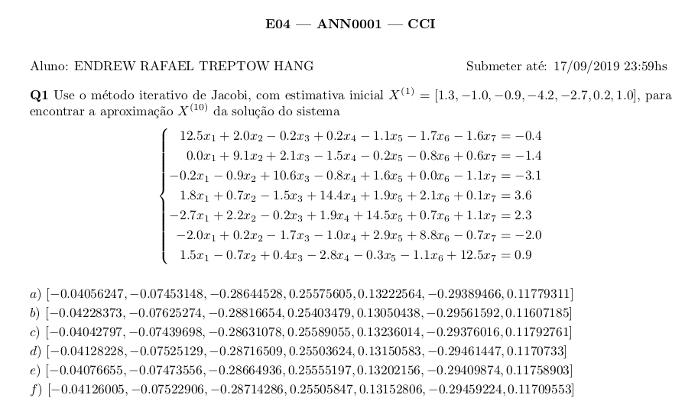
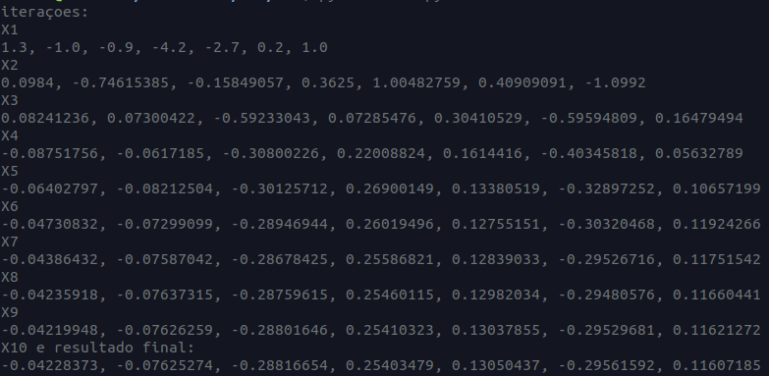
a = [1.3, -1.0, -0.9, -4.2, -2.7, 0.2, 1.0]
a2 = list()

print("iteraçoes:")

for i in range(1, 10):
print(f"X{i}")
print(*[round(i, 8) for i in a], sep=', ')
a2.append((-2*a[1]+0.2*a[2]-0.2*a[3]+1.1*a[4]+1.7*a[5]+1.6*a[6]-0.4)/12.5)
a2.append((0*a[0]-2.1*a[2]+1.5*a[3]+0.2*a[4]+0.8*a[5]-0.6*a[6]-1.4)/9.1)
a2.append((0.2*a[0]+0.9*a[1]+0.8*a[3]-1.6*a[4]+0*a[5]+1.1*a[6]-3.1)/10.6)
a2.append((-1.8*a[0]-0.7*a[1]+1.5*a[2]-1.9*a[4]-2.1*a[5]-0.1*a[6]+3.6)/14.4)
a2.append((2.7*a[0]-2.2*a[1]+0.2*a[2]-1.9*a[3]-0.7*a[5]-1.1*a[6]+2.3)/14.5)
a2.append((2.0*a[0]-0.2*a[1]+1.7*a[2]+1.0*a[3]-2.9*a[4]+0.7*a[6]-2.0)/8.8)
a2.append((-1.5*a[0]+0.7*a[1]-0.4*a[2]+2.8*a[3]+0.3*a[4]+1.1*a[5]+0.9)/12.5)
a = list(a2)
a2.clear()

print("X10 e resultado final:")

print(*[round(i, 8) for i in a], sep=', ')

