Reproducible Research: Peer Assessment 1

Enrique Reveron

## Loading and preprocessing the data

First load the data (read.csv())

dt <- read.csv("activity.csv")

Those are the dataset (dt) column names and one example of the values

colnames(dt)

## [1] "steps" "date" "interval"

dt[1,]

## steps date interval  
## 1 NA 2012-10-01 0

## What is mean total number of steps taken per day?

According with the instructions, we will ignore the missing values in the dataset.

1. Calculate the total number of steps taken per day

We will calculate the total steps per day in a new dataset using the function aggregate()

dt_total <- aggregate(steps ~ date, dt, sum)

Those are the columns of the new dataset (dt_total) and one of the values:

colnames(dt_total)

## [1] "date" "steps"

dt_total[1,]

## date steps  
## 1 2012-10-02 126

1. Make a histogram of the total number of steps taken each day

library(ggplot2)  
plot1 <- ggplot(dt_total,aes(x = steps)) +  
 ggtitle("Histogram of daily steps") +  
 xlab("steps") +  
 geom_histogram()  
plot1

## stat_bin: binwidth defaulted to range/30. Use 'binwidth = x' to adjust this.

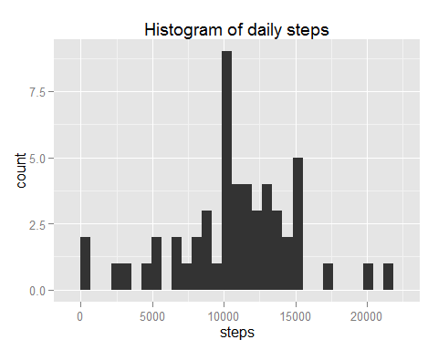

1. Calculate and report the mean and median of the total number of steps taken per day

mean(dt_total$steps, na.rm = TRUE)

## [1] 10766.19

median(dt_total$steps, na.rm = TRUE)

## [1] 10765

Those values must match with the ones that the function summary() provides:

summary(dt_total)

## date steps   
## 2012-10-02: 1 Min. : 41   
## 2012-10-03: 1 1st Qu.: 8841   
## 2012-10-04: 1 Median :10765   
## 2012-10-05: 1 Mean :10766   
## 2012-10-06: 1 3rd Qu.:13294   
## 2012-10-07: 1 Max. :21194   
## (Other) :47

|  |  |
| --- | --- |
| Variable | Value |
| Mean | 1.076618910^{4} |
| Median | 10765 |

## What is the average daily activity pattern?

1. Make a time series plot (i.e. type = "l") of the 5-minute interval (x-axis) and the average number of steps taken, averaged across all days (y-axis)

Let aggregate the steps of all days per intervals, and calculate the average (mean)

dt3 <- aggregate(steps ~ interval, dt, mean)

Those are the column names and one value of the new dataset

colnames(dt3)

## [1] "interval" "steps"

dt3[1,]

## interval steps  
## 1 0 1.716981

summary(dt3)

## interval steps   
## Min. : 0.0 Min. : 0.000   
## 1st Qu.: 588.8 1st Qu.: 2.486   
## Median :1177.5 Median : 34.113   
## Mean :1177.5 Mean : 37.383   
## 3rd Qu.:1766.2 3rd Qu.: 52.835   
## Max. :2355.0 Max. :206.170

This is the time series plot (type="l")

plot2 <- ggplot(dt3,aes(interval,steps)) +  
 ggtitle("Time Series Plot of Average Steps by Interval") +  
 geom_line()  
plot2

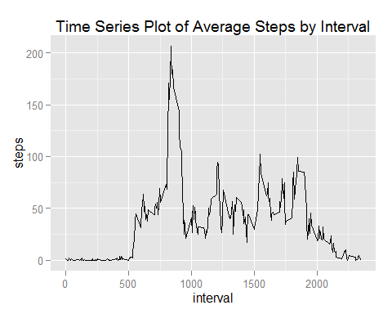

Is possible to see in the plot that the biggest average of steps is between 500 and 1000 interval (5:00am to 10:00am) and the value is:

max(dt3$steps)

## [1] 206.1698

1. Which 5-minute interval, on average across all the days in the dataset, contains the maximum number of steps?

And now to answer the question, let see the time interval for this maximun average value:

max_interval <- dt3[dt3$steps== max(dt3$steps),]  
max_interval

## interval steps  
## 104 835 206.1698

The time interval is 835

## Imputing missing values

1. Calculate and report the total number of missing values in the dataset (i.e. the total number of rows with NAs)

sum(is.na(dt$steps))

## [1] 2304

1. Devise a strategy for filling in all of the missing values in the dataset. The strategy does not need to be sophisticated. For example, you could use the mean/median for that day, or the mean for that 5-minute interval, etc.

Let's use the mean of every day to fill out the missing value, lets calculate those values

dt_non_na <- aggregate(steps ~ date, dt, mean, na.rm = FALSE, na.action = NULL)  
colnames(dt_non_na)

## [1] "date" "steps"

dt_non_na[1,]

## date steps  
## 1 2012-10-01 NA

1. Create a new dataset that is equal to the original dataset but with the missing data filled in.

Lets merge both dataset to create the new one and them substitute the NA values in the data set for the calculated median

dt5 <- merge(x = dt, y = dt_non_na, by = "date", all.x= TRUE)  
dt5[is.na(dt5$steps.x),c("steps.x")] <- dt5[is.na(dt5$steps.x),c("steps.y")]

Remove the last column added.

dt5 <- subset(dt5, select = date:interval)  
colnames(dt5) <- c("date","steps","interval")

1. Make a histogram of the total number of steps taken each day and Calculate and report the mean and median total number of steps taken per day. Do these values differ from the estimates from the first part of the assignment? What is the impact of imputing missing data on the estimates of the total daily number of steps?

Lets calculate the new total number of steps using the new dataset

dt_total2 <- aggregate(steps ~ date, dt5, sum)

Lets plot the data

plot3 <- ggplot(dt_total2,aes(x = steps)) +  
 ggtitle("Histogram for Total Steps using Mean for NA") +  
 xlab("Steps") +  
 geom_histogram()  
plot3

## stat_bin: binwidth defaulted to range/30. Use 'binwidth = x' to adjust this.

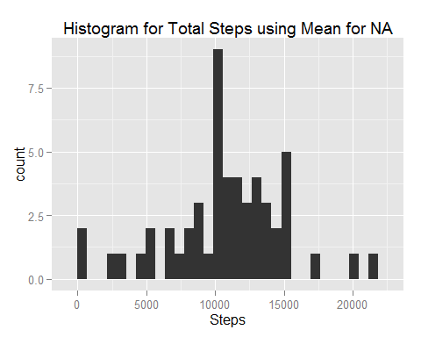

Let's calculate the new mean and median

mean(dt_total2$steps, na.rm = TRUE)

## [1] 10766.19

median(dt_total2$steps, na.rm = TRUE)

## [1] 10765

Those values must match with the ones that the function summary() provides:

summary(dt_total2)

## date steps   
## 2012-10-02: 1 Min. : 41   
## 2012-10-03: 1 1st Qu.: 8841   
## 2012-10-04: 1 Median :10765   
## 2012-10-05: 1 Mean :10766   
## 2012-10-06: 1 3rd Qu.:13294   
## 2012-10-07: 1 Max. :21194   
## (Other) :47

|  |  |
| --- | --- |
| Variable | Value |
| Mean (not changing NAs) | 1.076618910^{4} |
| Mean (changing NAs) | 1.076618910^{4} |
| -------------------------- | --------------------------------- |
| Median (not changing NAs) | 10765 |
| Median (changing NAs) | 1.076510^{4} |

## Are there differences in activity patterns between weekdays and weekends?

1. Create a new factor variable in the dataset with two levels - "weekday" and "weekend" indicating whether a given date is a weekday or weekend day.

dt5$weekday <- as.factor(  
 ifelse(  
 weekdays(as.Date(dt5$date)) %in%   
 c("Saturday","Sunday"),   
 "Weekend",   
 "Weekday"))

1. Make a panel plot containing a time series plot (i.e. type = "l") of the 5-minute interval (x-axis) and the average number of steps taken, averaged across all weekday days or weekend days (y-axis). See the README file in the GitHub repository to see an example of what this plot should look like using simulated data.

dt6 <- aggregate(x = dt5$steps,by=list(dt5$interval,dt5$weekday),   
 FUN = mean ,na.rm=TRUE)  
  
names(dt6) <- c("interval","weekday","steps")  
  
  
plot4 <- ggplot(dt6,aes(interval,steps,factor(weekdays))) +  
 ggtitle("Time Series Plot of Average Steps by Interval after NAs") +  
 facet_wrap(~weekday) +  
 ylab("Number of Steps") + xlab("Interval") +  
 theme_light() +  
 theme(legend.position = "top") +  
 geom_line(color = "blue", size = 1)  
plot4

