SABR: Spacer Alignment-Based Recognition for CRISPR-Phage Targeting Evidence
A transparent workflow for CRISPR spacer-targeting evidence, PAM/PFS diagnostics, and repeat-derived CRISPR-Cas subtype prediction.

Abstract
SABR is an early-stage bioinformatics workflow that accepts bacterial and phage FASTA files, detects candidate CRISPR arrays, extracts spacers and repeats, searches spacers against phage genomes, evaluates PAM/PFS support, predicts likely CRISPR-Cas subtype from repeat/array features, and reports bacteria-by-phage CRISPR targeting evidence. SABR is intentionally framed as an evidence mapper rather than a direct resistance caller. The best documented current production-candidate model was a flat ExtraTrees classifier with 0.9152 genus-holdout accuracy. A CRISPRCasdb-trained experimental ExtraTrees model achieved 0.9455 internal genome-holdout accuracy and transferred well to the current SABR table, but it remains a computational-label model requiring independent curated validation before final replacement.

Scientific Framing
Spacer-protospacer matches are evidence of possible CRISPR targeting or prior exposure, not proof of biological resistance. Resistance also depends on subtype, PAM/PFS compatibility, seed conservation, functional cas genes, expression, phage escape, anti-CRISPR genes, and assembly quality. SABR therefore reports CRISPR targeting evidence, not confirmed resistance.

Workflow
The pipeline parses bacterial and phage FASTA files, reports sequence diagnostics, detects candidate CRISPR arrays, extracts repeats and spacers, matches spacers against phage genomes, predicts Cas subtype from repeat/array features, evaluates PAM/PFS support, summarizes seed mismatches, and exports evidence matrices and detailed tables.
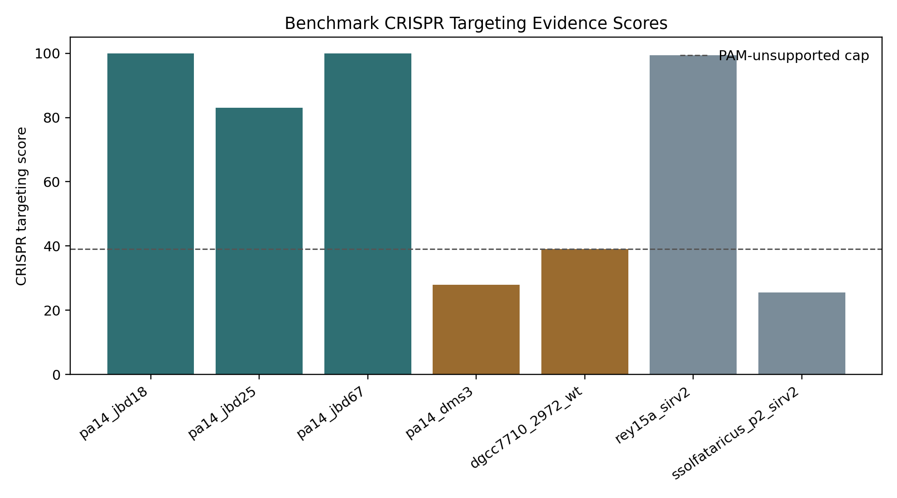
Figure 1. Benchmark CRISPR targeting evidence scores.

Cas Subtype Model Development
SABR uses features derivable from uploaded FASTA files, including repeat length, base composition, k-mer composition, terminal features, spacer count, mean spacer length, and hairpin-like repeat features. Runtime prediction does not use organism name, taxonomy, accession, source database, or cas-gene annotation as model features.
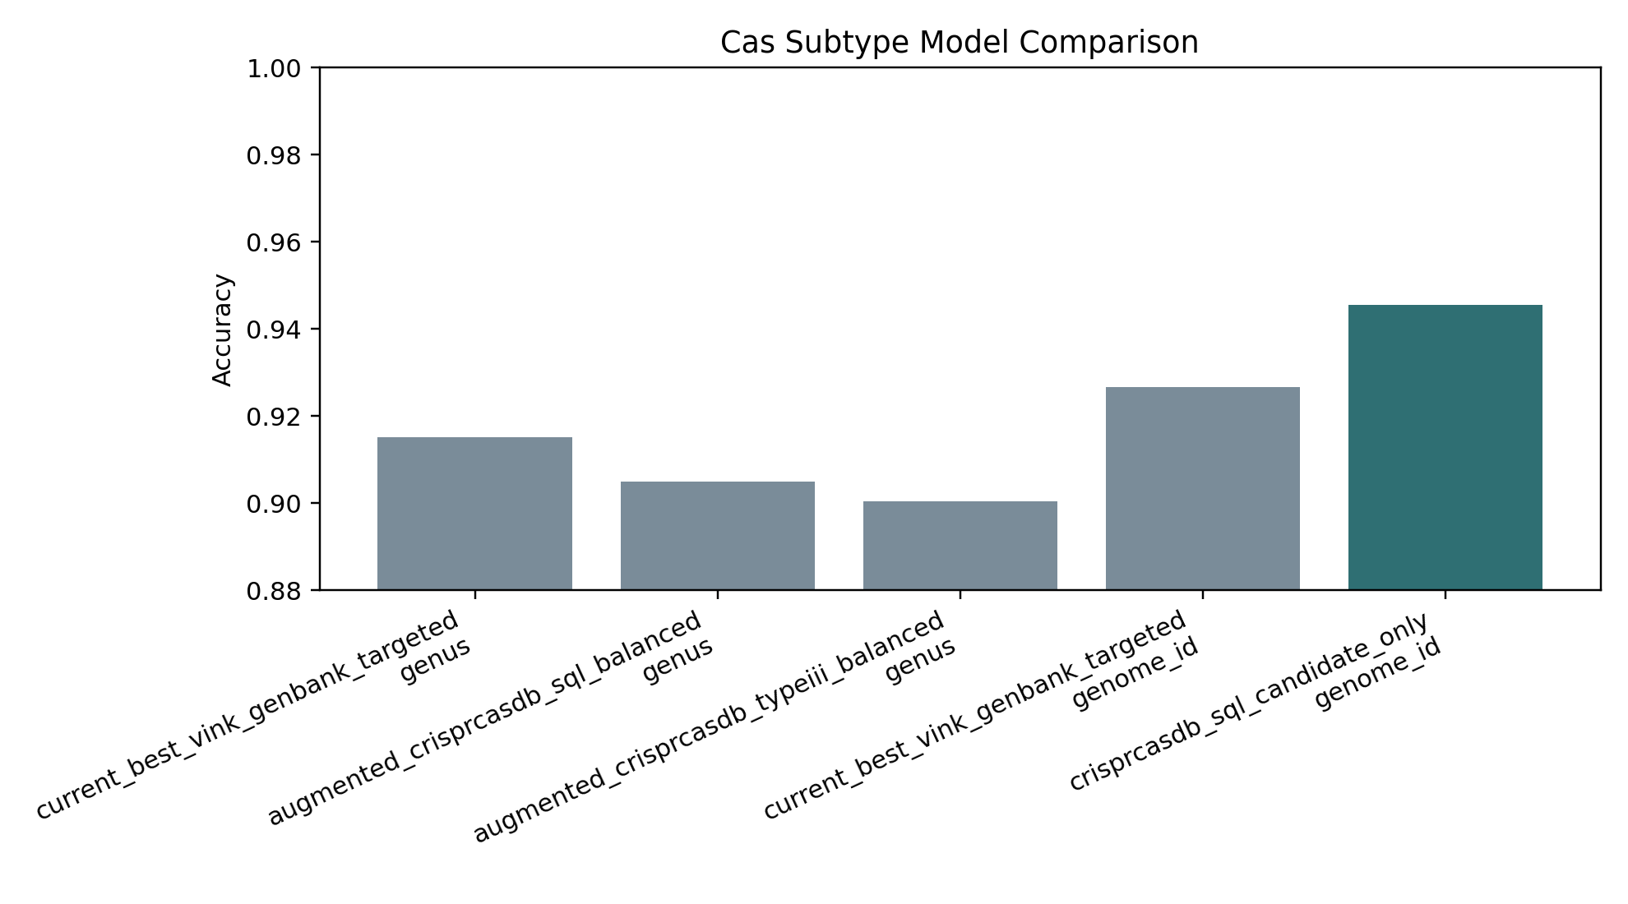
Figure 2. Model comparison across current and CRISPRCasdb-derived datasets.

Model Results
Table 1. Main model comparisons and transfer experiments.
dataset | method | group_column | accuracy | notes
augmented_crisprcasdb_sql_balanced | extra_trees | genus | 0.9050 | adds 3535 novel non-conflicting CRISPRCasdb SQL candidates capped at 500 per subtype
augmented_crisprcasdb_typeiii_balanced | extra_trees | genus | 0.9004 | adds 714 novel non-conflicting CRISPRCasdb SQL candidates restricted to III-A/III-B/III-C/III-D
current_best_vink_genbank_targeted | nearest_repeat | genome_id | 0.9084 | current best table under genome/accession holdout
current_best_vink_genbank_targeted | extra_trees | genome_id | 0.9266 | current best table under genome/accession holdout
crisprcasdb_sql_candidate_only | nearest_repeat | genome_id | 0.9389 | CRISPRCasdb SQL computational candidates only; strong internal consistency but not curated gold truth
crisprcasdb_sql_candidate_only | extra_trees | genome_id | 0.9455 | CRISPRCasdb SQL computational candidates only; best internal genome-holdout score so far
crisprcasdb_train_current_test | extra_trees | current_table | 0.9811 | trained on CRISPRCasdb SQL candidates and tested on current table rows whose labels exist in training; excludes 78 rows from I-U/I-V/V-B/VI-A/VI-C
current_train_crisprcasdb_test | extra_trees | crisprcasdb_table | 0.9559 | trained on current table and tested on CRISPRCasdb SQL candidate rows whose labels exist in training; excludes 526 rows from unseen candidate subtypes

CRISPRCasdb Experiments
CRISPRCasdb release 34 was imported as both direct-repeat inventories and SQL-derived candidate repeat/Cas labels. The SQL importer linked CRISPR loci to nearest same-sequence Cas clusters and produced 23,507 computational candidate rows. CRISPRCasdb-only training performed strongly, but the labels are computational candidates rather than manually curated gold-standard truth.
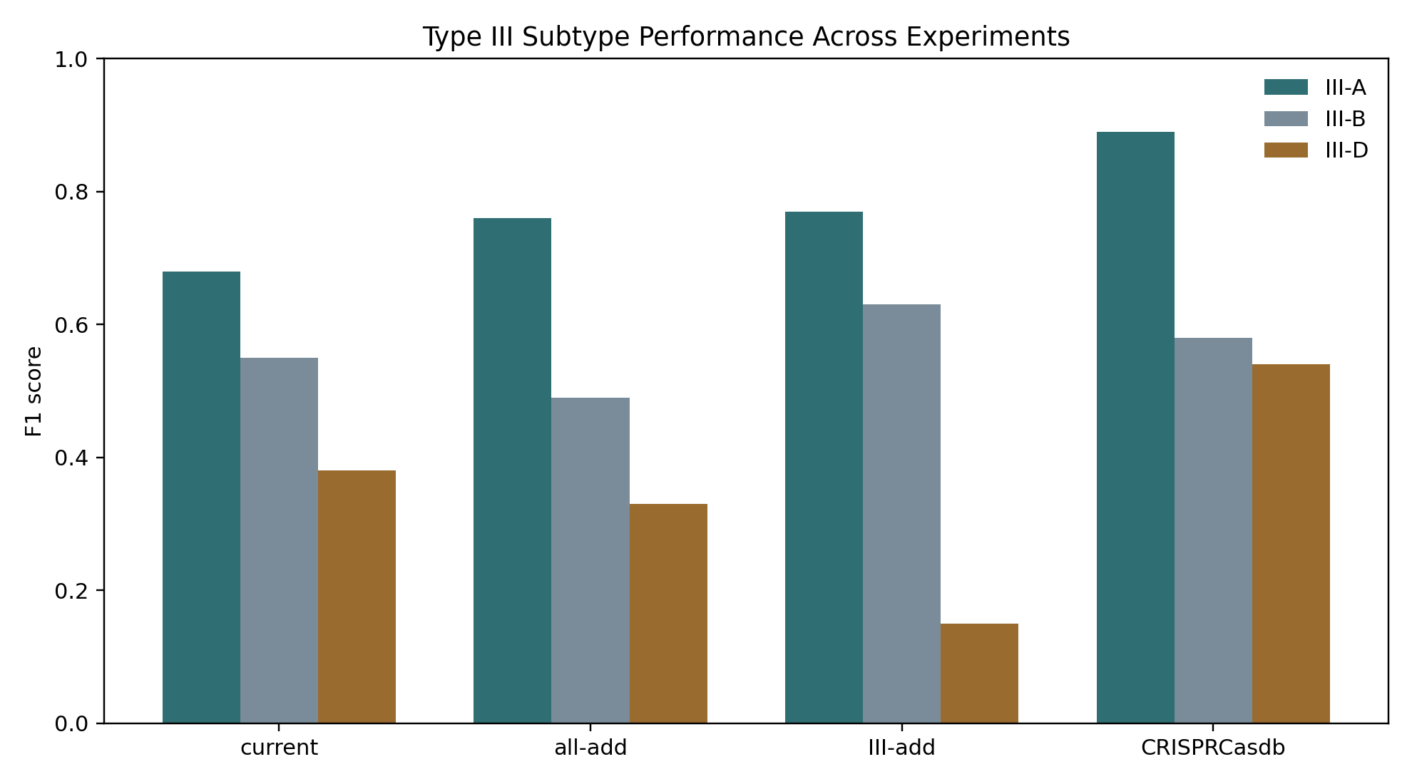
Figure 3. Type III subtype F1 scores across experiments.
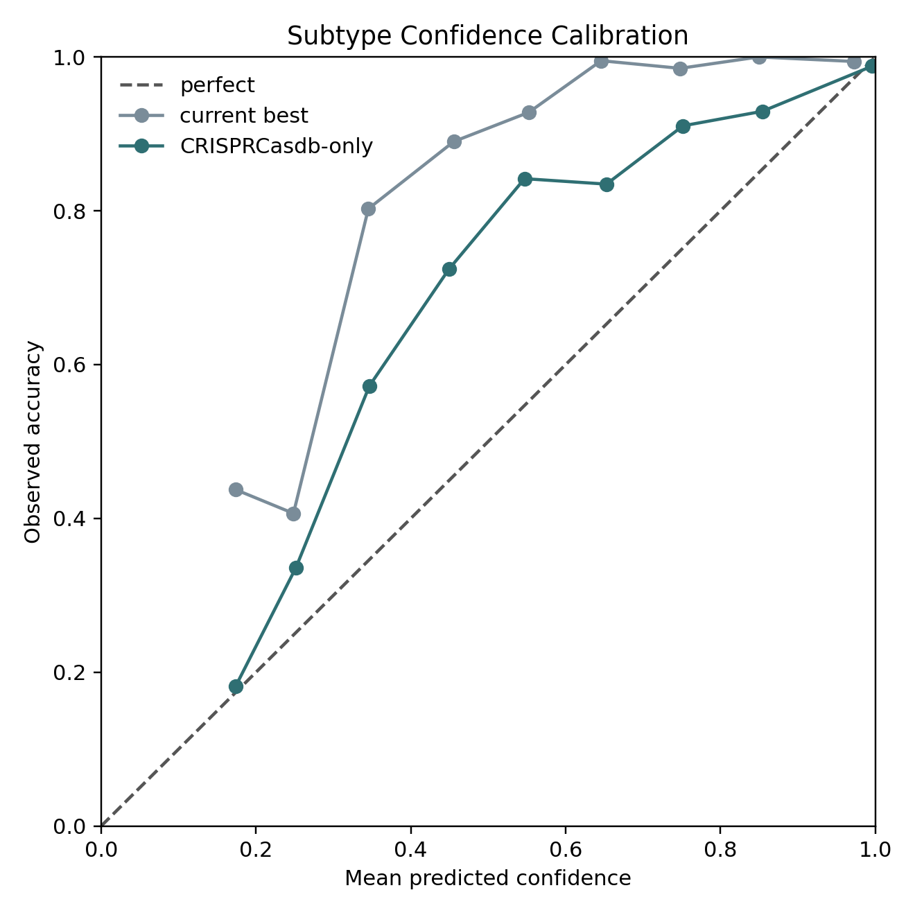
Figure 4. Probability calibration comparison.
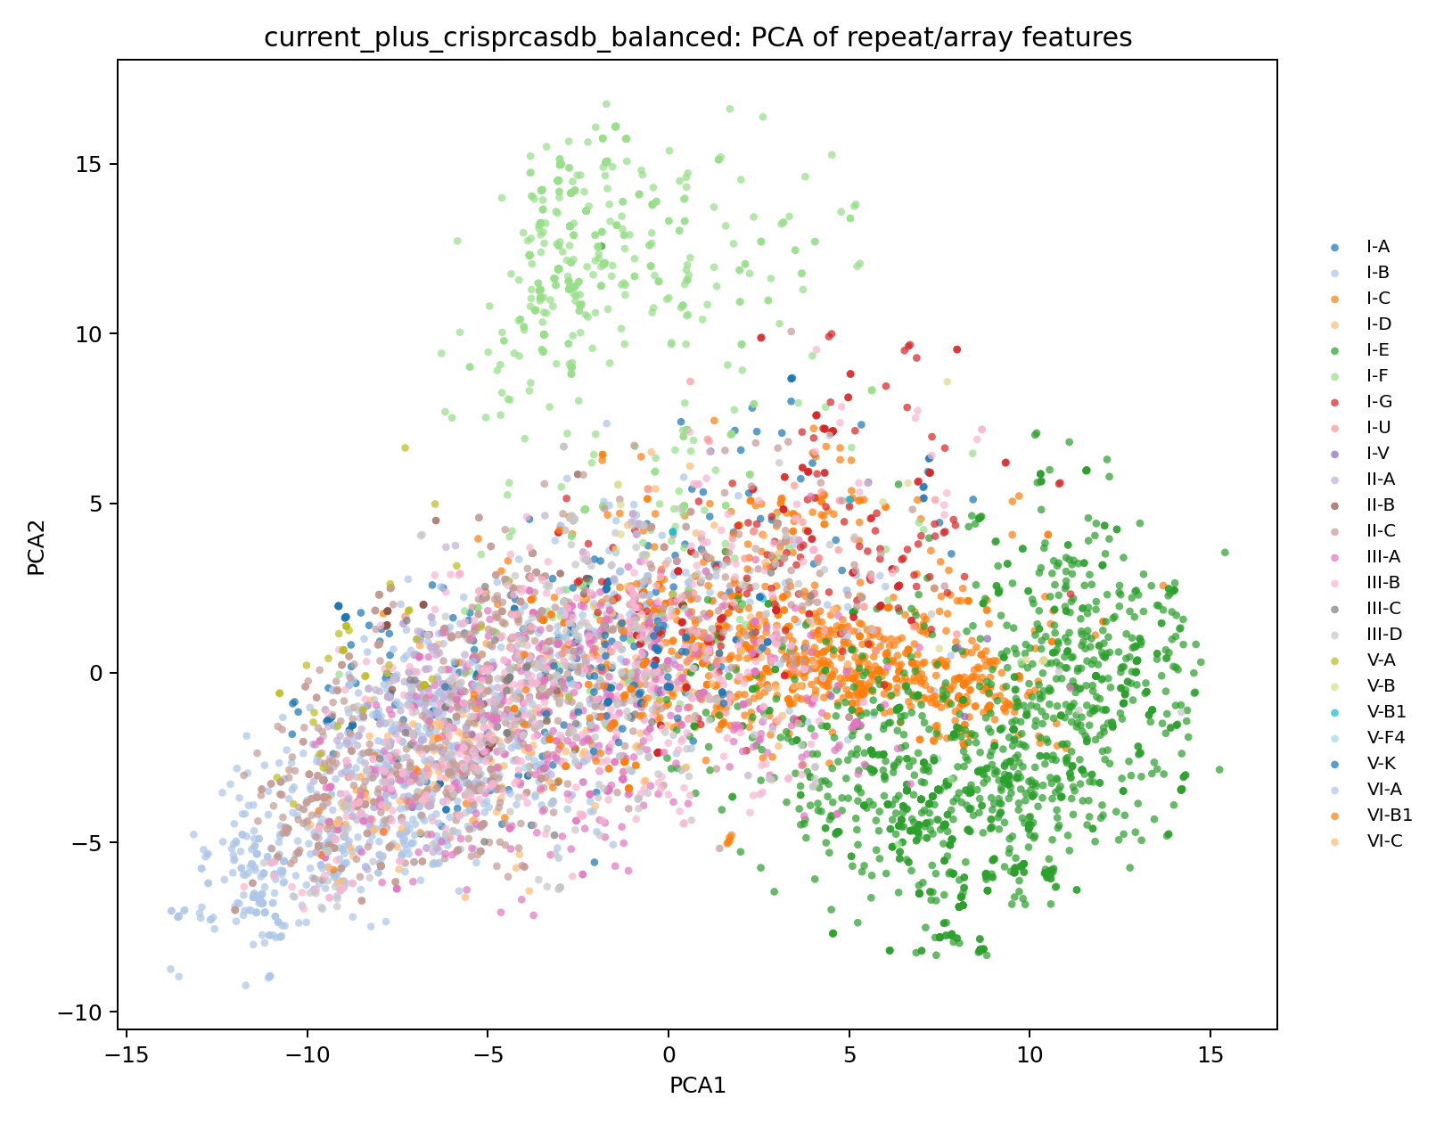
Figure 5. PCA projection colored by subtype.
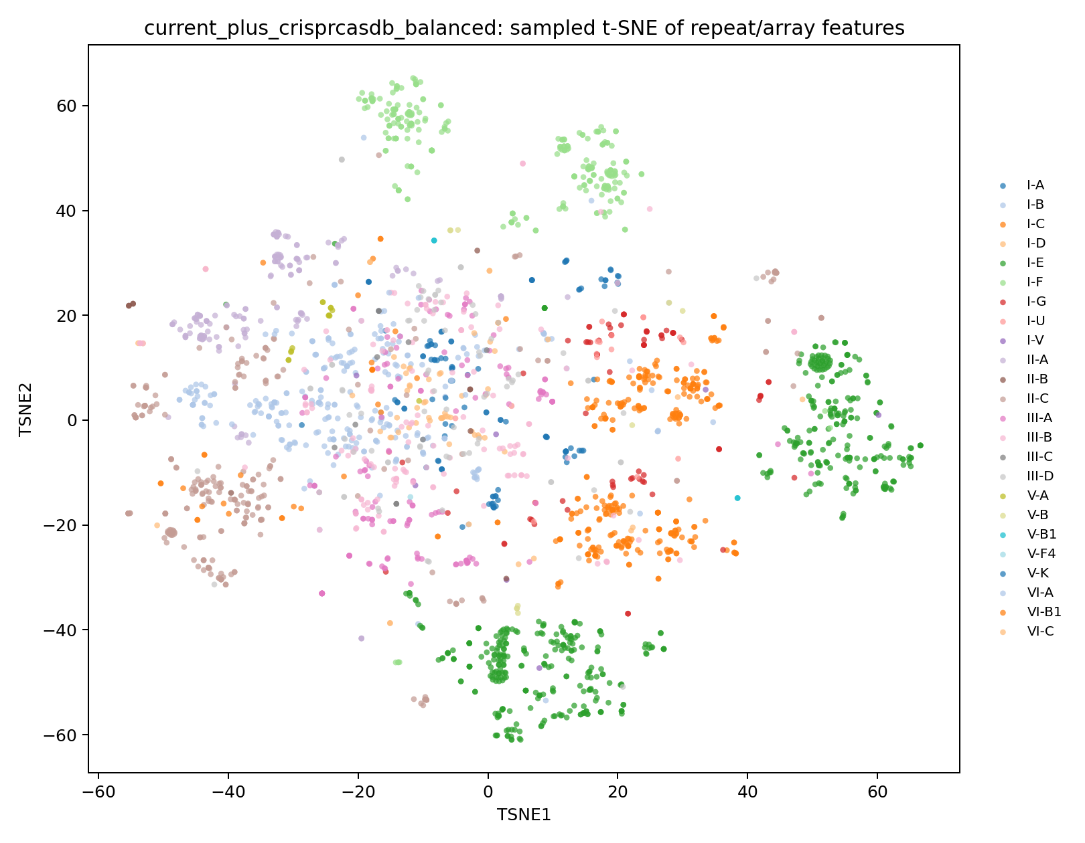
Figure 6. Sampled t-SNE projection colored by subtype.
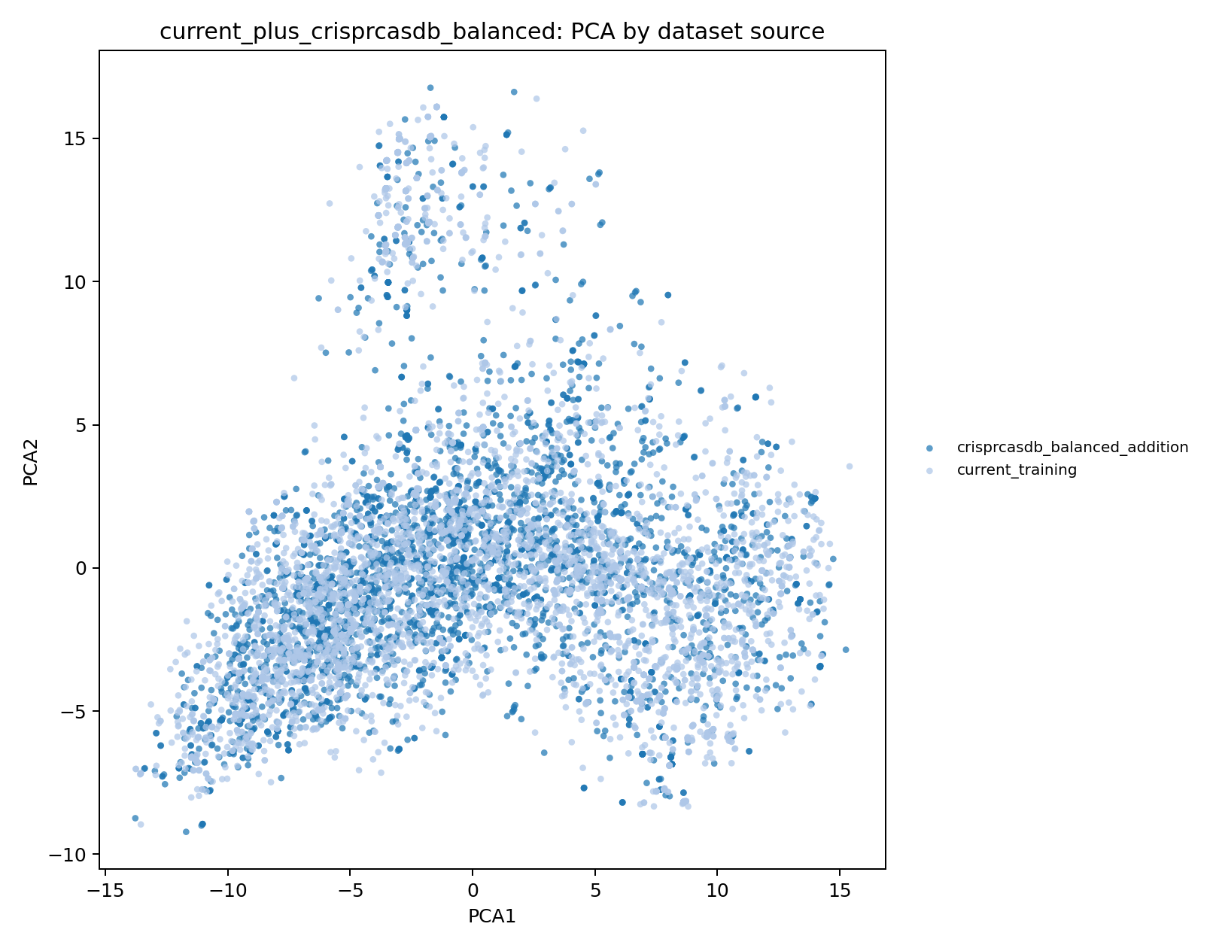
Figure 7. PCA projection showing current rows and CRISPRCasdb additions.
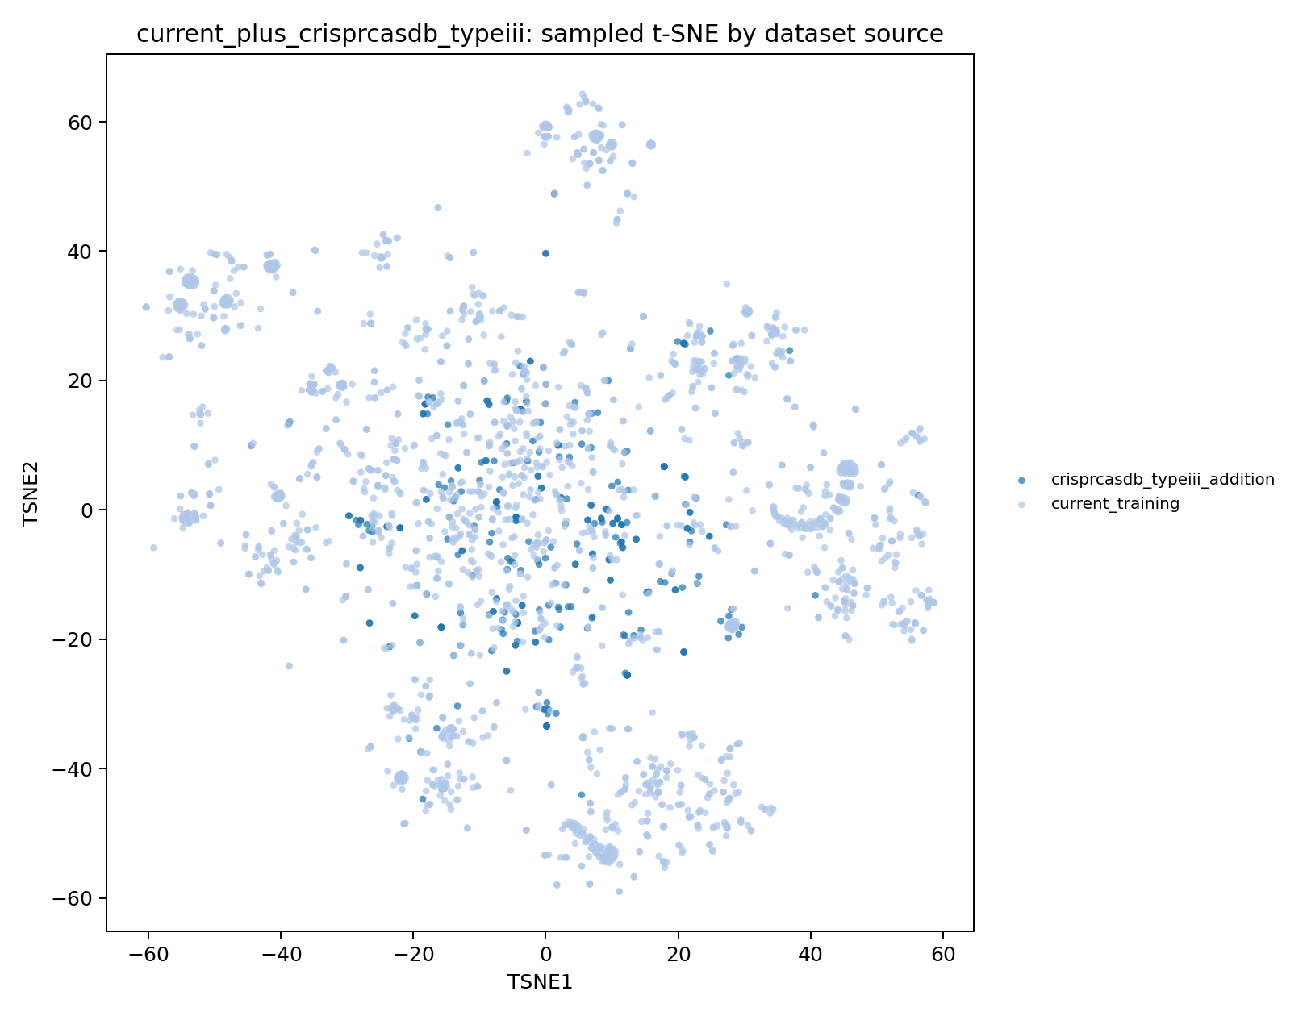
Figure 8. Type III-focused sampled t-SNE by dataset source.

Current Interpretation
The strongest current result is that CRISPRCasdb-derived training data are highly useful for repeat-to-subtype learning. However, because CRISPRCasdb labels are computationally derived and overlap conceptually with some existing sources, final claims require independent curated/literature/CCTyper-supported validation. SABR's core contribution remains the integrated, cautious, reproducible evidence framework.

Limitations
The internal CRISPR detector is an exact-repeat baseline. Spacer matching is exact by default. PAM/PFS rules are incomplete. CRISPRCasdb candidate labels are not gold-standard labels. Resistance/sensitivity claims remain limited by the small curated benchmark panel. Type III-B and Type III-D remain challenging in several experiments.

Future Work
Next steps include independent CCTyper/literature validation, larger bacteria-phage benchmark panels, confidence calibration in the GUI, anti-CRISPR and PAM-failure controls, and a careful decision about replacing the runtime model with the CRISPRCasdb-trained artifact.

SVG Assets
Manuscript figures are embedded as PNG for Word compatibility. Matching SVG files are stored in docs/manuscript_assets/ for publication-quality editing.

