Using a ‘private’ window (or Incognito on Chrome) I checked rankings for a couple of search terms. Woody’s shows up on:

Page 4 for ‘Gardening Eastbourne’

Page 2 for ‘Garden clearance Eastbourne’

So there’s definite chance for improvement. The below should help:

**1. Meta data**

Firstly, the **Page titles** are too long:

If you hover over the tab at the top of the page you’re on, a popup shows, which is the page title. This example is the garden clearance & maintenance page:

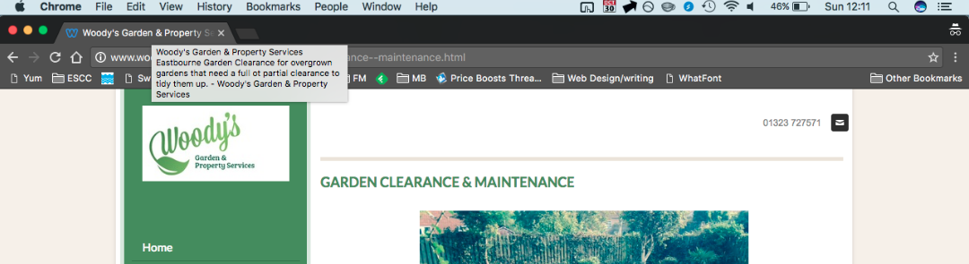

Go to this link: <http://www.seomofo.com/snippet-optimizer.html>

It tells you that the recommended length for the title is 70 characters or less. So this means the current one is far too long and it’s also not focused enough for Google. Something like the below example I think would be much more effective:

“Garden clearance, maintenance in Eastbourne | Woody's”

These are the two keywords ‘garden clearance’ and ‘garden maintenance’ that you should target for this page – so they go first, then if there’s the chance to put in the location and company name after they come next. As you can see the Google search result looks much neater and descriptive using this title:

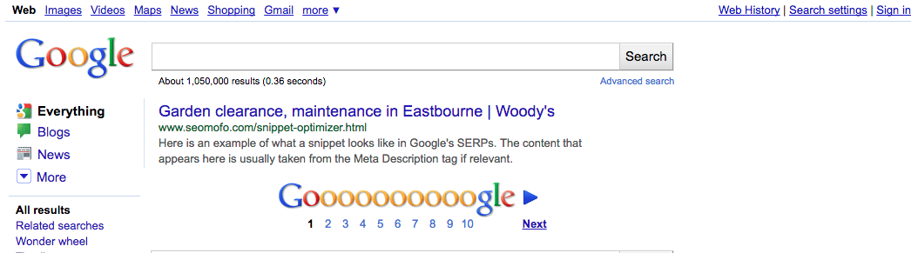

As opposed to how it currently looks:

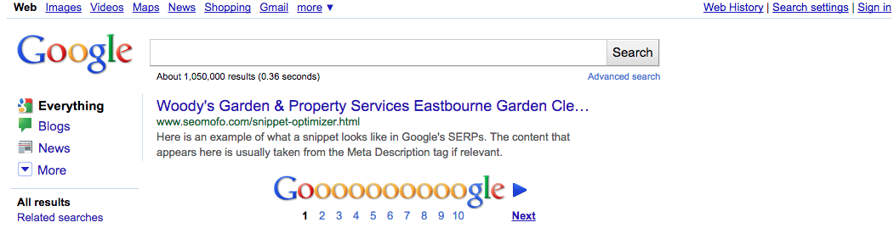

I took off the full company name for this page too, to keep it shorter. You can use the full name of the company in the content on the page itself, and it’s on other pages i.e. the ‘About’ page so Google will still know the company name.

To add to the point, this is from an SEO website:

* **Do not ‘keyword stuff’ title tags:**these are badly written title tags that try to rank for everything or repeat a word over and over. Keyword stuffing is the worst offense when it comes to title tags and you will be penalised for it.

The current page titles don’t seem to repeat keywords much, but they are written as sentences trying to cover everything, so something much more concise should see an improvement in rankings.

On your website admin this field to edit should be called something like ‘Page title’ or ‘Title’ or maybe ‘Meta title’.

**H1 Tags**

The second aspect of meta data is H1 tags. I can’t see from your pages that they have these tags.

An H1 tag is to tell Google what is the main heading of your web page, so for example on the above page, the heading: ‘Garden Clearance & Maintenance’ should be set as H1, rather than just bold text. Google looks at H1 tags before other content on the page, so it is given importance when ranking a page. Without them you can’t properly tell Google content it should expect to find on a page. Your admin page should allow you to select text and set it as ‘H1’ or ‘Heading 1’ – do this for the headings on all pages.

**Meta description**

The final aspect of meta data is the description field. At first glance it seems your pages use this pretty well. The SEO Mofo site I linked to above says a description should be 156 characters or less (close as possible), and it should describe what is on the page, with a mention of location and company name if possible.

This field *does not affect the ranking* of the page – however, it appears on the search results page and is used as marketing type copy to give a potential customer a reason to click the link. If it doesn’t make sense, they won’t.

You’ll see when title and description are both there, your site looks attractive on the results page and people are more likely to click a link:

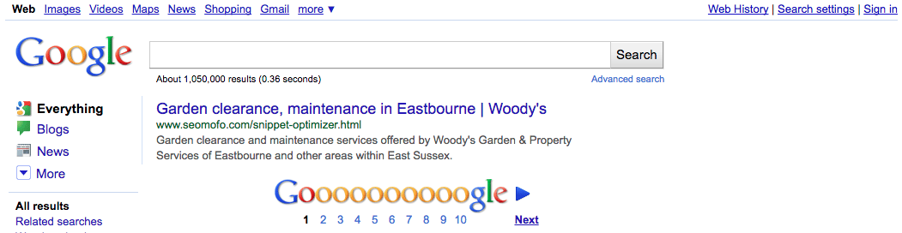

All three elements combined should make it easier for people to find your web pages.

**2. Page content**

The two things regarding content that Google is looking for are *relevance* and *regularily*.

**Relevance**

Google wants to see that a page you have told them is about, say, garden maintenance, is actually about that subject. Sounds obvious, but it just means that the page needs to benefit the user rather than trying to trick the search engine. So use relevant keywords but don’t overuse them. Three to four mentions of the main keywords on a page should be enough. The words need to be natural and useful and on-subject of the page.

This means it’s no good loading keywords into some sections of the page because you think Google wants to see them. It’s likely to have the opposite effect and see your search ranking take a hit.

The maintenance page looks a little thin on words for me. Perhaps a paragraph describing some of the jobs you’ve undertaken, or some of the techniques used would add to this page.

**Regularity**

If a website is never or rarely updated, Google will see this when it crawls the site. If it appears you have nothing new to offer then it will prioritise those sites which do.

This is a tricky one for a service, because your offering remains the same mostly. But my suggestion here would be to perhaps run a blog if you can find the time. Even, say, one post every week or two weeks should be enough to keep Google happy. Things like gardening tips would be really good to have – or a page that has before and after photographs and a summary of the work that you did would also work. Google will see that your site is being updated with relevant content and this can only be a good thing.

Also don’t just ignore existing pages. Refreshing photographs and updating the page if anything changes – or there’s extra information to provide are all good things to do. But not just for the sake of it – if there’s genuinely nothing to change then adding irrelevant words could have the opposite effect.

**3. Alt tags**

This is less important, but adds up to a good website. An alt tag is the description when you add images or video to the website. It’s used as an audio description for visually impaired people and also it tells Google what the image or video is about. Without these your media files will not come into consideration when the pages are ranked.

Hovering the mouse over an image should display its alt-text. It doesn’t look like the images on your site have these. In the admin of your site you should have a field called “alt” or “alt text” and enter a brief description of each one. For example, ‘Garden clearance in Eastbourne’ or ‘Decking installed in October 2016”. I see on some photos in the gallery you have done this, but I’d recommend going through the ones where a description is missing.