**Homework 5**

Professor: PhD. Eunseo Choi

Student: Evelyn Susana Delgado Andino

[*dlgdndno@memphis.edu*](mailto:dlgdndno@memphis.edu)

|  |
| --- |
| Part 1: Diagrams |

**Part 1)**

1.1

|  |  |
| --- | --- |
|  | |
| 10Ma | 20Ma |

* 1. m) 10

|  |  |
| --- | --- |
|  | |
| 10Ma | 20Ma |
|  | |

**Part 2)**

(a) First try to find a velocity field consistent with all of the boundaries. Regarding plate A as fixed, sketch this velocity field over the other plate or plates.

(b) If you can't find a consistent velocity field, mark the diagram "impossible." But remember that to a scientist, "impossible" is a very strong word.

1.2 f)

|  |  |
| --- | --- |
| This is imposible | |
|  |  |

1.2 k)

|  |  |
| --- | --- |
| This is imposible | |
|  |  |

**Part 3)**

A piece of paper lithosphere has been cut into three pieces A, B, and C in different ways. In all cases the paper plates have the velocity diagram shown at the top. All of the angles shown are multiples of 45°.

* Show whether the plate boundaries are ridges, trenches, or transforms.
* Draw a pair of arrows on opposite sides of each boundary showing the direction of relative motion (note that these arrows need not be perpendicular to ridges and trenches).
* Show the magnitude of the relative velocity across each boundary in mm/yr.

2.1 f)

|  |  |
| --- | --- |
|  |  |
|  | |

2.1 i)

|  |  |
| --- | --- |
|  |  |
|  | |

**Part 4)**

The plates are now moving as shown below. Proceed as before.

2.2 b)

|  |  |
| --- | --- |
|  |  |
|  | |

2.2 j)

|  |  |
| --- | --- |
|  |  |
|  | |

**Part 5)**

2.3 a)

|  |  |
| --- | --- |
|  |  |
|  | |

2.3 g)

|  |  |
| --- | --- |
|  |  |
|  | |
|  | |

|  |
| --- |
| Part 2: Ch.2 Problem 7 of Fowler (2004). |

In Fig. 2.26, the trench between B and C is consuming B only. The ridge between A and B is spreading symmetrically at right angles to its axis. The pole of rotation between A and C is fixed to C. The angular velocity of A with respect to C is in the direction shown, and is 2 in magnitude.

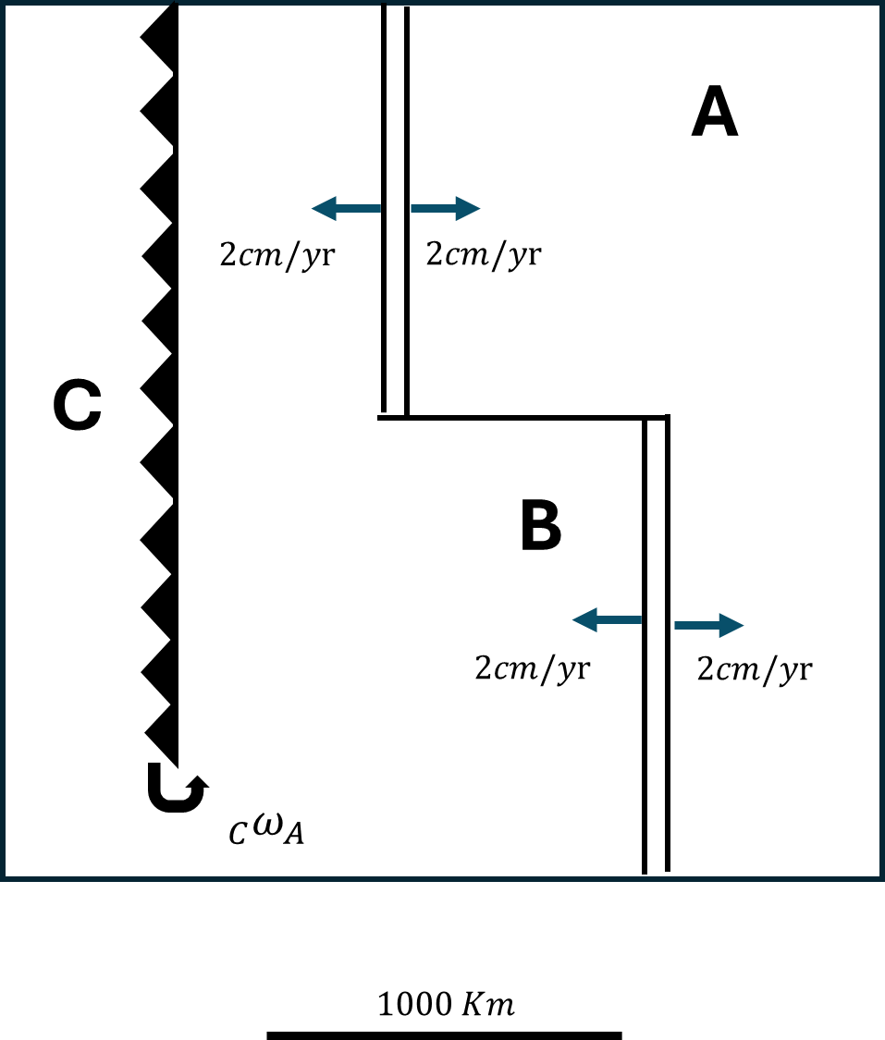

1. Mark the poles of rotation and angular velocities of (i) plate B and (ii) the ridge axis with respect to plate C. (Remember that the pole of motion between two plates is that point which is stationary with respect to both of them.)
2. Show the direction and rate of consumption at X and Y.
3. How long will it take for the ridge to reach (i) X and (ii) Y?
4. Sketch the history of the triple junction between A, B and C with respect to C.

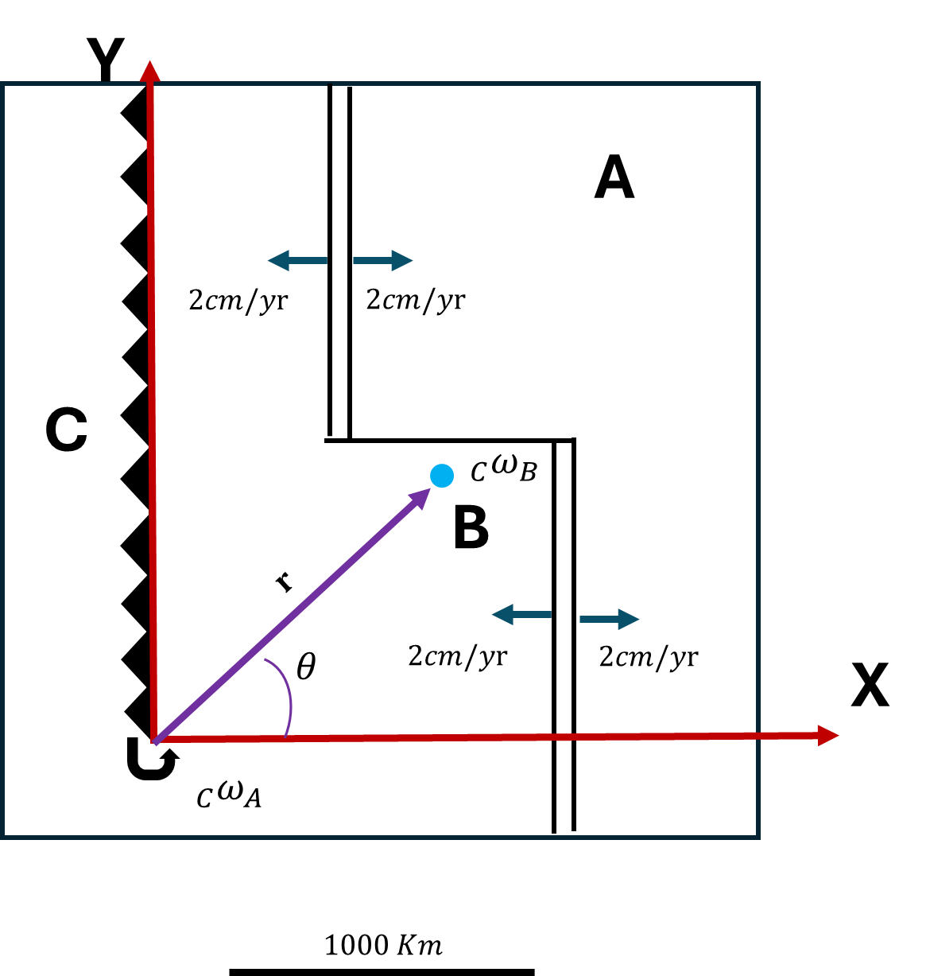

To solve this problem, we need to assume the following condition.

Setting the origin of our system at the pole of A with respect to C, we have:

From the data in the diagram, we know that the relative velocity of B with respect to A is:

For the response, we need plate A moves with that velocity. Then, we can obtain tangential velocity with:

We can construct:

To choose the sign

We know and we can determine from the figure that the separation from the pole of A relative to C to A is 1500 km.

Now, we have a right triangle, which allows us to calculate the distance from the pole of B relative to C to the ridge.

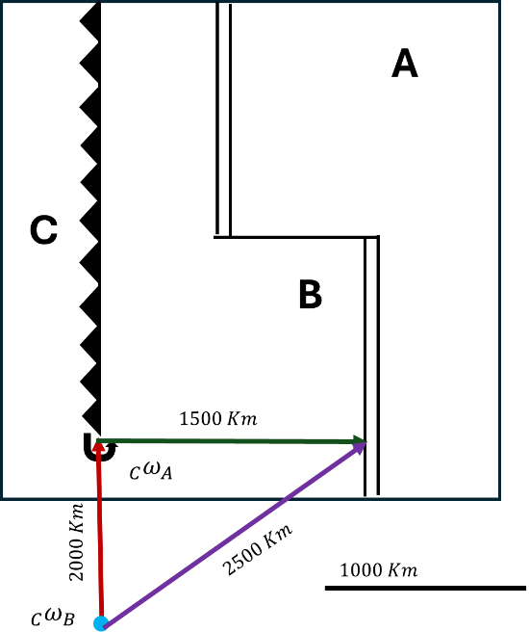

Now, we can use:

Then

Considering that areas farther from the pole move faster than those closer to it, in X will be consumed first the plate B and will produce a triple junction. The direction of rate consumption is a curve in both X and Y.

|  |
| --- |
| Part 3: Ch.2 Problem 10 of Fowler (2004). |

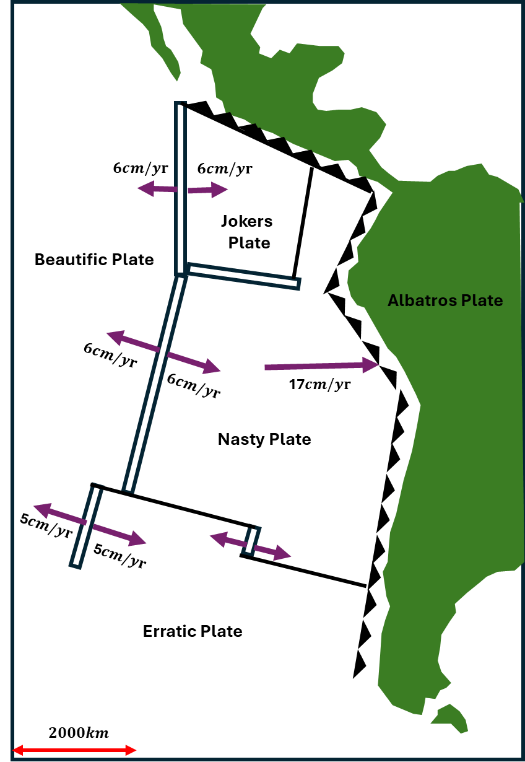

**Part a)**

Determine the relative motion vector of the Beautific–Joker’s–Nasty (BJN) triple junction to the Albatross plate.

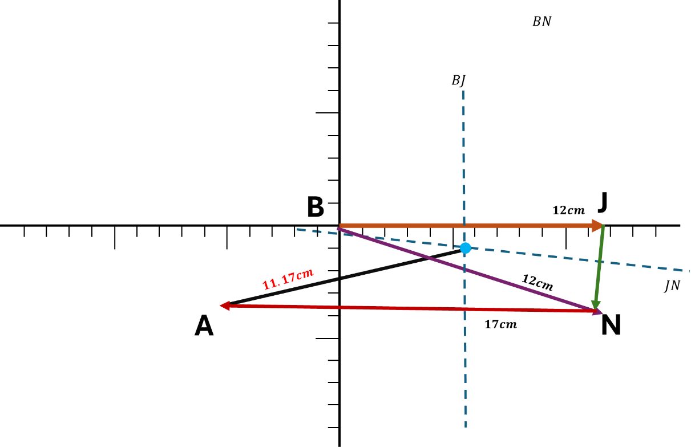

The relative motion of the velocity vector was calculated graphically, by projecting the vectors and maintaining the angles. The magnitude of the relative motion of BNJ was obtained by measuring the length of the line. The result is 11.17cm/yr to the NE-SO.

**Part b)**

Determine the relative motion vector of the Beautific–Nasty–Erratic (BNE) triple junction to the Albatross Plate.

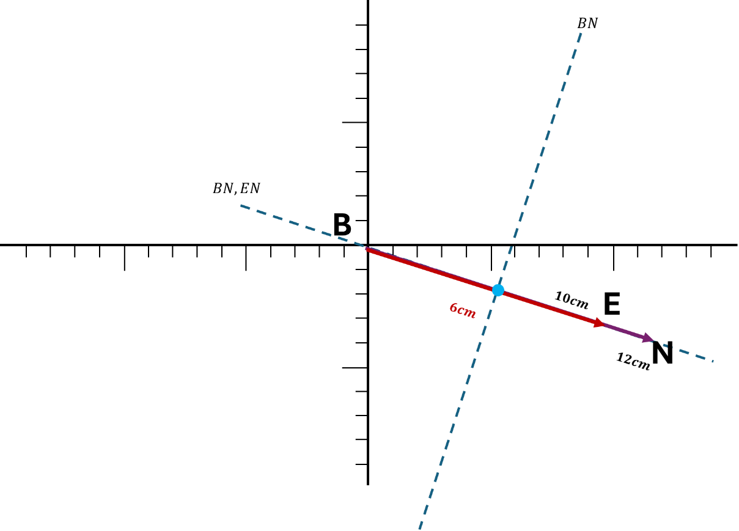

New location of the triple junctions.

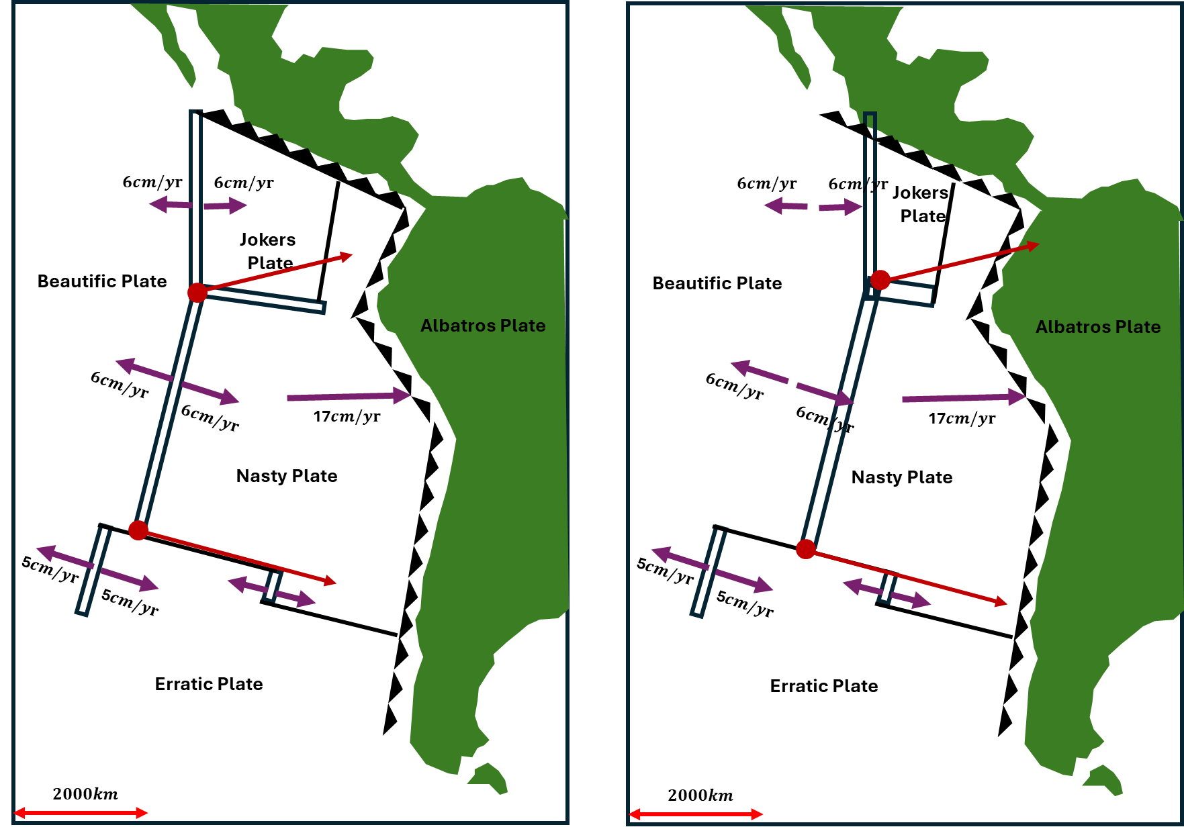

|  |
| --- |
| Part 4: Ch.2 Problem 3(a) of Fowler (2004). |

**Part a)**

**Jupiter Notebooks:**