**EnRoute Proposal**

**Abstract**

The EnRoute project will focus on designing a building model with a scaled down HVAC unit and implementing controls on mbeds that communicate to Matlab via BACnet. The HVAC unit will handle heating and cooling, as well as airflow through the ductwork using one [blower](https://www.sparkfun.com/products/11270) for supply and one for return air. Return air can be recycled to the HVAC or vented to the outside. Control for this project will use three mbeds. There will be one mbed per story, and one master controller for the HVAC. The mbeds for each story will take measurements, control the valves, and control the heating bulb. The master mbed will control the HVAC unit and handle communication to the host computer. We will also incorporate a flow sensor in and add sensors for measuring power consumption.

**Work Completed**

The Phase 1 work is listed here:

1. Prototype Design for a single room

2. Begin electrical network over serial

3. Prototype damper valves

4. Test Heating/Cooling methods

(1) We have designed & built a single room (14”x14”x9”) using ¼ MDF. The design is such that the ceiling can be placed and removed easily when we want to acquire data. Each of the inner edges have been made air-tight using spray foam, and the outer edges where necessary with hot glue. All the connections in our prototype make use of 1” PVC pipe. The inlet blower is connected (via 1” PVC pipes) to the inlet point of the room situated at one ceiling corner of the room with the Peltier enclosure and control valve in between. To channel the air being sucked out of the room, we utilized available items to construct the necessary attachment to the blower.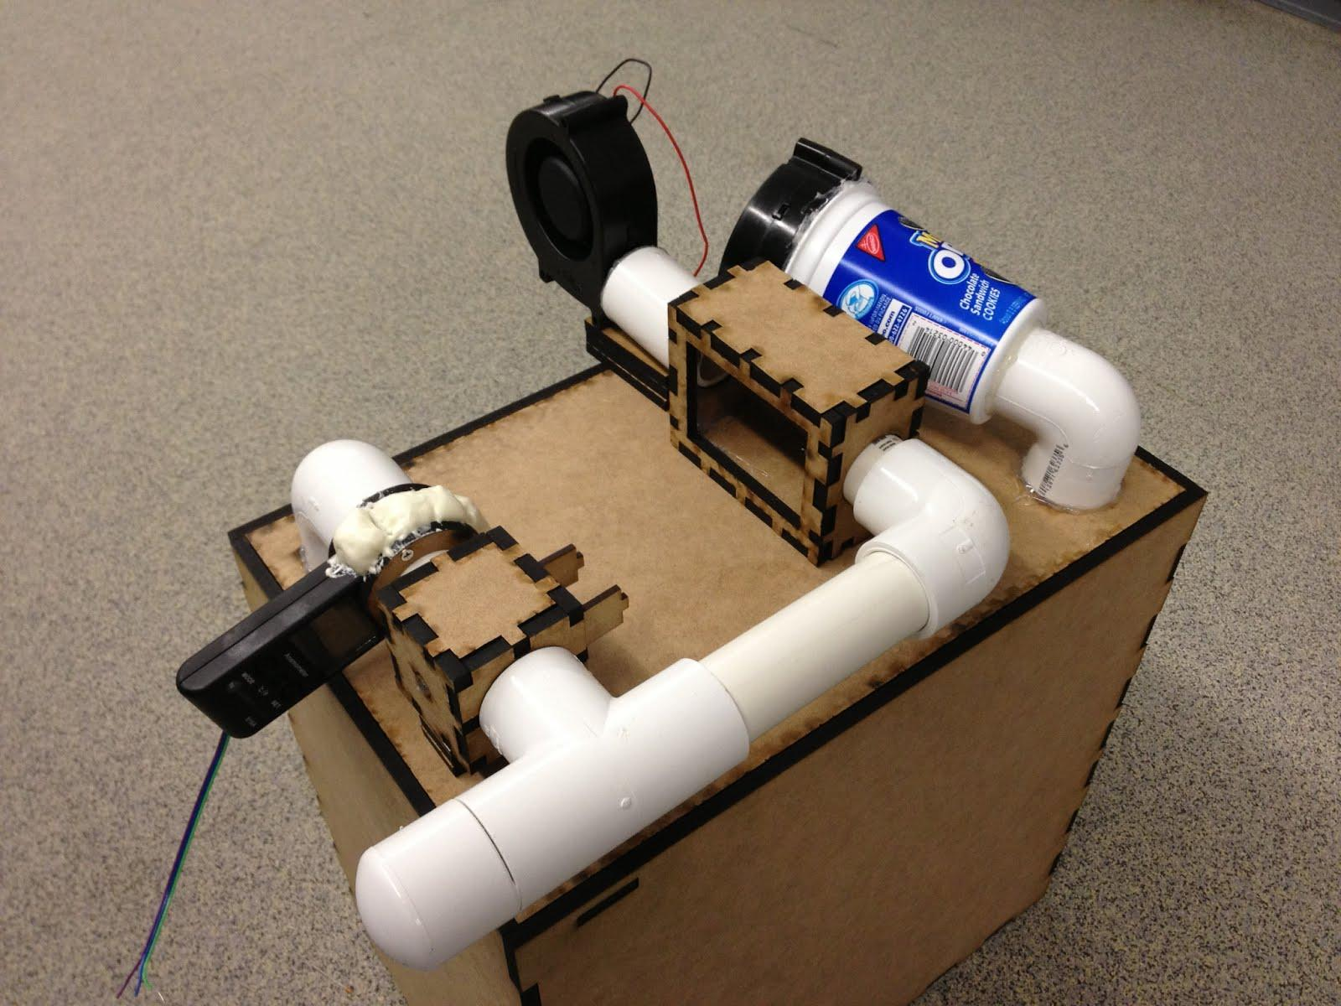

(2) We have individually tested each and every component like the blower, Peltier effect sensor/actuator, airflow sensor etc. by interfacing it with the mBed. Our blower’s maximum speed can be read with the Airflow sensor so we are not looking for a professional air flow sensor. Now we have to integrate them all to evaluate real-time performance. We hooked up the temperature sensor (SHT-15) to the mBed and placed this setting inside our room to monitor temperature variability. The test results have been discussed in section 4) of this write-up.

(3) We built a MDF based control valve with special consideration for motor shaft connectivity to the valve and rotary constraints of the valve itself. Once again insulation as mentioned earlier was checked. Also,using MDF we built a setup for the airflow sensor to be able to connect to the 1” pipes. With the valve completely open, we measured close to 9m/s flow velocity and about 1m/s with the valve closed.

(4) We built a simple MDF based encasing for the peltier sensor, placed a heat sink on one side with thermoelectric tape in between them to test the functionality of the sensor for our purposes. After hours of testing, we noticed that we got a temperature variance of +/- 2 deg celcius only. This seemed to have improved a bit after placing a small CPU fan at the heat sink in the hope of cooling the other side faster to lower temperatures. However, the variacne remained nearly the same. We have been thinking of using multiple peltier sensors together to study the effect but not yet implemented. We used an H-bridge to change the hot & cool sides of the sensor.

Unfortunately from the tests and research later, we may have come to the realization that while these tiny peltier sensors are excellent at providing large changes in temperature, they are stubborn in transferring these changes.

**Plan Forward**

Currently we are on schedule with a single room prototype, although the Peltier unit did not work to our liking. We are moving forward implementing a resistive heating coil for heating, and will explore cooling later on as time permits. Our attention will now shift to constructing the entire structure with four heating/cooling zones, running the duct work, designing the HVAC, creating a MATLAB interface, and controlling the structure with BACnet. Phase 2 and 3 are laid our as follows:

**Phase 2:** To be completed by November 16th

Finalize building design and construction. (Dan/Larry)

Implement controls in building. (Dan/Larry/Neel)

Begin work on BACnet communication. (Neel)

**Phase 3:** To be completed by November 27th

Modify building to fit last minute additions. (Dan/Larry)

Implement MATLAB and GUI control. (Dan/Larry)

Finalize BACnet communication. (Dan/Larry/Neel)

Add building enclosure. (Dan/Larry)