Design Specifications

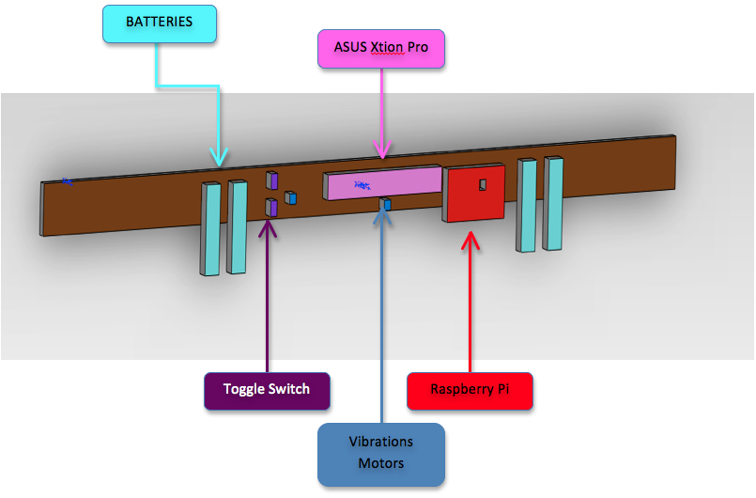
Figure 1: Belt Design with component placement
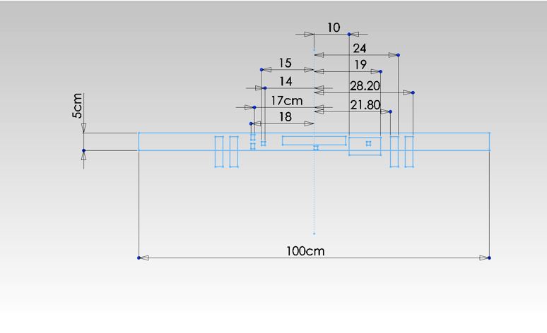
Figure 2: Component size measures
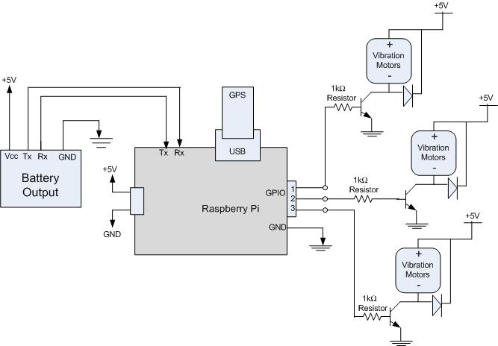
Figure 3: Overview of the Circuit Design

