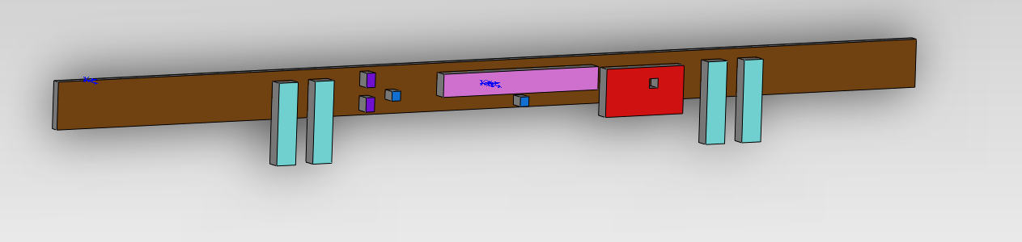
Batteries
Raspberry pi
Switches
Motors
Belt
Asus Xtion

