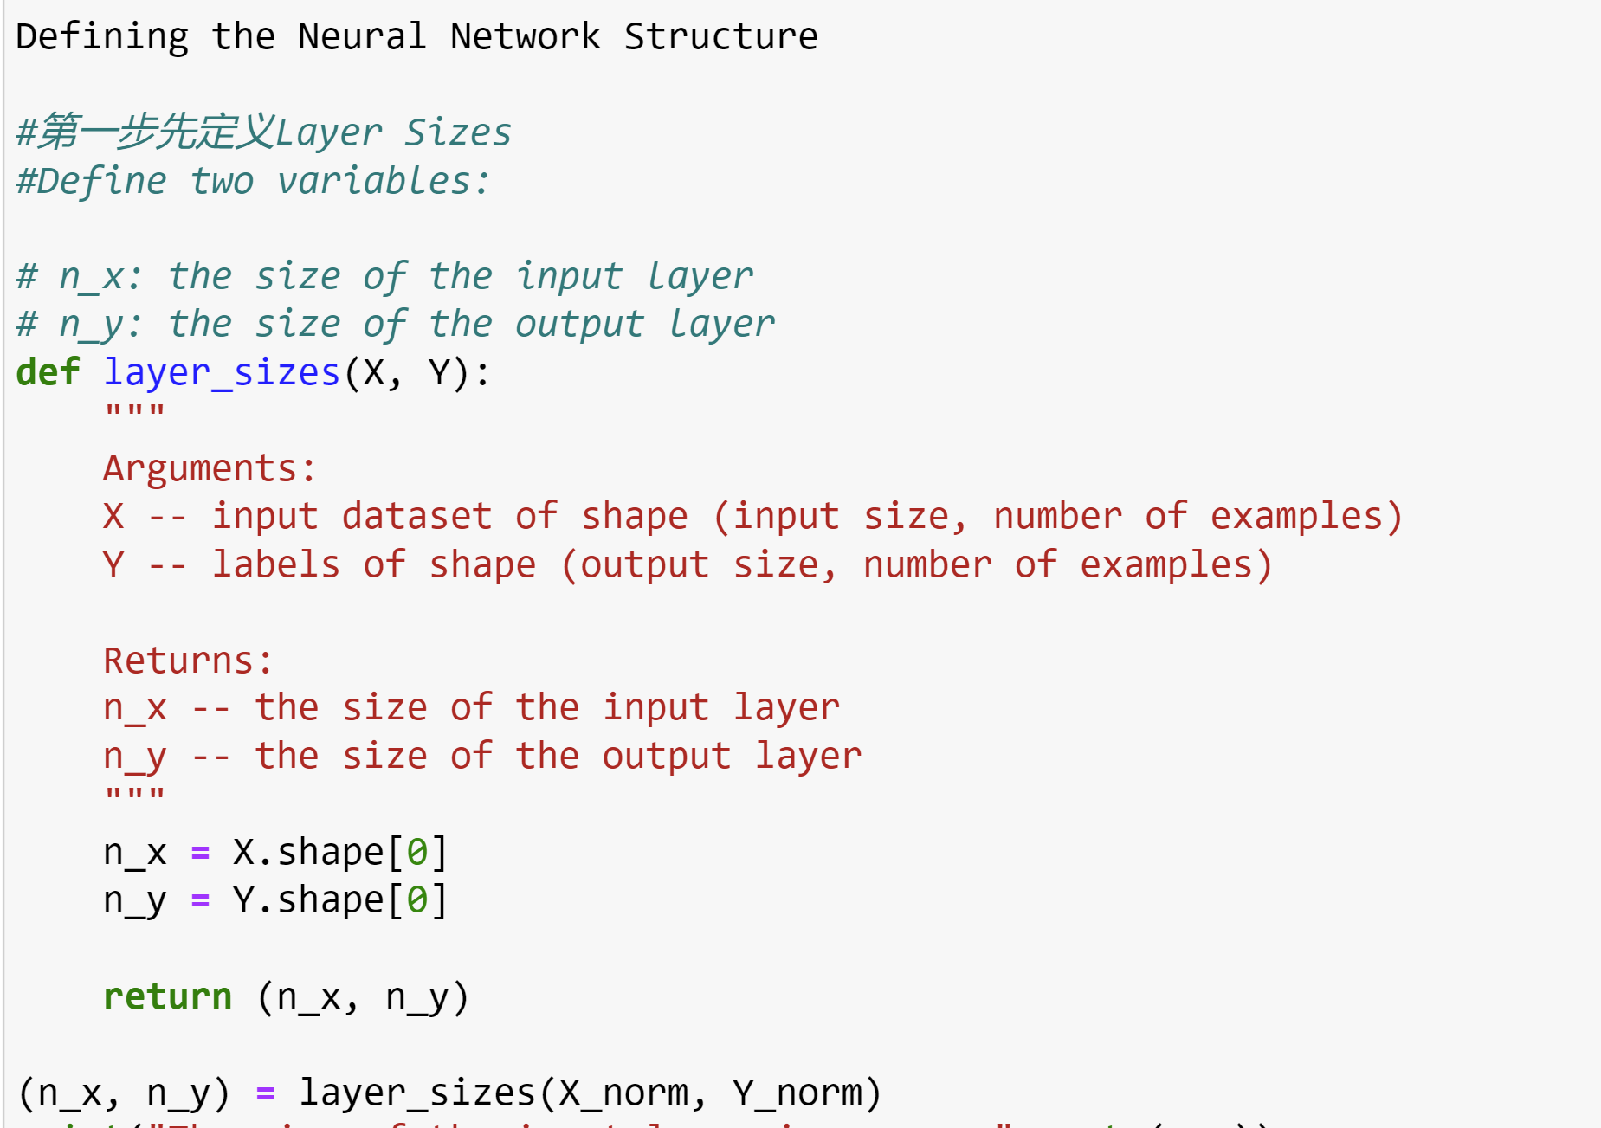

先建立了Forward Propagation推导出Y_hat后，再建立起Cost Function，Y_hat和Y的差异。

目标是解Loss Function导函数为0找到最小值。

Loss Function是关于L （w，b），两个未知数w和b，要求Gradient

求Gradient采取的是Backforward Propagation公式

利用求出的Gradient来更新w，w，b梯度下降找到目标点

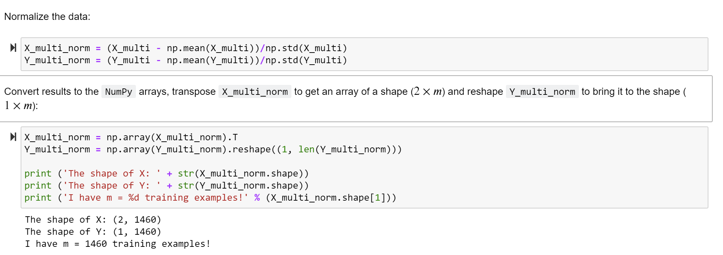

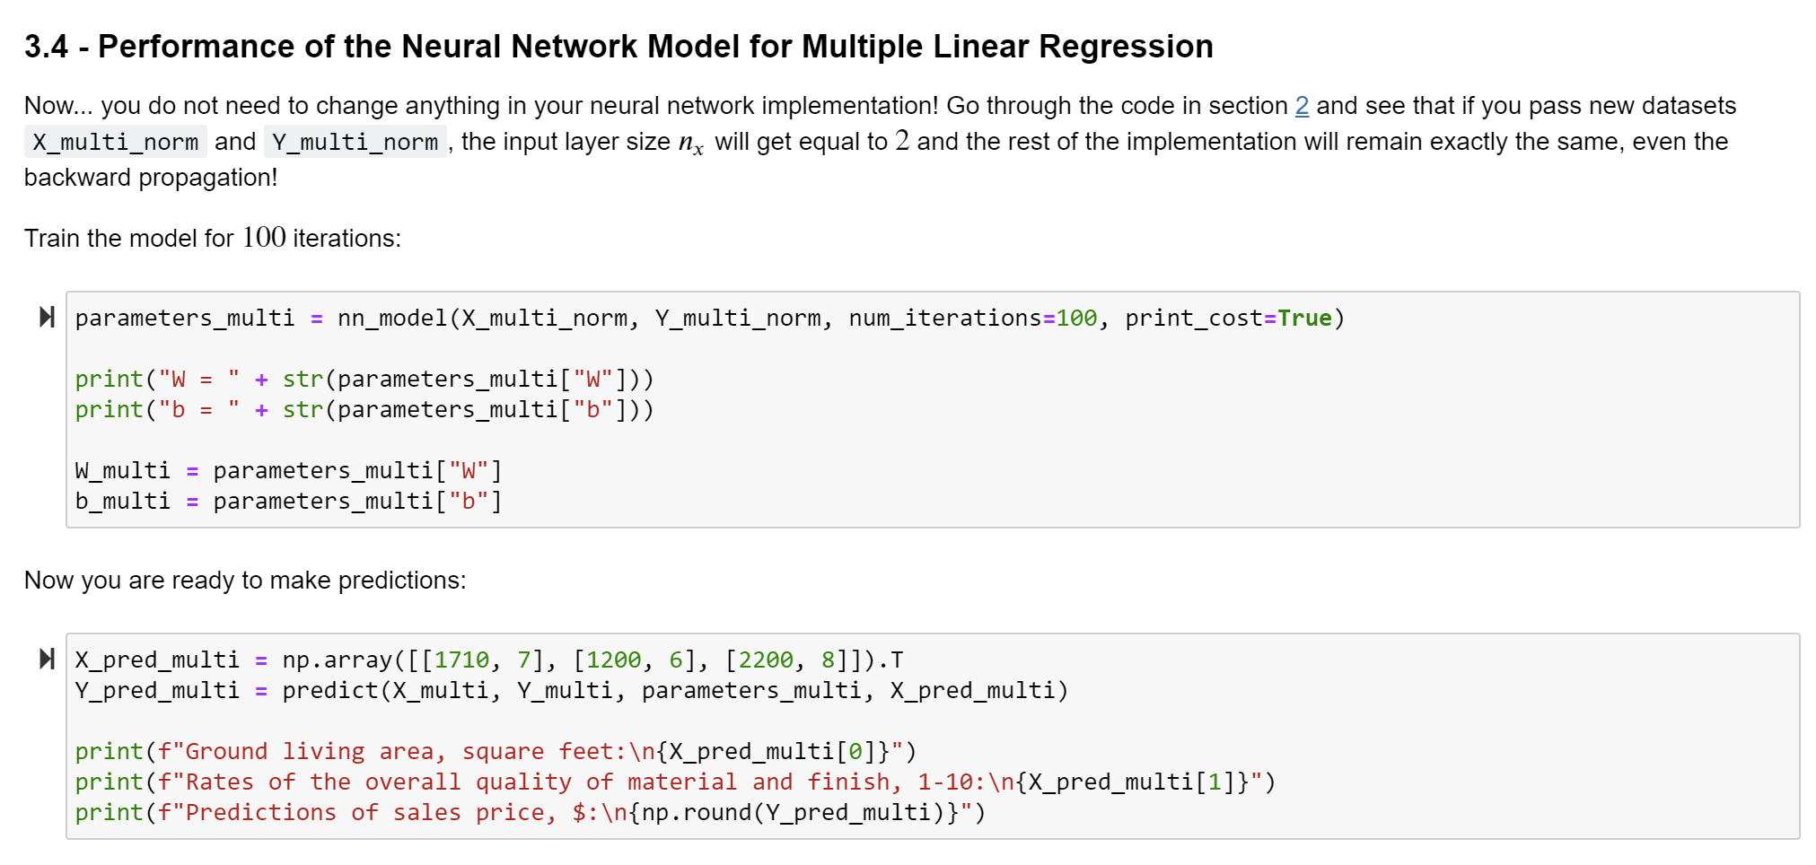

以上是Regression Model with OLS Cost Function

接下来是Classification Model{exp()activate function} with LogLoss Cost Function

代码上的修改：

整合Forward 从Forward——Gradient Dersent叫 Loop

Cost Function

Backward

Gradient Desent

建立 Neural Network Model “nn_model()”

最优化Cost，以至于然后可以开始Predicate Y

