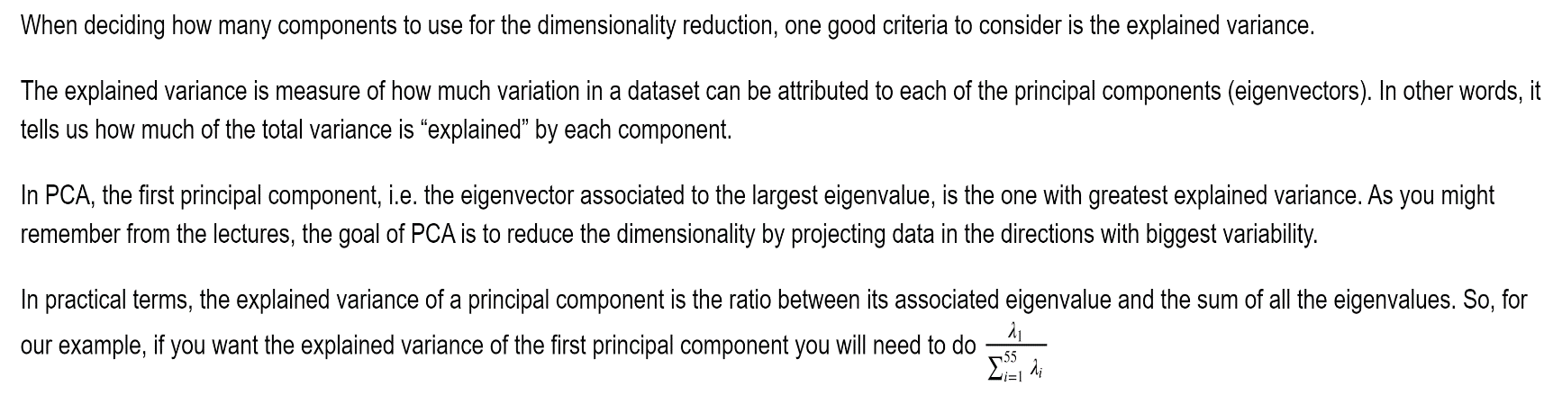

Plot the explained variance of each of the 55 principal components, or eigenvectors in our cat face sample：

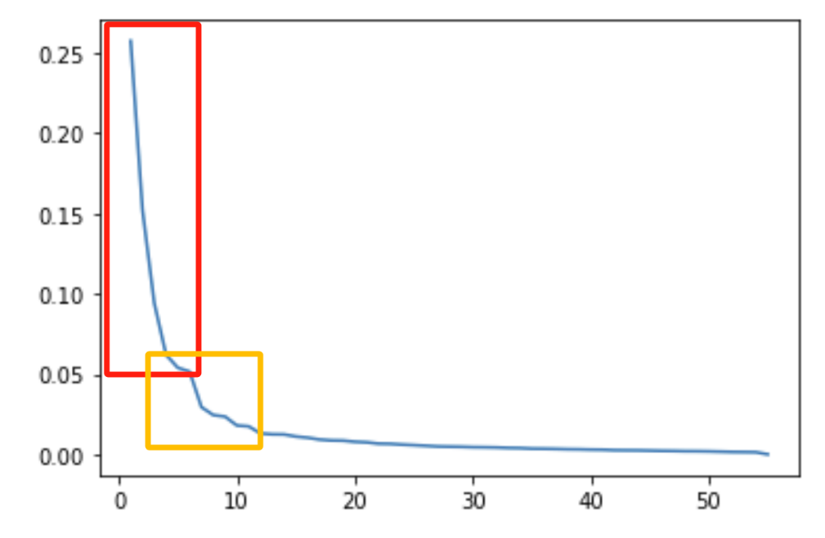

A good way to decide on the number of components is to keep the ones that explain a very high percentage of the variance, for example 95%.

For an easier visualization you can plot the cumulative explained variance. You can do this with the np.cumsum function. Let's see what this looks like:

