**MERN**

**backend**

hot reloading :- jaise he file save kerte hai to sab kuch automatically

start kar diya jata hai backend per to apko pata he ni lgta hai

jitna code rehta hai wo process hoke comp me or ja chuka hai

if output is not coming then restart the server and o/p sometime is not coming due to the hot reloading

npm install dotenv

used to remove preserved the server access , port access

make .env file and store the variable over their

if we use env then we make our application production ready

In chai aur code

Just start from the 1:26:

create vite@latest . dot ki wajha se sari file frontend k ander he banege jo folder h ushe me

cors

cors origin:-

different URL

different PORT

then diff origin

sabko allow na kero data lene k liye jinko allow kiya hai sirf wahi data lenge

like white list ip , id daal do , domain white list ker do

:

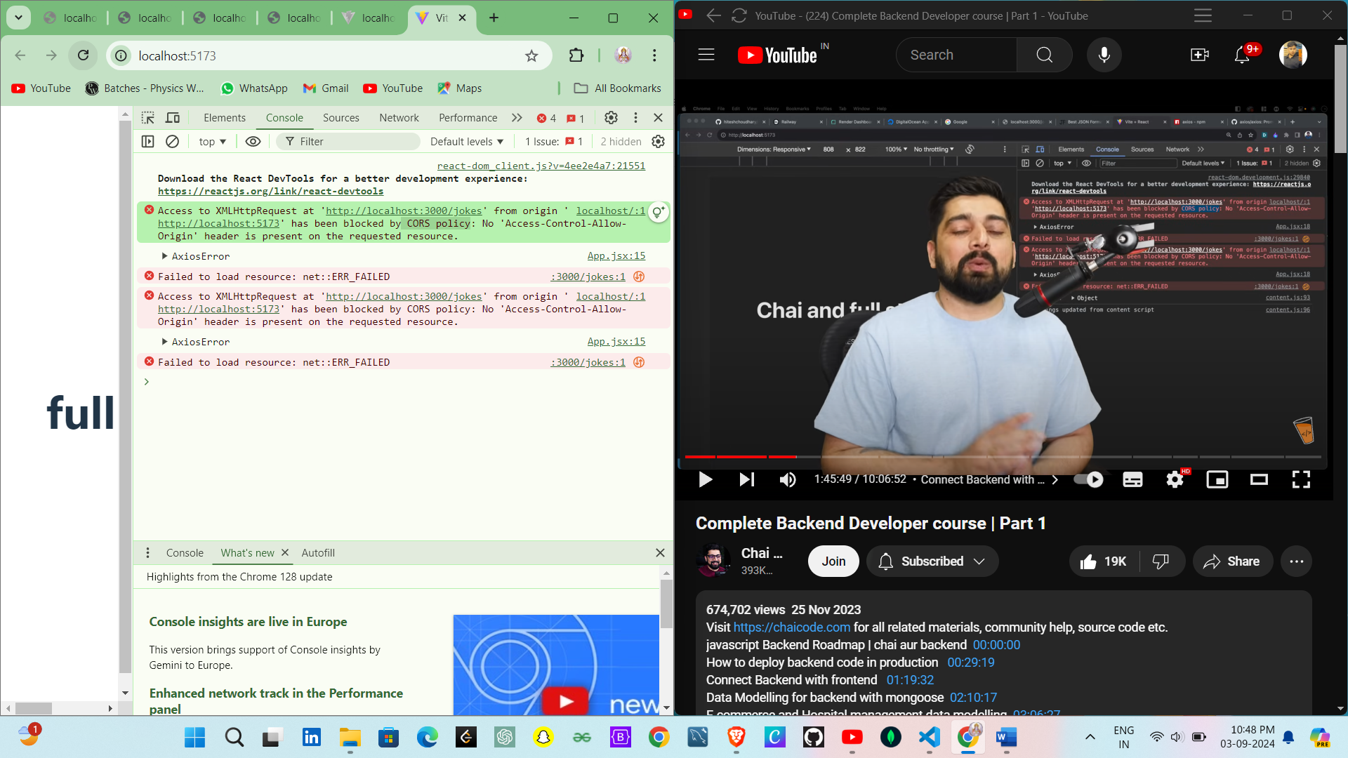

Using of proxy

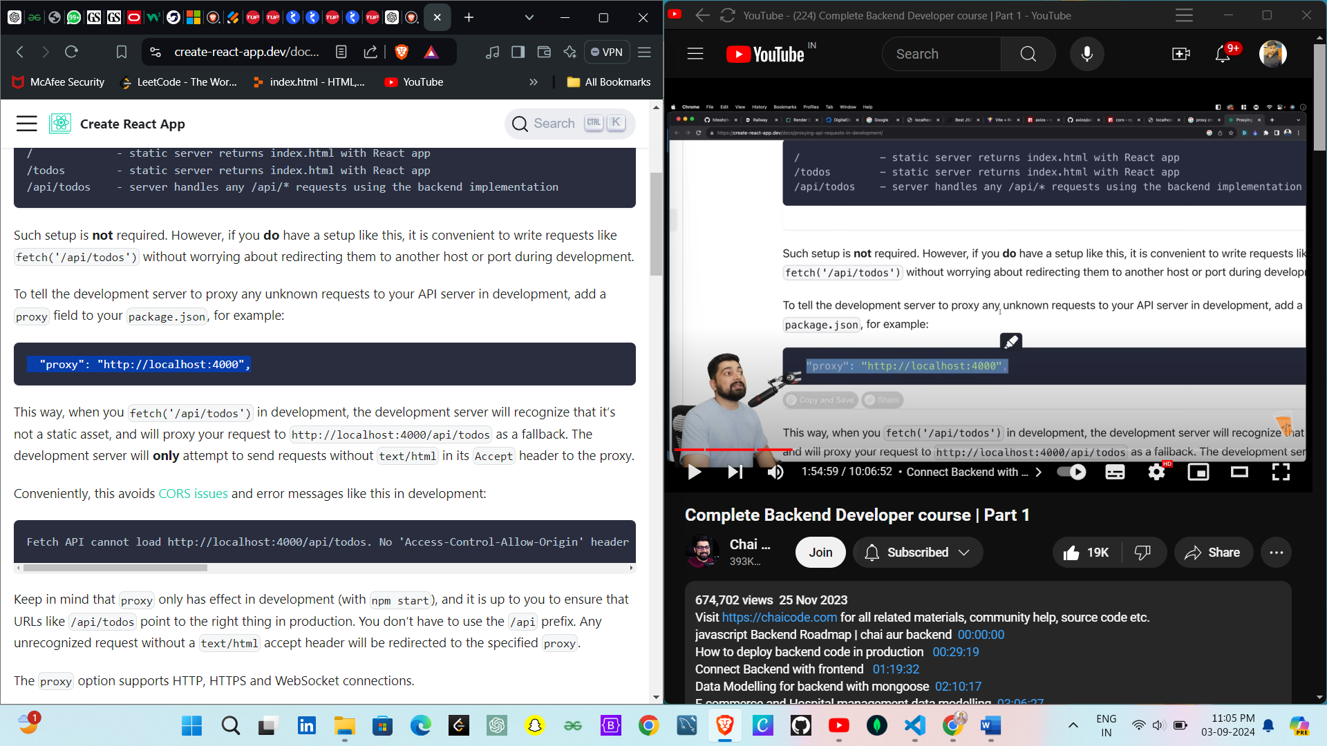

npm run build

:- is cammond se distribution folder mil jata hai it have all code , all css in compiled and srinked form or iske pure folder ko bakend folder me daal dete hai

app.use(express.static('dist'));

:- do this at the server side and it serve the static content on the screen

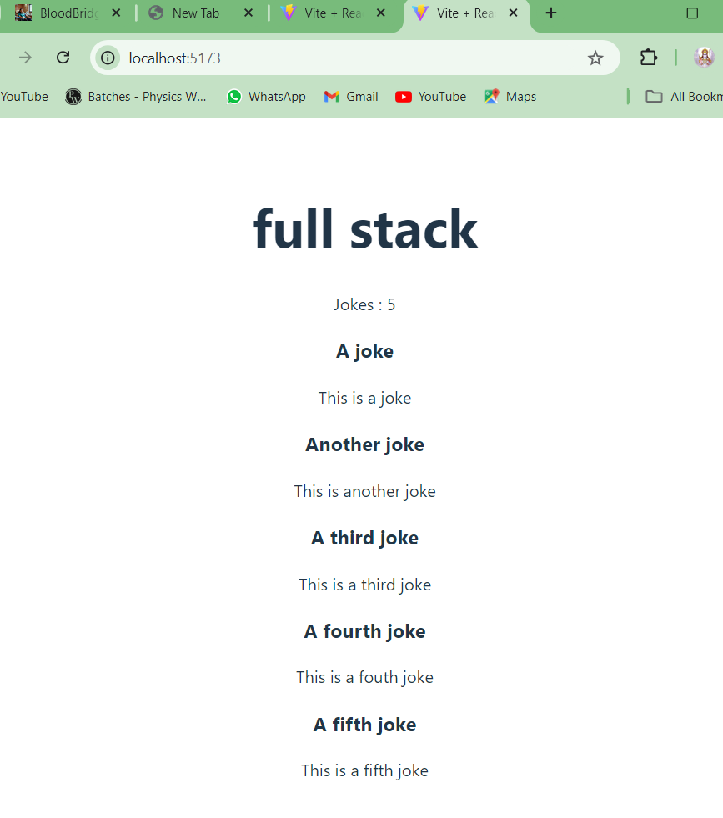

It save the server cost and work of frontend and backend

Fontend k change propagate nahi hote hai

Like <h1> chai and full stack | youtube </h1> //this change will not reflected

So it’s a bad practice , to reflect this change we have to again buil (npm run build )

* Local kuch na kerna sab cloud per store kerna
* Codesandbox
* Github codespaces
* Stackbitz

Ek jugha .model or ek jugha .models ye glt hai , ye inconsistency hai so it will generate a error

Mongoose shema banana me help kerta hai

import mongoose from "mongoose"

const userSchema = new mongoose.Schema({})

// mongoose k schema ko export kerne ka ek tarika , model ek method hai

// jo 2 parameter leta hai ki kya model banau(uska naam de do) kiske base per banau

export const User = mongoose.model("User" , userSchema)

mongoose.model("User" , userSchema) mongoose se model bante hai or ye model jab database se coonect ho jayega to ye file automatically run ho jayega or mongo db me ek structure designe ho jata hai

or jaise he ye data base me naam jata hai na like User to users(model in db converted singular to pular , upper case to lowercase)

example Todo -> todos

scheme me jo object hai na ushe me data rakte hai

import mongoose from "mongoose"

const userSchema = new mongoose.Schema(

  {

    username:String,

    email:String,

    isActive:Boolean

  }

  )

export const User = mongoose.model("User" , userSchema)

model just ask two question

Q1) what is the name of DataBase

Q2)kiske basis per schema banana

These Three Line are used for designe

L1)import mongoose from 'mongoose'

L2)const subTodoSchema = new mongoose.Schema({} , {timestamps: true })

L3)export const SubTodo = mongoose.model("SubTodo" , subTodoSchema);

# ***Sheriyans coding school Backend***

Java script se backend ni ban skta hai

Bcoz JS me wo functionality he nahi hai jisee backend banta hai

V8 engine chrome browser jaha pura JS ka code chalta hai , us code base ko ham engine kehte hai

Or wo engine hai V8

But v8 ka c++ me likha hua hai but ham JS ki help se server banana chate hai

So v8 engine k code WRAPED ker dete hai Js k code se

To ager ham koi Js me code kerte hai to wo jayega Js K code par fir wraped JS code c++ me convert kerke v8 Engine ko de deta hai jisse server banta hai

Hum js ka code Likhenge jo ki Wrapper layer of js recive kerege and wo code V8 engine ke c++ module ke sath ek server create krega

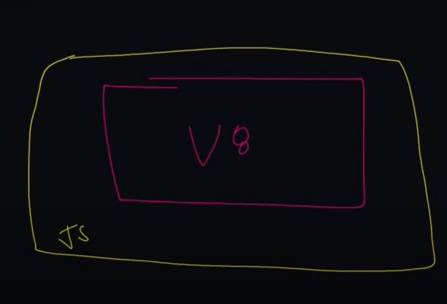

The Upper diagram is whole thing is Node JS

NodeJs is JS runtime environment

Ap JS se server ni create nahi kar skte hai but Node JS ek wrapper hai or ye cheez apke liye backend bana skte hai jab tak ye chalege

* npm Init –y means apse koi question nahi puchega but

If I use npm init mtlb ki apse question pucha jayega like apke file ka name

Nodejs -> doc -> **file system** -> call back API

ESM :- ecma script module

Some call backAPI

* writefile
* append file
* copyfile
* rename
* unlink

**fs.writeFile(file, data/options, callback)**

*const fs = require('fs'); // fs naam k variable me sari fs ki properties lay le*

*fs.writeFile("hey.txt" , "hey hello kaise ho" , function(err){// hey.txt naam ki file me hey hello kaise ho daal do*

*if(err) console.log(err);// ager koi error ate hai to wo error print else done iska output express per he ayega naki browser per*

*else console.log("done");*

*})*

**In terminal**

**Write node script.js (mtlb ki node ki help se file run kar rahe hai )**

So according to code hey.txt ki file create hoge

Then append operation -> rename ->

rmdir =  to remove the directory , means you can delete the blank folder

by using recusive we can del the folder insted it is not a blank

fs.rmdir("./copy" ,{recursive:true}, function(err){

    if(err) console.log(err.message);

    else console.log("removed");

})

o/p comes…..

(node:9360) [DEP0147] DeprecationWarning: In future versions of Node.js, fs.rmdir(path, { recursive: true }) will be removed. Use fs.rm(path, { recursive: true }) instead

(Use `node --trace-deprecation ...` to show where the warning was created)

Removed.

**http and https**

protocols – rules

internet par kuchh bhi karne ke liye rules banaaye gaye hai unke dwaara jinhone internet banaaya hai , ab un rules follow kerna bhut jaruri hai , aur ye rule follow ho isliye ye rules app ke operating system(window , linux , mac) ke software mein pre installed aate hai..

**http :-**ye be ek protocol hai (Rule ) jisko follow kere bina ap internet per na he kuch bhej sakte ho (req) sakte ho na manga saktee ho…

if we don’t follow the http then we can’t use the internet

How we use http protocal ?

**http.createServer([options][, requestListener])**

const server = http.createServer(function(req , res){})

http.createServer(function(req , res){}) :- used to create the server

const server :- used to save the server

**NPM:-**

**Intial names as**:- node package manager , nodejs k jitne be package honge but baad me jake diff- diff or be pakage a gaye jo nodeJS k nahi thay , so due to popularity of npm name is doesn’t rename but it has no full form

**Intall ->** npm i packageka naam

Jab ap kisi be cheez ko install kerte hai to wo cheez dependencie ban jati hai

**Unistall ->** npm uninstall package name

**Install particular version :-** npm install [accessibility@3.0.9](mailto:accessibility@3.0.9)

**Node modules:-** ap jo be package install kerte ho like accessibility , or ager accessibility depend kerta hai abc package per to unka code node module me a jata hai

Like if we install express then node module become very large

**Dependencies :-** packages and pakages ki dependencies

**Devdependencies:-** aise package jo sirf development me kaam ayenge par jab app ban jayega or upload ho jayega (deploy) tab ham in package ko use nahi ker rahe honge

**Example** nodemon

Q) kabhi kabhi run nahi likte hai or kabhi kabhi run likte hai

* npm start

* npm run dev

* npm run concurrent

Ans )2 script hote hai start or test , ye do cheez operating system me mentioned rehte hai

To ap ja npm start ya npm test likte ho to system ko phele se pata rehta hai

Operating sys ki kudki table hote hai

Ager apne koi cammond likhi to use phele is table me dundenge ager mil gaya to execute kerenge werna nahi kerenge

Ap hamne likha ki npm start to wo mil gaya , mila kaise ? , ans :- jab node js and npm install kiya tha apne to un node or npm ne start , test apke window ya operating sys k table me daal diya tha (install ker diya tha)

npm start in terminal

Express.js Framework

_INTRODUCTION :- express js ek npm package hai

Ye ek frame work …..

**Framework** :- ye apko batata hai konse cheez kaise kerne hai or wo cheez waise he kerne padege , like earbud kaise use kerna hai wo uska framework

, ye apko flow deta hai or ishe flow me apko kaam kerna padega

Example of flow …..

Bath -> breakfast -> work -> lunch -> go home ->then go party ->sleep

Like apko ye code likna hai then wo cheez banana hai…

Individual cheeze ap kudki lik sakte ho …

Eshi cheez ko frame work kehte hai or ye angular me be hota hai that’s why it called angular framework or reactjs me framework nahi hota hai , react apko tools deta hai , react apko koi flow nahi deta ki aise he kerna padega

**Summary**

Framework = flow, waha ham flow k anusaar cheeze rakhenge , express ko reqire kerna hai , app.use set up kerna pade , route create kerna pade flow me to kerna he padega,but ham route me kya jayega wo kudka taye ker skte hai

**Expressjs :-** manages everything from reciving the req and giving the response

**ExpressJS ROLE:-**

* Req :- recive , process
* Data ko bher nikalna
* Get post req ko seprate kerna
* Blobs ko json me conversion kerna

Req -> server -> express accept the req to kya response jayega sab kuch express js hai

Example :-

Play youtube vdo (send req)-> system ->expressJS comes into play

const express = require('express')



const app = express()



app.length('/' , function(req , res){



    res.send("hello World")



})

app.listen(3000)



**UNDER CODE Line by Line**

**Const express = require(‘express’);**

Yaha express constant to hai but usme ek function store hai or us function ko ham chala dete hai or jab wo function chalta hai to wo har cheez ker skta hai jo express kar skta hai

**const app = express();** ( function chalaya)

Express ki sare power us variable(app) me a jate hai

//routes create

Domain wala part chodo uske baad wala sara part route hota hai

i.e. Youtube/history/hest , Youtube = Domain else left part is route

**app.get(route , requestHandler )**

**requestHandler**:- ye ek middle ware hai

app.get(“/”,function(req, res){

res.send(“champion mera anuj “)

})

app.listen(3000)

isko likhe bina code nahi chalega

ab code brower per run hoga but ager koi be change kerte hai to server ko restart kerna padta hai

so for that install :-

**npm i nodemon -g**

**-g means global version**

**nodemon script.js**

means ye real time changes ko render kerta hai view port (browser per)

**Middleware:-**

Apne route ko chalne k phle ap ager kuch perform kerna chte ho that is all about middleware

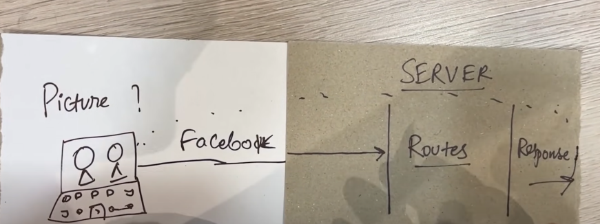

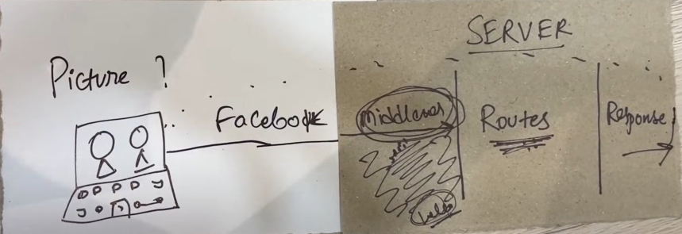

Jab be server request accept kerta hai , waha se route ke beech pahuchne tak Ager ap us request ko beech me rokte ho and kuch perform kerte ho, to ye element middleware kehlata hai ..

Server accept req -> element (middleware)-> print info like which client req is coming ->route-> route ko pata chal jayega user kon hai

Middleware lagne k 2 tarike hai

1. app.get k phele ye likhe , ye har request k phele chalega

app.use(function(req , res,next));

this function have three parameter

like brower se /about ki request gaye hai jo server code se accepted hai 

fir jayege wo app.use ()me

means /about phele nahi chalega phle app.use () chalege or uske function execute hone k baad route per jayegaa

* but ek dekat hoge function likne k baad hoge like browser load he hota rahegaa

like as a user ap request bhejte ho ki /about dena to wo req server code accept kerta hai fir wo req middle ware k pass jati hai but middle se req agee forward nahi hui ishi liye use next();

**next() :-** apka kaam ho gaya hai ab request agee forward ker de

**app.use(function(req , res,next){**

**console.log("middleware chal gaya!!!");**

**next();**

**});**

Ap app.use() kitne he bana skte ho

App.get() :- Ager wahi route hai tab chalao

NOTE

Frontend -> Backend -> frontend

url per cheeze likhe (url req) -> go to backend -> frontent(response)

**Error handling :-**

app.use((err , req , res , next)=>{

console.error(err.stack)

res.status(500).send(‘something broke!’)

})

**Form handling**

Handle backend process of form and making sure the data coming from any frontend lib , framework , templating engine , we still handle it at the backend process._.

**npm i cookie-parser**

**session cookie :-**

website par jake kehte ho ki hame ye photo do but wo website kehte hai ki phale login kero

login karne k turant baad website ne apko photo de de or website k photo dene k baad server or ap disconnect ho jate ho or server ko nahi pata hota ki ap kon hai …

ager koi be activity kerte ho waha jaise ki like the post , comment etc to firse login kerna padega jo bhut frustrating ho skta hai so for that we need session and cookie

Ham log kuch be data frontend par browser per rakh skte hai and jab bhi app kuchh bhi request backend par karoge wo frontend par saved data automatically backend par chala jayega

It is mainly used for the login purpose

like

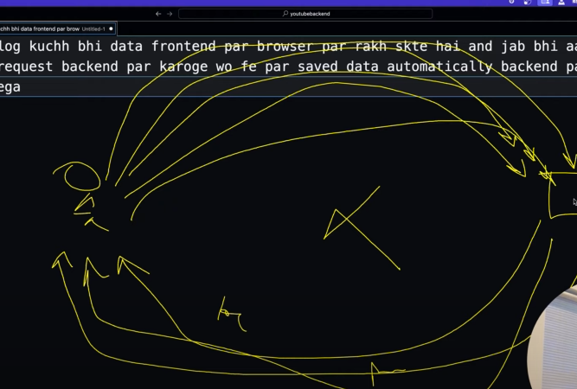

Login again

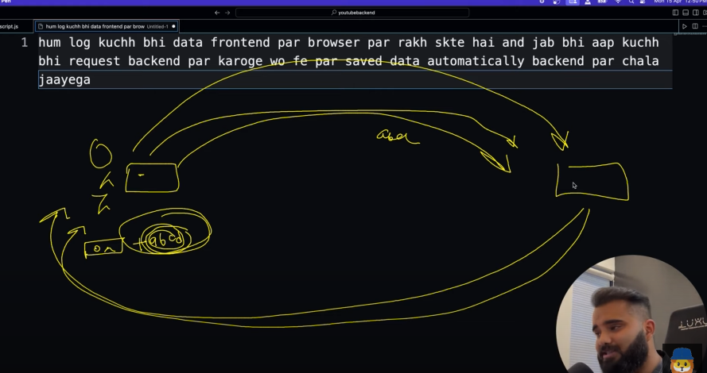

Server ne string de , ab kuch be bolna ya req

Kerna to last me ye rahe …

(server phele login per save ker leata h user ko or return me koi string deta hai let abcd)

Req be like :- ap kya kerte ho abcd

-apki age kya hai abcd

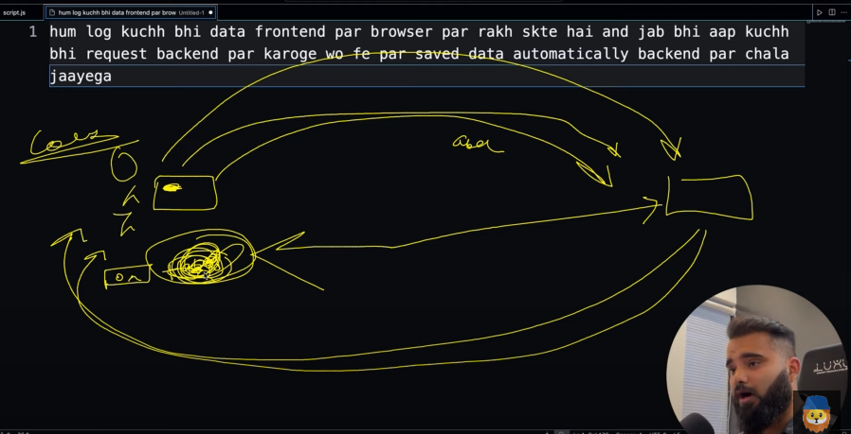

Login :- session stat

logout :- Session ENDS

app.use:- iska mtlb hai ki ap middle ware use ker rahe

**form data ->BLOB -> server**

so jo data from ka server per jata hai wo convert ho jata hai another form me called **blob**  (unreadable stream)

frontend data jo backend per jata hai wo stream me jata hai

apke browser ki information wo har cheez jo server pe jane chaiye ( browser info , ip info , desktop info , location etc)wo sab ek rayta bana hua hai (sab mixed up hai ) that is called **BLOB**

Tumne to bheja tha plain text par server ko mila blob which is not directly readable

Ab is cheej ko handle karna padega ki hum us blob ko wapus se readable kar sake so we use below two lines

***app.use(express.json());*** // json based data ko reable kerege

***app.use(express.urlencoded({extended:true}))*** // use when data accepted on backend ….

Above two lines are parser and they are not body parser

**Minor project (part-6)**

Setting up parser for form

Setting up ejs for ejs pages

EJS:-

Ejs html ki terha hota hai bilkul but uske ander calculation perform kar skte ho dynamic stuff lik sakte ho

*<h1>2+2</h1> o/p = 4*

But in Html it is not possible to calculate

**npm i ejs (install ejs )**

**app.set('view engine' , 'ejs'); (set up ejs as a view engine )**

iska mtlb apka backend kya render(show ) karega ? EJS pages show karega

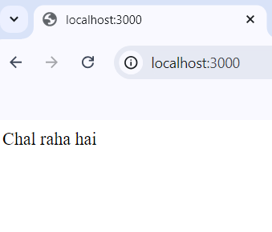

Ab is terha k output lane ki jarurat nahi routes per