Dastur berilishi



1-misol

Dastur kodi:

#include <iostream>

#include <list>

#include <ios>

using namespace std;

void print(int& v){

cout<<v<<" ";

}

int maxList(int v[],int n){

int small, big;

big = small = v[0];

for (int i = 0; i < n; i++)

{

if(v[i] > big)

{

big = v[i];

}

} return big;

}

int main(){

int n;

cin>>n;

int v[n];

list<int> a;

cout<<"Qiymatlarni kiriting :\n";

for(int i=0;i<n;i++){

cin>>v[i];

a.push_back(v[i]);

}

cout << "Ro'yxatdagi eng katta element " <<maxList(v,n)<< endl;

return 0;

}

Dastur natijasi:

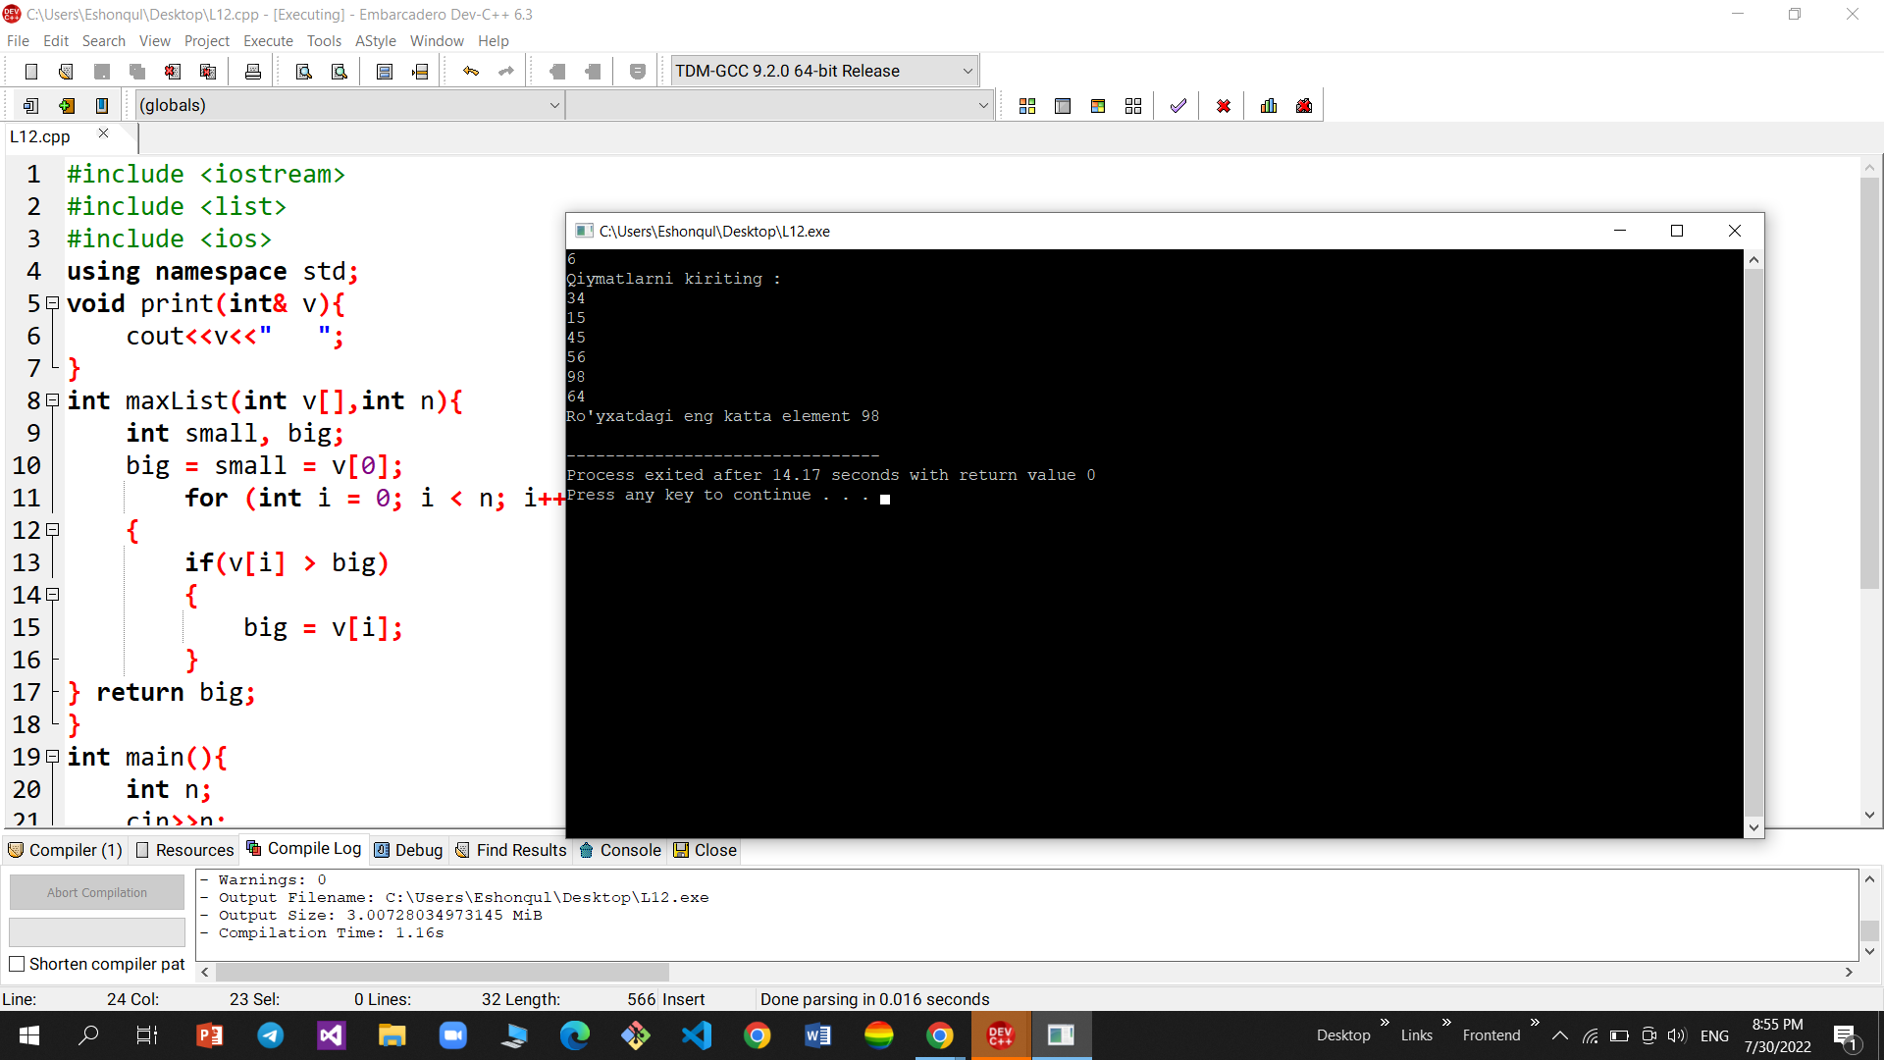

2-misol:

Dastur berilishi



Dastur codi:

#include <iostream>

#include <time.h>

#include <queue>

using namespace std;

int main()

{

int n;

srand(time(0));

queue <int> que;

cout<<"Manba navbati:"<< endl;

for (int i = 0; i <= 25; i++)

{

n = rand() % 100;

que.push(n);

cout << n << " ";

}

cout <<endl;

cout << endl;

cout << "O'zgartirilgan navbat:" << endl;

for (int j = 0; j <= 25; j++)

{

n= que.front();

if (n % 2 == 1)

{

cout << n << " ";

} que.pop();

}

system("pause");

}

Dastur natijasi: 