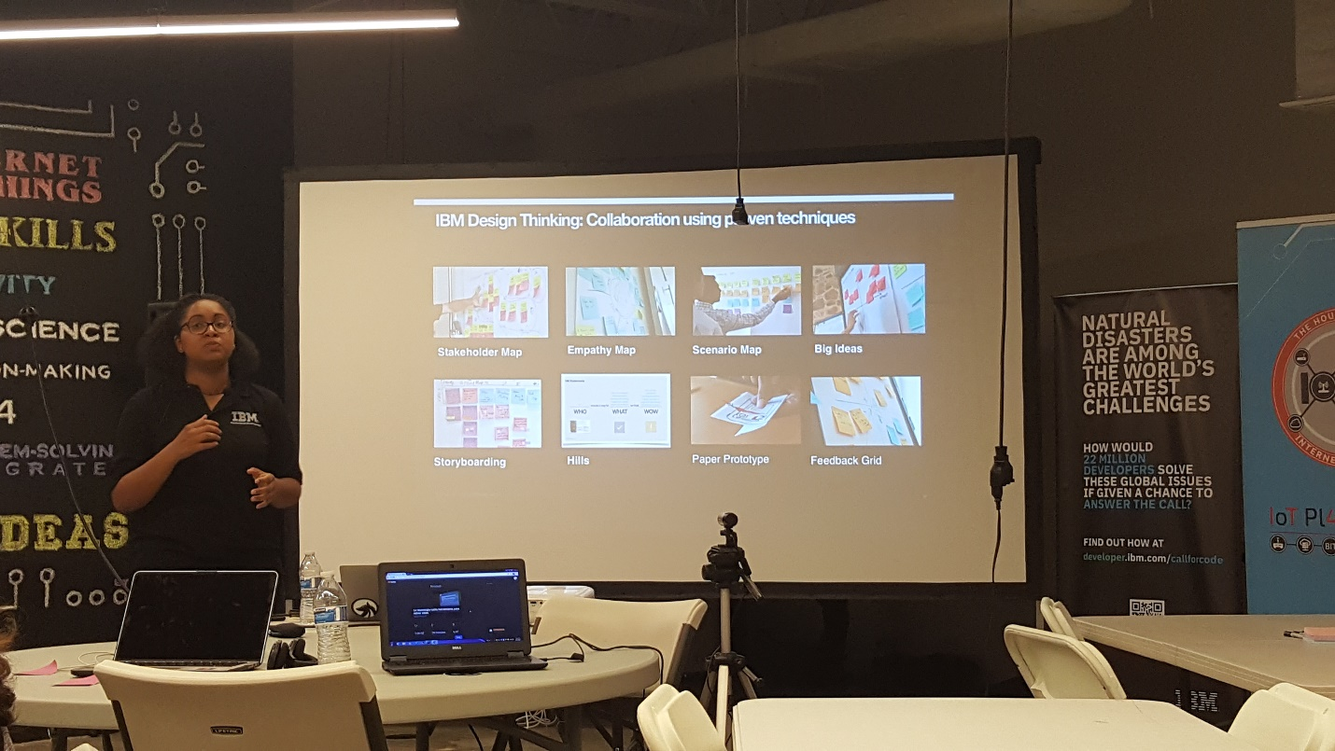

1. IBM trainer on design thinking

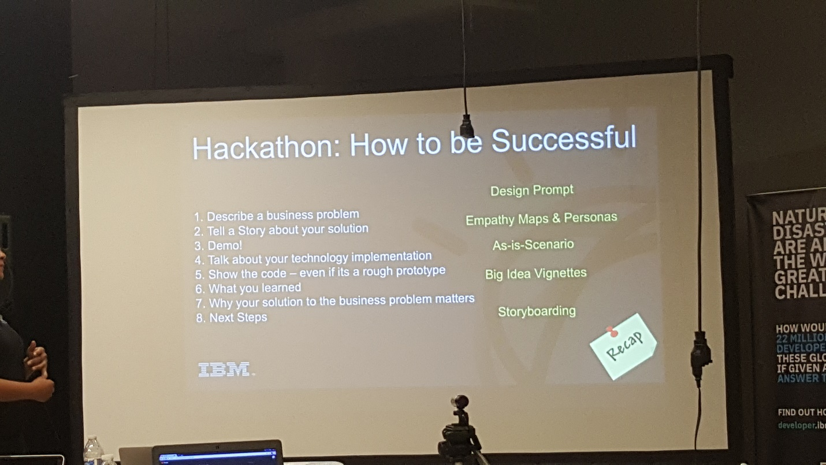

1. Qualitative themes for successful solution hacking

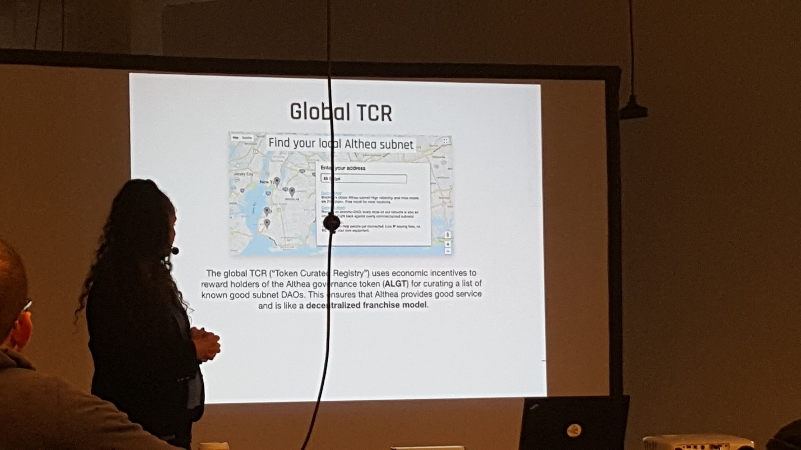

3. Althea Net - based out of Oregon (info about hardware performance with Althea MeshNet; each "down" is a data request transaction paid in bitcoin currency for jumping from antennae-to-antennae until internet is reached)

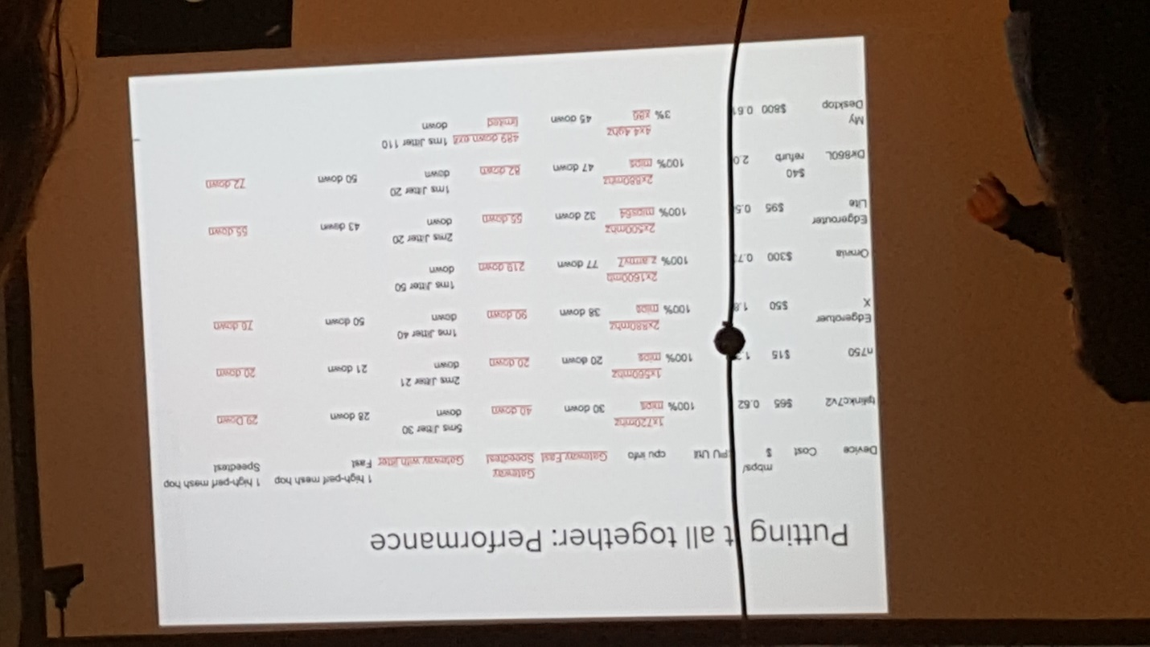

4. Althea Net (info about finding nearby Althea MeshNets and the user becomes a data purchaser or provider)

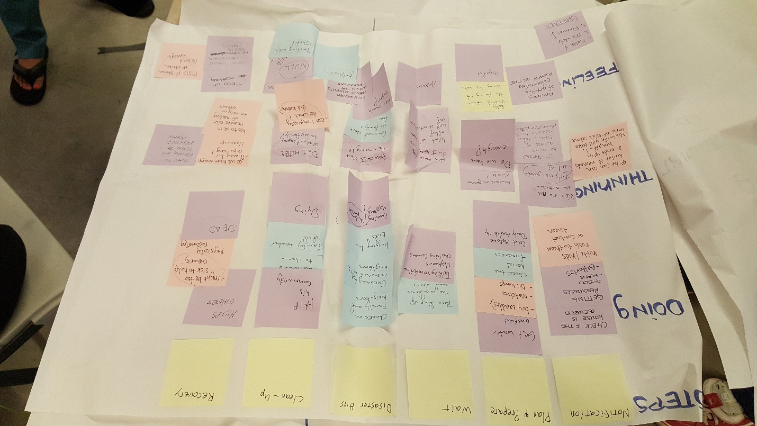

5. Empathy map (the first general one)

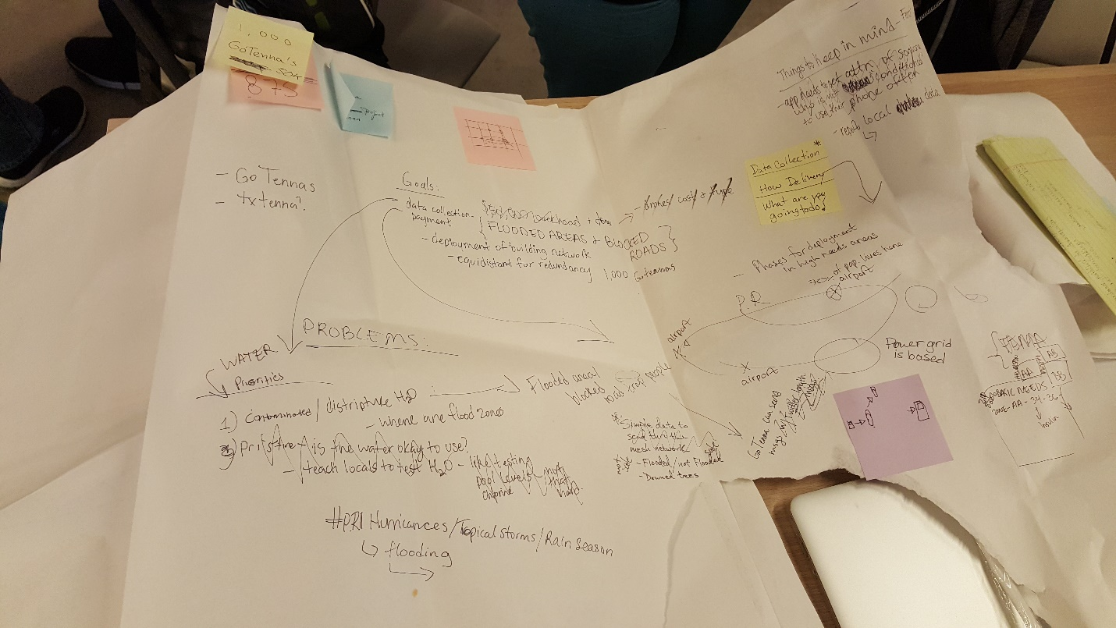

6. Empathy map (the second one to refine the scope with emoji text)

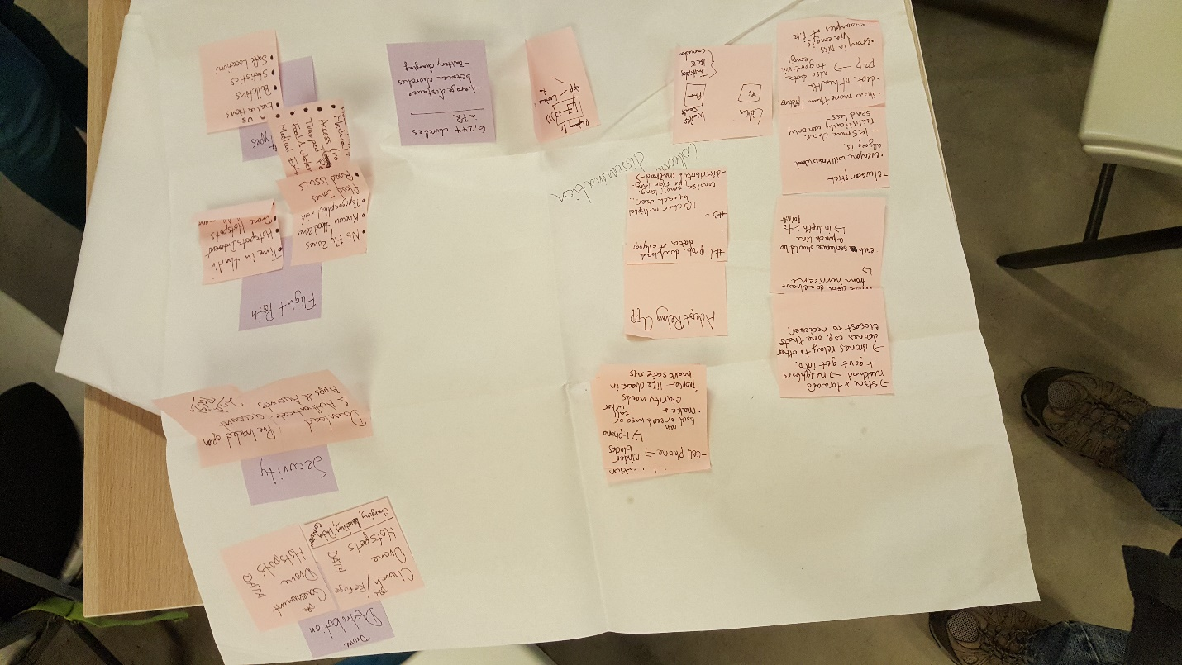

7. All previous plans hit walls, so let's try again. Another empathy map.

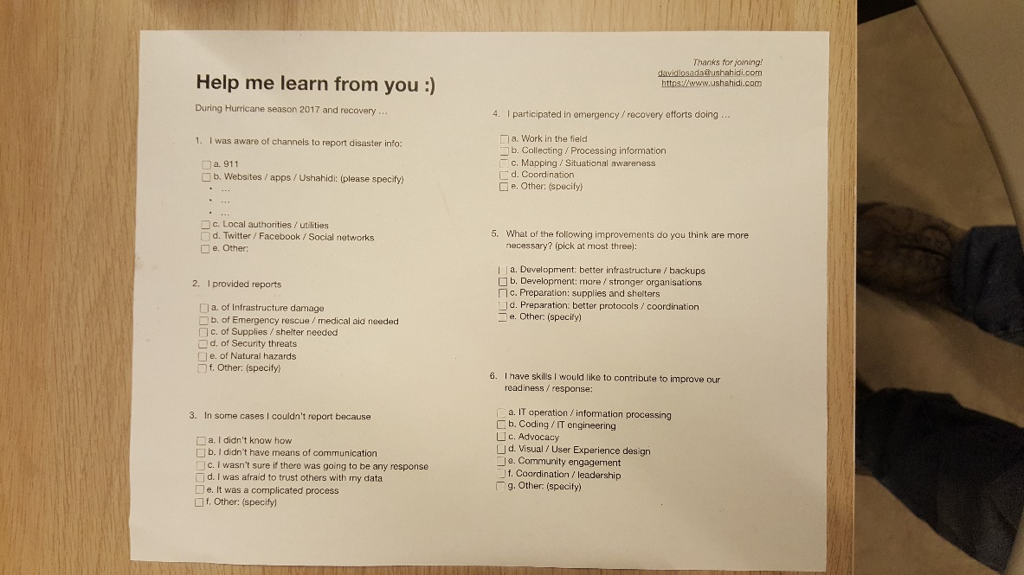

8. Ushahidi sample questionnaire that was distributed and discussed on the last day (too late in the game. We were presenting project presentations later that day)