

INTRO TO CS

TASK 8

Name: Eslam Yasser Fathy Amine.

id:  4221029

Webpage

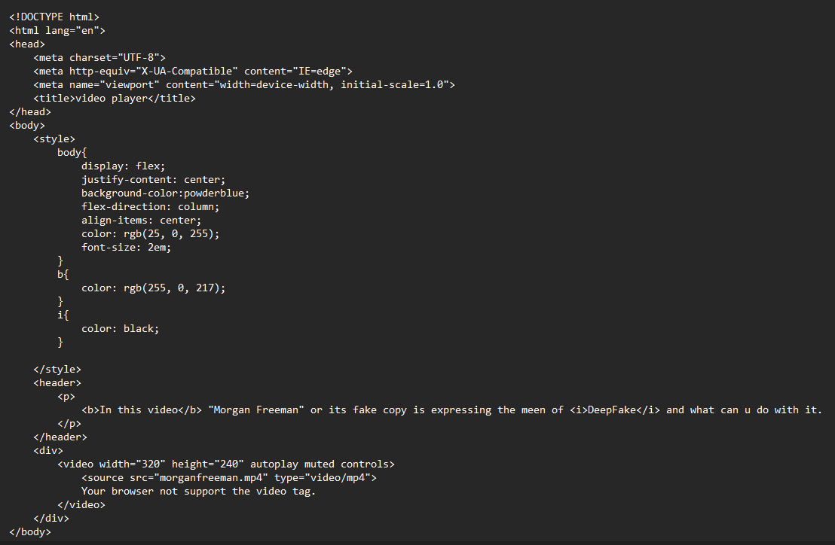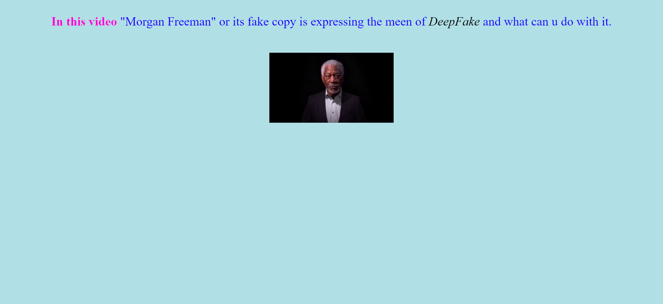

HTML