

INTRO TO CS

TASK 9

Name: Eslam yasser fathy amine

id:  4221029

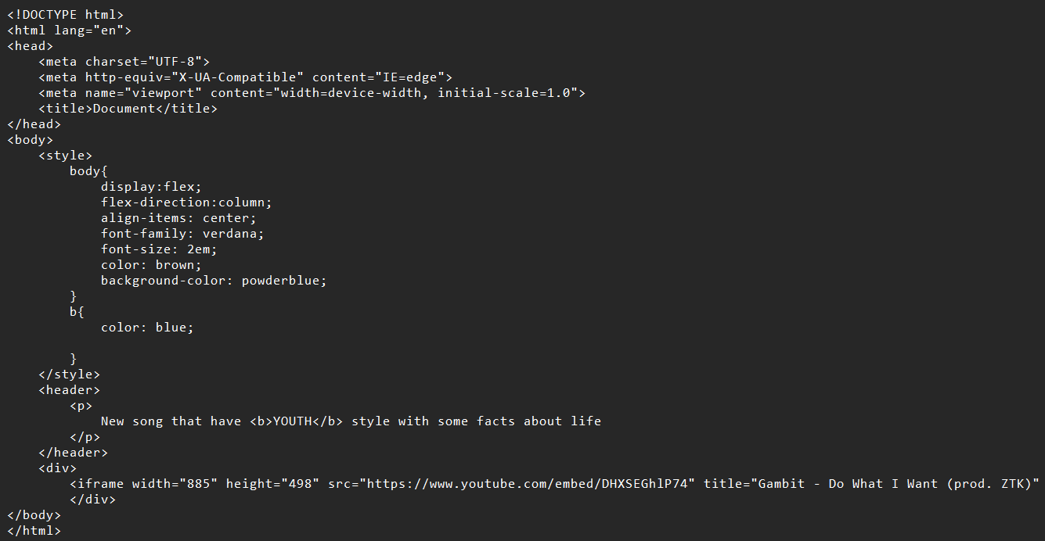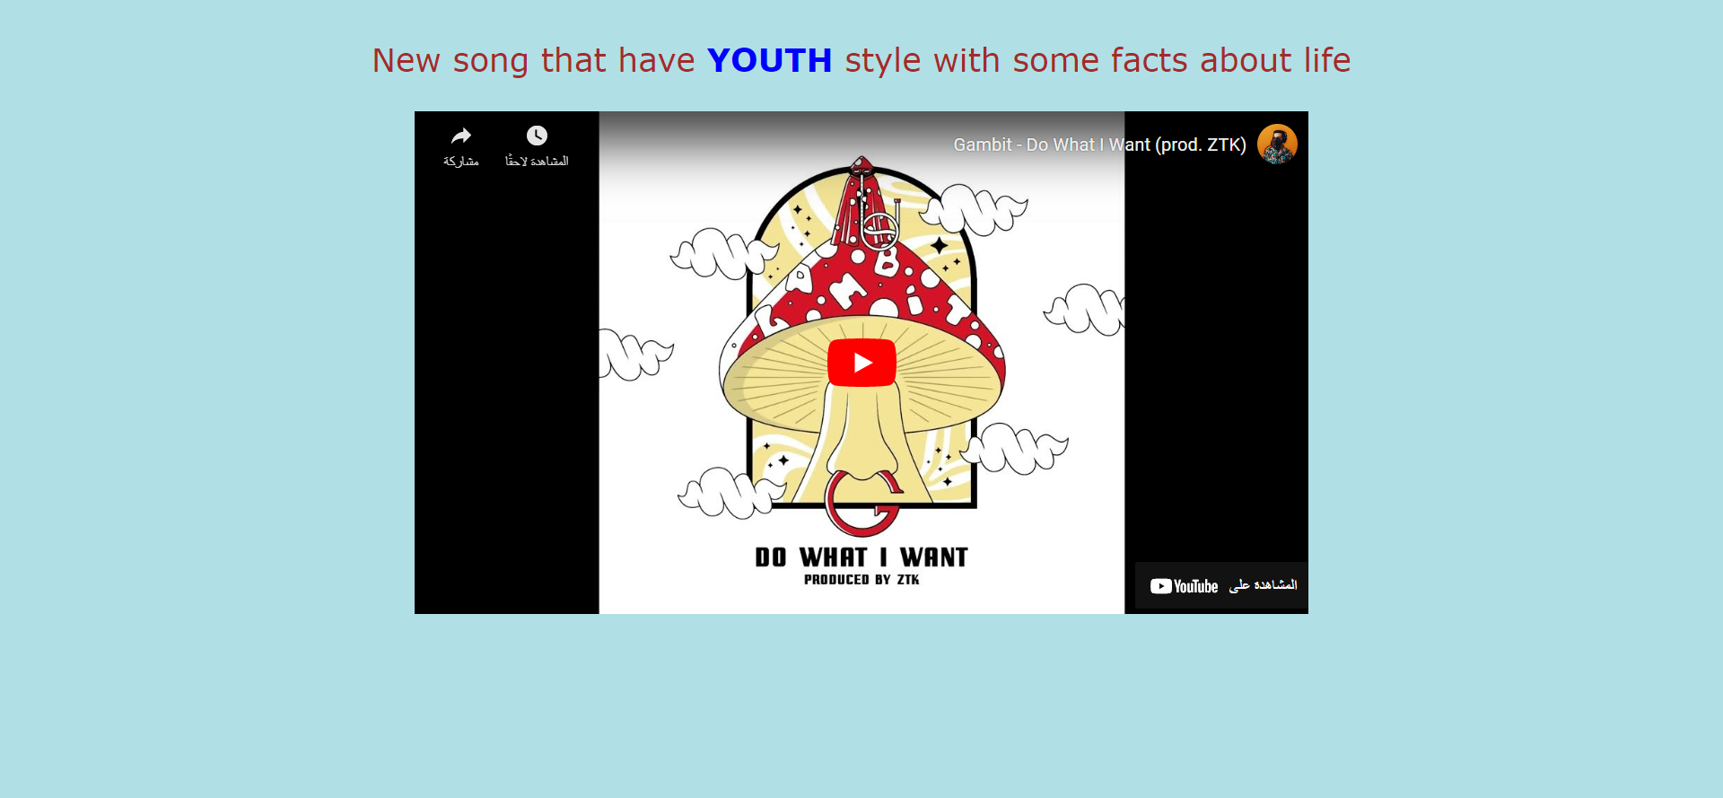

HTML

Webpage