FROM OFFLINE FUSION TO ONLINE DEPLOYMENT: ANOMALY DETECTION ON A UR10e COBOT

Adı SOYADI^{1*}, Adı SOYADI² (Dergi editörlüğü tarafından basım aşamasında yazılacaktır.)
1 Yazar 1 Adresi, ORCID No : https://orcid.org/
2 Yazar 2 Adresi, ORCID No : https://orcid.org/

Keywords | Abstract
Anomaly detection  Collaborative robots  LSTM autoencoder  Score-level fusion  Real-time deployment | Early detection of anomalies in collaborative robots matters for operator safety and production continuity. Previous work introduced a score-level fusion of a physics-informed residual autoencoder and a data-driven raw signal autoencoder, evaluated entirely offline. This paper reports the path from that result to a detector running on a physical UR10e cell. The pipeline was rebuilt and audited at measurement level; seven findings are documented, the decisive one being that the driver writes motor current, not torque, into the effort field, so the previously published figures came from a mixed-unit pipeline. That arrangement is reproduced explicitly and a corrected pipeline is rebuilt on 600 continuous runs. Under the original protocol fusion still outperforms both single models (F1 0.792 against 0.613 and 0.579) and the fault-type asymmetry motivating it is preserved. Reporting the evaluation split separately, however, shows that four fifths of the evaluation windows were also training windows, and that on windows never seen in training the two models exchange roles. The detector was then implemented as a 500 Hz ROS 2 node and commissioned on the robot over a two-hour session covering two production use cases with manually provoked anomalies. The threshold derived from offline data proved seven times too low, because the residual is pose dependent and spans three orders of magnitude across operating regimes, and the adaptive alarm rule that helped offline caught no verified event. The threshold was re-measured from all logged decisions, after which the detector raises no false alarm in 37 minutes of autonomous operation.
Research Article | Received / Geliş : Accepted / Kabul :

ÇEVRİMDIŞI BİRLEŞİMDEN ÇEVRİMİÇİ GERÇEKLEMEYE UR10e ANOMALİ TESPİTİ

Anahtar Kelimeler | Öz
Anomali tespiti  İşbirlikçi robotlar  LSTM özkodlayıcı  Skor birleşimi  Gerçek zamanlı sistem | İşbirlikçi robotlarda anomalilerin erken tespiti operatör güvenliği ve üretim sürekliliği açısından kritiktir. Önceki çalışmada, fizik tabanlı bir kalıntı özkodlayıcısı ile veri güdümlü bir ham sinyal özkodlayıcısının skor düzeyinde birleşimi sunulmuş ve yalnızca çevrimdışı değerlendirilmişti. Bu makale, o sonuçtan gerçek bir UR10e hücresinde çalışan dedektöre uzanan sürecin tamamını aktarmaktadır. Hat yeniden kurulmuş ve ölçüm düzeyinde denetlenmiştir; yedi bulgu belgelenmiş olup belirleyici olanı, robot sürücüsünün effort alanına tork değil motor akımı yazmasıdır — daha önce yayımlanan sayılar birimleri karışık bir hattan gelmektedir. Bu düzen açıkça yeniden üretilmiş, düzeltilmiş ve sızıntısız hat 600 kesintisiz koşu üzerinde kurulmuştur. Özgün değerlendirme protokolü altında birleşim iki tekil modeli de geçmekte (F1 0,792'ye karşılık 0,613 ve 0,579) ve arıza tipi asimetrisi korunmaktadır. Buna karşılık bölünme ayrı raporlandığında, değerlendirme pencerelerinin beşte dördünün aynı zamanda eğitim penceresi olduğu ve hiç görülmemiş pencerelerde iki modelin rollerini değiştirdiği görülmektedir. Dedektör ardından 500 Hz'lik bir ROS 2 düğümü olarak gerçeklenmiş ve iki üretim senaryosunun elle kışkırtılan anomalilerle koşturulduğu iki saatlik bir oturumda devreye alınmıştır. Çevrimdışı veriden türetilen eşik gerçek donanımda yedi kat düşük kalmıştır; sebebi kalıntının poza bağlı olması ve rejimler arasında üç büyüklük mertebesi değişmesidir. Çevrimdışı ortamda yardımcı olan uyarlanabilir kural doğrulanmış hiçbir olayı yakalamamıştır. Eşik tüm karar kayıtlarından yeniden ölçülmüş, sonrasında dedektör 37 dakikalık otonom çalışmada tek bir yanlış alarm üretmemiştir.
Araştırma Makalesi | Received / Geliş : Accepted / Kabul :

1. Introduction
Collaborative robots share their working volume with human operators, so anomalies such as a collision, a degrading motor or a failing sensor have to be detected before they become incidents. Two families of methods dominate. Physics-based residual methods compare a dynamic model of the robot with the measured forces and treat the difference as a fault indicator; they reduce dimensionality and suppress noise, but they also suppress low-amplitude sensor anomalies. Data-driven methods learn complex patterns directly from high-dimensional raw signals, but they lack the structure a physical model provides. The two families therefore fail on different fault types, and that asymmetry can be exploited by fusing them.
In earlier work we proposed exactly such a fusion for a UR10e cobot (Yılmaz, Kahraman, Yılmaz, Yavuz and Yayan, 2026). A residual Long Short-Term Memory (LSTM) autoencoder operating on twelve intrinsic and extrinsic residual channels derived from a Functional Mock-up Unit (FMU) inverse dynamics model was combined, at score level, with a raw LSTM autoencoder operating on twenty-four direct sensor channels. That study was evaluated entirely offline on a recorded dataset, and its own future-work list named a single most important open item: running the system online and simultaneously with the robot.
This paper closes that item and presents a comprehensive empirical analysis of the costs incurred by the transfer. The pipeline was rebuilt from scratch, audited against the original at measurement level rather than at claim level, corrected where the audit found defects, implemented as a real-time Robot Operating System 2 (ROS 2) node, and commissioned on a physical UR10e cell. Every stage produced measurements that do not appear in the offline literature, and some of them invert conclusions that the offline evaluation had supported.
The gap this study fills is therefore not a new architecture. Fusion frameworks for robot anomaly detection are numerous and are almost always evaluated on recorded data with injected faults. What is rarely reported is which parts of such a framework survive contact with hardware: whether the operating threshold transfers, whether the normalisation is even causal, whether the auxiliary decision rules still help, and what the residual actually does when the arm changes pose. This paper reports those measurements for one complete system.
The contributions are:
• an audit of an independently rebuilt pipeline against the reference study, documenting seven measurable findings, of which five were corrected, one was deliberately accepted and one is a typesetting inconsistency;
• an explicit reproduction of the data path from which the previously published figures originate, together with a corrected, physically consistent and leakage-free pipeline and its re-evaluation;
• a causal formulation of the fusion normalisation and an operating threshold for the fused score, neither of which the offline method defines;
• a real-time ROS 2 implementation whose feature engine is numerically identical to the offline pipeline, with a measured latency budget;
• a commissioning report from a physical UR10e cell in which the simulation-derived threshold is shown to be seven times too low, the residual is shown to be pose dependent over three orders of magnitude, and the adaptive alarm rule is shown to invert its usefulness.
The remainder of the paper is organised as follows. Section 2 reviews the related literature. Section 3 describes the platform, the data, the audit and the corrected pipeline, and the online implementation. Section 4 presents the offline and the real-cell findings. Section 5 discusses them and states the limitations, and Section 6 concludes.
2. Literature Review
Physics-based detection for manipulators is a mature field. Haddadin, De Luca and Albu-Schäffer (2017) survey collision detection, isolation and identification and establish the residual observer as the canonical tool. Li, Han and Xiong (2020) place a force/torque sensor at the bedplate and detect collisions from the resulting residual, while Zhang, Chen and Zou (2024) use an external torque observer for the same purpose. Katsampiris-Salgado et al. (2024) address high-payload collaborative assembly, where the model error itself becomes the limiting factor. The common weakness of this family is that whatever the model does not represent — friction, payload, joint elasticity — is indistinguishable from a fault, and whatever the model filters well is also filtered away when it is the fault.
Data-driven detection for multivariate time series is surveyed by Darban, Webb, Pan, Aggarwal and Salehi (2024). Reconstruction-based autoencoders are the dominant design: Malhotra, Vig, Shroff and Agarwal (2015) introduced LSTM networks for time-series anomaly detection, and Malhotra, Ramakrishnan, Anand, Vig, Agarwal and Shroff (2016) extended the idea to a multi-sensor encoder–decoder. Park, Hoshi and Kemp (2018) applied an LSTM-based variational autoencoder to robot-assisted feeding, one of the few studies to report on a physical robot. These methods need no fault labels, but they inherit whatever bias the training distribution carries.
Hybrid approaches attempt to combine the two. Liu et al. (2025) constrain an LSTM autoencoder with mechanism knowledge for pump operations, but do not study the fusion of two separate models' scores. Huang, Chen, Deng and Huang (2024) apply graph attention and a Transformer to multivariate anomaly detection without any physics-based preprocessing stage. Correia, Goos, Klein, Bäck and Kononova (2024) survey online model-based anomaly detection specifically, and identify threshold selection and non-stationary operating conditions as open research challenges — precisely the two problems that this paper measures on hardware.
The transfer of a model calibrated on simulated or recorded data to a physical robot is studied mostly in the control and reinforcement learning literature, where it is known as the reality gap (Zhao, Queralta and Westerlund, 2020). For anomaly detection the equivalent question — does the decision threshold transfer? — is seldom asked, because most studies never define an operating threshold at all, reporting instead the best achievable F1 over all thresholds. That statistic requires the labels it is supposed to predict and therefore does not exist online. The present study makes this gap explicit and closes it with a causal threshold rule, then measures what happens when the rule is applied to real hardware.
3. Method
3.1. Platform And Data Collection
Experiments were carried out on a robotic quality inspection platform consisting of a Universal Robots UR10e collaborative robot (six joints, 12.5 kg payload) mounted on a Festo linear axis, together with an inspection chassis frame, shown in Figure 1. The target application is automated visual quality inspection of automotive body panels. A force/torque sensor (FTS) is mounted at the end effector. The cell runs ROS 2 Humble with MoveIt 2, and the recorded motions were produced by eleven different motion planning algorithms so that the normal operating distribution is not dominated by a single planner.
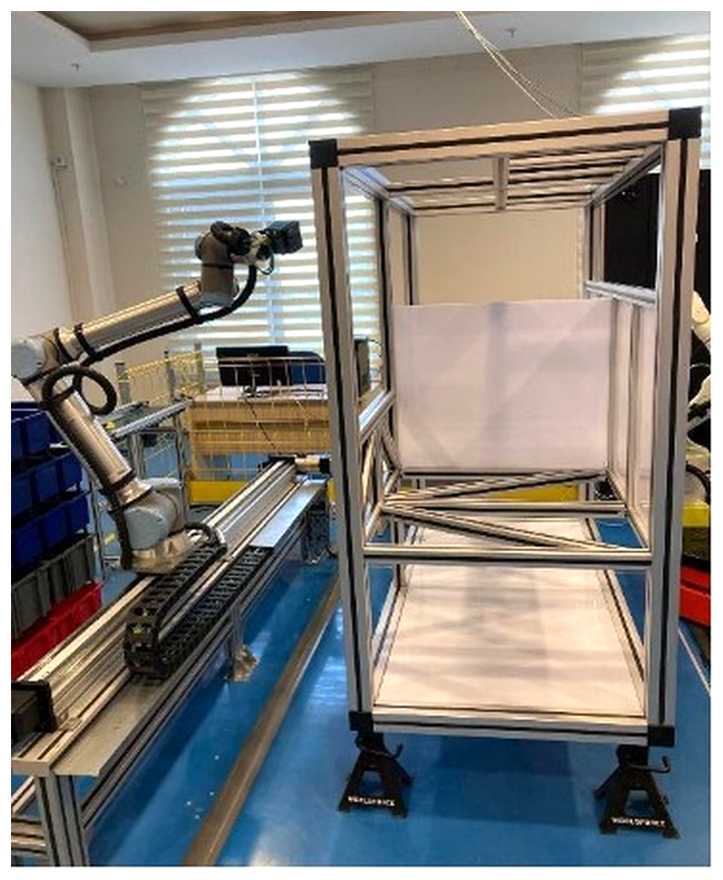
Figure 1. Robotic Quality Inspection Platform UR10e robot on a Festo linear axis, with the inspection chassis frame on the right.
The source dataset is a 79-day export of joint states and wrench measurements, 1,124,432 samples nominally at 500 Hz. Model training was performed on a laptop with an Intel Core i7-13650HX processor and an NVIDIA RTX 4060 GPU; the deployment workstation is an Intel Core i9-14900 with 64 GB of memory and an NVIDIA RTX 4000 Ada GPU.
The study uses no human subjects and required no ethics committee approval. All measurements were collected on laboratory equipment of the ESOGÜ Intelligent Systems Application and Research Centre, and the principles of research and publication ethics were observed throughout. The anomalies of the commissioning campaign were provoked deliberately by trained operators at reduced speed, with the robot's own protective-stop function active at all times; one of them, reported in Section 4.7, involved an operator's hand being caught between two links, and the protective stop halted the robot without injury.
3.2. Data Investigation And Preparation
The first stage of the audit was the data itself, and it produced the largest single correction. The export is not globally ordered by timestamp. Measured over the 1,124,432 samples, 321,841 consecutive pairs (28.6 %) are discontinuous, 96,107 of them with a negative or zero time step; the median step is the expected 2.00 ms but the range spans from −5.5·10⁹ ms to +3.6·10⁹ ms. Three quarters of the sliding windows (33,700 of 44,974, 74.9 %) therefore splice together two recording sessions that may be hours or days apart.
This matters twice. It puts an arbitrary jump in the middle of the dynamics an LSTM autoencoder is asked to learn, and it corrupts the joint acceleration. Acceleration is obtained from the velocity channel by a Savitzky–Golay derivative (window 51, order 3) (Savitzky and Golay, 1964), which is a convolution: across a splice it produces a non-physical spike. Since acceleration enters the inverse dynamics directly through the M(q)q̈ term, the error propagates into the residual. Measured on the same 200,000 samples, the standard deviation of q̈ derived across splices is two to six times larger than when the derivative is taken inside continuous runs.
The correction is to segment the export into physically continuous runs. Two consecutive samples belong to the same run only if the time step lies in (0, 8 ms] and the joint displacement stays below what the joint velocity limit allows over that step; the second condition catches gaps that a plausible-looking timestamp hides. Runs shorter than 150 samples are discarded, and each run is resampled onto a uniform 2 ms grid. Table 1 gives the outcome. The reduction in sample count is not a loss: the discarded samples are exactly those between which no physical continuity exists.
Table 1. Outcome Of Data Preparation.
Quantity | Value
Raw exported samples | 1,124,432
Physically continuous runs | 600
Prepared samples | 342,480 (685 s of robot time)
Interpolated samples | 5.02 %
Run length (median / min / max) | 227 / 155 / 35,860

3.3. Current-To-Torque Calibration
The UR ROS 2 driver writes the motor current, in amperes, into the effort field of the joint state message; the field is filled directly from the actual current reported by the controller. The inverse dynamics model, in contrast, produces newton metres. A conversion coefficient is therefore required before the residual of Equation (2) can be formed at all.
In a first rebuild this coefficient was obtained by regressing measured current on model torque, and verified by repeating the same regression. That verification is circular: the coefficient is chosen so as to satisfy the equality that is then tested. The coefficient was therefore re-derived from a source independent of the residual under test. When the robot is nearly at rest (|q̇| < 0.005 rad/s) the joint torque is dominated by gravity, so g(q) ≈ k·(i − i₀) with g(q) taken from the closed-form gravity vector rather than from the model being audited. Of 197,090 quasi-static samples, 65,697 entered the regression. Table 2 lists the result.
Table 2. Measured Current-To-Torque Coefficients And Their Sensitivity.
Joint | Nm/A | R² | Meas. | ρ −50 % | ρ +50 %
shoulder_pan | 10.522 | — | no | 0.968 | 0.995
shoulder_lift | 10.522 | 0.984 | yes | 0.162 | 0.637
elbow | 9.130 | 0.993 | yes | 0.023 | 0.758
wrist_1 | 3.409 | 0.000 | no | 0.890 | 0.968
wrist_2 | 3.409 | 0.012 | no | 0.957 | 0.993
wrist_3 | 3.409 | 0.010 | no | 0.994 | 0.999
R² is that of the quasi-static gravity regression and “Meas.” marks the joints on which the coefficient could be measured directly. The last two columns give the correlation between the intrinsic residual recomputed with the coefficient perturbed by ∓50 % and the nominal one, over all 342,480 prepared samples. Coefficients that could not be measured are copied within the same module family or scaled by the torque-limit ratio, and the node warns about them at start-up.
The consequence of the four assumed coefficients was measured rather than argued. Each coefficient was perturbed by ±50 % and the intrinsic residual recomputed, which requires no further evaluation of the inverse dynamics because the model torque is stored separately from the measurement. On the four joints whose coefficient could not be measured, the perturbation leaves the residual almost unchanged in shape: the correlation with the nominal residual is between 0.890 and 0.999 and the effect is close to a pure rescaling, with the standard deviation changing by factors of 0.55 to 1.45. Since the autoencoders standardise their inputs, a transformation of that form cannot alter the learned dynamics. On the two joints whose coefficient was measured, the same perturbation is destructive: the correlation falls to 0.162 for shoulder_lift and to 0.023 for the elbow at −50 %. The asymmetry is itself diagnostic. Where the current term carries the gravity torque that the model is meant to cancel, mis-scaling it destroys the cancellation; where the model contributes little, as at the wrists, the coefficient acts as a scale factor only. The assumed coefficients therefore affect the physical interpretation of a fault amplitude in newton metres rather than the detection performance.
3.4. Hybrid Residual Decomposition
The inverse dynamics model packages the Newton–Euler formulation of the UR10e in the Functional Mock-up Interface format (Blochwitz et al., 2011):

τ̂_model = M(q)·q̈ + C(q, q̇)·q̇ + g(q) (1)

The total residual is the difference between measurement and model,

r_total = τ_meas − τ̂_model (2)

the extrinsic residual is the projection of the end-effector wrench into joint space,

r_ext = J(q)ᵀ · F_FTS (3)

and the intrinsic residual is the difference of the two,

r_int = r_total − r_ext (4)

where M(q) is the inertia matrix, C(q, q̇) the Coriolis and centrifugal matrix, g(q) the gravity vector, J(q) the geometric Jacobian, τ_meas the measured joint torque and F_FTS the measured wrench. This decomposition makes r_int sensitive to internal faults such as motor degradation or an encoder glitch, and r_ext sensitive to external interaction such as a collision or a payload change. Because Equation (4) is a definition, the numerical consistency of the decomposition can be tested directly: over 200,000 samples the identity holds to a residue of 7.1·10⁻¹⁵, and the analytical Jacobian agrees with a numerical one to machine precision.
Equation (3) requires an agreement of reference frames whose violation produces no diagnostic. The UR e-Series driver rotates the wrench into the tool frame and publishes it with the tool frame identifier, whereas J(q) is defined in the base frame. Multiplying the two directly produces a wrong residual with no error message. Measured over 40,000 samples, the correlation between the correct and the unrotated extrinsic residual is −0.995 on the first joint — the sign inverts — and −0.143 across all channels; on the second joint the amplitude triples. Both force and moment halves are therefore rotated into the base frame before the Jacobian transfer, in the offline pipeline and in the online engine through the same code path.
One property of the solver was measured and deliberately not corrected. Over 500 random joint poses the inertia matrix is asymmetric in every pose and its symmetric part is not positive definite, the friction vector is identically zero and no payload model is present. The solver had been validated against the physical robot and was treated as fixed, so its cost is reported instead of repaired: on wrist_2 and wrist_3 the standard deviation of the model torque is only 10 % and 2 % of the measured torque (0.095 and 0.030 Nm against 0.959 and 1.246 Nm). In those two channels the residual is effectively the raw measurement and carries no model information.
3.5. Dual LSTM Autoencoders
Both models share a symmetric encoder–decoder architecture that compresses a sliding window of T = 100 samples (0.2 s) into a latent vector. A two-layer LSTM encoder reduces the input sequence to a fixed-size latent vector; the decoder repeats it over T steps and reconstructs it with symmetric LSTM layers. Dropout of 15 % is applied between layers. Both models are trained on normal operating data only, with a mean squared error loss, and the anomaly score of a window is its reconstruction error. Each model's own threshold is the 97th percentile of the reconstruction errors on the validation set.
Windowing uses a stride of 25 samples, that is 75 % overlap. Two rules are enforced jointly: no window may span two runs, and windows containing samples invalidated by the derivative edge margin are dropped. The train/validation split is made at 80 %, but the cut is aligned to the nearest run boundary. Without that alignment, overlapping windows of the same run fall into both sets and the validation loss is systematically optimistic. Table 3 reports the architectures and the training outcome.
Table 3. Model Architectures And Training Outcome On The Corrected Pipeline.
 | Residual AE | Raw AE
Input channels | 12 | 24
Hidden / latent | 128 / 32 | 256 / 64
Parameters | 478,892 | 1,907,032
Train / validation windows | 8,294 / 2,128 | 8,294 / 2,128
Best epoch (early stop) | 21 (46) | 22 (47)
Best validation loss | 0.582 | 0.930
Threshold θ (validation P97) | 1.6008 | 3.4461
Optimiser Adam (lr = 10⁻³, β = 0.9/0.999), batch size 256, gradient clipping at 1.0, ReduceLROnPlateau (factor 0.5, patience 8), early stopping with patience 25 over at most 300 epochs; both models were trained once, with a fixed seed, in under five minutes each on the RTX 4060 laptop. The thresholds exceed those of the reference study (0.420 and 0.854) because the residuals are now on a true newton-metre scale.
3.6. Score-Level Fusion And Causal Normalisation
The normalised scores of the two models are combined by a weighted average,

S_fused = w_res · z_res + w_raw · z_raw (5)

with w_res + w_raw = 1 and the weight w_res swept over [0, 1] in steps of 0.05. The reference study normalises each score by a min–max transform whose bounds come from the fault-injected test set. That is not usable online for two reasons: the bounds contain future maxima, and those maxima are never seen in normal operation. Measured consequence: because the test-set maxima are 4341 and 7752, the entire normal operating range compresses to the order of 10⁻⁴, the fused threshold becomes stricter than either single threshold, and motor drift and encoder glitches are never detected at all.
Both normalisations are affine, so the online engine implements a single code path,

z = (S − lo) / span (6)

and two causal candidates for (lo, span) were measured against each other: the scale z = S/θ, and the reference study's own min–max formula with the bounds taken from clean validation windows rather than from the test set. The two are practically equal (F1 0.791 against 0.792) and the second was chosen, because it keeps the published formula and reduces the deviation from the reference method to a change of bounding set only. The fused operating threshold is then obtained by extending the study's own rule to the fused score: it is the 97th percentile of the fused score on clean validation windows, which on the offline data gives θ = 0.6436 and the expected 3 % false-alarm rate.
3.7. Fault Injection And Evaluation Protocol
Ground-truth labels do not exist, so four synthetic fault scenarios are injected in measurement space, listed in Table 4. Joint 3 (elbow) and joint 5 (wrist 2) are chosen because they carry the largest gravity load and the widest motion range. A window is labelled anomalous when at least 10 % of its samples overlap the fault mask.
Table 4. Synthetic Fault Scenarios.
Scenario | Affected channel | Amplitude | Extent
Motor drift | Joint 3 torque, linear ramp | 15 Nm | 30–38 %
Collision | All FTS channels, Gaussian pulse | 30 N | centre 65 %
Encoder glitch | Joint 5 position, step | 1.5 rad | from 92 %
Sensor noise | All FTS channels, Gaussian noise | 3.5 N | 15–23 %
Sensor noise is deliberately kept at a low amplitude so that it affects the raw signal only; it is the scenario that tests complementarity. In the corrected pipeline the amplitudes are converted into measurement space through the calibration file, because the channels are genuinely in newton metres.
3.8. Reproducing The Reference Pipeline
Taken separately the audit findings are defects; taken together they form a consistent pattern, and that pattern is testable. The hypothesis is that the previously published numbers come from a pipeline with mixed units: τ_meas in amperes, τ̂_model in newton metres, r_ext in newton metres and computed with an unrotated wrench, the three subtracted directly, and fault amplitudes specified in newton metres added as bare numbers to ampere channels. A further finding compounds it: the residual generator zeroes the model torque on joints whose fit quality falls below a threshold, and under mixed units that guard fires on all six joints, silently reducing the residual to the measurement itself without any message.
The hypothesis makes a falsifiable prediction: rebuilt in that configuration, the signature findings of the reference study should return — specifically the blindness of the residual model to sensor noise and the roughly one-quarter share of anomalies detected by the residual model alone. The reproduction is scripted and was rerun for this paper; its result is reported in Section 4.5.
3.9. Online Implementation
The online system differs structurally from the offline pipeline in three ways, and its design is entirely the management of those three differences. Causality: nothing computed over a whole dataset may be used live. Time budget: at 500 Hz there are 2 ms per sample and, with a stride of 25, 50 ms per decision. Continuity: the offline pipeline may segment the data into runs, whereas the live system notices an interruption only after it has happened and must reset its state. Figure 2 shows the resulting data path.
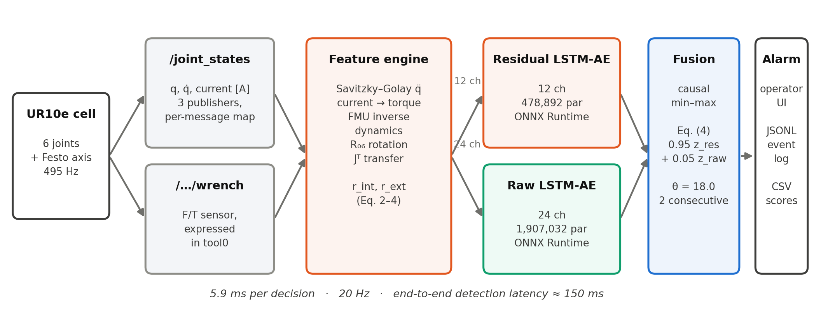
Figure 2. Data Path Of The Online Detector every stage between the robot and the alarm runs once per decision, twenty times a second.
The feature engine is the sample-by-sample equivalent of the offline computation. It keeps a 51-sample ring buffer and, for every new sample, emits the features of the sample at the centre of the buffer: the Savitzky–Golay derivative applied as an inner product with precomputed coefficients, the current-to-torque conversion, the inverse dynamics evaluation, the base-frame rotation and the Jacobian transfer. The centred derivative costs a structural delay of 25 samples (50 ms), which is the price of a noise-free acceleration and is identical to the offline definition.
Equivalence was verified rather than assumed. The prepared dataset was pushed through the online engine sample by sample and compared with the offline feature file: over 8 runs and 61,524 samples the largest absolute differences are 1.4·10⁻¹⁴ for torque, exactly zero for model torque, 8.0·10⁻¹⁵ for the total residual, 2.7·10⁻¹⁵ for the extrinsic and 8.9·10⁻¹⁵ for the intrinsic residual. These are floating-point rounding levels, so the deployed node sees the features the models were trained on, not merely similar ones.
Two optional rules were added on top of the reference method. An adaptive rule fires when the fused score exceeds median + k·1.4826·MAD of the last 600 decisions, where 1.4826·MAD is a robust estimate of the standard deviation (Leys, Ley, Klein, Bernard and Licata, 2013); it exists because an absolute threshold cannot see a fault that raises the score a hundredfold inside a run whose baseline sits far below that threshold. The scale is floored so that a nearly constant baseline does not make the rule hypersensitive, the baseline is frozen while an alarm lasts, and the freeze expires after 3 s so that a long alarm is treated as a regime change rather than as an attack. The second rule requires two consecutive decisions (100 ms) before an alarm is raised. Both can be switched off with a single parameter, which restores the reference behaviour exactly.
The detector is packaged as a ROS 2 node (Macenski, Foote, Gerkey, Lalancette and Woodall, 2022) that keeps the whole computation in a ROS-independent core; the node is a thin wrapper around it, so replay tests exercise the class the node actually runs. The models are exported to ONNX and executed with ONNX Runtime, with two threads per session so that a greedy inference cannot starve the 500 Hz callback loop. Every decision is written to a comma-separated log and every alarm to a line-buffered JSON-lines event log; these two files are the raw material from which the real-cell thresholds of Section 4.7 were re-measured.
Deployment surfaced three connection-layer measurements, all of them silent. The wrench topic advertised in the controller configuration is not the one the running broadcaster uses, and subscribing to the wrong name yields no wrench and therefore no score at all. The joint state topic carries three different name sets from three publishers, of which the UR data arrives in a seven-element set in scrambled order at about 112 non-UR messages per second; the joint mapping must therefore be resolved per message and cached per name set, since resolving it once and applying it blindly reads five of six channels from the wrong joints. Finally the measured sample rate is 495 Hz rather than 500 Hz, which the fixed-step derivative tolerates at the one per cent level.
3.10. Operator Interface
The detector was integrated into the laboratory's existing web dashboard as a third tab. A collector subscribes to the node's decision, alarm and score topics, keeps a 60-second ring buffer and pushes it to the browser at 5 Hz. Each collector runs its own single-threaded executor: in a first version both collectors used the shared global executor, two threads then raced on the same wait set, the node disappeared from the graph, the subscriptions received nothing and no error was printed.
Three interface decisions follow directly from measurements rather than from taste. Alarms are latched on the rising edge and held for five seconds, because the clearest verified real event of the campaign lasted 0.25 s — five decisions — and level sampling at 5 Hz misses it entirely; in a controlled test with synthetic 0.25 s alarms, edge capture saw four events out of four and level sampling only two. The vertical axis is linear from 0 to 30 and grows in round steps when a peak exceeds it, because normal operation sits near 1.3 while the threshold is at 18 and a logarithmic axis visually flattens the region above the threshold, which is the only region that matters. In the event table the peak score is the primary column and the entry score is secondary, because reading an entry value of 8.5 without seeing the peak of 90.55 led to a misjudged event during commissioning. Operator labels are written atomically to a separate file that the detector never touches, and they accumulate the retraining set that Section 5 identifies as the next step.
4. Findings
4.1. Offline Performance Of The Corrected Pipeline
The corrected pipeline was evaluated on 41,688 test windows of which 3,623 (8.7 %) are anomalous, a class balance consistent with the 8.0 % of the reference study. Table 5 places the two side by side and Figure 3 shows the corresponding curves.
Table 5. Overall Performance Of The Corrected Pipeline, With The Reference Study For Comparison.
Model | AUC | ref. | PR-AUC | ref. | Best F1 | ref.
Residual LSTM AE | 0.812 | 0.908 | 0.553 | 0.695 | 0.584 | 0.692
Raw LSTM AE | 0.837 | 0.952 | 0.627 | 0.761 | 0.647 | 0.698
Fusion (0.95/0.05) | 0.939 | 0.980 | 0.780 | 0.905 | 0.800 | 0.859
Fusion MAX | 0.930 | 0.976 | 0.803 | 0.889 | 0.792 | 0.824
Residual norm threshold | 0.646 | 0.849 | 0.383 | 0.805 | 0.398 | 0.707
Isolation Forest | 0.652 | 0.688 | 0.130 | 0.459 | 0.241 | 0.547
One-Class SVM | 0.734 | 0.815 | 0.534 | 0.816 | 0.596 | 0.760
The reference study also lists an OR row, with values identical to its MAX row in all three metrics. OR is a decision-level combination: it produces a binary outcome, not a ranking, so AUC, PR-AUC and Best F1 are not defined for it, and the row in fact reports the MAX score. The row is therefore omitted here; the operating-point behaviour of the OR rule is reported in Section 4.2 instead, where its recall of 0.757 is meaningful. Best F1 is listed only for comparability with the reference study: it is the maximum over all thresholds and so requires the labels it is meant to predict, which is why Section 3.6 derives a causal operating threshold instead. The baselines are trained on the residual features.
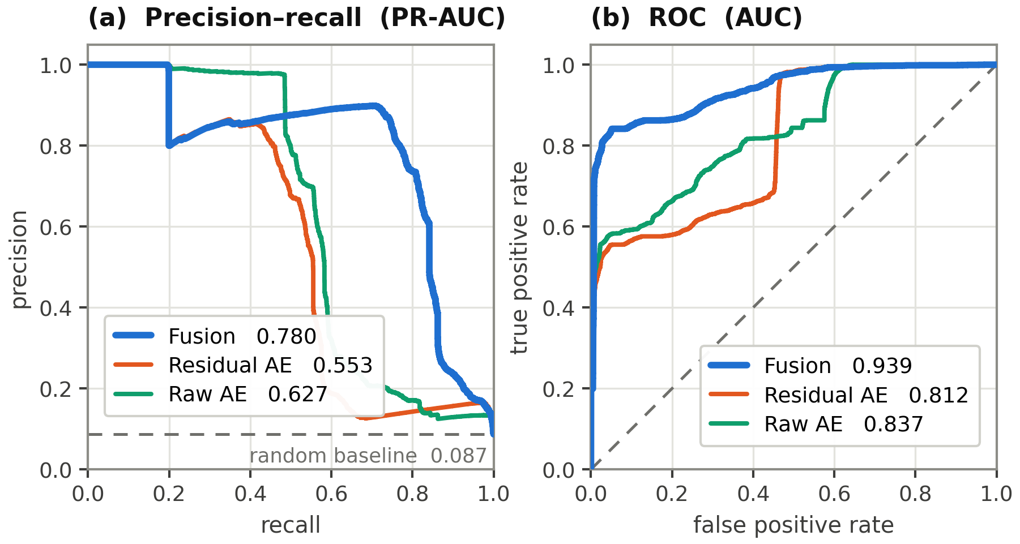
Figure 3. Precision–Recall And ROC Curves Of The Corrected Pipeline 41,688 test windows, 8.7 % anomalous. Fusion dominates both single models on both curves; the margin is larger on the precision–recall panel because ROC is optimistic under class imbalance.
At the causal operating point θ = 0.6436 the fused detector produces 2,731 true positives, 546 false positives, 892 false negatives and 37,519 true negatives, that is precision 0.833, recall 0.754, F1 0.792 and specificity 0.986. The false-alarm rate on clean validation data is 3.0 %, as the 97th-percentile rule intends.
The absolute values are below those of the reference study, and this is an expected consequence of the corrections rather than a regression. Three measurable reasons are given in Section 5.1. The property that both pipelines share is structural: in each of them the fusion exceeds both single models and every baseline by a clear margin.
4.2. Fault-Type Asymmetry And Complementarity
Figure 4(b) breaks the result down by fault type and shows the asymmetry that justifies fusion in the first place. On the encoder glitch the physical model reflects the joint position deviation as a large residual and the residual autoencoder dominates (AUC 0.988 against 0.491). On sensor noise the situation inverts exactly: the low-amplitude wrench noise is filtered out by the inverse dynamics model, so the residual autoencoder is blind (0.296) while the raw autoencoder is perfect (1.000). The fused score follows the stronger of the two in both columns. The two models' blind spots do not overlap, which is precisely the reason to combine them.
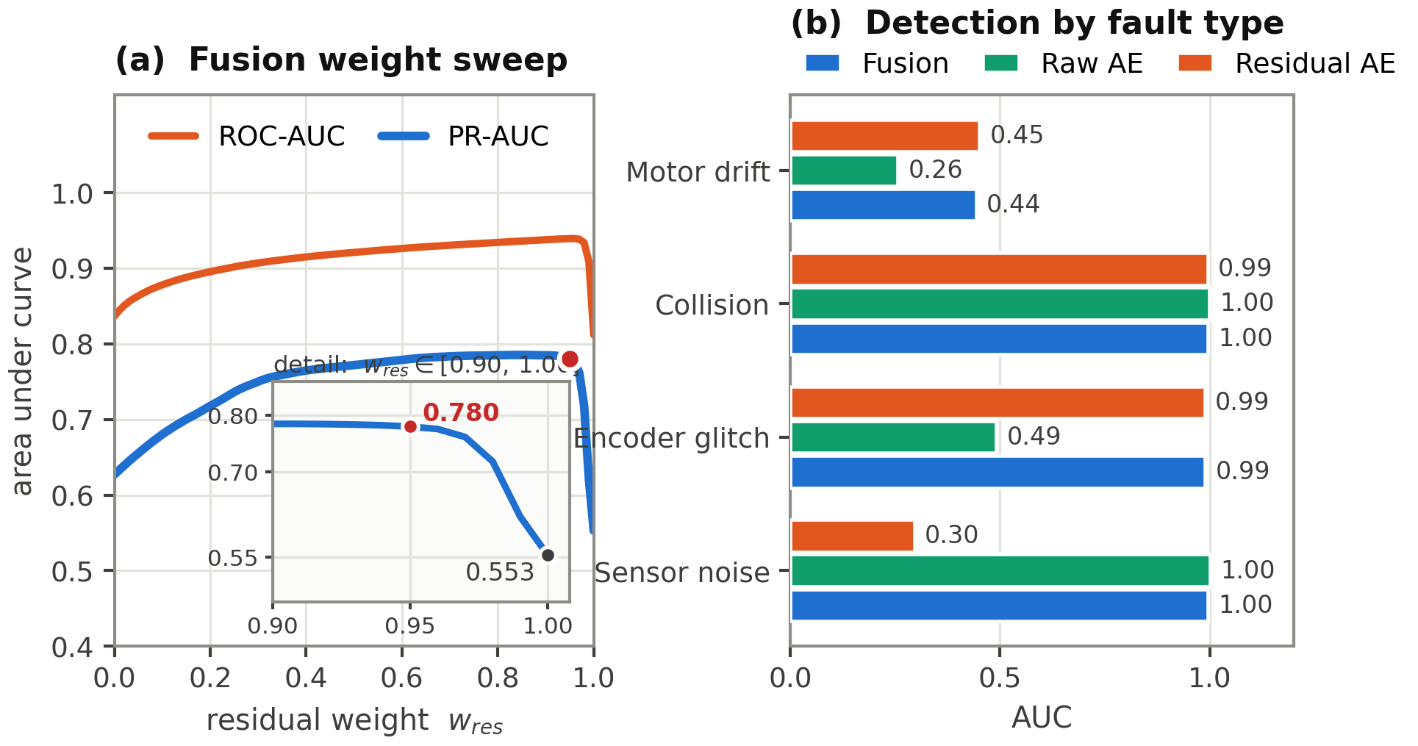
Figure 4. Value Of The Fusion (a) sweep of the residual weight; the inset expands the interval in which the contribution of the raw model disappears. (b) detection by fault type; the two models cover each other's blind spots.
At window level, with each model using its own 97th-percentile threshold, 24.3 % of the 3,623 anomalous windows are detected by the residual model only and 28.7 % by the raw model only, against 24.1 % and 25.9 % in the reference study. The recall of the OR combination is 0.757, well above either single model (0.470 and 0.514). Table 6 adds the decision-level ablation at the selected operating point.
Table 6. Complementarity And Decision-Level Ablation On 41,688 Windows.
Configuration | Precision | Recall | F1
Raw only (w_res = 0.00) | 0.759 | 0.514 | 0.613
Residual only (w_res = 1.00) | 0.756 | 0.470 | 0.579
Fusion (w_res = 0.95) | 0.833 | 0.754 | 0.792
Removing the five per cent weight of the raw model lowers recall from 0.754 to 0.470. The gain over the better single model is ΔF1 = +0.178; the reference study reports +0.161 at a different absolute level.
4.3. Sensitivity To The Fusion Weight
The weight was swept from 0.00 to 1.00, with the fused threshold taken at every point from clean validation windows only, so that the test set never sees the threshold. Figure 4(a) shows a broad plateau: between 0.25 and 0.95 the performance is stable, which reproduces the stable region reported by the reference study. The informative part is the edge. At w_res = 0.95 the PR-AUC is 0.780; at 0.98 it is 0.718, at 0.99 it is 0.621 and at 1.00 it collapses to 0.553. A weight of five per cent on the raw model is therefore associated with a gain of +0.227 PR-AUC relative to the pure residual detector. This is the strongest numerical evidence that the fusion is functional rather than nominal, and it accounts for the position of the selected weight on the shoulder immediately preceding the drop: the contribution of the raw model is admitted at a small weight but is not eliminated.
Two independent checks confirm that both models really run. Structurally, every rule of the reference method maps onto the deployed decision path. Operationally, the scoring method of each ONNX session was wrapped and counted over a replay of 6 runs and 5 scenarios: 13,160 decisions produced 13,160 residual-model calls and 13,160 raw-model calls, so neither model is cached or skipped.
4.4. Evaluation On Windows Not Seen In Training
The evaluation protocol inherited from the reference study builds the test set by injecting each of the four scenarios into every window of the recording, which is how 41,688 test windows arise from 10,422 windows. The autoencoders, however, were trained on the first 8,294 of those windows. Consequently 79.6 % of the evaluation windows are windows the models had already seen, in their clean form, during training. The protocol is kept here so that the comparison with the reference study remains valid, but the split is reported rather than left implicit, because the two halves behave very differently.
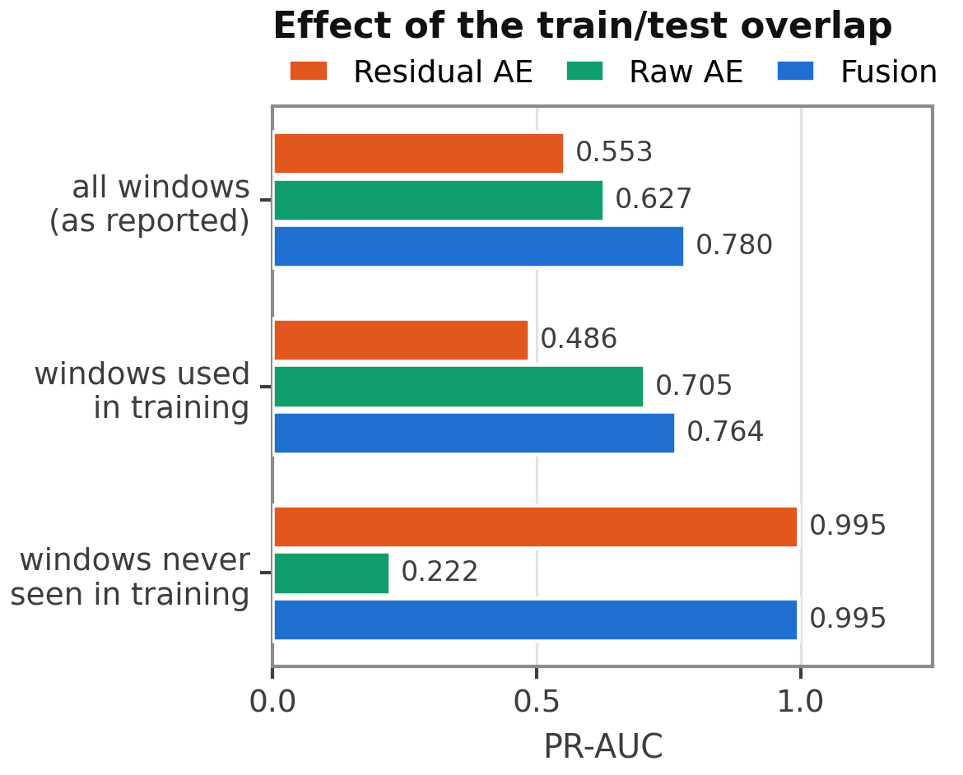
Figure 5. Effect Of The Train/Test Overlap PR-AUC on all evaluation windows, on those the autoencoders were trained on, and on the 8,512 windows they never saw. On unseen data the two models exchange roles and the fusion gains nothing over the residual model alone.
On the 8,512 windows outside the training range the ranking quality inverts completely. The residual autoencoder rises to PR-AUC 0.995 and Best F1 0.959, while the raw autoencoder falls to PR-AUC 0.222 and Best F1 0.336; the fusion reaches 0.995 and 0.961, that is, it matches the residual model and gains nothing from the raw one. Table 7 gives the corresponding areas under the ROC curve.
Table 7. Ranking Quality On The Two Halves Of The Evaluation Set (AUC).
Subset | Windows | Residual | Raw | Fusion
All (as reported) | 41,688 | 0.812 | 0.837 | 0.939
Used in training | 33,176 | 0.829 | 0.866 | 0.947
Never seen | 8,512 | 0.999 | 0.687 | 0.999
The unseen windows are the clean validation set, from which the normalisation bounds and the 97th-percentile thresholds are also taken, so they are not an untouched test set either. AUC, PR-AUC and Best F1 are invariant to the monotone per-model scaling, so the residual and raw columns are unaffected by that dependence; the fusion column is not, because the relative scale of the two scores is fitted on these windows.
Two conclusions follow. First, the margin of +0.178 reported in Table 6 is measured under the reference protocol and is inflated by the overlap: the raw autoencoder is strong on the windows it was trained on (PR-AUC 0.705) and weak outside them (0.222), which is the signature of memorisation rather than generalisation. The claim that the fusion beats the better single model therefore holds under the reference protocol but not on the unseen segment, where the residual model alone is equally good. Second, the complementarity claim itself survives, and in a sharper form: each model dominates in a different regime, and the regimes are separated here not by fault type but by position in the recording.
The second conclusion matters beyond the offline evaluation. A shift large enough to move the raw model's PR-AUC from 0.705 to 0.222 occurs inside a single recording of one robot performing one task family. It is the same out-of-distribution effect that dominates the real-cell results in Section 4.7, observed here two hours of robot operation earlier and on simulated faults. A run-disjoint retraining, in which no window of an evaluation run contributes to training, is the proper remedy and is left as the immediate next step.
4.5. Origin Of The Previously Published Figures
Rebuilt in the mixed-unit configuration of Section 3.8, the pipeline reproduces the reference study point by point. Table 8 lists the comparison.
Table 8. Reproduction Of The Reference Pipeline.
Quantity | Rebuild | Reference | Δ
Test windows | 179,888 | 179,896 | 8
Fault windows | 14,401 (8.01 %) | 14,402 (8.0 %) | 1
Residual-only share | 23.9 % | 24.1 % | 0.2 pt
Sensor noise — residual | 0.267 | 0.272 | 0.005
OR recall | 0.841 | 0.854 | 0.013
Recall — raw | 0.601 | 0.613 | 0.012
Encoder glitch — residual | 0.975 | 0.986 | 0.011
Raw model AUC | 0.943 | 0.952 | 0.009
Fusion MAX — AUC | 0.974 | 0.976 | 0.002
The decisive row is sensor noise. A residual model scoring 0.267 on that scenario can only arise on a pipeline where the residual has lost its physical meaning, that is where amperes and newton metres are subtracted directly. Agreement of the window counts to 8 and 1 windows in 179,896 confirms that the same raw dataset is being split the same way.
The conclusion is not that the reference study's claim is wrong. The complementarity of the two representation spaces is measured on both pipelines — 23.9 % residual-only on the reproduction and 24.3 % on the corrected pipeline — and the fusion margin survives on both. What was wrong is the physical scale of the reported numbers. The corrected pipeline is therefore the main result of this paper, and the reproduction is an appendix that documents where the earlier figures came from.
4.6. Latency And Compute Budget
Per sample, the inverse dynamics evaluation costs 22 µs and the Jacobian about 30 µs, together 1.5 % of the 500 Hz budget. Per decision, the two ONNX forward passes cost 5.9 ms, that is 12 % of the 50 ms budget, measured on CPU in offline replay, and 8.5 ms (17 % of the budget) on the cell, where the ROS 2 executor and the logging layer share the same cores; on the deployment workstation with the CUDA provider both fall further. The detection latency is the sum of the 50 ms filter delay and the 50 ms decision period, plus one more decision period when the two-consecutive rule is active, giving 120–150 ms end to end. At a tool speed of 0.25 m/s that corresponds to about 3.75 cm of additional travel.
An end-to-end replay of the prepared data through the deployed class, over 6 runs and 113,722 samples, gives a false-alarm rate of 0.0 % on clean data and detects 6 of 6 runs for collision and sensor noise, 5 of 6 for the encoder glitch and 4 of 6 for motor drift. Median latency is about 70 ms for the abrupt faults and 1,677 ms for the slow ramp, a split that is structural: within a 200 ms window a slow ramp is almost a constant offset, and an autoencoder reconstructs a constant offset without difficulty.
4.7. Commissioning On The Real Robot
All results up to this point were obtained on the recorded dataset. The system was then commissioned on the physical UR10e cell in a session that ran from 10:14 to 12:13 on 21 August 2026, just under two hours. The session covered the two production use cases of the platform — the autonomous visual inspection cycle and a pick-and-place scenario — together with dedicated fault-trial runs in which anomalies were provoked by hand so that the detector could be exercised against events whose ground truth is known to the operator. Across eight runs the detector logged 50.4 minutes of decisions, roughly sixty thousand decisions in total, with every decision written to disk and every alarm block written to an event log. Table 9 summarises how the online system had to deviate from the reference method, and how much of that was forced.
Table 9. Deviations Of The Online System From The Reference Method.
Deviation | Status | Reason
D1 Normalisation bounds from clean validation instead of the test set | forced | the published bounds are not causal and compress the live range to ~10⁻⁴
D2 Operating threshold for the fused score | forced | the reference method reports Best F1 only, which needs the labels it predicts
D3 Adaptive median + k·MAD rule | optional, off | helps offline, catches no verified event on hardware
D4 Two consecutive decisions before alarm | optional, on | suppresses single-decision noise triggers
D3 and D4 are switched off by a single parameter each, which restores the reference behaviour exactly. D1 keeps the published min–max formula and changes only the set the bounds are taken from.
The first measurement invalidated the operating threshold. On a clean run the median fused score is 4.27 while the threshold derived from the offline validation set is 0.6436; 97 % of all decisions are therefore declared alarms. The threshold is seven times too low.
The cause was measured, and it is not the threshold. The residual is pose dependent. Figure 6(b) shows the fused score in four operating regimes of the same robot with the same models: 0.0037 in the folded park pose, 0.32 during a protective stop, 1.57 in normal motion and 4.41 in a gravity-loaded static pose — three orders of magnitude. The current-to-torque coefficient could be measured on only two of six joints and the calibration offset is a constant, which cannot compensate a pose-dependent error. A single global threshold is therefore inherently fragile. The limitation originates in model fidelity rather than in the choice of threshold.
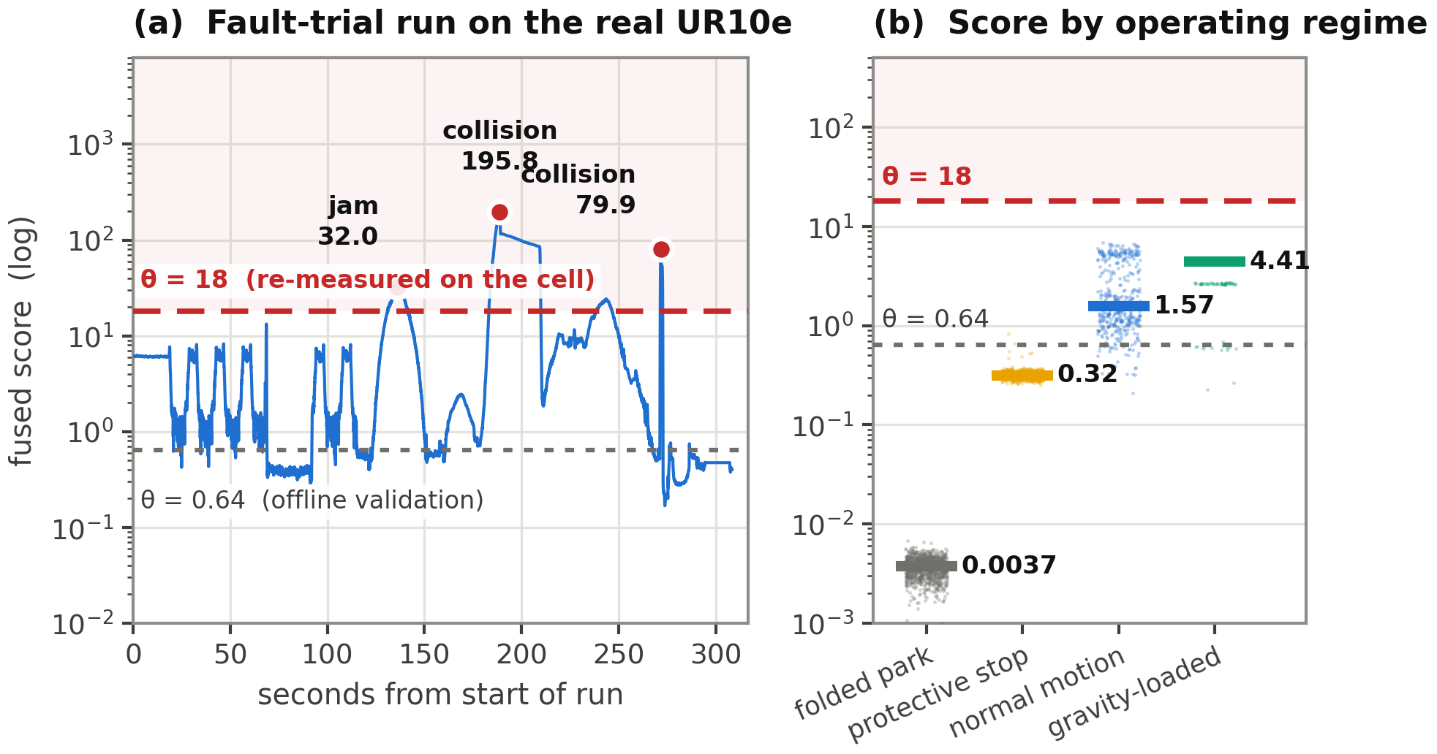
Figure 6. Behaviour On The Physical Cell (a) fused score over a fault-trial run with the three operator-confirmed events marked. (b) score distribution by operating regime; the threshold derived from offline data passes through the middle of three of the four regimes.
A second offline conclusion inverted. In the first run the node was started while the robot stood still; the adaptive baseline was learned from motionless noise and settled at 0.0103, the score jumped to 0.34 as soon as the robot moved, the alarm latched, and because the baseline freezes while an alarm lasts it could never update again. The result was a single alarm block of 564 s in a 620 s run — 91 % of the recording — which also hid a genuine event: a hand caught between links drove the robot into a protective stop and the fused score to the highest value of the run, 10.27, but no new event record was produced because the system was already alarming. The 3 s freeze timeout was added for this reason. On the labelled set the adaptive rule was then re-swept over k ∈ [8, 30]; no value caught a verified event and every value added false blocks to clean data, because the rule's baseline absorbs the peaks of normal motion, the MAD inflates and the adaptive threshold climbs above the real events. On the physical robot the component that catches events is the absolute threshold — the exact opposite of the offline finding.
The threshold was therefore re-measured by an exhaustive recount rather than selected. Every alarm block the detector would have raised was recounted directly from the logged decisions of all eight runs, for each candidate threshold and under the same two-consecutive-decision rule the node applies; each block was then classified against the five events the operator had confirmed while standing at the cell. The recount reproduces the event logs exactly where they overlap — at the threshold of 8.0 that was active during the inspection run it returns the same sixteen blocks with the same peaks — so the sweep of Table 10 covers the whole 50.4 minutes rather than only the runs that happened to be labelled.
Table 10. Threshold Sweep Recounted From All 50.4 Minutes Of Logged Decisions.
Threshold | Real caught | FA | FA / hour | Alarm duty
0.6436 (offline) | 5 / 5 | 335 | 398.7 | 74.4 %
8.0 (first deployed) | 5 / 5 | 29 | 34.5 | 7.1 %
12.0 | 4 / 5 | 25 | 29.8 | 4.7 %
18.0 (selected) | 4 / 5 | 12 | 14.3 | 2.9 %
26.0 | 4 / 5 | 5 | 6.0 | 1.8 %
33.0 | 3 / 5 | 1 | 1.2 | 1.0 %
91.0 | 2 / 5 | 0 | 0.0 | 0.6 %
Alarm duty is the share of logged time spent in an alarm state. The value first deployed, 8.0, was carried over from an initial estimate and is shown for reference.
The selection is an interval, not a point. Its lower bound is the ceiling of the autonomous inspection cycle, measured at 17.43: any threshold above that value silences all sixteen of the cycle's periodic excursions at once, and any threshold below it lets all sixteen through. Its upper bound is the weakest operator-confirmed event, 31.98. Within the resulting interval [17.43, 31.98] the value 18.0 is the conservative end, chosen to keep the largest possible margin for events weaker than the ones observed; a purely false-alarm-minimising choice inside the same interval would be about 26, at the cost of that margin. The single missed event at either value is the first jam, peak 10.27, which the robot's own protective stop had already interrupted.
The distribution of the residual false alarms over the runs is as informative as their number. At θ = 18 the six runs of ordinary operation — 37.4 minutes, covering five complete cycles of the autonomous inspection task — produce no false alarm; by the rule of three this bounds the false-alarm rate of that configuration at 4.8 per hour with 95 % confidence. All twelve alarms occur in the two runs in which a person interacted physically with the robot or the workpiece: ten in pick-and-place and two in a fault-trial run. The detector is therefore silent while the cell operates autonomously and active while a human is inside the workspace, which is the inverse of the intended behaviour of a safety function and is attributable to the same cause as the remaining findings of this section.
The remaining false alarms are not stochastic; they are structured and locked to the trajectory. In the inspection cycle the intervals between alarm onsets are 60, 38, 59, 32, 60, 32, 59, 32 and 60 seconds, and each 92-second cycle repeats the same triplet: 6.2 s with a peak near 17, then 3.0 s with a peak near 10.3, then 0.15 s near 8.4. The pattern was identical in all five cycles observed. This determinism has a methodological consequence: the natural unit of observation for this false-alarm process is the task cycle rather than elapsed time, since repeating the same trajectory reproduces the same excursions. It is also direct evidence that the models do not recognise the real trajectories: for autoencoders trained on the recorded dataset, the actual inspection scan is out of distribution.
A discriminating feature other than amplitude was sought and not found. Block sharpness, defined as peak over within-block median, is 1.08–1.99 for the real events and 1.00–4.83 for the false alarms, so the sharpest block in the campaign is a false alarm; rise time does not separate the classes either. The peak distributions overlap genuinely: the confirmed real events peak at 10.27, 31.98, 79.86, 146.44 and 195.83, while the confirmed false alarms range from 8.28 to 90.55 with a median of 10.42. One false alarm therefore peaks higher than three of the five real events. That case cannot be removed by any choice of threshold.
Detection latency on the physical cell is the sum of the 50 ms filter delay, the 50 ms decision period at 495 Hz and one further decision period for the two-consecutive rule, about 150 ms in total, with an inference time of 8.5 ms as reported in Section 4.6. The clearest verified event — the collision at the end of the pick-and-place scenario, peak 146.44 — lasted only 0.25 s, which forces every consumer of the alarm to treat it as an edge rather than as a level.
4.8. Operator Interface
Figure 7 shows the interface connected to the running robot. The status banner reads NORMAL, the decision rate is 20.0 Hz and the operating threshold is 18.00. The peak of about 14 visible in the live chart stayed below the threshold and therefore produced no alarm. The breakdown panel shows that the raw model was driving the decision at that moment (raw 5.60 / 3.45 = 1.62 times its own threshold, residual 1.57 / 1.60 = 0.98 times). The event table below lists the pick-and-place run, with the collision of peak 146.44 in the top row.
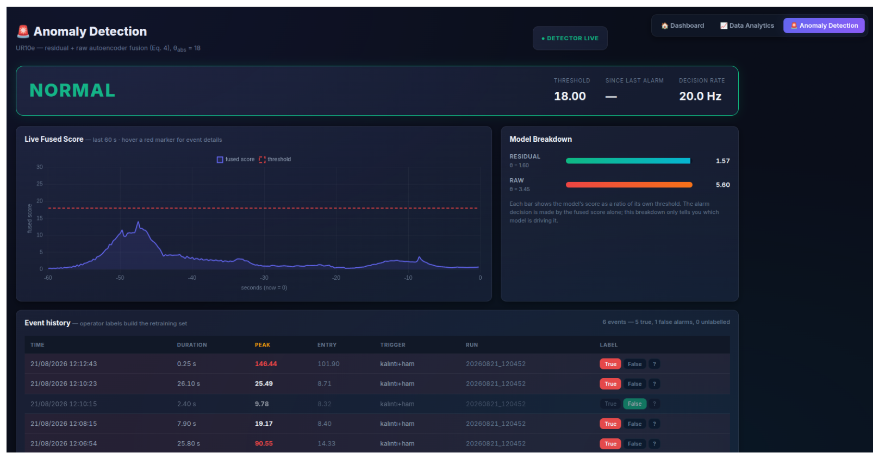
Figure 7. Operator Interface Connected To The Physical UR10e the labels recorded in the event table form the retraining set identified in Section 5.
5. Discussion
5.1. Why The Absolute Values Fell
The corrected pipeline scores below the reference study on every absolute metric, for three measurable reasons. First, fault amplitudes are now on the true physical scale. On the mixed-unit pipeline a ramp specified as 15 Nm was added as a bare number to a channel expressed in amperes, which is a perturbation roughly ten times larger than its physical counterpart; the corrected pipeline injects a genuine 15 Nm, so the problem is harder. Second, the dataset was cleared of discontinuities, and those discontinuities did not merely add noise — they created artificial jumps that a reconstruction model reads as anomalous, so removing them shrinks the apparent distance between normal and anomalous to its true value. Third, the evaluation is now leakage-free, with the split aligned to run boundaries and windows respecting them.
What should be compared between the two pipelines is therefore not the absolute number but the structure, and the structure is preserved in every respect: the two models complement each other in the same proportions, the weight sweep is broad and stable in the same region, the fusion margin over the better single model is of the same order (+0.178 against +0.161), and the fault-type asymmetry that motivates the whole design is reproduced almost exactly. Both pipelines, however, share the evaluation protocol audited in Section 4.4, so both margins are measured largely on windows the models were trained on, and neither should be read as a generalisation estimate.
5.2. Why Motor Drift Stays Hard
Motor drift is the weakest scenario for both single models and for the fusion (AUC 0.443; the reference study reports 0.588 and also records a marginal loss from fusion in this scenario). This is a structural limit of a windowed autoencoder rather than an implementation defect: inside a 100-sample window a slow linear ramp is almost a constant offset, and a constant offset is reconstructed without difficulty. Online, the adaptive rule partly covers this gap because its baseline follows the last 30 seconds, so a slowly growing score can raise an alarm without ever crossing the absolute threshold; in replay, motor drift was caught in 4 of 6 runs with a median delay of 1,677 ms. The correct long-term answer is not to force a windowed autoencoder but to add a second, long-horizon indicator such as the slope of a moving-average residual.
5.3. What The Transfer To Hardware Changed
Two conclusions supported by the offline data were inverted by the physical cell, and this is the central finding of the paper. The operating threshold had to be raised by a factor of seven, because the residual is pose dependent while the threshold is a single global constant. The adaptive alarm rule — the component that rescued the single models offline, and whose justification came from the reference method's own blind spot argument — caught no verified event on hardware and only added false blocks; it is disabled by default.
Both inversions have the same root. The autoencoders were trained on a recorded dataset that does not contain the real inspection trajectories, so on hardware those trajectories are out of distribution. The evidence is direct rather than inferential: the false alarms repeat with the cycle of the trajectory, to the second, and the same motion produces the same excursion every time. Under that condition no threshold rule can succeed, because the score is not measuring abnormality but unfamiliarity. This is the anomaly-detection counterpart of the reality gap described for control policies by Zhao et al. (2020), and it suggests that reporting a detection threshold without stating the operating regime it was measured in is of limited value.
The offline result of Section 4.4 is the same phenomenon at a smaller scale, and it is what makes the hardware outcome predictable in hindsight. Moving from the first four fifths of one recording to the last fifth already moves the raw model's PR-AUC from 0.705 to 0.222 while the residual model rises from 0.486 to 0.995. If a segment boundary inside a single recording can do that, a change of task profile on real hardware certainly can. The two models are not equally exposed: the residual model sees a physically normalised quantity and degrades gracefully, whereas the raw model sees the signals themselves and degrades sharply. That asymmetry, rather than the size of the fusion margin, is the transferable finding of this study.
The practical consequence is a design rule. An operating threshold must be measured on the deployment hardware, over at least one full task cycle, and it must be revisited whenever the task profile changes. The system stores the offline value alongside the deployed one and records the justification for the deployed one, so that the difference between the two remains visible rather than being quietly overwritten.
5.4. Effect Of The Measured Solver Limitations
The solver contains no friction model and its inertia matrix fails the symmetry and positive-definiteness tests, so the theoretical advantage of the residual space is not realised at the wrist joints, where the model torque is a small fraction of the measured torque. The lower single-model performance of the residual autoencoder relative to the reference study (AUC 0.812 against 0.908) is consistent with this effect. The survival of the fusion margin under this limitation is itself diagnostic: the raw model carries the information directly in exactly those channels, which is the intended function of the fusion.
5.5. Limitations
• A single robot (UR10e) and a single task profile; no validation on other robot types has been performed.
• Synthetic faults may not reflect the full dynamics of real faults; in particular the collision pulse is distributed equally over the wrench channels instead of being propagated from a real contact point through the Jacobian.
• The current-to-torque coefficient could be measured directly on only two of six joints; the other four are derived by assumption, which affects the physical interpretation rather than the detection.
• Four fifths of the offline evaluation windows are also training windows, because the evaluation protocol of the reference study is retained for comparability. Section 4.4 reports the split separately, but a run-disjoint retraining is required before the offline margins can be read as generalisation.
• The operating threshold is selected on the same commissioning campaign on which its false-alarm rate is reported, and the campaign yields only five operator-confirmed events. The threshold should be validated on a campaign it was not fitted to.
• The observation covers five complete cycles of the inspection task. Because the false-alarm process is deterministic and cycle-locked, additional repetitions of the same trajectory would add little information about it; what a longer campaign would add is the variation the two-hour window cannot contain, namely thermal drift of the drives, part-to-part and payload variation, mechanical wear and operator differences. The results reported here are therefore a commissioning-scale proof of concept with respect to those factors.
• Online measurements were taken on CPU; they should be repeated with the GPU provider on the deployment workstation.
6. Conclusions
This paper followed a score-level fusion framework for cobot anomaly detection from a published offline result all the way to a detector running on a physical UR10e cell, and reported every measurement taken on the way, including the ones that were unfavourable.
The method of the reference study was rebuilt independently and its architectural and procedural components were shown to match exactly. Seven findings were measured in the data path; five were corrected, one — the measured limitations of the inverse dynamics solver — was deliberately accepted under a fixed constraint, and one is a typesetting inconsistency. The previously published figures were traced to a mixed-unit pipeline, and that pipeline was reproduced explicitly so that the origin of the numbers is documented rather than merely asserted.
On the corrected pipeline, and under the reference study's own evaluation protocol, the value of the fusion is preserved: F1 0.792 against 0.613 for the raw model and 0.579 for the residual model, a gain of +0.178 over the better single model, with complementarity ratios matching the reference study. Removing the five per cent raw weight collapses PR-AUC from 0.780 to 0.553, which shows that the fusion is functional rather than cosmetic.
That protocol was also audited. Four fifths of its evaluation windows are windows the autoencoders were trained on, and on the remaining fifth the two models exchange roles: the residual model reaches PR-AUC 0.995 while the raw model falls to 0.222, and the fusion gains nothing over the residual model alone. The complementarity claim survives this test in a sharper form — each model dominates a different regime — but the size of the fusion margin does not, and is reported here as protocol-dependent rather than as a generalisation estimate.
The system was implemented as a ROS 2 node running at 500 Hz whose feature engine is numerically identical to the offline pipeline to floating-point rounding, in which both models run on every decision, and whose inference consumes 12 % of the decision budget.
The measurements on the physical robot inverted two offline conclusions: the operating threshold had to be raised sevenfold, and the adaptive alarm rule had to be disabled. Both follow from the same root cause, which was measured and not assumed — the real trajectories are out of distribution for models trained on the recorded dataset. The replacement threshold is not a free parameter: recounting every alarm block over the full 50.4 minutes of logged decisions from a two-hour commissioning session bounds it from below by the ceiling of the autonomous inspection cycle (17.43) and from above by the weakest confirmed event (31.98), and at the selected value of 18.0 the detector is silent through 37.4 minutes of autonomous operation. The remaining limit cannot be removed by any threshold, since one confirmed false alarm peaks higher than three of the five confirmed real events.
The next step follows directly from that limit and is already instrumented: the operator interface accumulates verified labels, and those labels form the set on which the two autoencoders should be retrained on real robot data, under a run-disjoint split in which no window of an evaluation run contributes to training. Two further directions are a long-horizon indicator to cover the slow drift scenario, and a pose-conditioned rather than global threshold, since the score was measured to vary over three orders of magnitude with the pose of the arm.
Acknowledgement
The project is supported by the KDT Joint Undertaking (101140216) and its members, including additional funding from Vinnova (Sweden), Österreichische Forschungsförderungsgesellschaft mbH – FFG (Austria), Business Finland (Finland), Ministry of Universities and Research (Italy), FCT (Portugal) and TÜBİTAK (124N448) (Türkiye). The measurements were carried out at the Autonomous Systems and Reliability Laboratory of the ESOGÜ Intelligent Systems Application and Research Centre.
Contribution Of Researchers
Author 1: design and implementation of the offline pipeline, the audit and the ROS 2 detector node, commissioning measurements, preparation of the manuscript. Author 2: … . Author 3: … . (To be completed by the authors.)
Conflict Of Interest
No conflict of interest has been declared by the authors.
References
Blochwitz, T., Otter, M., Arnold, M., Bausch, C., Clauß, C., Elmqvist, H., … Wolf, S. (2011). The Functional Mockup Interface for tool independent exchange of simulation models. Proceedings of the 8th International Modelica Conference, 105–114, Dresden, Germany.
Correia, L., Goos, J. C., Klein, P., Bäck, T. & Kononova, A. V. (2024). Online model-based anomaly detection in multivariate time series: Taxonomy, survey, research challenges and future directions. Engineering Applications of Artificial Intelligence, 138, 109323.
Darban, Z. Z., Webb, G. I., Pan, S., Aggarwal, C. C. & Salehi, M. (2024). Deep learning for time series anomaly detection: A survey. ACM Computing Surveys, 57(1), 1–42.
Haddadin, S., De Luca, A. & Albu-Schäffer, A. (2017). Robot collisions: A survey on detection, isolation, and identification. IEEE Transactions on Robotics, 33(6), 1292–1312.
Huang, X., Chen, N., Deng, Z. & Huang, S. (2024). Multivariate time series anomaly detection via dynamic graph attention network and Informer. Applied Intelligence, 54, 7636–7658.
Katsampiris-Salgado, K., Dimitropoulos, N., Gkrizis, C., Michalos, G. & Makris, S. (2024). Collision detection for collaborative assembly operations on high-payload robots. Robotics and Computer-Integrated Manufacturing, 87, 102708.
Leys, C., Ley, C., Klein, O., Bernard, P. & Licata, L. (2013). Detecting outliers: Do not use standard deviation around the mean, use absolute deviation around the median. Journal of Experimental Social Psychology, 49(4), 764–766.
Li, W., Han, Y. & Xiong, Z. (2020). Collision detection of robots based on a force/torque sensor at the bedplate. IEEE Transactions on Industrial Electronics, 67(12), 12440–12449.
Liu, K., Wang, L., Zhang, X., Sun, Y. & Li, J. (2025). Anomaly detection in multidimensional time series for water injection pump operations based on LSTMA-AE and mechanism constraints. Scientific Reports, 15.
Macenski, S., Foote, T., Gerkey, B., Lalancette, C. & Woodall, W. (2022). Robot Operating System 2: Design, architecture, and uses in the wild. Science Robotics, 7(66), eabm6074.
Malhotra, P., Ramakrishnan, A., Anand, G., Vig, L., Agarwal, P. & Shroff, G. (2016). LSTM-based encoder-decoder for multi-sensor anomaly detection. arXiv preprint arXiv:1607.00148.
Malhotra, P., Vig, L., Shroff, G. & Agarwal, P. (2015). Long short term memory networks for anomaly detection in time series. Proceedings of the European Symposium on Artificial Neural Networks (ESANN), 89–94, Bruges, Belgium.
Park, D., Hoshi, Y. & Kemp, C. C. (2018). A multimodal anomaly detector for robot-assisted feeding using an LSTM-based variational autoencoder. IEEE Robotics and Automation Letters, 3(3), 1544–1551.
Savitzky, A. & Golay, M. J. E. (1964). Smoothing and differentiation of data by simplified least squares procedures. Analytical Chemistry, 36(8), 1627–1639.
Yılmaz, C. S., Kahraman, S., Yılmaz, M., Yavuz, H. S. & Yayan, U. (2026). FMU tabanlı kalıntı ayrıştırma ve ikili LSTM özkodlayıcı birleşimi ile işbirlikçi robotlarda anomali tespiti [FMU-based residual decomposition and dual LSTM autoencoder fusion for anomaly detection in collaborative robots]. ⟨KONFERANS ADI VE YERİ — yazarlar tarafından tamamlanacaktır⟩ kurultayında sunulmuş bildiri, Türkiye.
Zhang, T., Chen, Y. & Zou, Y. (2024). Robot collision detection based on external torque observer. Journal of South China University of Technology, 52(3), 84–92.
Zhao, W., Queralta, J. P. & Westerlund, T. (2020). Sim-to-real transfer in deep reinforcement learning for robotics: A survey. 2020 IEEE Symposium Series on Computational Intelligence (SSCI), 737–744, Canberra, Australia.

