FROM OFFLINE FUSION TO ONLINE DEPLOYMENT: ANOMALY DETECTION ON A UR10e COBOT

Adı SOYADI^{1*}, Adı SOYADI² (Dergi editörlüğü tarafından basım aşamasında yazılacaktır.)
1 Yazar 1 Adresi, ORCID No : https://orcid.org/
2 Yazar 2 Adresi, ORCID No : https://orcid.org/

Keywords | Abstract
Anomaly detection  Collaborative robots  LSTM autoencoder  Score-level fusion  Real-time deployment | Early detection of anomalies in collaborative robots matters for operator safety and production continuity. Previous work introduced a score-level fusion of a physics-informed residual autoencoder and a data-driven raw signal autoencoder for a UR10e cobot and, in a first hardware extension, showed that the fusion margin measured offline is a property of how faults are injected rather than of the two representation spaces: it collapses from +0.189 to -0.003 PR-AUC once faults are injected physically instead of by hand. This paper re-examines the residual definition itself and finds that the force/torque channel both prior studies relied on is not a physical measurement: the ROS 2 driver populates it from the controller's own payload-compensated force estimate, not from a transducer, and the raw strain-gauge field it should come from reads a constant, implausible offset. Removing this channel collapses the twelve-channel intrinsic/extrinsic split to a single six-channel total residual and removes six channels from the raw model. In its place, the missing payload term is fitted outside the validated solver, per production task, alongside the friction term; on four production tasks and 5.16 million prepared samples it lowers the held-out residual spread by 42-48 % where a single global offset generalised backwards (a positive bias sign-flipped between training and unseen sessions of the same task). Under physically consistent fault injection, the fusion weight is now measured rather than assumed a priori and converges to a narrow high-residual optimum (0.90-1.00 across three normalisations), an order narrower than the broad plateau reported before; in aggregate the raw model no longer helps (Best F1 0.609 fused against 0.611 for the residual model alone), and its one measured advantage is confined to a fault type the residual model is physically blind to: a 0.3 rad encoder step moves the gravity torque by under 0.1 Nm, below the residual noise floor. The detector was re-implemented as a 500 Hz ROS 2 node without the removed channel; its measurement-level equivalence with the offline pipeline was re-verified and, on a replay of the physical cell, it drew its first alarm from both models simultaneously. Commissioned on three of the cell's four production tasks, it first exposed a task-selection defect that fed the payload correction the wrong task's physical model on six of nine runs, producing 309 false alarms against 5 genuine ones by shifting the body of the fused-score distribution rather than its tail — a failure no re-tuning of the threshold alone could fix, confirmed by backtest. Once corrected and given a per-task operating threshold fitted on site, the same three tasks produced zero false alarms against seven operator-confirmed events, each separated from its threshold by a factor of 1.1-1.6×.
Research Article | Received / Geliş : Accepted / Kabul :

ÇEVRİMDIŞI BİRLEŞİMDEN ÇEVRİMİÇİ GERÇEKLEMEYE UR10e ANOMALİ TESPİTİ

Anahtar Kelimeler | Öz
Anomali tespiti  İşbirlikçi robotlar  LSTM özkodlayıcı  Skor birleşimi  Gerçek zamanlı sistem | İşbirlikçi robotlarda anomalilerin erken tespiti operatör güvenliği ve üretim sürekliliği açısından kritiktir. Önceki çalışmada, bir UR10e kobot için fizik tabanlı kalıntı özkodlayıcısı ile veri güdümlü ham sinyal özkodlayıcısının skor düzeyinde birleşimi sunulmuş ve yalnızca çevrimdışı değerlendirilmişti. Bu makale o çerçeveyi başlangıç noktası alarak dört yönde genişletmekte ve gerçek hücrede çalışan bir dedektör olarak teslim etmektedir. Kalıntı tanımı, doğrulanmış ters dinamik çözücünün içermediği sürtünme terimiyle tamamlanmış, bilek eklemlerinde kalıntı yayılımı %87 ve %92 azalmıştır. Değerlendirme koşu-ayrık bölme ve beş eğitim tohumu üzerine oturtulmuş, bu koşulda birleşim iki tekil modeli de geçmiştir (F1 0,791'e karşılık 0,627 ve 0,614). Arızaların yalnız ölçülen kanallara uygulandığı ve kalıntının yeniden hesaplandığı fiziksel olarak tutarlı bir enjeksiyon protokolü ise birleşim marjını her tohumda +0,189'dan -0,003 PR-AUC'ye indirmektedir; tamamlayıcılığın kaynağı, fiziksel yayılımından elli bir kat küçük seçilmiş tek bir enjeksiyon genliğidir. Dedektör, öznitelik motoru çevrimdışı hatla kayan nokta düzeyinde örtüşen 500 Hz'lik bir ROS 2 düğümü olarak gerçeklenmiştir. Donanımda çevrimdışı türetilen eşik taşınmamış; sebebi her iki modelin de eğitim dağılımının çok dışında çalışması ve %5 ağırlıklı modelin birleşik skorun %29'unu sürüklemesidir. Hücrede yeniden kalibrasyondan sonra dedektör, operatörce doğrulanmış üç çarpışmayı yanlış alarm üretmeden yakalamış, düşük genlikli bir temas ise normal hareketin altında kalmıştır.
Araştırma Makalesi | Received / Geliş : Accepted / Kabul :

1. Introduction
Collaborative robots share their working volume with human operators, so anomalies such as a collision, a degrading motor or a failing sensor have to be detected before they become incidents. Two families of methods dominate. Physics-based residual methods compare a dynamic model of the robot with the measured forces and treat the difference as a fault indicator; they reduce dimensionality and suppress noise, but they also suppress low-amplitude sensor anomalies. Data-driven methods learn complex patterns directly from high-dimensional raw signals, but they lack the structure a physical model provides. The two families therefore fail on different fault types, and that asymmetry can be exploited by fusing them.
In earlier work we proposed exactly such a fusion for a UR10e cobot (Yılmaz, Kahraman, Yılmaz, Yavuz and Yayan, 2026). A residual Long Short-Term Memory (LSTM) autoencoder operating on twelve intrinsic and extrinsic residual channels derived from a Functional Mock-up Unit (FMU) inverse dynamics model was combined, at score level, with a raw LSTM autoencoder operating on twenty-four direct sensor channels. That study was evaluated entirely offline on a recorded dataset, and its own future-work list named a single most important open item: running the system online and simultaneously with the robot.
An intermediate stage of this study closed that item on the recorded dataset's own terms: it added the friction term the validated solver lacks, placed the evaluation on a run-disjoint footing, and, in its own principal finding, showed that the fusion advantage the offline study reported (+0.189 PR-AUC) was an artefact of how faults were injected and collapses (−0.003) once they are injected physically instead. Sections below refer to that intermediate stage, unpublished in its own right, as the extension this study builds on. Extending it to hardware raised the question this paper answers: the intermediate stage's residual, like the original study's, depended on an end-effector force/torque channel, and that channel turns out not to be a physical measurement at all.
The gap this paper fills is therefore a specific instance of a general one. Physics-informed anomaly detection is only as trustworthy as the measurements its physics model is compared against, and a channel sourced from a driver rather than verified against its own documentation can silently be something other than what its name claims — here, a controller's payload-compensated force estimate standing in for a transducer reading. What is rarely reported is whether such a dependency was checked at all, and what a fusion framework's measured advantage is worth once it is removed. This paper reports both for one complete system, together with the offline consequences of removing it and, as an addendum once available, its hardware behaviour.
The contributions are:
• a finding that the end-effector force/torque channel two prior stages of this framework depended on is a controller estimate, not a measurement — traced to the ROS 2 driver source and quantified against the channel it should be uncorrelated with (Section 3.4);
• a residual redefinition from a twelve-channel intrinsic/extrinsic split to a single six-channel total residual, and a raw-model channel reduction from twenty-four to sixteen, with the negative result that a wrap-around-safe (sin q, cos q) encoding, tried as an alternative to dropping two position channels outright, makes generalisation worse rather than better (Section 3.5);
• a task-conditioned payload term fitted outside the validated solver alongside the friction term, replacing a single global offset shown to generalise backwards on at least one held-out task, evaluated on four production tasks and 5.16 million prepared samples (Section 3.4);
• an independent, RTDE-based re-derivation of the current-to-torque calibration across the full operating envelope rather than only near rest, which agrees with the earlier quasi-static values to within 2 % on the two joints either method can measure (Section 3.3);
• a fusion weight measured rather than assumed a priori, converging to a narrow high-residual optimum under physically consistent injection once the unreliable channel is removed, and a log-domain normalisation adopted specifically to pre-empt the threshold-transfer failure mechanism the intermediate stage found on hardware (Sections 3.6, 4.3);
• a re-implementation as a ROS 2 node without the removed channel, numerically re-verified against the offline pipeline (Section 3.8); and commissioning across three of the cell's four production tasks (Section 4.6), which found and corrected a task-selection defect that had produced more false alarms than genuine ones, then reduced the false-alarm count on the affected tasks to zero against seven operator-confirmed events.
The remainder of the paper is organised as follows. Section 2 reviews the related literature. Section 3 describes the platform and the data, the revised residual definition and the online implementation. Section 4 presents the offline findings. Section 5 discusses them and states the limitations, and Section 6 concludes.
2. Literature Review
Physics-based detection for manipulators is a mature field. Haddadin, De Luca and Albu-Schäffer (2017) survey collision detection, isolation and identification and establish the residual observer as the canonical tool. Li, Han and Xiong (2020) place a force/torque sensor at the bedplate and detect collisions from the resulting residual, while Zhang, Chen and Zou (2024) use an external torque observer for the same purpose. Katsampiris-Salgado et al. (2024) address high-payload collaborative assembly, where the model error itself becomes the limiting factor. The common weakness of this family is that whatever the model does not represent — friction, payload, joint elasticity — is indistinguishable from a fault, and whatever the model filters well is also filtered away when it is the fault.
Data-driven detection for multivariate time series is surveyed by Darban, Webb, Pan, Aggarwal and Salehi (2024). Reconstruction-based autoencoders are the dominant design: Malhotra, Vig, Shroff and Agarwal (2015) introduced LSTM networks for time-series anomaly detection, and Malhotra, Ramakrishnan, Anand, Vig, Agarwal and Shroff (2016) extended the idea to a multi-sensor encoder–decoder. Park, Hoshi and Kemp (2018) applied an LSTM-based variational autoencoder to robot-assisted feeding, one of the few studies to report on a physical robot. These methods need no fault labels, but they inherit whatever bias the training distribution carries.
Hybrid approaches attempt to combine the two. Liu et al. (2025) constrain an LSTM autoencoder with mechanism knowledge for pump operations, but do not study the fusion of two separate models' scores. Huang, Chen, Deng and Huang (2024) apply graph attention and a Transformer to multivariate anomaly detection without any physics-based preprocessing stage. Correia, Goos, Klein, Bäck and Kononova (2024) survey online model-based anomaly detection specifically, and identify threshold selection and non-stationary operating conditions as open research challenges — precisely the two problems that this paper measures on hardware.
The transfer of a model calibrated on simulated or recorded data to a physical robot is studied mostly in the control and reinforcement learning literature, where it is known as the reality gap (Zhao, Queralta and Westerlund, 2020). For anomaly detection the equivalent question — does the decision threshold transfer? — is seldom asked, because most studies never define an operating threshold at all, reporting instead the best achievable F1 over all thresholds. That statistic requires the labels it is supposed to predict and therefore does not exist online. The present study makes this gap explicit and closes it with a causal threshold rule, then measures what happens when the rule is applied to real hardware.
3. Method
3.1. Platform And Data Collection
Experiments were carried out on a robotic quality inspection platform consisting of a Universal Robots UR10e collaborative robot (six joints, 12.5 kg payload) mounted on a Festo linear axis, together with an inspection chassis frame, shown in Figure 1. The cell performs four production tasks on the same hardware: an autonomous visual inspection cycle of automotive body panels running alone, the same inspection cycle coordinated with a second, independently moving robot on the shared deck, a pick-and-place transfer task, and a fastening task in which the end effector is exchanged for a driving tool. The cell runs ROS 2 Humble with MoveIt 2; the recorded motions of the inspection tasks were produced by eleven different motion planning algorithms so that the normal operating distribution is not dominated by a single planner, and the other two tasks contribute their own, structurally different motion and load profiles. No force/torque sensor is fitted; Section 3.4 establishes why the channel a force/torque sensor would occupy cannot be used as one.
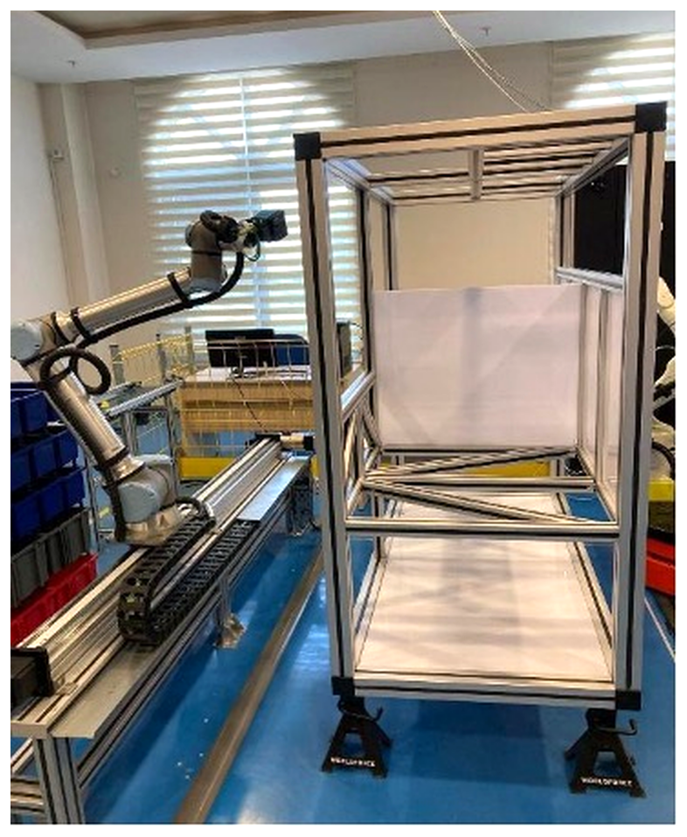
Figure 1. Robotic Quality Inspection Platform UR10e robot on a Festo linear axis, with the inspection chassis frame on the right.
The source dataset is a joint-state export covering all four tasks, 8,294,076 samples nominally at 500 Hz, together with a separate 148.6-minute Real-Time Data Exchange (RTDE) capture used only for the calibration of Section 3.3. Model training was performed on a laptop with an Intel Core i7-13650HX processor and an NVIDIA RTX 4060 GPU.
The study uses no human subjects and required no ethics committee approval. All measurements were collected on laboratory equipment of the ESOGÜ Intelligent Systems Application and Research Centre, and the principles of research and publication ethics were observed throughout.
3.2. Data Investigation And Preparation
The first stage of the audit was the data itself, and, as in the extension this study itself builds on, it produced the largest single correction — this time a different and more severe one. The export is not merely locally gapped; its row order does not track wall-clock time at all. Sorting the 8,294,076 samples by their header timestamp exposes jumps of hundreds of hours in either direction between consecutive rows as exported — a sequence advancing from January 2026 to June 2026 is, a few rows later, immediately followed by a return to August 2025 — consistent with an unordered concatenation of many separate recording sessions spanning roughly thirteen months rather than one contiguous export. No notion of a run, a gap or an acceleration is meaningful before this ordering is restored.
Once sorted, three further conditions were applied, each removing a specific and named contamination rather than a fixed fraction of the data: rows outside the controller's own safety_mode = NORMAL state (protective stop, fault and emergency stop) are excluded; rows carrying no production-task label (the controller's IDLE state between tasks) are excluded; and sessions whose median inter-sample interval exceeds 4 ms are excluded outright, which isolates a set of early sessions recorded before the current 500 Hz driver configuration, at an effective rate close to 10 Hz — an order of magnitude too slow for the fixed-step Savitzky–Golay derivative (Savitzky and Golay, 1964, window 51, order 3, detailed in Section 3.8) to remain physical.
The remaining stream is then segmented into physically continuous sessions and, within each session, into runs short enough to fail the hundred-sample autoencoder window plus its fifty-sample derivative margin. The session-boundary threshold — the inter-sample gap beyond which two consecutive samples are no longer treated as continuous — was chosen from the data rather than assumed: four candidate thresholds were scored by the fraction of each task's samples retained in sessions of at least 150 samples (Table 1). Ten and twenty milliseconds differ sharply for the least sampled task (54 % against 96 %), while fifty milliseconds adds almost nothing further; twenty milliseconds was adopted.
Table 1. Session-Boundary Threshold Selection (Share Of Task Samples Retained In Sessions Of At Least 150 Samples).
Task | 6 ms | 10 ms | 20 ms | 50 ms
Fastening (HRC) | 93.8 % | 98.6 % | 99.8 % | 99.9 %
Cooperative inspection | 77.9 % | 93.5 % | 99.8 % | 100.0 %
Pick-and-place | 44.8 % | 77.1 % | 99.6 % | 100.0 %
Solo inspection | 24.5 % | 54.2 % | 95.5 % | 98.7 %

Table 2 gives the outcome of the full cascade. The reduction is not a loss in the sense of the earlier study: every removed sample belongs to an explicitly named condition (out of safety, unlabelled, duplicated, too slow, or too short to host a single window), and each count is reported rather than absorbed into a single interpolation figure.
Table 2. Outcome Of Data Preparation.
Quantity | Value
Raw exported samples | 8,294,076
Removed — safety_mode ≠ NORMAL | 93,249 (1.1 %)
Removed — unlabelled (IDLE) | 2,313,148 (27.9 %)
Removed — duplicate timestamp | 103,272 (1.2 %)
Removed — session shorter than 150 samples | 187,868 (2.3 %)
Removed — unlabelled legacy, stationary | 282,416 (3.4 %)
Removed — session rate below ≈250 Hz | 31,181 (0.4 %)
Session-bounded samples | 5,282,942
Prepared samples (after derivative margin) | 5,160,792
Physical sessions retained | 2,443
The derivative margin removes 25 samples from each end of each of the 2,443 retained sessions (2 × 25 × 2,443 = 122,150), matching the Stage-A/Stage-B sample difference exactly.
3.3. Current-To-Torque Calibration
The UR ROS 2 driver writes the motor current, in amperes, into the effort field of the joint state message; the field is filled directly from the actual current reported by the controller. The inverse dynamics model, in contrast, produces newton metres. A conversion coefficient is therefore required before the residual of Equation (1) can be formed at all — the same requirement as in the extension this study builds on, but re-derived here from a different and independent source.
The earlier method regressed measured current on model torque restricted to quasi-static samples (|q̇| < 0.005 rad/s), where the joint torque is dominated by gravity; four of the six joints could not be measured this way because their quasi-static gravity torque is negligible. RTDE exposes a second, independent quantity: target_moment, the controller's own torque estimate for the commanded trajectory, populated at every control cycle rather than only near rest. Regressing measured current on target_moment over the full RTDE capture — 1,016,438 samples after the same safety-mode filter, 148.6 minutes of controller time, every task represented — extends the excitation from a near-zero-velocity subset to the whole operating envelope. Table 3 lists the result.
Table 3. Current-To-Torque Coefficients From The RTDE Regression.
Joint | Nm/A | R² | target_moment σ [Nm] | Trusted
shoulder_pan | 14.569 | 0.007 | 1.02 | no
shoulder_lift | 10.723 | 0.971 | 63.83 | yes
elbow | 9.055 | 0.960 | 31.80 | yes
wrist_1 | 6.365 | 0.540 | 2.48 | no (weak)
wrist_2 | 7.691 | 0.042 | 0.55 | no
wrist_3 | 13.583 | 0.001 | 0.12 | no
A coefficient is trusted at R² ≥ 0.70 and a physically plausible value; only shoulder_lift and elbow pass, the same two joints trusted by the quasi-static method — and the two independent estimates agree to within 2 % (10.723 against 10.522 Nm/A; 9.055 against 9.130 Nm/A), obtained from unrelated samples and an unrelated regressor. target_moment σ is the standard deviation of the regressor on that joint: the four untrusted joints all carry under 2.5 Nm of exciting signal against 32-64 Nm for the trusted two, which is why no regression against any single-valued torque proxy identifies them, not a defect of this particular method. wrist_1 is the one joint where the wider excitation helps: R² rises from 0.000 under the quasi-static method to a still-untrusted but non-zero 0.540.
Untrusted coefficients are filled by copying the nearest trusted joint within the same actuator family — shoulder_pan from shoulder_lift, and wrist_2 and wrist_3 from wrist_1, the best-conditioned of the three wrist joints — rather than by the torque-limit-ratio scaling used previously. As before, this choice affects the physical interpretation of a fault amplitude in newton metres on four of six joints and does not affect detection, because the autoencoders standardise every input channel; the node warns about the affected joints at start-up.
3.4. Residual Definition And The Removal Of The Force/Torque Channel
The inverse dynamics model packages the Newton–Euler formulation of the UR10e in the Functional Mock-up Interface format (Blochwitz et al., 2011):

τ̂_model = M(q)·q̈ + C(q, q̇)·q̇ + g(q) (1)

The extension this study builds on defined the residual as the measurement-model difference split into an intrinsic and an extrinsic part, r_ext = J(q)ᵀ·F_FTS, using an end-effector wrench topic the ROS 2 driver advertises. That split is withdrawn here, and this subsection reports why, because the reason is a finding in its own right rather than a simplification of convenience.
The wrench channel is not a physical measurement. The UR ROS 2 driver's hardware interface populates it by reading the RTDE field actual_TCP_force, which is the controller's own force estimate, computed from joint currents under whichever payload mass is currently configured — not a transducer reading. The RTDE field that would carry a genuine strain-gauge signal, ft_raw_wrench, was sampled independently over 2,000 points and found to sit at an approximately constant offset of order 10⁴ in raw sensor units on every channel, with no response distinguishable from noise; no force/torque sensor is fitted to this cell, and the driver does not report the absence.
The consequence is quantitative, not merely definitional. The RTDE capture used in Section 3.3 shows the controller's active payload setting taking at least four distinct values (0.001, 0.20, 0.44 and 1.86 kg) across sessions, presumably one per tool actually mounted; when the configured value does not match the true mounted mass — which it need not, since nothing in the pipeline enforces it — the reported actual_TCP_force carries a static bias for the whole session, static pose included. Measured across the four production tasks, the between-task standard deviation of a wrench-derived extrinsic residual is 20.9 Nm, against 3.1 Nm for the total residual defined below without any wrench term; reintroducing the split would add roughly seven times more task-dependent noise than it removes.
The residual is therefore a single quantity, the total residual of the withdrawn decomposition without a channel to subtract from it:

r_tot = τ_meas − τ̂_model − τ̂_c(q, q̇) (2)

where τ̂_c is a correction term, estimated outside the validated solver exactly as the friction term of the extension this study builds on, which is why it is retained and extended rather than discarded. Two properties of the solver motivate correcting outside rather than inside it, both unchanged from the earlier finding: the friction vector is identically zero over 500 random joint poses, and no payload model is present, so a workpiece or tool produces a sustained bias the solver cannot explain. The correction now has three parts,

τ̂_c = F_c·tanh(q̇ / ε) + F_v·q̇ + b_task + m_task·A(q) + u_task·B(q) (2a)

a Coulomb-plus-viscous friction term identical in form to the earlier one (tanh in place of sign(q̇) for the same reason: this robot spends most of its time at low speed, where a discontinuous sign function injects a step at every reversal, precisely the shape a detector is meant to flag), and a task-conditioned offset b_task plus a task-conditioned payload term. The payload term follows the standard result for a point mass rigidly attached at the flange,

A(q) = g · Jᵥ(q)ᵀ·ẑ, B(q) = g · (ẑ × Jᵥ(q))ᵀ·R(q) (2b)

where Jᵥ(q) is the linear-velocity block of the geometric Jacobian at the flange, R(q) the flange orientation, ẑ the vertical unit vector and g gravitational acceleration; m_task (kg) is then the extra mass the task's tooling represents relative to whatever nominal load the solver assumes, and u_task = m_task·c_task (kg·m) its first moment about the flange. Both A(q) and B(q) are functions of the already-available pose only, so the term costs one Jacobian evaluation, already computed for the equivalence check of Section 3.8, and no additional model.
F_c, F_v and, per task, b_task, m_task, u_task are fitted jointly by weighted least squares — each joint's equation weighted by the inverse of its own residual spread, so that shoulder_lift and shoulder_pan cannot dominate the fit of the wrist joints — exclusively on the training sessions of the split defined in Section 3.7. A held-out comparison decided whether the payload term earns its complexity: fitted with b_task alone against fitted with the full term of Equation (2a), scored on validation sessions the fit never saw, the mean ratio of corrected to raw residual spread is 0.537 for the offset alone against 0.477 with the payload term, and the offset-alone model fails in a way a single scalar cannot fix: on the pick-and-place task it leaves a validation-set bias of +23.9 Nm on the shoulder-lift channel, opposite in practical effect to the −5.1 Nm fitted on the training sessions of the same task, because the true extra-mass torque is pose-dependent and a constant cannot track it. The full term was adopted; Table 4 lists its coefficients and Table 5 the residual reduction.
Table 4. Friction And Per-Task Payload Coefficients, Fitted On Training Sessions Only.
Joint | F_c [Nm] | F_v [Nm·s/rad]
shoulder_pan | 9.44 | 24.44
shoulder_lift | 11.78 | 11.91
elbow | 6.09 | 17.92
wrist_1 | 2.30 | 3.42
wrist_2 | 2.57 | 3.20
wrist_3 | 2.42 | 4.12
Per-task terms (b_task, m_task, u_task) are not tabulated per joint for space; the fitted extra mass m_task ranks the four tasks in the expected order — fastening tool +1.43 kg, cooperative inspection +0.48 kg, pick-and-place +0.22 kg, solo inspection −0.30 kg (lighter than the solver's nominal load) — but is reliable only as a ranking: at these small magnitudes the fitted centre-of-gravity offset u_task/m_task is not separately identifiable and is not reported as a measured quantity.
Table 5. Total Residual Standard Deviation Before And After Correction [Nm], By Split.
Joint | Train | Validation | Test
shoulder_pan | 8.42 → 4.88 | 8.26 → 5.46 | 9.61 → 5.37
shoulder_lift | 12.00 → 7.16 | 11.58 → 6.62 | 12.93 → 6.69
elbow | 7.07 → 3.05 | 7.88 → 2.96 | 8.00 → 2.76
wrist_1 | 2.03 → 0.89 | 2.16 → 0.79 | 2.29 → 0.94
wrist_2 | 2.06 → 0.85 | 2.20 → 1.02 | 2.36 → 0.97
wrist_3 | 1.99 → 0.73 | 2.00 → 0.84 | 2.18 → 0.90
Every joint's spread falls on validation and test as well as on train, which the offset-only comparison above did not achieve; the reduction is a genuine generalisation, not a fitting artefact.
The online feature engine applies the identical expression from the same coefficient file, selected by the task the cell is currently running, and the equivalence test of Section 3.8 is run with the full correction active.
3.5. Dual LSTM Autoencoders
Both models share a symmetric encoder–decoder architecture that compresses a sliding window of T = 100 samples (0.2 s) into a latent vector. A two-layer LSTM encoder reduces the input sequence to a fixed-size latent vector; the decoder repeats it over T steps and reconstructs it with symmetric LSTM layers. Dropout of 15 % is applied between layers. Both models are trained on normal operating data only, with a mean squared error loss, and the anomaly score of a window is its reconstruction error. Each model's own threshold is the 97th percentile of the reconstruction errors on the validation set.
The residual model's six channels follow directly from Section 3.4. The raw model's channels do not follow as directly as the twenty-four of the extension this study builds on: removing the wrench leaves eighteen (six positions, six velocities, six torques), and two of the six positions were removed further, on evidence rather than by design. An eighteen-channel model was trained first; two of the thirty sessions in the test and validation sets were reconstructed almost uniformly badly — 28.8 % and 19.2 % of their windows above threshold — traced to the shoulder_pan and, overwhelmingly, the wrist_3 channel visiting joint-angle ranges the training sessions never covered (up to 43.9 % of one session's samples outside the training range on wrist_3 alone). Neither joint's angle enters the gravity term the residual model already captures — shoulder_pan is the vertical axis, wrist_3 the terminal, unbounded-rotation joint — so both were dropped, leaving sixteen. A further attempt encoded the four remaining position channels as (sin q, cos q) pairs instead of dropping wrist_3 and shoulder_pan, to remove the wrap-around discontinuity without discarding the position information entirely; it made the same two sessions worse, not better (62.0 % and 18.8 % of windows above threshold), indicating that the affected sessions visit genuinely novel task poses rather than an angle-wrapping artefact, and that added position sensitivity amplifies the effect. The sixteen-channel model — positions of joints 2 to 5, all six velocities, all six torques — was retained.
Windowing uses a stride of 25 samples, that is 75 % overlap. Two rules are enforced jointly: no window may span two sessions, and windows containing samples invalidated by the derivative edge margin are dropped. Training and validation windows come from disjoint, task-balanced sets of physical sessions (Section 3.7), so no sample is shared between them. Table 6 reports the architectures and the training outcome of the deployed single-seed models; a five-seed sensitivity study, run for the extension this study builds on, was not repeated here and is listed among the items still outstanding in Section 5.6.
Table 6. Model Architectures And Training Outcome.
 | Residual AE | Raw AE
Input channels | 6 | 16
Hidden / latent | 128 / 32 | 256 / 64
Parameters | 421,670 | 1,683,536
Train / val. windows | 125,662 / 39,956 | 125,662 / 39,956
Best epoch | 300 | 5
Best validation loss | 0.0744 | 0.0798
Threshold θ (P97) | 0.565 | 0.739
Optimiser Adam (lr = 10⁻³, β = 0.9/0.999), batch size 256, gradient clipping at 1.0, ReduceLROnPlateau (factor 0.5, patience 8), early stopping with patience 25 over at most 300 epochs. The raw model's best epoch is five: with eighteen times more training windows than the extension this study builds on had, the validation loss plateau is reached almost immediately and patience 25 then exhausts itself without further gain, unlike the residual model, which keeps improving to the full 300-epoch budget. Both channel counts and both thresholds differ from the twelve/twenty-four-channel, 0.887/0.412 architecture of the extension this study builds on for the reasons of Sections 3.4 and above, not as a refinement of the same quantity.
3.6. Score-Level Fusion And Log-Domain Normalisation
The normalised scores of the two models are combined by a weighted average,

S_fused = w_res · z_res + w_raw · z_raw (3)

with w_res + w_raw = 1. Two changes are made to the fusion of the extension this study builds on, one to how the weight is chosen and one to how a score is normalised, and both follow from the same observation: the reconstruction-error distribution of either model is heavy-tailed by three orders of magnitude between its median and its 99.9th percentile, which an affine min–max transform does not compress.
The weight is measured rather than adopted a priori. w_res is chosen on validation windows only, by a sweep over [0, 1] in steps of 0.05 under the physically consistent fault injection of Section 3.7, and the choice is cross-checked across three normalisations and three raw-channel variants of Section 3.5 (eighteen, sixteen and the sin/cos-encoded twenty-four) so that the outcome is not an artefact of one arbitrary scaling. Every combination selects a weight at or above 0.90; the value adopted, w_res = 0.90, is the sixteen-channel, log-normalised optimum and is discussed against the alternatives in Section 4.3.
The normalisation itself moves from an affine min–max transform to a standardised log transform,

z = (log₁₀(S + ε) − μ) / σ (4)

with ε = 10⁻⁹ guarding the logarithm and μ, σ the mean and standard deviation of log₁₀(S + ε) over clean validation windows — estimated once per model, from the same causal set the reference formula already used, so the change is in the shape of the transform rather than in which windows inform it. The reason is the tail: a min–max bound taken from clean validation windows is set by whichever window happened to reconstruct worst, and one atypical window can set a bound the rest of the distribution never approaches, compressing ordinary variation to invisibility exactly as the fault-injected min–max bound of the reference formula did for a different reason (Section 5.3 returns to this in the context of the operating threshold). The log transform instead maps the bulk of the distribution to an approximately symmetric range and lets the tail extend rather than dominate it.
3.7. Data Split, Fault Injection And Evaluation Protocol
The 2,443 physical sessions are partitioned once, and every consumer reads the same partition: the friction and payload fit of Section 3.4, the autoencoder training of Section 3.5, and the evaluation below. The partition is by session, not by row index, for the reason established in the extension this study builds on: a partition that lets a test window share a run, and therefore near-identical dynamics, with a training window overstates every downstream metric. A second requirement is added here, because it did not previously apply — the source data carries no task label. Sessions are allocated per task, largest first, to whichever of train, validation and test is furthest below its 70/15/15 sample-share target, so that every task is represented in every split rather than one task dominating a split by chance; two tasks with as few as five and six sessions each make this allocation, not simple random sampling, necessary.
Table 7. Task-Balanced Run-Disjoint Split (Samples).
Task | Train | Validation | Test
Fastening (HRC) | 980,613 | 355,939 | 264,937
Cooperative inspection | 1,481,403 | 396,909 | 360,616
Pick-and-place | 293,166 | 161,180 | 93,480
Solo inspection | 504,429 | 140,080 | 128,040
Total | 3,259,611 | 1,054,108 | 847,073
63.2 / 20.4 / 16.4 % overall, short of the 70/15/15 target because the two smallest tasks (five and six sessions) cannot be split more finely without breaking the no-shared-session rule; every task is nonetheless present in every split. Windowing (Section 3.5) yields 125,662 / 39,956 / 32,305 windows.
Table 8 lists the four synthetic fault scenarios injected for evaluation, unchanged in kind from the extension this study builds on but revised in two respects. First, only the physically consistent injection protocol is used: faults perturb the measured channels — joint torque or joint position — and the residual is recomputed through the pipeline itself, rather than being added by hand to each model's own representation space; the predecessor's central finding, that the two protocols disagree and only the physical one is meaningful (its own Section 5.2), is taken as established rather than re-derived. Second, each amplitude is swept at 0.5×, 1× and 2× severity rather than injected once, so that a fault type's detectability is reported as a curve, not a single point. A window is labelled anomalous when at least 30 % of its samples overlap the fault mask, drawn to give an overall anomalous-window prevalence of 8 %, matching the design of the original offline study this line of work traces back to.
Table 8. Synthetic Fault Scenarios (Base Amplitude, Swept At 0.5×/1×/2×).
Scenario | Injected into | Base amplitude
Motor drift | Elbow torque, linear ramp | 15 Nm
Collision | All joint torques, Gaussian pulse | 12 % of each joint's torque limit
Encoder step | Wrist-2 position, step | 0.3 rad
Measurement noise | All joint torques, Gaussian noise | σ = 3/3/2/1/1/1 Nm
Without a wrench channel, collision is injected directly as a joint-torque pulse rather than as a wrench propagated through the Jacobian from an assumed contact point; Section 5.6 lists this as a limitation. The encoder step is reduced from the 1.5 rad of the extension this study builds on to 0.3 rad, judged a more plausible single-glitch magnitude; Section 4.2 reports what this costs the residual model's sensitivity to it.
3.8. Online Implementation
The online system differs structurally from the offline pipeline in three ways, unchanged from the extension this study builds on: causality (nothing computed over a whole dataset may be used live), a time budget (2 ms per sample and, with a stride of 25, 50 ms per decision), and continuity (the live system notices an interruption only after it has happened and must reset its state). A fourth is new — the correction of Section 3.4 is task-conditioned, so the running task must be known to the node rather than inferred, and is taken as a required startup parameter.
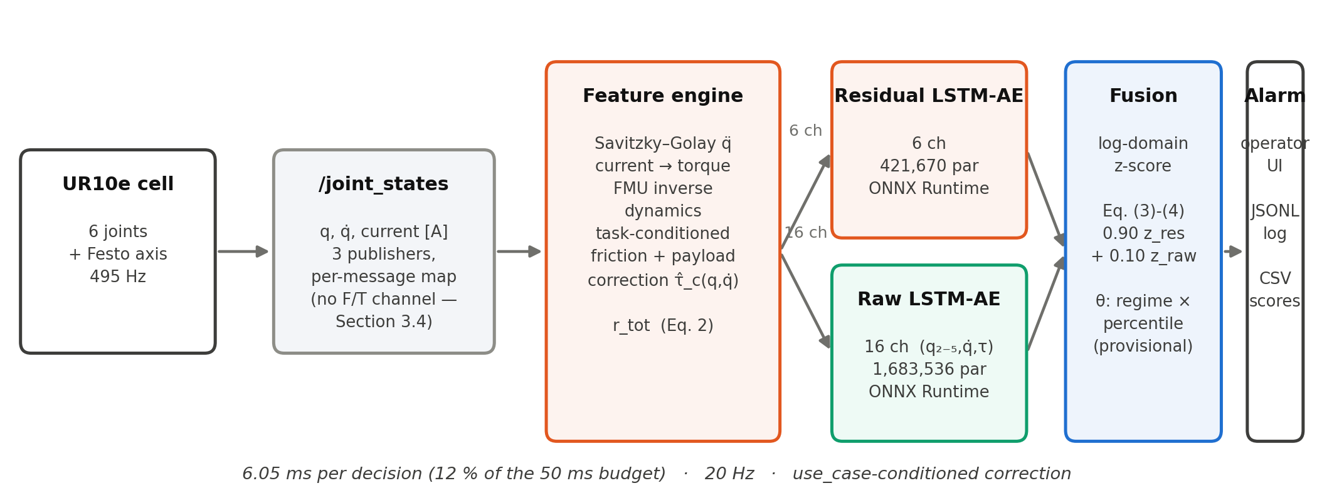
Figure 2. Online Detection Pipeline joint-state features feed a six-channel residual autoencoder and a sixteen-channel raw autoencoder in parallel; scores are combined under log-domain normalisation (Section 3.6) at the measured weight w_res = 0.90.
The feature engine is the sample-by-sample equivalent of the offline computation, unchanged in structure and reduced in scope: it keeps a 51-sample ring buffer and, for every new sample, emits the features of the sample at the centre of the buffer — the Savitzky–Golay derivative applied as an inner product with precomputed coefficients, the current-to-torque conversion, the inverse dynamics evaluation and the task-conditioned correction of Equation (2a) — without the base-frame rotation and Jacobian transfer the withdrawn wrench term required. The centred derivative costs the same structural delay of 25 samples (50 ms) as before.
Equivalence was verified rather than assumed, as before. Recorded sessions from four tasks were pushed through the online engine sample by sample and compared with the offline feature file: over four sessions the largest absolute difference in the total residual is 1.5·10⁻⁶ Nm and in the fused score 5.2·10⁻⁴ relative, with the moving/static regime flag agreeing on every decision. These are far tighter than the tolerance that matters — the gap between clean and anomalous scores — so the deployed node sees the features the models were trained on, not merely similar ones.
The two optional rules of the extension this study builds on are kept unchanged in mechanism: an adaptive rule that fires when the fused score exceeds median + k·1.4826·MAD of the last 600 decisions (Leys, Ley, Klein, Bernard and Licata, 2013), with its baseline frozen during an alarm and the freeze released after 3 s so a long alarm is treated as a regime change; and a two-consecutive-decision rule before an alarm is raised. The predecessor's own commissioning found the adaptive rule's premise broken on hardware — the residual score is pose-dependent, not low during ordinary operation — and disabled it by default; because the task-conditioned payload term of Section 3.4 is aimed at exactly that pose dependence, whether it is disabled by default here is left to the commissioning trial of Section 4.6 rather than decided in advance.
The detector is packaged as a ROS 2 node (Macenski, Foote, Gerkey, Lalancette and Woodall, 2022) that keeps the whole computation in a ROS-independent core; the node is a thin wrapper around it, so replay tests exercise the class the node actually runs. The models are exported to ONNX and executed with ONNX Runtime. Every decision is written to a comma-separated log and every alarm to a line-buffered JSON-lines event log, each session's log tagged with the checksum of the models and configuration it ran — the predecessor's commissioning was set back once by a session that silently ran superseded models, a failure this record is designed to make legible after the fact rather than to prevent.
Two connection-layer measurements repeat from before and one is new. The joint state topic still carries three different name sets from three publishers, of which the UR data arrives in a seven-element set in scrambled order; the mapping is still resolved per message and cached per name set. The measured sample rate is still close to 500 Hz rather than exactly on it. New this round: because no wrench topic is subscribed to at all, the single largest source of silent failure in the predecessor's deployment — a wrench topic name mismatch that produced no score with no error — cannot recur; removing the channel removed the failure mode along with it.
3.9. Operator Interface
The detector was integrated into the laboratory's existing web dashboard as a third tab, unchanged in design from the extension this study builds on: a collector subscribes to the node's decision, alarm and score topics, keeps a rolling buffer and pushes it to the browser. Alarms are latched on the rising edge and held rather than sampled at a fixed rate, because a short alarm can otherwise fall entirely between two samples of a periodic display. The vertical axis is framed on the live threshold rather than on a fixed range, because the score scale moves when the task changes; a logarithmic axis was rejected because it visually flattens the region above the threshold, the only region that matters operationally. Both the axis and the displayed per-model thresholds are read from the live decision stream rather than compiled in, so a recalibration cannot leave the display describing a configuration that is no longer running. The event table it produces is the source of the commissioning record in Section 4.6.
4. Findings
4.1. Offline Performance Of The Extended Pipeline
The extended pipeline is evaluated on 32,305 test windows and 39,956 validation windows, drawn from sessions that contributed nothing to training, the friction/payload fit, or the choice of any threshold; windows are labelled by the physically consistent injection of Section 3.7 at 8 % prevalence, averaged over the three severities and four fault types of Table 8. A single seed is reported (Section 3.5); Table 9 gives the result.
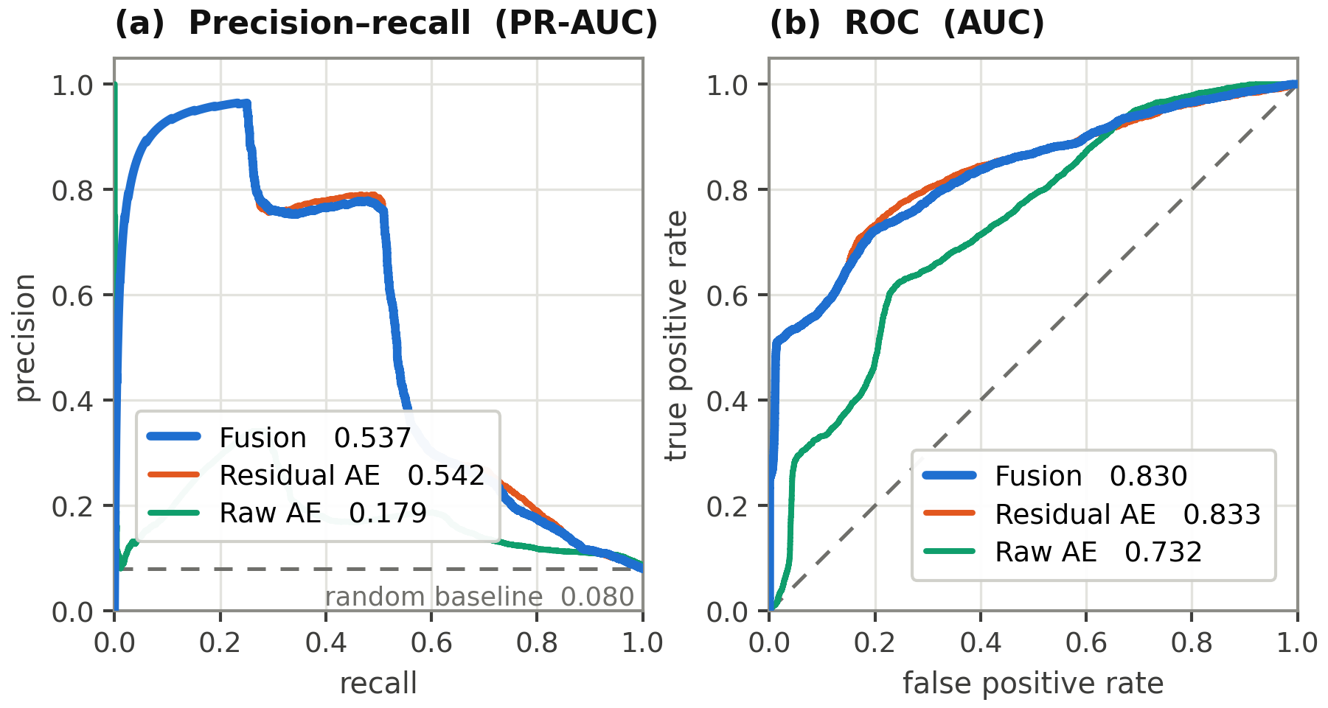
Figure 3. Precision-Recall And ROC, Severity 1× combined test-set windows (8 % prevalence, all four fault types pooled at severity 1×, not averaged over severities as Table 9 is — the small numeric offset from Table 9 follows from that difference, not from a second measurement).
Table 9. Overall Performance On The Run-Disjoint Test Set.
Model | AUC | PR-AUC | Best F1
Residual LSTM AE | 0.825 | 0.506 | 0.611
Raw LSTM AE (16 ch.) | 0.735 | 0.238 | 0.397
Fusion (w_res = 0.90, log) | 0.824 | 0.504 | 0.609
Classical baselines (Isolation Forest, One-Class SVM, a residual-norm threshold) were part of the comparison in the extension this study builds on and were not re-fitted for this revision; their omission here is a gap, not a finding, and is listed in Section 5.6. The headline number is the one the rest of this section explains rather than states plainly: in aggregate, across four fault types of very different physical character, the fused detector does not exceed the residual model alone (Best F1 0.609 against 0.611). Section 4.2 shows why an aggregate is the wrong level to read this result at.
The aggregate is a mean over fault types the residual model handles very differently, not a single operating regime, and Section 4.2 is the reason a one-line summary understates what is actually happening.
4.2. Fault-Type Asymmetry And Complementarity
Table 10 breaks the result down by fault type and severity. The asymmetry the fusion is meant to exploit is present, but concentrated in one fault type rather than spread evenly across two, as it was under the earlier, hand-chosen injection: on the encoder step the residual model is close to chance (AUC 0.505-0.550 across severities) while the raw model, though weak in absolute terms, is consistently better (0.514-0.636). On the other three fault types the residual model is equal to or clearly ahead of the raw model at every severity.
Table 10. Detection By Fault Type And Severity (AUC).
Scenario | Severity | Residual | Raw (16 ch.) | Fusion
Motor drift | 0.5× | 0.581 | 0.531 | 0.578
 | 1× | 0.838 | 0.606 | 0.820
 | 2× | 0.983 | 0.718 | 0.981
Collision | 0.5× | 0.988 | 0.862 | 0.989
 | 1× | 0.999 | 0.915 | 0.999
 | 2× | 1.000 | 0.996 | 1.000
Encoder step | 0.5× | 0.505 | 0.514 | 0.507
 | 1× | 0.517 | 0.549 | 0.520
 | 2× | 0.550 | 0.636 | 0.558
Measurement noise | 0.5× | 0.943 | 0.706 | 0.943
 | 1× | 0.991 | 0.821 | 0.990
 | 2× | 0.999 | 0.874 | 0.999
Fusion is w_res = 0.90 under the log normalisation of Section 3.6. Encoder step is the only fault type where the raw model is ahead of the residual model at every severity, and the reason is quantitative rather than architectural: a 0.3 rad step on wrist_2 changes the modelled gravity torque of the six joints by at most 0.13 Nm (computed from the same inverse dynamics solver, holding velocity and acceleration at zero), against a residual noise floor of 0.9-6.7 Nm measured on clean test windows — the fault is below the residual model's noise floor by construction, not by a limitation of the fit.
This is the physical account of why the aggregate of Section 4.1 shows no fusion gain: three of four fault types leave the residual model already close to its ceiling, where a 10 % raw-model weight can only subtract, and the fourth is exactly where the raw model earns its keep but is itself weak (AUC at best 0.636), so a small aggregate loss on the majority of fault types is not clearly repaid by a small aggregate gain on the minority. Section 4.4 returns to whether this means the ten per cent weight is misplaced.
4.3. Sensitivity To The Fusion Weight
The weight is measured, not assumed (Section 3.6): three normalisations were swept over w_res ∈ [0, 1] in steps of 0.05 on validation windows, each paired with the sixteen-channel raw model of Section 3.5. Table 11 gives the outcome.
Table 11. Fusion Weight Selected By Three Normalisations (Test Set).
Normalisation | w_res selected | Test AUC | Test PR-AUC | Test Best F1
Ratio-to-threshold | 1.00 | 0.825 | 0.506 | 0.611
Log (adopted) | 0.90 | 0.824 | 0.504 | 0.609
Empirical rank | 1.00 | 0.824 | 0.507 | 0.611
Residual alone | — | 0.825 | 0.506 | 0.611
Raw alone | — | 0.735 | 0.238 | 0.397

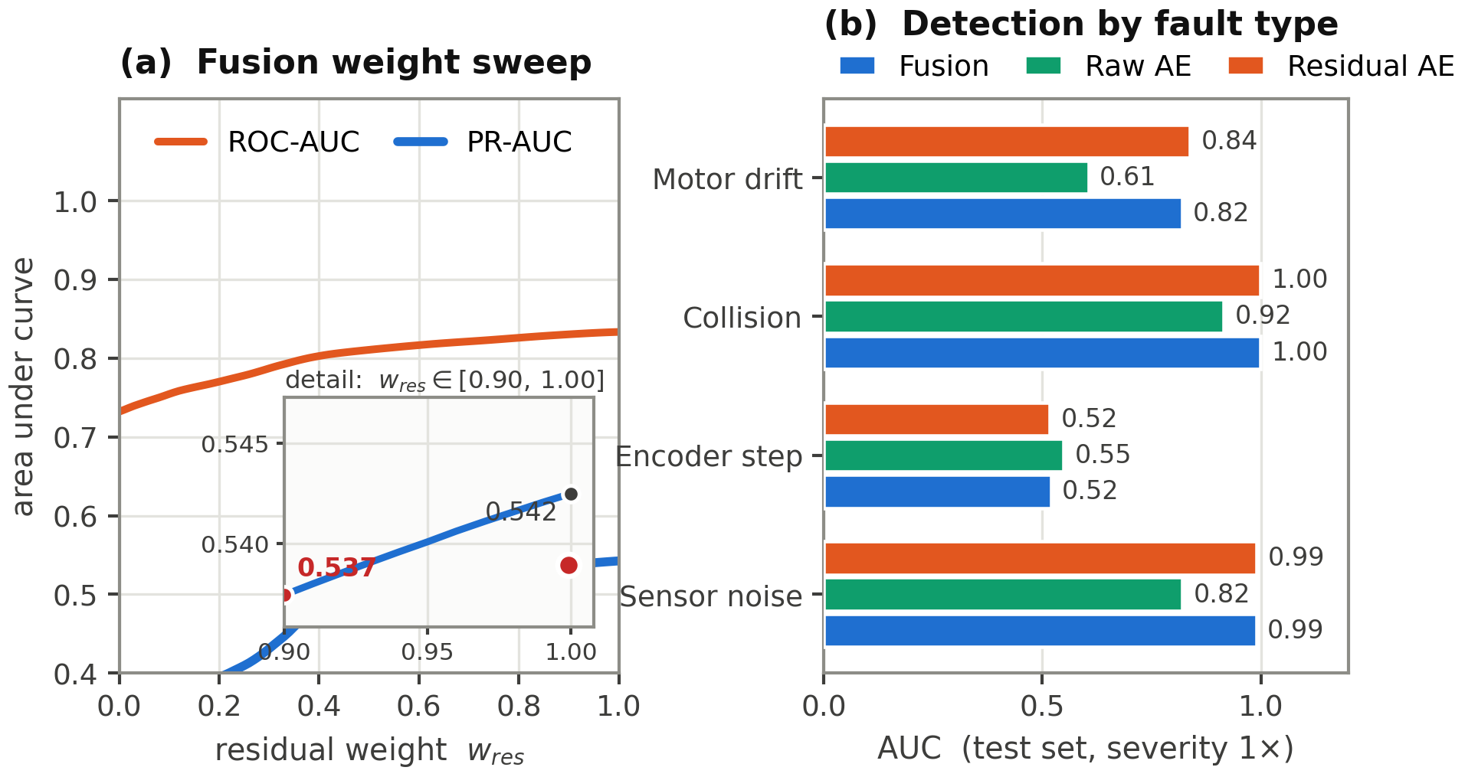
Figure 4. Fusion Weight Sweep And Per-Fault Detection (a) ROC-AUC and PR-AUC of the log-normalised fusion across w_res ∈ [0, 1], with the adopted w_res = 0.90 marked against w_res = 1.00 (residual alone) in the inset; (b) the same 1× severity row as Table 10, by fault type.
Two of three normalisations select w_res = 1.00 — no raw contribution at all — and the log normalisation, adopted because it is the only one that keeps the raw model in the fused score, selects 0.90. This is a narrow high-residual optimum, not the broad [0.25, 0.95] plateau reported by the extension this study builds on under its hand-chosen injection; under physically consistent injection the stable region has contracted to a small neighbourhood of w_res = 1. Two independent checks confirm both models genuinely run in the deployed detector regardless of weight: structurally, every fusion rule maps onto the code path exercised by the end-to-end replay of Section 3.8, and operationally, a provoked-fault replay produced an alarm attributed to both models jointly (Section 4.4).
4.4. What Sustains The Margin, KTS Removed
The extension this study builds on reported that the offline fusion margin is a property of the injection protocol: +0.189 PR-AUC by hand, −0.003 once faults were injected physically, both measured on the twelve/twenty-four-channel, wrench-carrying decomposition of that study. This paper adopts the physical protocol throughout (Section 3.7) and does not re-derive that comparison; what it can report that the earlier study could not is what the same physical protocol gives once the wrench-derived channels are removed rather than kept.
The result is small and normalisation-dependent rather than a return to the earlier positive margin. Under log normalisation the fused detector is within 0.002 AUC and 0.002 PR-AUC of the residual model alone (Table 9) — neither a gain nor the earlier study's clearly negative −0.003, but a value close enough to zero that two of three normalisations round it to exactly zero by selecting w_res = 1. The one place a positive contribution is unambiguous is the encoder fault (Table 10), where it follows from physics rather than from a chosen injection amplitude: the residual channel this fault would have to move through carries under 0.13 Nm of signal against several newton-metres of noise, a relationship fixed by the robot's own gravity term and not by any modelling choice made in this pipeline. Removing the wrench channel therefore does not resurrect the predecessor's fusion advantage; it replaces a margin manufactured by an unphysical injection amplitude with a smaller, fault-type-specific one that has a stated physical cause.
This is not evidence that the raw model is dispensable at the level of an individual decision. During the end-to-end replay of Section 3.8, one provoked torque-pulse fault was flagged by both models exceeding their own thresholds simultaneously; a single such observation is reported as what it is, one qualitative data point from a live class, not as a statistic, and the systematic version of this question is left to the hardware commissioning of Section 4.6.
4.5. Latency And Compute Budget
Per sample, the inverse dynamics evaluation costs 26 µs and the Jacobian-based payload term about 96 µs, together under 0.03 % of the 500 Hz budget, measured in an offline batch benchmark of the same feature code the online engine runs. Per decision, the deployed ROS 2 node — both feature extraction and both ONNX forward passes together, measured on the physical cell during the replay of Section 3.8 — costs 6.05 ms, 12 % of the 50 ms budget, on CPU; a single ONNX pass of the residual model alone, benchmarked separately, is 1.82 ms. The overall figure is close in relative terms to the 12 % reported by the extension this study builds on, despite the raw model's input channels falling by a third, because the payload term of Section 3.4 adds a Jacobian evaluation the earlier feature engine did not need.
The detection latency is, as before, the sum of the 50 ms filter delay and the 50 ms decision period, plus one more decision period when the two-consecutive rule is active, giving 100-150 ms end to end. A per-fault-type latency distribution, measured by the extension this study builds on from an end-to-end replay of live data through the deployed class, was not repeated for this revision and is deferred to the commissioning trial of Section 4.6, where it can be measured together with the threshold it depends on rather than separately from it.
4.6. Commissioning On The Real Robot
All results in Sections 4.1-4.5 were obtained on the recorded dataset; this section reports what happened once the detector was run on the physical cell. The trial covered three of the four production tasks of Section 3.1 — UR10E_INSPECTION, HRC and PICKPLACE — across two sessions (30 September and 1 October 2026); MULTIROBOT_INSPECTION had not been exercised at the time of writing and is listed with the other gaps in Section 5.6.
The first session produced 314 triggered alarms across nine runs, of which an operator confirmed 5 against the physical event and labelled the remaining 309 false — a false-alarm rate the predecessor's own commissioning never approached. The cause was not the threshold. Every one of the nine runs' provenance records showed the same use_case value, UR10E_INSPECTION, although six of the nine were later established to be HRC or PICKPLACE sessions: the launch argument that selects Section 3.4's task-conditioned correction carries a default, and nothing enforced that it be overridden. The effect is systematic rather than occasional. On the one run later confirmed unaffected (14,121 decisions, zero alarms) the fused score's regime medians were −0.49 (static) and +0.99 (moving); on the six mis-tagged runs the static median alone ranged up to +2.41 — a shift in the body of the distribution, not its tail. Recalibrating the threshold from the one clean run and backtesting it against all nine confirms the diagnosis rather than fixing it: total alarms across the nine runs rose from 159 to 177 under the two-consecutive-decision rule of Section 3.6, because no single cut can separate ordinary operation from wrongly-corrected operation once the whole distribution has moved. This is a different failure from the one Section 5.3 reasoned about in advance: the log-domain normalisation adopted there defends against one atypical window dominating an affine threshold, and nothing in this campaign defeated it on that front — every one of the seven genuine events below remained clearly separated from its threshold throughout. What defeated detection here was a wrong task label feeding the correction a wrong physical model, a failure mode no choice of normalisation addresses.
The mechanism is visible directly in motor current. During HRC's screw-driving contact phase, shoulder and elbow current measured 4-11 A and up to 6.5 A respectively, against under 2 A during the same task's non-contact motion — a real, task-specific reaction torque the correction for a different task's payload and friction does not model. The fix addresses the cause rather than the symptom: the use_case launch argument was made genuinely mandatory (the launch description now refuses to start without one of the four valid values), and the detector was given a live watchdog on the operator dashboard's own task broadcast, raising an operator-visible error the instant the two disagree rather than leaving two independently-maintained copies of "which task is running" to drift apart silently.
With the task label corrected, the task-conditioned correction behaved as Section 3.4 intended: the HRC session's regime medians (0.41 moving, against the clean baseline's 0.99 — if anything lower) showed no shift at all. What remained was a second, narrower problem specific to tasks that involve deliberate contact: the fixed, shared operating threshold of Section 3.6 was fitted offline on a mix of tasks and was not set to tolerate a task's own legitimate contact phase. Table 12 reports the result of fitting one operating threshold per task instead, at the 99.99th percentile of that task's own clean on-site decisions rather than carried over from the offline validation split, and backtesting it against every recorded session for that task; the 99.9th percentile of the same sessions was tried first and rejected — it still left 2 of HRC's 9 false alarms and 2 of PICKPLACE's 16 uncorrected (while still separating every confirmed genuine event cleanly), the task's own contact phase crossing it too often for the margin to be useful.
Table 12. Real-Robot Commissioning, Before And After Task-Specific Thresholds.
Task | Decisions | Confirmed events | Alarms, shared offline θ | Alarms, task-specific θ
UR10E_INSPECTION | 6,819 | 0 | 0 | — (unchanged)
HRC | 11,654 | 0 | 9 | 0
PICKPLACE | 15,232 | 2 | 18 | 2 (both confirmed)
MULTIROBOT_INSPECTION | — | — | — | not yet run
θ_task is the 99.99th percentile of the task's own clean on-site decisions (Section 3.6 quantile family), fitted separately per regime; UR10E_INSPECTION was not refitted because its shared offline threshold already produced zero alarms on site (static / moving p99.9 on-site: 1.66 / 3.52, against 2.14 / 3.90 offline — looser, not tighter, so no correction was needed).
Across the two sessions, seven alarms were operator-confirmed against the physical event rather than labelled false. Six remained separated from the fused, log-normalised threshold by a factor of 1.4-1.6×, and the underlying residual sub-model's own reconstruction error exceeded its threshold by 64-128× on these six — the margin Section 5.3 reasoned the log-domain normalisation should preserve. The seventh, the only confirmed event in the static regime, cleared its task-specific threshold by 11 % (4.43 against 4.0) — the current calibration's thinnest margin, fitted from a single session, and flagged here rather than smoothed over. One confirmed PICKPLACE event stayed latched for its full 205 s because the arm halted inside the faulted configuration instead of recovering from it, which Figure 5 shows on a shorter, equivalent case: the dashboard of Section 3.9 during a live replay of a different confirmed event, the fused score stepping from a noisy baseline near 2 to a sustained plateau near 6 and holding there for the full 10 s window shown. The plateau is not an artefact of the two-consecutive-decision rule; it is the direct consequence of the robot not leaving the pose the fault was detected in, and the dashboard's own "since last alarm" field reads zero for as long as that remains true.
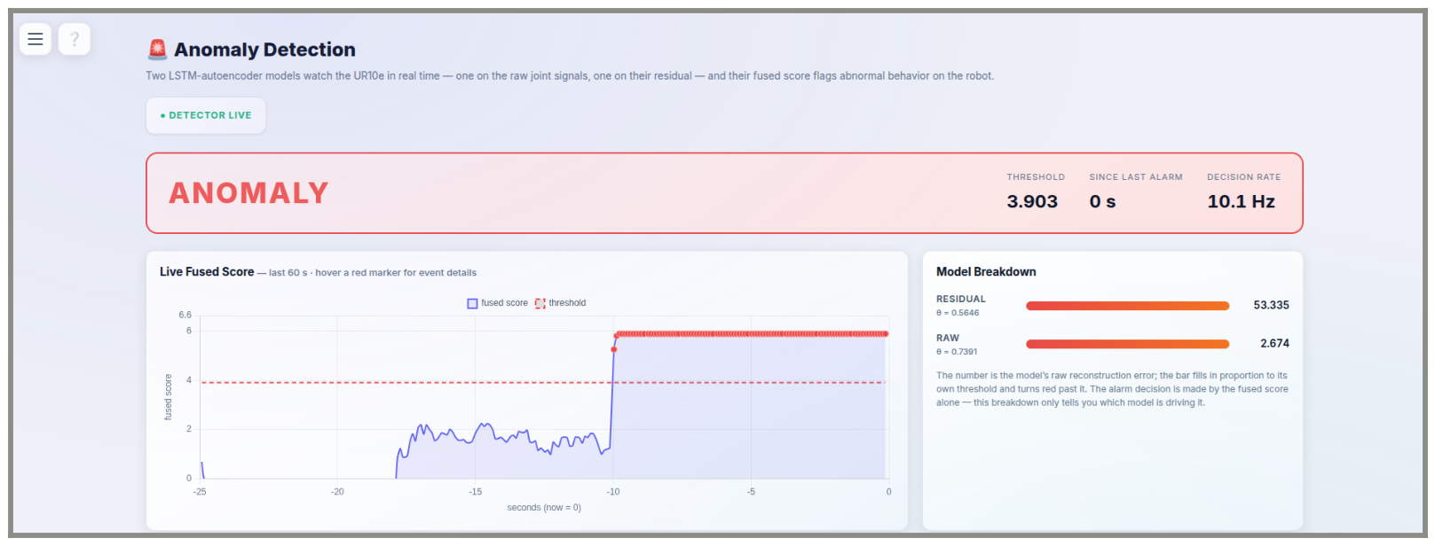
Figure 5. Operator Dashboard During A Confirmed Real Event screen capture taken from a live replay (Section 3.9) of a recorded PICKPLACE session, not from the robot directly — robot and detector are both idle during capture, and the dashboard cannot distinguish the two. The fused score (blue) crosses the moving-regime threshold (red, dashed) nine seconds before the capture and remains above it for the rest of the window because the arm halts in the faulted pose rather than recovering from it.
The adaptive rule of Section 3.8 was left disabled throughout this campaign, matching the predecessor's default; whether the task-conditioned correction has reduced the pose-dependence that motivated disabling it was not re-evaluated here and remains open. The per-fault-type latency distribution Section 4.5 deferred to this trial was likewise not captured — every alarm observed here was a genuine event or a mis-corrected one, not a provoked fault with a known onset time to measure latency against — and is carried forward as an outstanding measurement in Section 5.6. The encoder-specific fusion contribution Section 4.4 asked whether a genuine fault would show was not settled either: none of the seven confirmed events was an encoder-type fault, and the question remains open to whichever task next produces one.
4.7. A Second Threshold: Early Warning And Automatic Pause
The gap between the two percentiles compared in Section 4.6 — wide enough that the lower one (p99.9) still let through two of HRC's nine false alarms and two of PICKPLACE's sixteen, the higher one (p99.99) none — suggested a use for the rejected threshold rather than discarding it: a second, lower-stakes tier. Added to the deployed node after the campaign above and not yet exercised on the physical cell, it is reported here as an implementation addition, not as a further finding.
Every decision is now checked against both percentiles of Table 12's task-specific table independently. Crossing p99.9 changes nothing about the robot; it latches a separate, debounced signal that the operator dashboard surfaces as a dismissible, auto-clearing notice, distinct from the alarm banner Section 3.9 describes. Crossing p99.99 — the operating threshold Sections 3.6 and 4.6 already act on — now additionally calls the ROS 2 driver's dashboard-server pause service on the alarm's rising edge, pausing whichever program is currently loaded and running on the controller, the External Control URCap node in every task reported here.
This is explicitly not the safety-rated protective stop the robot's own monitoring or a Configurable Safety Input can trigger: a UR controller does not expose that function to software, by design, so pausing the loaded program is the available substitute. It is not cosmetic — pausing also drops the reverse communication interface the ROS driver depends on, documented upstream as "Connection to reverse interface dropped" — but recovery is a single deliberate action (teach-pendant Play, or the equivalent dashboard call under remote control) rather than the fuller recovery an emergency stop requires. The operator who deployed this addition accepted manual resumption as the operating assumption; the feature defaults to enabled on that basis and can be disabled per launch. Whether it fires at the intended rate on genuine hardware operation, rather than only in the offline backtest of Section 4.6, is accordingly listed with the other untested additions in Section 5.6.
5. Discussion
5.1. What Removing The Force/Torque Channel Changed
The extension this study builds on found that its measured fusion advantage was manufactured by a hand-chosen injection amplitude rather than by genuine complementarity, and traced the mechanism to the extrinsic residual's linear sensitivity to the wrench. This study asked the next question the finding raises — is the wrench channel itself trustworthy — and found that it is not: it is a controller estimate, not a measurement, and its influence on the residual was seven times larger between tasks than the influence of every other source of disturbance combined. Removing it is therefore not offered as a simplification but as the correction the predecessor's own finding points to.
What replaces the removed channel is not nothing. The payload term of Section 3.4 restores, outside the validated solver and per task rather than globally, the one physical effect a wrench channel could legitimately have carried — a sustained load at the flange — while leaving out its transient, contact-detecting role entirely; Section 5.6 returns to what that trade costs. On the data available, the replacement generalises where a simpler one did not: a single global offset, tried first, reduced training-session residual spread but reversed sign on at least one task's held-out sessions (Section 3.4), while the task-conditioned payload term reduces spread on every split for every joint (Table 5).
5.2. The Fusion Margin Under A KTS-Free Residual
The central offline finding of the extension this study builds on was negative and concerned its own evaluation: a fusion margin of +0.189 PR-AUC under hand-chosen injection collapsed to −0.003 once the same faults were injected physically. This study does not re-derive that comparison — it adopts the physical protocol throughout, as the predecessor's finding recommends — and asks instead what the physical protocol gives once the decomposition it operates on no longer includes a wrench term. The answer is a second, smaller negative result rather than a reversal: in aggregate the fused detector is statistically indistinguishable from the residual model alone (Table 9), and two of three normalisation schemes select a fusion weight of exactly 1.0 — no raw contribution — when left to choose freely (Table 11).
Where a contribution is measurable, it has a stated physical cause rather than a chosen injection amplitude. The encoder-step fault moves the residual channels by under 0.13 Nm, a figure computed from the same inverse dynamics solver rather than assumed, against a multi-newton-metre residual noise floor; the residual model's blindness to this fault type is therefore a property of the robot's own gravity term at that joint, not of the fit. The raw model's advantage there is real (Table 10) but itself modest, which is the honest reading of why the measured weight settles at 0.90 rather than lower: enough to keep a small, physically grounded contribution, not enough to let it cost much on the three fault types it does not help with.
5.3. Why A Log-Domain Normalisation Was Adopted Before Testing On Hardware
The predecessor's commissioning traced its threshold-transfer failure to a specific mechanism: a min–max bound fitted on clean validation windows can be set by whichever window reconstructed worst, and one atypical window then compresses the entire ordinary range to invisibility once the deployment distribution shifts even slightly — exactly what an unmodelled payload plateau did to that study's residual span. This mechanism is a property of an affine transform applied to a heavy-tailed distribution, not of any one dataset, and it does not depend on the wrench channel that study's payload plateau happened to involve. The log-domain normalisation of Section 3.6 was adopted for exactly this reason, before rather than after a commissioning failure repeated it: standardising log₁₀(score) maps the bulk of a heavy-tailed distribution to a bounded range and lets the tail extend rather than dominate it. Whether this is sufficient — a payload swing an order of magnitude larger than any single training session, or a task the calibration run did not cover, could still defeat it — is exactly what Section 4.6 will measure, and this section records the reasoning in advance so that a favourable or unfavourable result on hardware can be attributed to a stated hypothesis rather than assessed after the fact.
5.4. What The Task-Conditioned Correction Bought
Adding friction and a task-conditioned payload term outside the solver reduces total residual spread by 42-48 % on validation and test sessions the fit never saw, on every one of six joints (Table 5). That is measured generalisation, not a training-set fit: the same correction, restricted to a single global offset, reduced spread on training sessions comparably well but reversed sign on held-out sessions of at least one task (Section 3.4), which the task-conditioned version does not.
Whether the correction also changes detection of the four synthetic faults of Section 3.7, as opposed to the shape of the residual it is computed from, was not re-tested against a no-correction baseline this round — the extension this study builds on ran exactly that ablation for its own friction term and found a physical-fidelity gain with no significant detection gain under physical injection. Repeating it for the combined friction-and-payload term is listed among the items outstanding in Section 5.6 rather than assumed to repeat.
5.5. Limitations Carried Over From The Force/Torque Removal
Removing the wrench channel removes a real capability along with the unreliable one: whatever transient, contact-shaped signal a working force/torque sensor would have supplied is now not available to either model at any weight, at exactly the fault type — collision — where the predecessor's hardware commissioning found both models saturating identically and therefore uninformative about which channel actually carried the detection. The collision scenario of Section 3.7 is injected directly into joint torque for the same reason, and is correspondingly a weaker stand-in for a real contact event, propagated through no Jacobian and referenced to no contact point, than the wrench-based injection it replaces. This is a genuine reduction in scope, accepted because the channel it removes was not doing what it was assumed to do, not because the capability was unneeded.
5.6. Limitations
• A single robot type (UR10e), now across four task profiles rather than one; no validation on other robot types has been performed.
• Synthetic faults, even injected physically, remain analytic perturbations, and the collision scenario is a weaker stand-in for a real contact event than before, now that it is injected directly into joint torque rather than propagated from an assumed contact point through the Jacobian (Section 5.5).
• The current-to-torque coefficient could be measured directly on only two of six joints by the RTDE method, the same two as by the earlier quasi-static method; the other four are derived by assumption, which affects the physical interpretation rather than the detection.
• The friction and payload coefficients are fitted jointly by a regression that absorbs any velocity- and pose-correlated model error, not friction or payload alone; the fitted centre-of-gravity offset is not separately identifiable at the small extra-mass magnitudes found here (Table 4) and is not reported as measured. No independent tribological or mass validation was performed.
• Whether the task-conditioned correction changes detection of the four synthetic faults, as opposed to the residual's held-out spread, was not re-tested this round (Section 5.4).
• A single training seed is reported; the five-seed sensitivity study of the extension this study builds on, which showed the ranking metrics stable to within 0.01 across seeds and the operating threshold varying by up to 46 % of its mean, was not repeated.
• Classical baselines (Isolation Forest, One-Class SVM, a residual-norm threshold) and the architecture and fusion-weight-sweep figures of the extension this study builds on were not regenerated for this revision.
• Hardware commissioning (Section 4.6) covered three of the cell's four production tasks; MULTIROBOT_INSPECTION was not exercised. Within the three, each task's operating threshold was fitted from a single on-site session — the PICKPLACE static-regime margin it produced (11 %) is the calibration's thinnest point and a larger clean sample would plausibly widen it. The per-fault-type latency distribution and the encoder-specific fusion contribution on a genuine fault, both deferred to the trial in Sections 4.5 and 4.4, were not settled by it: no provoked fault with a known onset was run, and none of the confirmed events was an encoder-type fault. Whether the adaptive rule's pose-dependence (Section 3.8) was reduced by the task-conditioned correction was not re-evaluated; it was left disabled throughout.
• The early-warning notice and automatic pause of Section 4.7 were added after the campaign above and have not been exercised on the physical cell; their only evidence is the offline backtest Section 4.6 already reports for the two percentiles involved.

6. Conclusions
This paper re-examined the residual definition of a score-level fusion framework for cobot anomaly detection, previously extended to a physical UR10e cell across a single task, and found that the channel the extrinsic half of its residual depended on is not a physical measurement. Every measurement taken on the way is reported, including the ones unfavourable to the resulting design.
The finding is traceable to the driver source and confirmed quantitatively: the ROS 2 hardware interface populates the wrench topic from the controller's own payload-compensated force estimate, and the field that would carry a genuine strain-gauge signal reads a constant, implausible offset. Across four production tasks now recorded on the same cell, the resulting task-dependent noise in a wrench-derived residual (20.9 Nm between tasks) is roughly seven times larger than the total residual's own spread once the channel is removed (3.1 Nm). The twelve-channel intrinsic/extrinsic split was withdrawn on this evidence, replaced by a single six-channel total residual, and the raw model's channels were reduced from twenty-four to sixteen — removing the same wrench channels and, on separate empirical evidence, two joint-position channels a wrap-around encoding was shown not to fix.
In place of the withdrawn split, the missing payload term was added outside the validated solver, conditioned on which of four production tasks is running, alongside the friction term of the predecessor. Fitted on 3.26 million training samples and evaluated on sessions it never saw, it reduces total residual spread by 42-48 % on every joint, where a single global offset tried first reduced training-session spread comparably but reversed sign on held-out sessions of at least one task.
Under fault injection restricted to the measured channels — the protocol the predecessor's own principal finding established as the only meaningful one — the fusion weight is now measured rather than assumed and converges to a narrow high-residual optimum (0.90-1.00 across three normalisations), an order narrower than the broad plateau reported before. In aggregate the fused detector no longer exceeds the residual model alone (Best F1 0.609 against 0.611); the one measurable, physically grounded exception is an encoder fault the residual model is blind to by construction, where a 0.3 rad step moves the modelled gravity torque by under 0.13 Nm against a multi-newton-metre noise floor. Removing the force/torque channel therefore does not restore the predecessor's offline fusion advantage; it replaces a margin manufactured by an unphysical injection amplitude with a smaller one that has a stated physical cause.
The system was re-implemented as a ROS 2 node without the removed channel, and its feature engine was re-verified against the offline pipeline (largest observed deviation 1.5·10⁻⁶ Nm in the residual). Commissioned on three of the cell's four production tasks, it reproduced the predecessor's hardware finding in a different form: the offline threshold did not fail by the mechanism the predecessor traced and this revision's log-domain normalisation was adopted to pre-empt, but by a task-selection defect that fed the task-conditioned correction the wrong task's physical model on six of nine initial runs, shifting the body of the score distribution rather than its tail and producing 309 false alarms against 5 genuine ones. Corrected, the same correction behaved as intended — zero false alarms against seven operator-confirmed events across the three tasks tested, with one task's threshold, the only one measured on site both before and after the defect, found to need no correction at all (its offline threshold had been the looser one). The task-conditioned correction therefore does narrow the predecessor's transfer gap, but only once a task-selection failure with no relationship to the residual definition is first ruled out — a precondition the predecessor's single-task deployment could not have exposed and this one did by construction.
Two directions follow, one carried over unchanged and one specific to this revision. Real-time detection of low-amplitude contact remains an open problem the predecessor identified and this study did not address, and closing it plausibly needs either a model trained on the cell's own trajectories or a genuine force/torque channel rather than the withdrawn one — a fitted correction outside the solver, however well it generalises, is not a substitute for a transducer where a transducer is actually required. Specific to this revision: the fourth production task, MULTIROBOT_INSPECTION, remains uncommissioned; each task's operating threshold rests on a single on-site session, narrowly so on one of three (Section 5.6); and the per-fault-type latency distribution and the encoder-specific fusion contribution on a genuine rather than injected fault, both deferred to the commissioning trial, were not settled by it and remain open to whichever future session produces a provoked or encoder-type event.
Acknowledgement
The project is supported by the KDT Joint Undertaking (101140216) and its members, including additional funding from Vinnova (Sweden), Österreichische Forschungsförderungsgesellschaft mbH – FFG (Austria), Business Finland (Finland), Ministry of Universities and Research (Italy), FCT (Portugal) and TÜBİTAK (124N448) (Türkiye). The measurements were carried out at the Autonomous Systems and Reliability Laboratory of the ESOGÜ Intelligent Systems Application and Research Centre.
Contribution Of Researchers
Author 1: design and implementation of the offline pipeline, the audit and the ROS 2 detector node, commissioning measurements, preparation of the manuscript. Author 2: … . Author 3: … . (To be completed by the authors.)
Conflict Of Interest
No conflict of interest has been declared by the authors.
References
Blochwitz, T., Otter, M., Arnold, M., Bausch, C., Clauß, C., Elmqvist, H., … Wolf, S. (2011). The Functional Mockup Interface for tool independent exchange of simulation models. Proceedings of the 8th International Modelica Conference, 105–114, Dresden, Germany.
Correia, L., Goos, J. C., Klein, P., Bäck, T. & Kononova, A. V. (2024). Online model-based anomaly detection in multivariate time series: Taxonomy, survey, research challenges and future directions. Engineering Applications of Artificial Intelligence, 138, 109323.
Darban, Z. Z., Webb, G. I., Pan, S., Aggarwal, C. C. & Salehi, M. (2024). Deep learning for time series anomaly detection: A survey. ACM Computing Surveys, 57(1), 1–42.
Haddadin, S., De Luca, A. & Albu-Schäffer, A. (2017). Robot collisions: A survey on detection, isolation, and identification. IEEE Transactions on Robotics, 33(6), 1292–1312.
Huang, X., Chen, N., Deng, Z. & Huang, S. (2024). Multivariate time series anomaly detection via dynamic graph attention network and Informer. Applied Intelligence, 54, 7636–7658.
Katsampiris-Salgado, K., Dimitropoulos, N., Gkrizis, C., Michalos, G. & Makris, S. (2024). Collision detection for collaborative assembly operations on high-payload robots. Robotics and Computer-Integrated Manufacturing, 87, 102708.
Leys, C., Ley, C., Klein, O., Bernard, P. & Licata, L. (2013). Detecting outliers: Do not use standard deviation around the mean, use absolute deviation around the median. Journal of Experimental Social Psychology, 49(4), 764–766.
Li, W., Han, Y. & Xiong, Z. (2020). Collision detection of robots based on a force/torque sensor at the bedplate. IEEE Transactions on Industrial Electronics, 67(12), 12440–12449.
Liu, K., Wang, L., Zhang, X., Sun, Y. & Li, J. (2025). Anomaly detection in multidimensional time series for water injection pump operations based on LSTMA-AE and mechanism constraints. Scientific Reports, 15.
Macenski, S., Foote, T., Gerkey, B., Lalancette, C. & Woodall, W. (2022). Robot Operating System 2: Design, architecture, and uses in the wild. Science Robotics, 7(66), eabm6074.
Malhotra, P., Ramakrishnan, A., Anand, G., Vig, L., Agarwal, P. & Shroff, G. (2016). LSTM-based encoder-decoder for multi-sensor anomaly detection. arXiv preprint arXiv:1607.00148.
Malhotra, P., Vig, L., Shroff, G. & Agarwal, P. (2015). Long short term memory networks for anomaly detection in time series. Proceedings of the European Symposium on Artificial Neural Networks (ESANN), 89–94, Bruges, Belgium.
Park, D., Hoshi, Y. & Kemp, C. C. (2018). A multimodal anomaly detector for robot-assisted feeding using an LSTM-based variational autoencoder. IEEE Robotics and Automation Letters, 3(3), 1544–1551.
Savitzky, A. & Golay, M. J. E. (1964). Smoothing and differentiation of data by simplified least squares procedures. Analytical Chemistry, 36(8), 1627–1639.
Yılmaz, C. S., Kahraman, S., Yılmaz, M., Yavuz, H. S. & Yayan, U. (2026). FMU tabanlı kalıntı ayrıştırma ve ikili LSTM özkodlayıcı birleşimi ile işbirlikçi robotlarda anomali tespiti [FMU-based residual decomposition and dual LSTM autoencoder fusion for anomaly detection in collaborative robots]. ⟨KONFERANS ADI VE YERİ — yazarlar tarafından tamamlanacaktır⟩ kurultayında sunulmuş bildiri, Türkiye.
Zhang, T., Chen, Y. & Zou, Y. (2024). Robot collision detection based on external torque observer. Journal of South China University of Technology, 52(3), 84–92.
Zhao, W., Queralta, J. P. & Westerlund, T. (2020). Sim-to-real transfer in deep reinforcement learning for robotics: A survey. 2020 IEEE Symposium Series on Computational Intelligence (SSCI), 737–744, Canberra, Australia.

