Blower door to ESP-r AIM-2 Inputs

This document is with reference to the AIM model and the required inputs to ESP-r. It is a result of confusion and conflicts in the existing documentation.

Four documents referenced to gain understanding are of the implementation are:

* Bradley, B. 1993. Implementation of the AIM-2 infiltration model in HOT2000. NRCan
* Beausoleil-Morrison, I. 2000. AIM-2 implementation in ESP-r. NRCan
* CAN/CGSB-149.10-M86. 1986. Determination of the airtightness of building envelopes by the fan depressurization method. Canadian General Standards Board.
* <http://en.wikipedia.org/wiki/Orifice_plate>

# Air infiltration and blower door measurement

Air infiltration (the leakage of air in/out) of a house is a function of pressure differential and airtightness characteristics. The AIM-2 model has been suggested to assess these things and determine a flowrate and proportioning of infiltrating air to an ESP-r house model. AIM-2 considers both:

* Wind induced pressure differential caused by air velocities around the house thermal envelope
* Stack effect pressure differential caused by the buoyancy difference of the internal and external air temperatures

In Canada, the airtightness characteristics of a house are determined using a depressurization technique. This technique utilizes a fan to impose a pressure difference across the thermal envelope of the house, and measures the resulting air flowrate. This is completed according to CAN/CGSB-149.10-M86 (1986). The results of such a test are shown in the following table:

Table Depressurization test on 72 Oceanic Dr., Lawrencetown Beach, NS, B2Z 1T6, 27/08/2009, volume of conditioned zone is 588 m3

|  |  |
| --- | --- |
| Depressurization pressure (Pa) | Flowrate (m3/s) |
| 50.7 | 0.26 |
| 45.7 | 0.23 |
| 40.7 | 0.21 |
| 35.9 | 0.19 |
| 30.6 | 0.18 |
| 25.2 | 0.16 |
| 20.2 | 0.13 |
| 13.3 | 0.09 |

# Flow coefficient and flow exponent

When these values are plotted, it may be seen that a power law profile consisting of a coefficient and exponent can be used to represent the function. The equation is:

$$Q=C_{\text{F}}{∆P}^{n}$$

with flowrate $Q \left(\frac{{\text{m}}^{3}}{\text{s} }\right)$, flow coefficient $C_{\text{F}} \left(\frac{{\text{m}}^{3}}{\text{s} {\text{Pa}}^{n}}\right)$, pressure $P \left(\text{Pa}\right)$, and flow exponent $n$. A simple power law curve was fit to the depressurization test data, and after manipulating the $C_{\text{F}}$ and $n$ values, fit well. The values are shown in the figure.

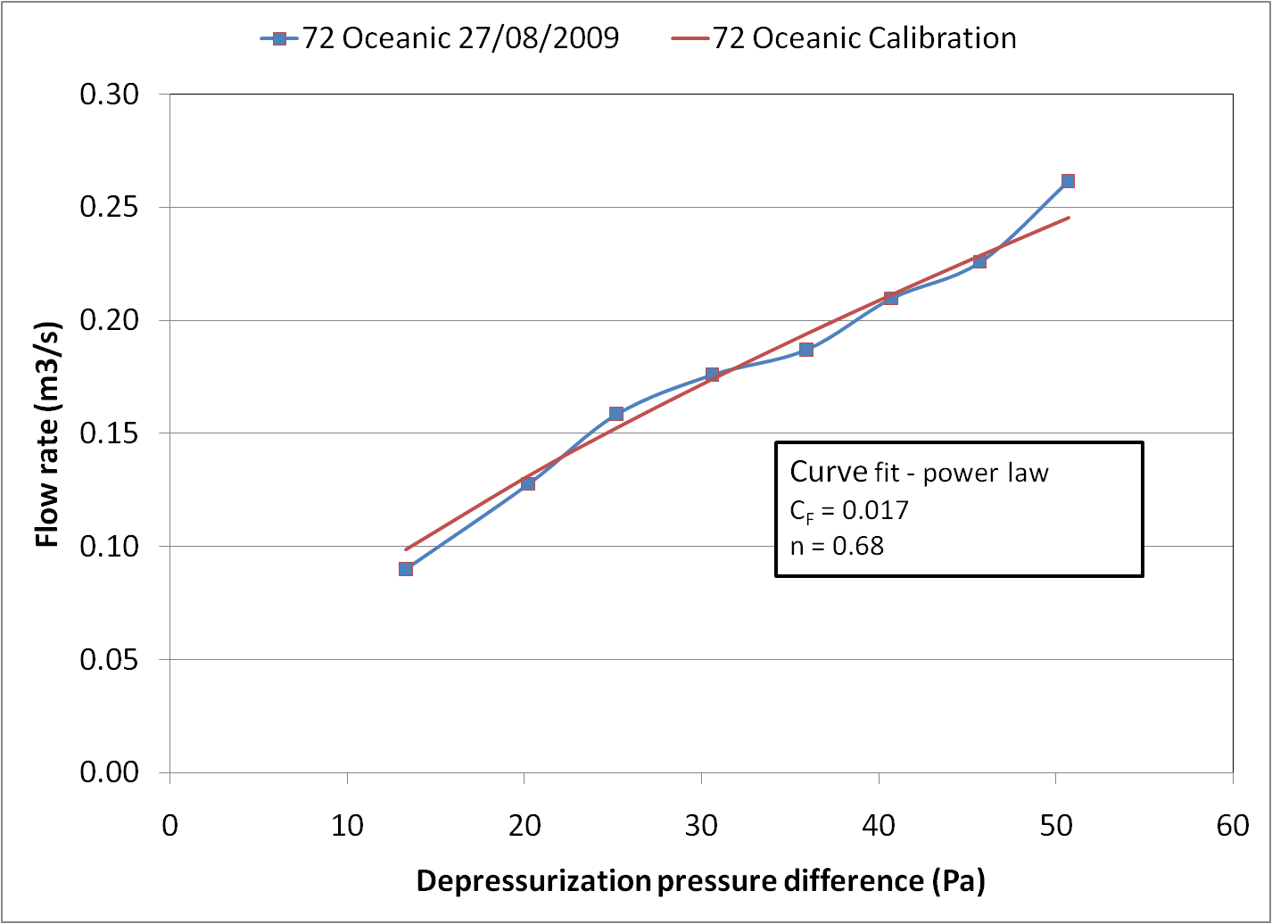

Figure Depressurization results and applied power law curve fit to 72 Oceanic

The values of flow coefficient $C_{\text{F}}$ and flow exponent $n$ are required by AIM-2 for use in ESP-r. The functionality in ESP-r solves for the total wind induced and buoyancy pressure difference and applies the flow coefficient and flow exponent to determine the infiltration flowrate.

# Common presentation of air infiltration results

However, instead of providing the flow coefficient and flow exponent values, the test method in Canada often calls for a presentation of the following:

* AC/h50 (unitless) which is the number of air volume changes of the thermally conditioned zone in one hour at a pressure difference of 50 Pa (a very high value)
* ELA10 (cm2)which is the effective leakage area of the thermal envelope at a pressure difference of 10 Pa (a more typical number)
* VOL (m3) is the volume of the thermally conditioned zone

## Air changes per hour

Using the power law (with determined coefficients and exponents) the flowrate at 50 Pa pressure difference may be calculated. The AC/h50 is determined by dividing this flowrate by the house volume and converting from seconds to hours:

$${AC/h}_{50}=\frac{Q_{50}}{VOL}×\frac{3600 \text{s}}{\text{h}}$$

## Estimated leakage area

The ELA10 is more difficult to determine and requires reference to orifice flow. From Wikipedia: *By assuming steady-state,* [*incompressible*](http://en.wikipedia.org/wiki/Incompressible_flow) *(constant fluid density),* [*inviscid*](http://en.wikipedia.org/wiki/Inviscid_flow)*,* [*laminar*](http://en.wikipedia.org/wiki/Laminar_flow) *flow in a horizontal pipe (no change in elevation) with negligible frictional losses,* [*Bernoulli's equation*](http://en.wikipedia.org/wiki/Bernoulli%27s_principle) *reduces to an equation relating the conservation of energy between two points on the same streamline*. Combining this with the continuity equation results in the following Wikipedia equation:



where area is $A$ (in terms for this document ELA), diameter is $d$, and density is $ρ \left(\frac{\text{kg}}{{\text{m}}^{3}}\right)$ (see Wikipedia for more description).

In the treatment of a house, the diameter relationship becomes zero, and the orifice has a discharge coefficient $C_{\text{D}}$ (unitless) which acts as a restriction coefficient that linearly impacts the flowrate $Q$.

Thus, the equation simplifies to:

$$Q=C_{\text{D}} \text{ELA} \sqrt{\frac{2∆P}{ρ}}$$

As the intention is to determine the ELA10, we can rearrange the previous equation, solving for ELA, and replacing $Q$ with the power law equation.

$$\text{ELA}=\frac{C_{\text{F}}{∆P}^{n}}{C_{\text{D}}\sqrt{\frac{2∆P}{ρ}}}=\frac{C_{\text{F}}{∆P}^{\left(n-0.5\right)}}{C_{\text{D}}\sqrt{\frac{2}{ρ}}}$$

It may be shown by a unit analysis that $\text{ELA}$ is in units of m2 and thus a conversion factor (104) must be applied to achieve the units of cm2. For housing efforts, the orifice discharge coefficient $C_{\text{D}}$ is 0.611 (Bradley 1993)

## 72 Oceanic example

For clarity, the AC/h50, and ELA10, are calculated here for the 72 Oceanic house.

The house conditioned zone volume: $\text{VOL}=588 {\text{m}}^{3}$

From the test data: $C_{\text{F}}=0.017 \frac{{\text{m}}^{3}}{\text{s} {\text{Pa}}^{n}}$, $n=0.68$

From the orifice discussion: $C_{\text{D}}=0.611$

Air density at standard temperature and pressure: $ρ=1.2 \frac{\text{kg}}{{\text{m}}^{3}}$

$$Q_{50}=C_{\text{F}}{∆P}^{n}=0.017 \frac{{\text{m}}^{3}}{\text{s} {\text{Pa}}^{n}}×{50 \text{Pa}}^{0.68}=0.243 \frac{{\text{m}}^{3}}{\text{s} }$$

$${AC/h}_{50}=\frac{Q_{50}}{VOL}×\frac{3600 \text{s}}{\text{h}}=\frac{0.243 \frac{{\text{m}}^{3}}{\text{s} }}{588 {\text{m}}^{3}}×\frac{3600 \text{s}}{\text{h}}=1.49 {\text{h}}^{-1}$$

$${ELA}_{10}=\frac{C_{\text{F}}{∆P}^{\left(n-0.5\right)}}{C_{\text{D}}\sqrt{\frac{2}{ρ}}}=\frac{0.017 \frac{{\text{m}}^{3}}{\text{s} {\text{Pa}}^{n}}×{10 \text{Pa}}^{\left(0.68-0.5\right)}}{0.611×\sqrt{\frac{2}{1.2 \frac{\text{kg}}{{\text{m}}^{3}}}}}=0.0326 {\text{m}}^{2}×\frac{10000 {\text{c}\text{m}}^{2}}{{\text{m}}^{2}}=326 {\text{c}\text{m}}^{2}$$

$${ELA}_{10}$$

# AIM-2 implementation in ESP-r

The *.aim file holds the air infiltration characteristics of the house for use by the building simulation engine *bps*. The file is fixed format and the first two data lines are of interest for describing the information covered in this document. The following table describes the lines.

Table Data lines of the *.aim file

|  |  |  |
| --- | --- | --- |
| Data line | Line example | Notes |
| 1 | FileVersion 2 | The word ‘FileVersion’ should be used with a value other than ‘0’ to promote the read-in of the house infiltration characteristics. If it is not specified it will revert to old read-in. For function of each FileVersion value, consult the source file /src/cetc/aim2_pretimestep.F |
| 2 | 1 3 1.6 10 327 0.611 | The first digit is the ‘airtightness type’, set this to 1 or 2 to read-in subsequent data  The second digit is the ‘blower door input’ and key the remaining data line digits as listed in the next table |

Table Infiltration data line of the *.aim file

|  |  |  |  |  |  |  |
| --- | --- | --- | --- | --- | --- | --- |
| Data item | | | | | |  |
| 1 | 2 | 3 | 4 | 5 | 6 | Notes |
| 1 | 1 | $$C_{\text{F}}$$ | $$n$$ |  |  | Version ‘1’: simply specify the flow coefficient and flow exponent |
| 1 | 2 | $${AC/h}_{50}$$ | $${∆P}_{\text{ELA}}$$ |  |  | Version ‘2’: specify the air change rate at 50 Pa, and give a pressure difference ${∆P}_{\text{ELA}}$ for ESP-r to evaluate the ELA. ESP-r will assume that $n = 0.68$, then calculate ${ELA}_{∆P}$, and finally calculate $C_{\text{F}}$ |
| 1 | 3 | $${AC/h}_{50}$$ | $${∆P}_{\text{ELA}}$$ | $${ELA}_{∆P}$$ | $$C_{\text{D}}$$ | Version ‘3’: specify all of the information so that ESP-r can calculate both $C_{\text{F}}$ and $n$. Note that it is typical for ${∆P}_{\text{ELA}} = 10 \text{Pa}$ and $C_{\text{D}}=0.611$ |