Electrical network with PV

ESP-r power modelling demonstration

PV-electrical network
In this exercise, we’ll couple the pumps from our solar heating mechanical system to an electrical network that also includes photovoltaics and occupant-driven loads. The network depicted in Figure 1 features both AC and DC power.

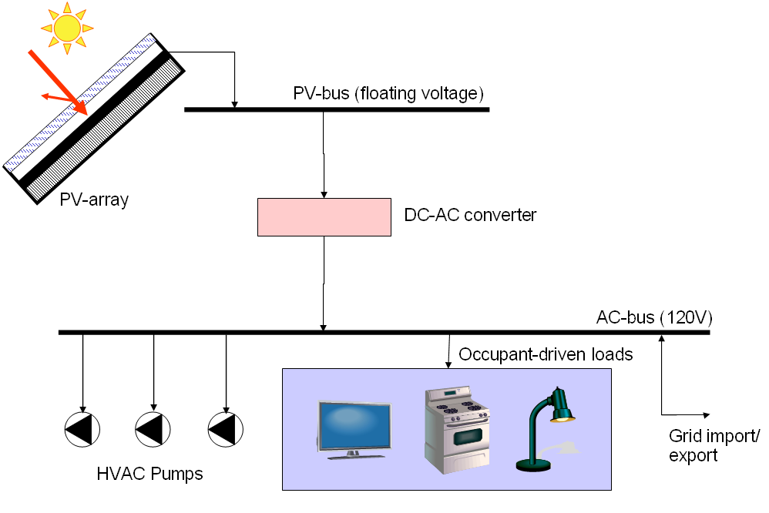
Figure 1: Electrical network with PV and occupant loads

PV-materials
The photovoltaic materials must first be added to the building fabric. In this exercise, we’ll add the PV to the large “w_roof” surface in the “roof_space” zone, depicted in Figure 2. To do so, the west roof surface construction must be re-attributed from “roof” to “PVroof.”
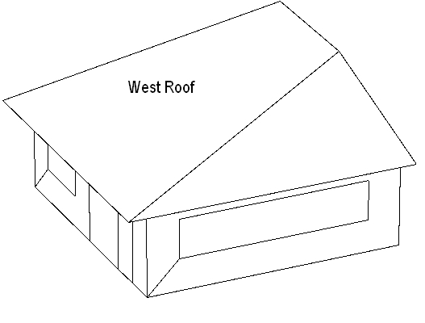
Figure 2: West roof PV installation

PV attributes
Under Embedded renewables section, select “Crystaline PV” and “WATSUN-PV_multic”. Enter in the component parameters as follows.
Parameter | Value
Open circuit voltage at ref (V) | 20.37
Short circuit current at ref (A) | 3.0200
Voltage at maximum power point at ref (V) | 15.3200
Current at maximum power point at ref (A) | 2.700
Reference insolation (W/m²) | 1000.0
Reference temperature. (K) | 298.0
Temperature coefficient of Isc (/K) | -8.310E-05
Temperature coefficient of Voc (/K) | 0.00355
Coefficient of logarithm of irradiance for Voc (-) | 0.0054
Number of series connected cells (not modules) (- | 36.0000
Number of parallel connected branches. (-) | 1.0000
Number of modules in surface. (-) | 188
Load type (0-maximum power, 1-fixed V) | 0.0
Load value - voltage (V) | 0.0
# Shading treatment (0-def,1-prop,2-total,3-diff.) | 0.0
Miscellaneous loss factor (-) | 0.0

Locate the material on the west roof surface, in the silica layer (node 3).

“Electrifying” plant components
Before they can be coupled to the electrical network, the pumps in the plant component models must first be configured to compute power consumption. Turn the “electrical flag” for each component on, and enter the following data:
Parameter | Value
Power factor | 1.0
Load type | Resistive
Nominal power | 0.0 W
Operating voltage | 120. V
Phase | 1

Electrical nodes
Add a new electrical network, and select a “balanced” type. Create two nodes, as follows:
Name | Type | Voltage | Phase
PV-bus | DC | Calc-by-PV | 1
AC-bus | 1-phase | Fixed | 1

Hybrid components
Connect the three pumps (pump-GFT, pump-BT and pump-RAD) up to the AC-bus. Connect the PV array to the PV-bus. Configure each hybrid component as “1-phase”.

Power-only components

Occupant-driven loads
Select the “non-HVC electric loads” from the power-only components menu, and couple it to the AC-bus. Configure the component as follows:
Parameter | Value
Number of data items | 1
Scalar multiplier for loads | 1.0
Number of string data items | 1
non-HVAC electric loads input file | ../elec_loads/4UL.fcl

DC-AC converter
Select the DC-AC inverter from the power-only components menu, and configure it as follows. When prompted for the “node sending current to the PCU”, select PV-bus. When prompted for “node receiving current from the PCU”, select the AC-bus
Parameter | Value
Number of data items | 6
Operating mode of PCU | 1.0
Nominal power | 5000.
non-HVAC electric loads input file | 0.8975E-05
Set point voltage | 3.650
Internal resistance constant (V²) | 2.0
Auxiliary power (W) | 0.0
Number of string data items | 0.0

