Solar hot water heating system

ESP-r plant modelling demonstration

Solar heating system
In this exercise, we’ll implement a model for a simple solar heating system. This system, depicted in Figure 1, uses a solar collector to heat water stored in a buffer tank. The buffer tank is connected in series with a gas-fired tank, which supplies hot water to the space.

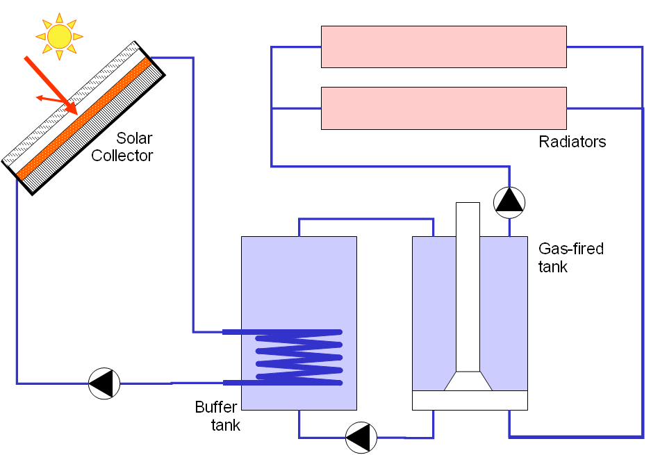
Figure 1: Solar hot-water heating system

Components
This network will use the following ESP-r components:
Name | Type | Catagory
Buffer-tank | 2-node storage tank with immersed coil | Solar and others
Gas-fired-tank | 3-node tank for charging by residential fuel cell | Solar and others
Solar-collector | Simplified flat-plate solar collector, 1-node model | Solar and others
Pump-BT | Pressurized domestic WCH pump | Solar and others
Pump-GFT | Pressurized domestic WCH pump | Solar and others
Pump-RAD | Pressurized domestic WCH pump | Solar and others
Office-RAD | Domestic hot water radiator VO ~ 2 m^2 ; 2-node model | Wet central heating
Reception-RAD | Domestic hot water radiator VO ~ 2 m^2 ; 2-node model | Wet central heating
Junction | Water flow converger ; 1-node PP model | Primitive parts

For this exercise, the default parameters for the water tank, pump and junction components will suffice. Make the following changes to collector and radiator components:

Name | Input | Value | Units
Solar-collector | Collector area | 10.0 | m²
Office-RAD | Nominal heat emission of radiator | 5000.0 | W
Reception-RAD | Nominal heat emission of radiator | 10000.0 | W

Connections
The components will be connected as follows. Take care when selecting the connected node.
Component | Node |  | Component | Node | M.D. Ratio
Buffer-tank | Water node 2 | → | Pump-BT | Water node 1 | 1.0
Pump-BT | Water node 1 | → | Solar-collector | Water node 1 | 1.0
Solar-collector | Water node 1 | → | Buffer-tank | Water node 2 | 1.0
Gas-tank | Water node 1 | → | Pump-GFT | Water node 1 | 0.5
Pump-GFT | Water node 1 | → | Buffer-tank | Water node 1 | 1.0
Buffer-tank | Water node 1 | → | Gas-tank | Water-node 1 | 1.0
Gas-tank | Water node 1 | → | Pump-RAD | Water node 1 | 0.5
Pump-RAD | Water node 1 | → | Office-RAD | Water node 1 | 0.5
Pump-RAD | Water node 1 | → | Reception-RAD | Water node 1 | 0.5
Office-RAD | Water node 2 | → | Junction | Water node 1 | 1.0
Reception-RAD | Water node 2 | → | Junction | Water node 1 | 1.0
Junction | Water node 1 | → | Gas-tank | Water node 1 | 1.0

Containments
While containments can be defined for each component, only the following containments are necessary:
Component | Containment type | Zone | Location
Buffer-tank | Zone (air/surface/const) temp. | Reception | Air point
Gas-fired-tank | Zone (air/surface/const) temp. | Reception | Air point
Reception-RAD | Zone (air/surface/const) temp. | Reception | Air point
Office-RAD | Zone (air/surface/const) temp. | Office | Air point
Solar-collector | Ambient air temperature | — | —

Controls
The network requires four plant controls:

Buffer-tank pump
The buffer-tank pump will be activated whenever the temperature inside the tank is at least 5 °C greater than the solar collector, and deactivated when the difference falls to 1°C.
Sensor | Output from a plant component: a) Solar collector, node 1  b) Buffer tank, node 1
Actuator | Node within a plant-component: Pump-BT, node 1
Period of validity | Jan 1 − Dec 31
Control type | Senses Dir. Normal solar radiation, actuates flow
Control law | On-off controller
Period start time | 0.0 h
Mode of operation | -1.0 (cooling)
Off-setpoint | 5 °C
On-setpoint | 1 °C
Output at high: | 0.1 kg/s
Output at low: | 0.0 kg/s
Sensor lag: | 0 s
Actuator lag: | 0 s

Gas-fired-tank burner
The tank burner will be activated whenever the tank temperature drops below 50 °C, and deactivated when it rises above 55 °C.
Sensor | Output from a plant component (Gas-tank, node 1)
Actuator | Node within a plant-component: (Gas-tank, node 2)
Period of validity | Jan 1 − Dec 31
Control type | Senses db temperature, actuates variable.
Control law | On-off controller
Period start time | 0.0 h
Mode of operation | 1.0 (heating)
Off-setpoint | 55 °C
On-setpoint | 50 °C
Output at high: | 1.0
Output at low: | 0.
Sensor lag: | 0 s
Actuator lag: | 0 s

Gas-fired--tank pump
The circulation pump between the buffer and gas-fired tanks will be activated whenever temperature in the buffer tank exceeds 60°C, and deactivated when the temperature drops below 55 °C.
Sensor | Output from a plant component (Buffer-tank, node 1)
Actuator | Node within a plant-component: (Gas-tank-pump, node 1)
Period of validity | Jan 1 − Dec 31
Control type | Senses db temperature, actuates variable.
Control law | On-off controller
Period start time | 0.0 h
Mode of operation | -1.0 (cooling)
Off-setpoint | 55 °C
On-setpoint | 60 °C
Output at high: | 0.1 kg/s
Output at low: | 0. kg/s
Sensor lag: | 0 s
Actuator lag: | 0 s

Radiator pump
The pump supplying the radiators will be activated when the temperature in reception drops below 19°C, and deactivated whenever the temperature rises above 21°C.
Sensor | Senses temperature in a specific zone (Reception, air point temperature)
Actuator | Node within a plant-component: (pump-rad, node 1)
Period of validity | Jan 1 − Dec 31
Control type | Senses db temperature, actuates variable.
Control law | On-off controller
Period start time | 0.0 h
Mode of operation | 1.0 (heating)
Off-setpoint | 21 °C
On-setpoint | 19 °C
Output at high: | 0.02 kg/s
Output at low: | 0.0 kg/s
Sensor lag: | 0 s
Actuator lag: | 0 s

