ESP-r Training Course

Required Information for Hands-on Modelling

House Description

Main Floor Geometry and Construction

The vertices of the house main floor are shown in Figure 1. Figure 2 shows the location and dimensions of the windows. The constructions of the exterior walls, floors, ceiling, and the windows are shown in Figures 3-6.

Site Information

Latitude = 45.3
Longitude = 75.6 (site longitude difference = -0.6)
Terrain = isolated rural site
Ground reflectance = 0.2
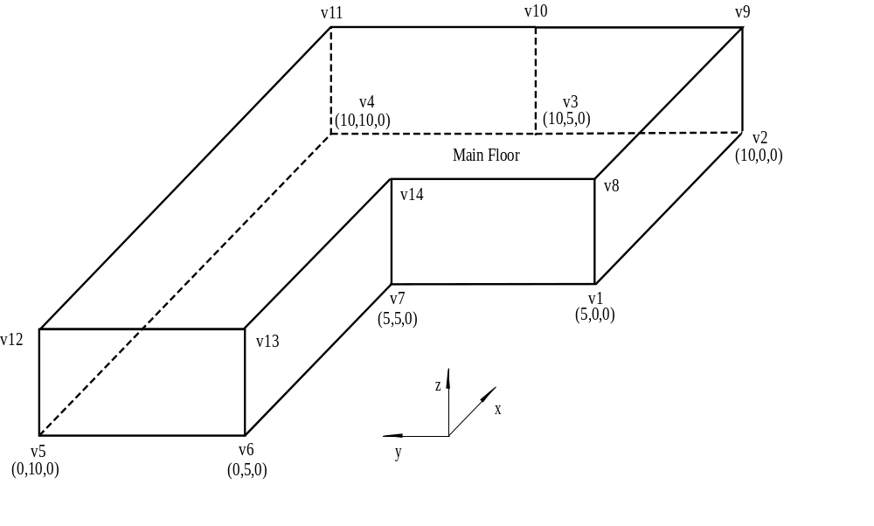
(10,0,2.5)
Figure 1: Vertex points defining the zone.

x
y
z
1.5 m
0.5 m
0.5 m
w1
w2
w3
w4
w5
w6
w7
1.5 m
all windows are 2 x 1.5 m
Figure 2: Window locations and dimensions.

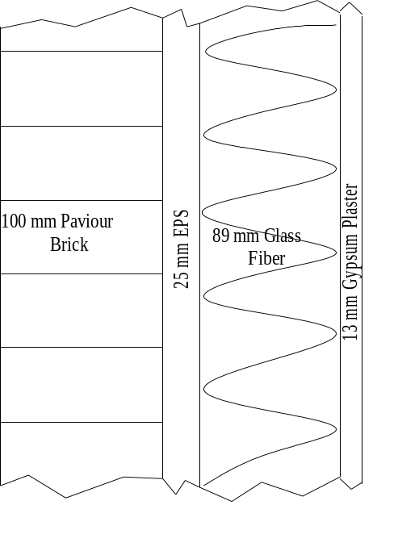
Figure 3: Exterior wall construction.

38 mm EPS
100 mm Light Mix Concrete
10 mm Synthetic Carpet
Figure 4: Floor construction.

13 mm Gypsum Plaster
200 mm Glass Fiber
Figure 5: Ceiling construction.

4 mm Clear Float
12.7 mm Air Gap
4 mm Clear Float

Figure 6: Window construction.

Infiltration

0h00 – 7h00: 0.5 ach
7h00 – 20h00: 0.1 ach
20h00 – 24h00: 0.5 ach

Internal Loads

These are non-HVAC related loads from people, lights, and equipment. The sensible loads are 70% radiative and 30% convective. The average hourly sensible and latent loads are constant throughout the week:

Sensible Load = 600 W
Latent Load = 150 W

Foundation Type

The foundation type is a slab-on-grade. The floor slab sits directly on the ground.

Thermostat Control Strategies

The heating and cooling capacities are set to 500 kW.

Two control strategies are to be modelled. The first is an ideal control with a heating setpoint:

Heat = ON if temperature is less than 21ºC
Cooling = OFF (specify a zero maximum cooling capacity)

The second is an ideal control for heating with night setback:

From 0h00 – 6h00
Heat = ON if temperature is less than 16ºC
Cooling = OFF (specify a zero maximum cooling capacity)

From 6h00 – 22h00
Heat = ON if temperature is less than 21ºC
Cooling = OFF (specify a zero maximum cooling capacity)

From 22h00 – 24h00
Heat = ON if temperature is less than 16ºC
Cooling = OFF (specify a zero maximum cooling capacity)

Obstruction geometry

Origin: x: -10.0 m, y: -10.0 m, z: 0.0 m

Block Width, Depth, Height: 20.0 m, 8.0 m, 8.0 m

Window reveal thickness: 0.5 m

