PersonAI

Julian Berrio

Kimberly Germinal

Michael Rogatinsky

**Florida Atlantic University**

**Author Note**

Correspondence concerning this paper should be addressed to Julian Berrio, Kimberly Germinal, or Michael Rogatinsky

CONTACT:

[jaberrio88@hotmail.com](mailto:jaberrio88@hotmail.com), 113 NE 2nd Ter Hallandale Beach, Florida 954-512-4418

[kimberly.gemi@gmail.com](mailto:kimberly.gemi@gmail.com), 4957 Victoria Cir West Palm Beach Fl, 33409 or 561-951-3969

[mrogatinsky@gmail2015.com](mailto:mrogatinsky@gmail2015.com)

Abstract:

PersonAI is an app built around student life. The goal of this app is to help students better organize themselves during and after school. We used methods such as the predictability of school life to better fit the students. Processing was incorporated as a method of customizability. Along with processing we incorporated graphics to add to the design of the app. The overall goal was to create an app that would adapt to the routine of students. This app was created to help students keep more organized in school. Many features were designed within the app such as NFC sensors, schedule and textbook inputs, alerted reminders, and more. In the end we were able to create a sensible and functional app that allows students to keep organized as we had hoped for.

Background:

We got our idea for the app by analyzing how other calendar and organizers work. If we take for example Google Calendar, their approach is not tailored for students but for simply note reminders(figure 1). We took the idea and overhauled it with powerful text and input fields instead of Google’s one text field. A student does not need a reminder that tells them they need to input a location for a homework that is due, but they do need a field that reminds them what page number. This inspired us to create this app for students to adapt to a more organized lifestyle.

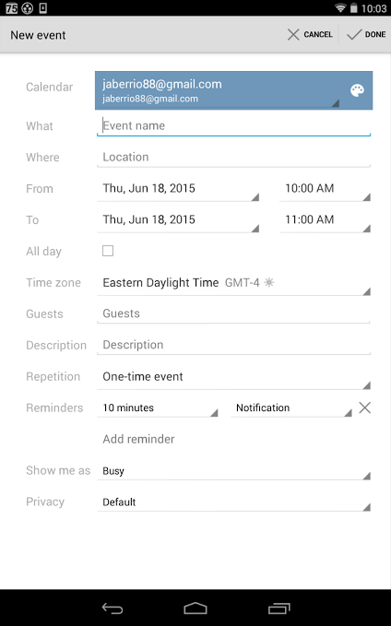Figure 1

Methods:

School life is extremely routine therefore we can use this to make a template that will fit almost all students similar to “One Size Fits All”. This resulted in the app being governed by predictability. Such as reminding the student to update his homework in between periods due to this being a free time that all students with “multiperiods” have.

NFC will be incorporated such that the user can quickly launch the app by having an NFC tag inside his or her book. This allows for actions such as simply taping said textbook and it being automatically selected for easy input of homework or other object.

The layout for the apps buttons was also made due to how the average student holds a tablet. We surveyed 15 students and found out the most common way of holding a tablet was landscape with fingers on the side. A larger pool should be used later to better determine the full spectrum such as having the top 3 as settings.

The Processing incorporation was made to allow app users to customize the app to their liking. When the user opens the Processing tab there are alowed to draw an icon that will replace the period of their choice. Although because of processing limitation this was not possible. This will later on be replaced with a Java Drawing canvas which will simplify the app due to less external outsourcing .

As for the graphics part of the app, our goal was to establish a sketch theme to help the app feel more personalized. We added pictures of sketches for buttons, we created a splash screen, and an app icon that were created with color palettes that blend well together to draw in the consumer's attention.We tried to steer away from the boring google appearance and add color to help personalized the app and create a more student friendly atmosphere. Below is a picture of the final product( figure 2).

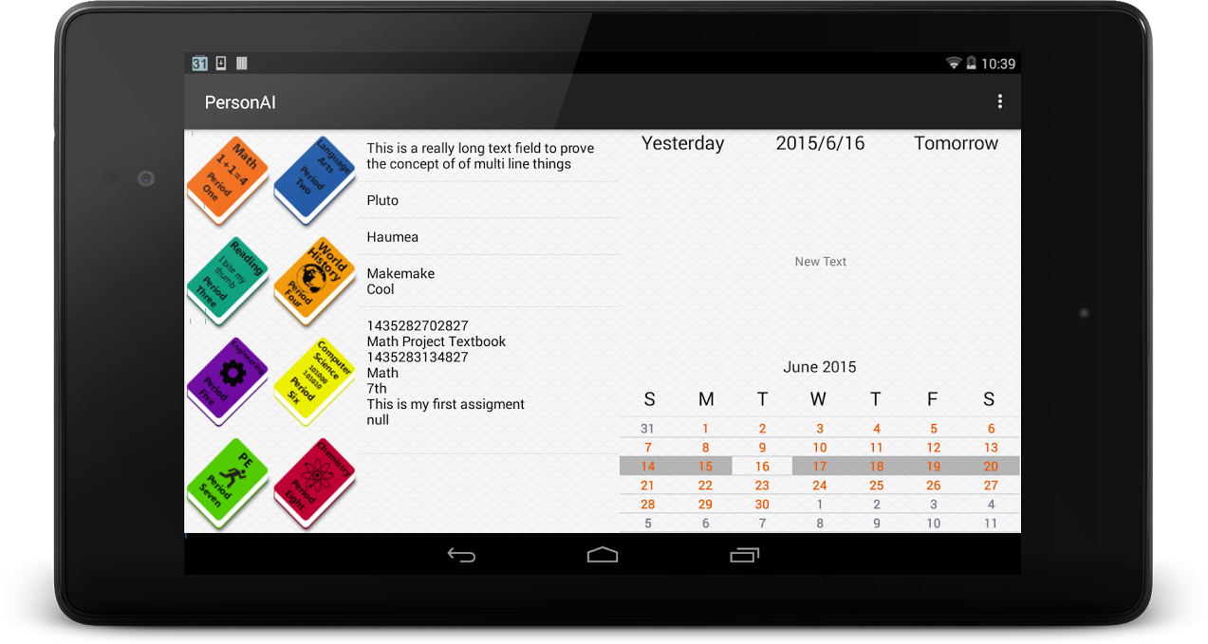

Figure 2

Results and Discussion:

Having only the limited time of 3 days we were able to create an app that functions beyond what we expected. The app used a custom Database structure made by the coder. The app also included personalized graphics that helped create a more relaxed theme. Our group consisted of 3 inexperienced members, each in charge of a specific area to aid in designing the app itself. Despite the limited time we had to create this app overall, the final product was decent and functional.

Conclusion:

Our goal within the app was accomplished. We were able to create an app that allows student to input any data they would like regarding school information and note taking. We added special features such as the NFC tab, which when placed on the camera sensor allows the textbook to appear on screen. Some improvements we believe could be implemented within the app is a camera sensor that allows you to take quick pictures of assignments written on the board and store it in the assignment section, image recognition would be a possibility too as a long term goal.