Nowadays, the energy crisis is a constant theme because of the inflated energy prices \cite{energy_crisis}. Furthermore, huge energy consumption is a burden to the environment, as not all means of energy production are non-polluting. According to "Our World in Data"\cite{owidenergy}, in 2019, 63,3\% of eletrical energy production comes from fossil fuels. It is known that, in cities, street lamps are continuously switched on at night, most of the time unnecessarily glowing with its full intensity, in the absence of any activities in the street, leading to a great waste of energy. Furthermore, it is in cities where the consequences of using cars are most noticeable. An example of this is the search for a parking space. According to the RAC Foundation [ref], in England, an average car is parked 95 % of the time, which explains how hard it can get sometimes when trying to find a parking spot. This struggle leads to an increase in carbon dioxide production as well as fuel consumption.
With that in mind, the main objective of this project is the creation of a distributed system, composed by smart street lights capable of turning on only when they detect movement in the surroundings, at night time, and also, capable of detecting available parking spaces in the street post vicinity.
https://www.racfoundation.org/media-centre/cars-parked-23-hours-a-day
-------------------------------

The main purpose of this system is to control a street lamppost, using Raspberry Pi 4B. When there is no activity in the area, the lamppost is at a pre-defined minimum light level, as when a car or pedestrian is noticed in the area, the light must automatically activate. Therefore, each street lamp post must communicate wirelessly with the neighbor lamp posts, allowing to dynamically turn on the lights of the following poles. To detect movement in the vicinity of the pole, a motion detector must be used, which must only work at night. To ensure this, a luminosity sensor can be used, determining the ambient light conditions. In order to facilitate the maintenance of the pole, a system that determines the operating conditions of the lamp must be implemented. When this system verifies that the lamp is not in good working conditions, that is, that it is broken or burnt, this information must be transmitted to the entity responsible for the network of lampposts through a mobile app. This should also be used by the person in charge, to manage all information on the pole network, such as the location of each pole, O QUE MAIS???. In order to allow the detection of parking spots, this system should only be used in an area where there are parking spaces nearby. For this, the lamppost must have a camera, turned on all day, and, after Raspberry processes the acquired information, it must be made available on a website, so that a user can know where parking spaces are available.

Market Research
Public lighting is essential to the society quality of life, since it allows citizens to enjoy public spaces at night, providing greater security. “In 1417, the Mayor of London ordered all houses to hang lanterns outdoors after dark during the winter months. This marked the first organized public lighting.” \cite{street_lighting_history}. From oil lamps to \ac{led} lamps, public lighting has become a more efficient, cheaper and less polluting way of lighting the streets.

+smart parking

.1 Scope ??
In this project it will be implemented a street lighting solution for residential areas and public spaces, with the creation of smart light pole technology, feasible of being installed in existent lampposts. This technology comprises sensors, a video-camera, a controller, and wireless connection to the smart street light network. This solution provides cost reduction and improved maintenance quality associated with street lighting, and also supports the deployment of smart city applications, through the use of the video-camera to detect available parking spaces.

.2 Market definition
Smart Street lighting is a rapidly growing lighting market, boosted by regulatory policies that encourage energy efficiency, IoT convergence and the drop of LED prices. This new concept of smart light post is also growing, implementing not only the smart management of street lights, but also features that go from basic LED replacement control, to traffic and video monitoring, environmental monitoring, and others. Smart street lights represent a strategic infrastructure for smart city development, in particular, for video-surveillance services and autonomous driving. [ref1] In figure x, we can see the global growth rate for connected street lighting market, evidencing the high growth rate in Asia, and the largest market in North America.
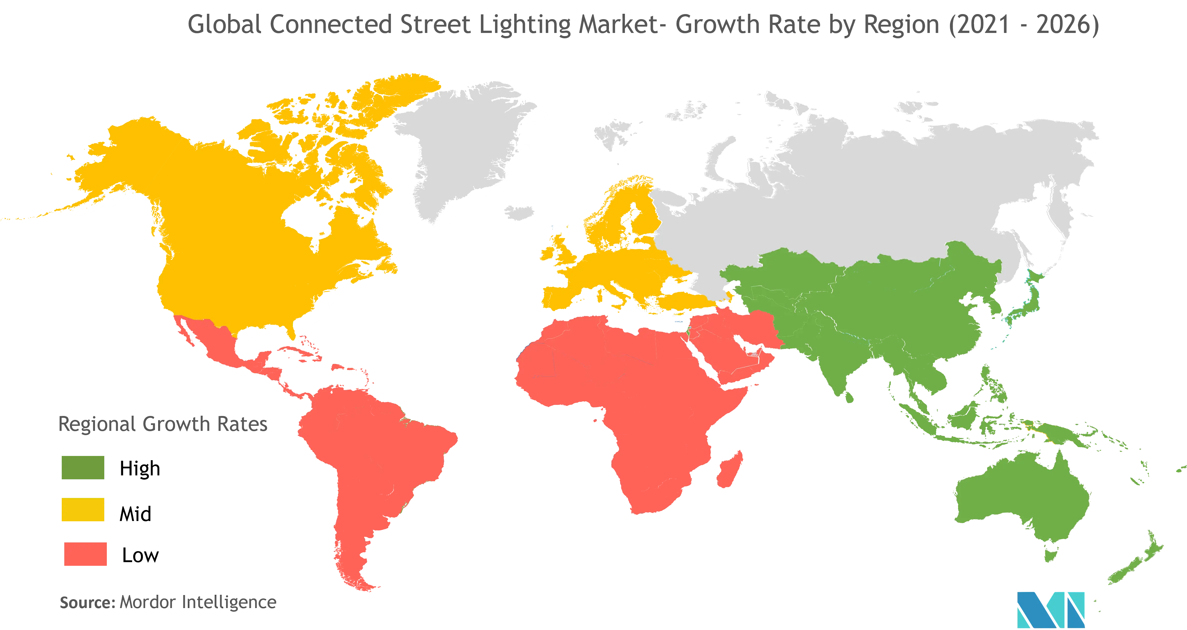
https://www.mordorintelligence.com/industry-reports/connected-street-lights-market
Currently, many countries are replacing the traditional street lights, \ac{hps} which is a gas-discharge lamp that uses sodium to produce light at a distinctively yellow-orange, monochromatic glow, with the smart LED street lighting. \ac{led} technology has lower maintenance cost and operation cost that the \ac{hps} lamps, and can generate savings of more than 60 percent of energy costs \cite{light_pollution}, allowing payback of the initial investment.
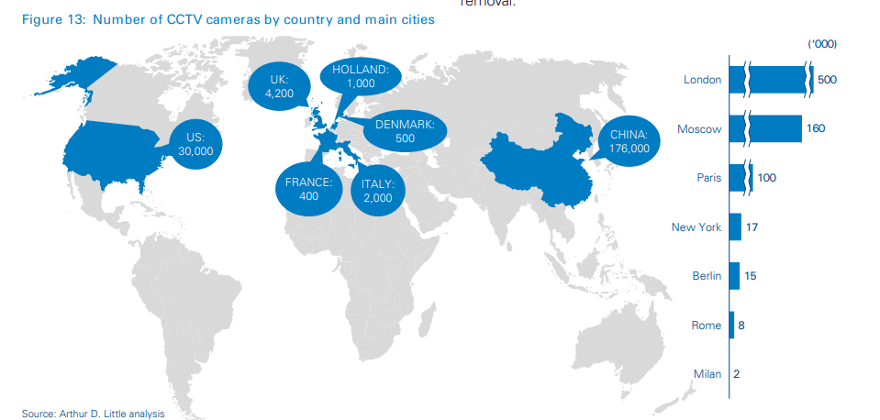

[ref1] https://www.adlittle.com/en/insights/report/evolution-street-lighting-market
------------------
.3 Similar products
+diferenças de consumos
+smart parking

Cities are looking at smart infrastructure to reduce costs, improve sustainability, and provide better services to residents. Nowadays, Telensa is the market share leader in smart street lighting with more than ten years of experience.\cite{telensa} PLANet is an intelligent street lighting system, consisting of wireless nodes connecting individual lights, a dedicated network owned by the city and a central management application. This system reduces energy and maintenance costs associated with street lighting and also improves quality of maintenance through automatic fault reporting. Doncaster, the largest metropolitan borough in England, houses over 45,000 smart Telensa streetlights, covering 220 square miles, achieving energy savings of approximately 1,5 million euros annually, with potential to increase this in the future. Telensa is also developing a new generation of light pole sensor devices featuring smartphone Artificial Intelligence (AI) technology, enabling detailed real-time insights on traffic mix, pedestrian movements and others.

FLASHNET is a company focused on developing intelligent systems for smarter cities and better infrastructures and have created a solution that provides the right amount of light where and when needed to lighten the streets, the inteliLIGHT \cite{inteli_light}. Using the existing infrastructure, this solution saves money and transforms the existing distribution level network into an intelligent infrastructure of the future. Furthermore, the system is integrated with major \ac{iot} platforms and provides \ac{api} connectivity with City Management applications, ensuring compatibility with existing smart lighting and smart city initiatives.
Note that smart street light is an emerging technology that, despite being established in the market, is still relatively uncommon in cities due to the initial investment it entails. However, it is clear that in the long run it is compensatory and now, as the consequences of light pollution tiptoe from the shadows and into the spotlight, cities, regulatory agencies, and conservation groups are agitating for solutions.

.4 Why choose our product
junção de smart street light e smart parking

