# Connect 4 Documentation

## GitHub:

<https://github.com/ESSODillon/Connect4>

## Web Server

<https://essodillon.github.io/Connect4/index.html>

## Program Design

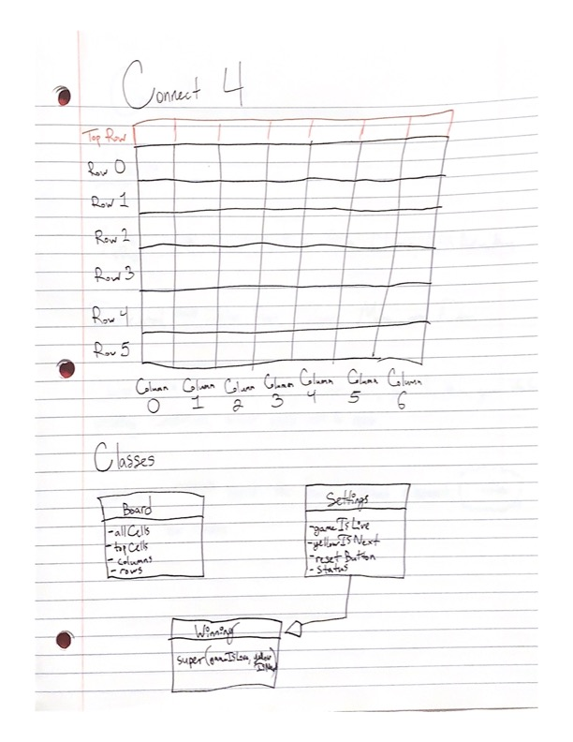

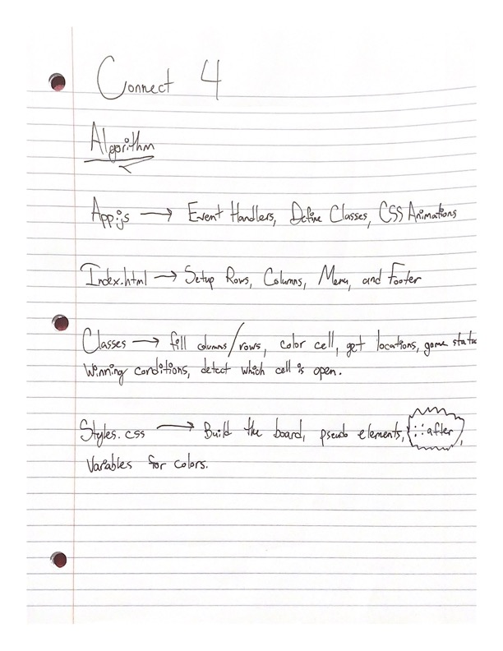

# Development Process

Building Connect 4 from the ground up was a very cool process. I started by sketching out my board and writing out what all classes and functions would be needed. My first step coding wise was the HTML and CSS files, I wanted to have my board existing before starting to build out functionality with game settings and just JavaScript in general. Writing the CSS was more challenging than I thought, since I used a lot of the advanced methods I had learned over the summer, such as “:not” and “::after”. The primary resources I used while building Connect 4 were previous lectures, as well as watching YouTube videos of the game being played. I had to refer to the Instrumental lecture to setup my Settings / Winning class relationships.

A problem I ran into while developing my game was pushing the rows in the wrong order, I saw that I was pushing the topRow before row0, and the way I had programmed my application was for topRow to be last in the array. Another issue I ran into was how I was approaching Object Oriented Programming; I was calling on the Game Settings class while I should have just only been using the Winning class to access all the properties and methods from the Settings class. After developing my game and getting it to basically work, I added a menu screen that uses CSS transitions, and a reset button that clears the board and game settings. If I were to design this application in a different way, I would use flexbox and x/y locations instead of a grid approach. That way I could make the game pieces fall and tell them exactly where to land. I also think it would be cool to make a mobile friendly version of the game, which would challenge the hover effect I currently have.