**Annotation Approval and Solr Index Update Flow**

In **ESTC21**, there are **4 user roles** defined as follows:

1. **Admin**
2. **Bibliographer**
3. **Scholar**
4. **User**

Users with role **Admin** or **Bibliographer:**

1. Can **search** **solr indexes**.
2. Can add **annotations** to **solr indexes.**
3. Can add **feedback** on **annotations** submitted by **scholars.**
4. Can **Review, Approve or Disapprove** the **contributions** (annotations**)** submitted by **scholars.**
5. **Annotations** added by **admin** or **bibliographer** are self approved.

Users with role **Scholar:**

1. Can **search** **solr indexes**.
2. Can add **annotations** to **solr indexes.**
3. Can add **feedback** on **annotations** submitted by other **scholars.**
4. Can see annotation feedback history.

Users with role **User (Read-only Access):**

1. Can **search** **solr indexes.**
2. Can see **annotation history.**
3. Cannot **contribute** to **solr indexes.**
4. Cannot add feedback to **solr indexes.**

***\*Feedback section*** *is just a user feedback,* ***Agree/Disagree*** *will be treated as* ***Like / Dislike.*** *Actual approve / disapprove will be done by* ***Admin or Bibliographer*** *by clicking* ***Review User Contribution*** *section.*

Here is complete **flow (Add annotation, provide feedback and approve contributions)** (with screenshots):

**Add Annotation & Provide Feedback:**

1. Login as **Scholar** and perform search e.g; ‘**George Barnwell**’.
2. User will be able to see **Solr index** as search results.
3. Click any **contribute** button available with each record. 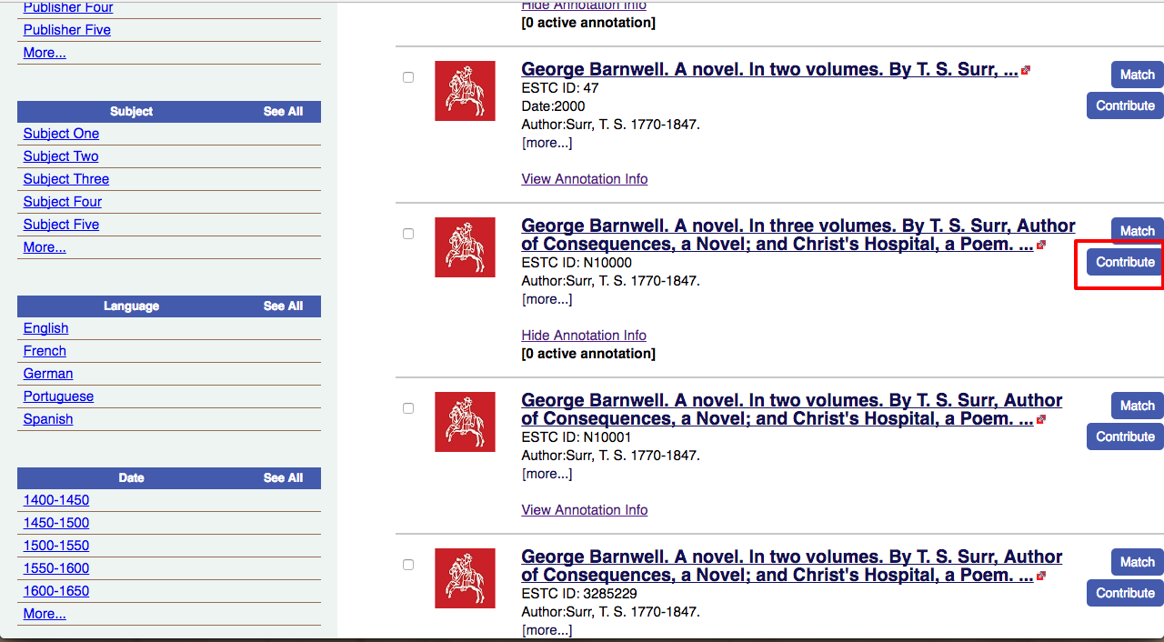
4. User will see a new popup window with a form as shown below. 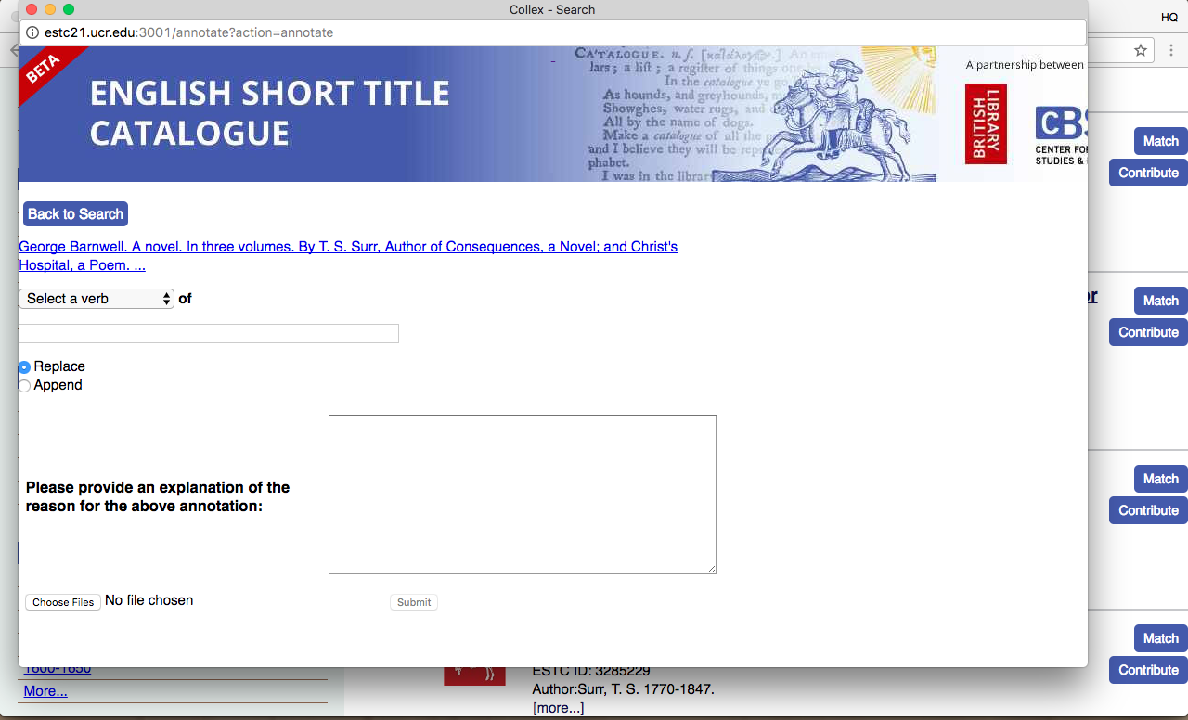
5. **Select a verb** (which attributes / field users want to change or replace), add name, and finally add detailed description for why user needs this annotation. Click **Submit** button to submit this annotation to **Admin** for **review.** 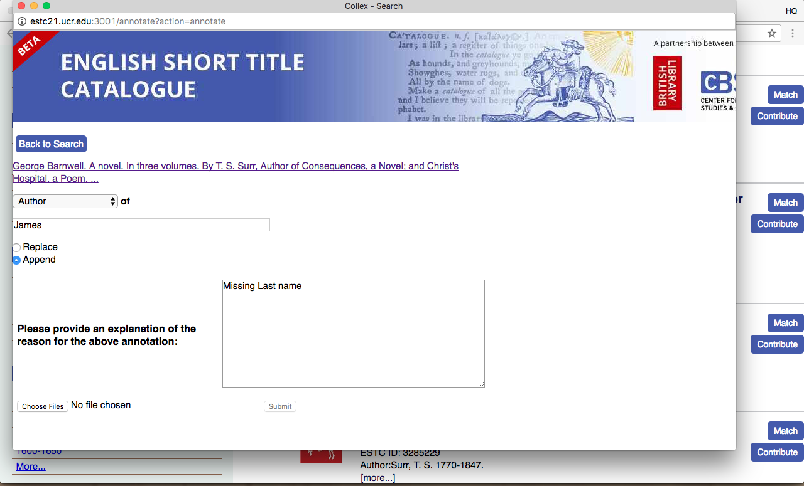
6. To see annotation, **make search again** and click **Show Annotation Info** link under **Record Title.** It shows that there is **1 active annotation.** 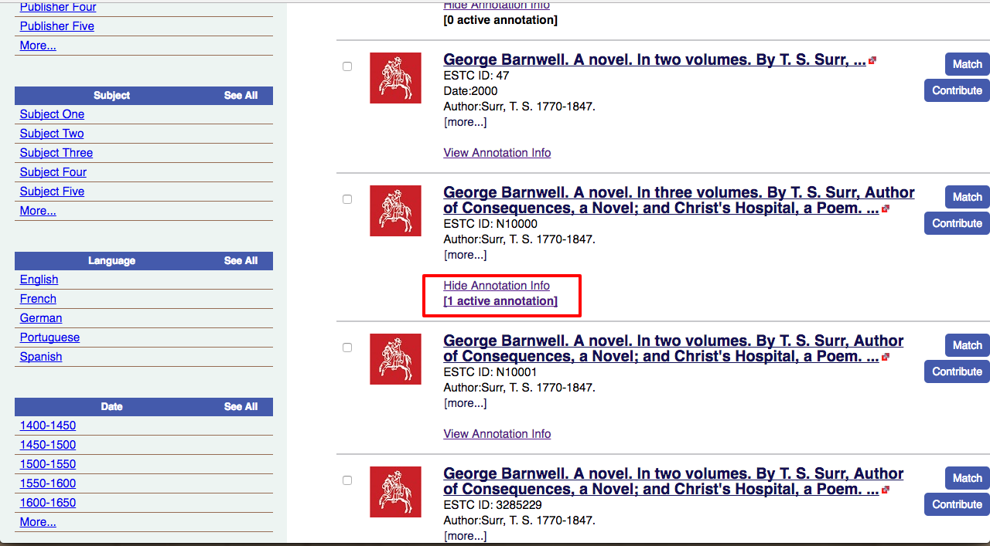
7. Click **1 active annotation** link, user will be able to see another page displaying **Annotation History, Approve / Disapprove count.**
8. User can **provide feedback** for any annotation here. 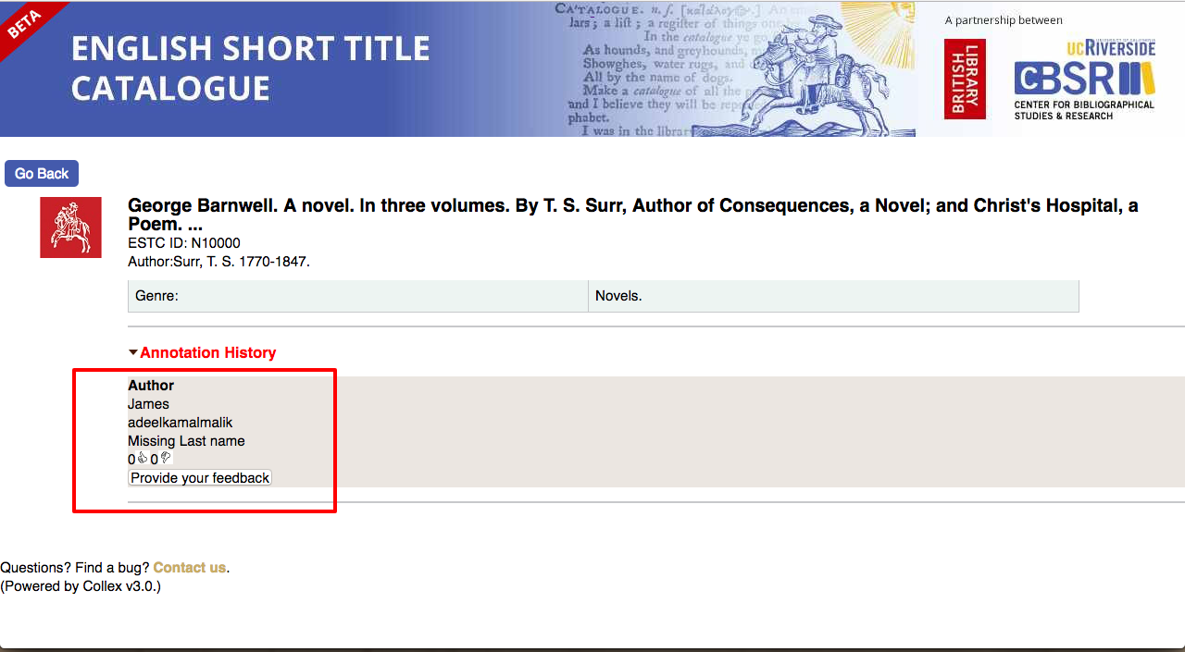
9. User can **see all the annotations** added so far. For this, click **Review User Contributions.** 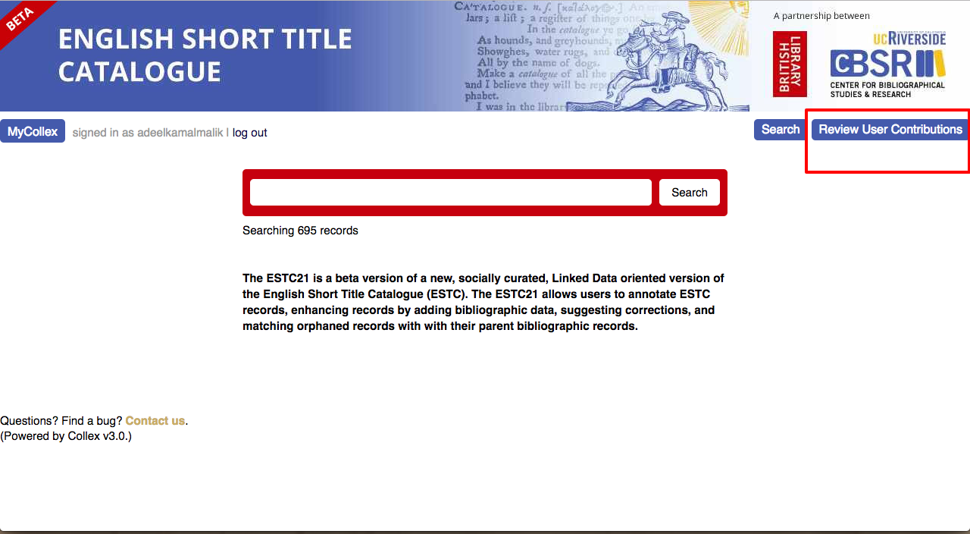
10. User will be able to see all available **annotations** with **Record Title** and **History** as shown below. 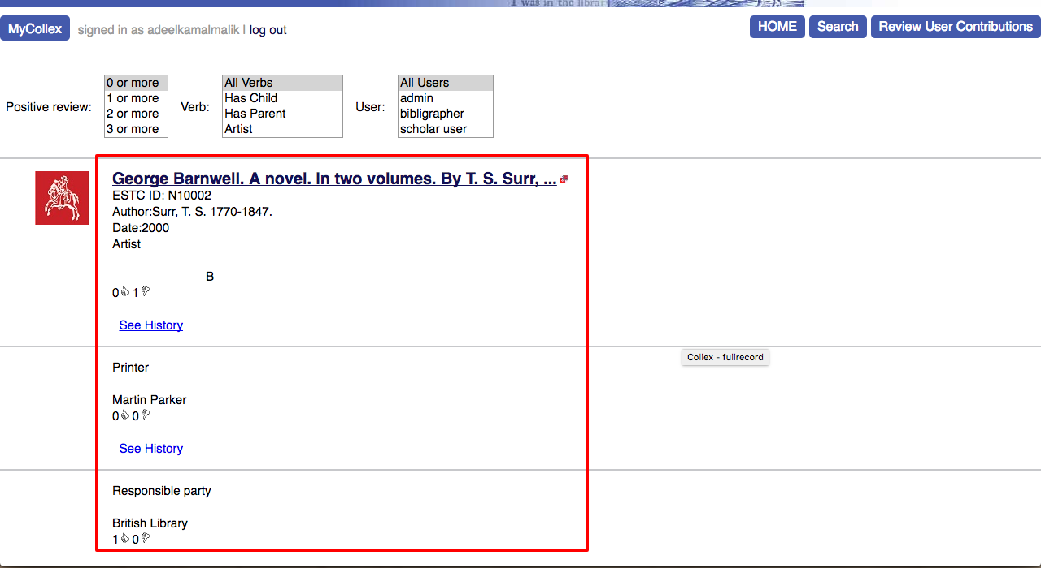

**Approve / Disapprove User Contributions:**

1. Login as **Admin** or **Bibliographer** and click **Review User** **Contributions** as shown below. 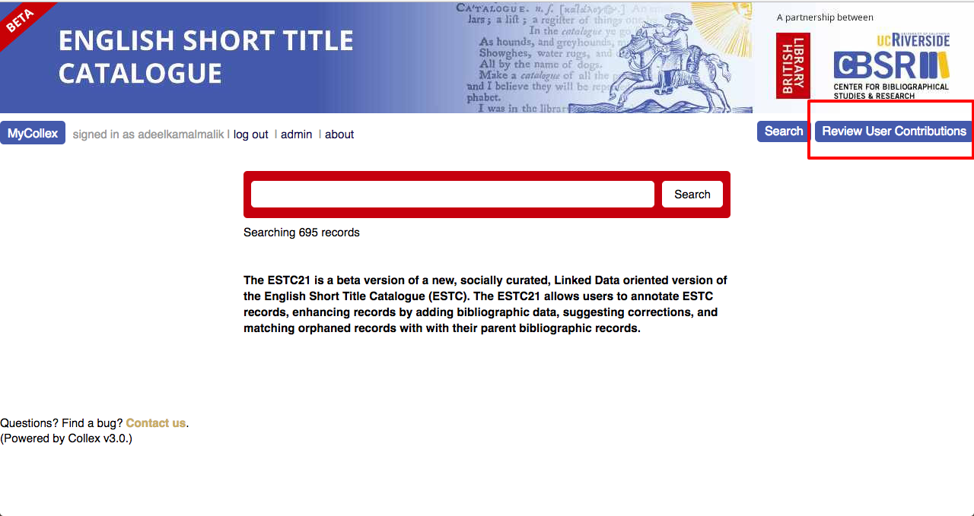
2. User will be able to see **all annotations added** so far.
3. To **Approve / Disapprove,** click **Review** button available at the bottom of a record, as shown below. 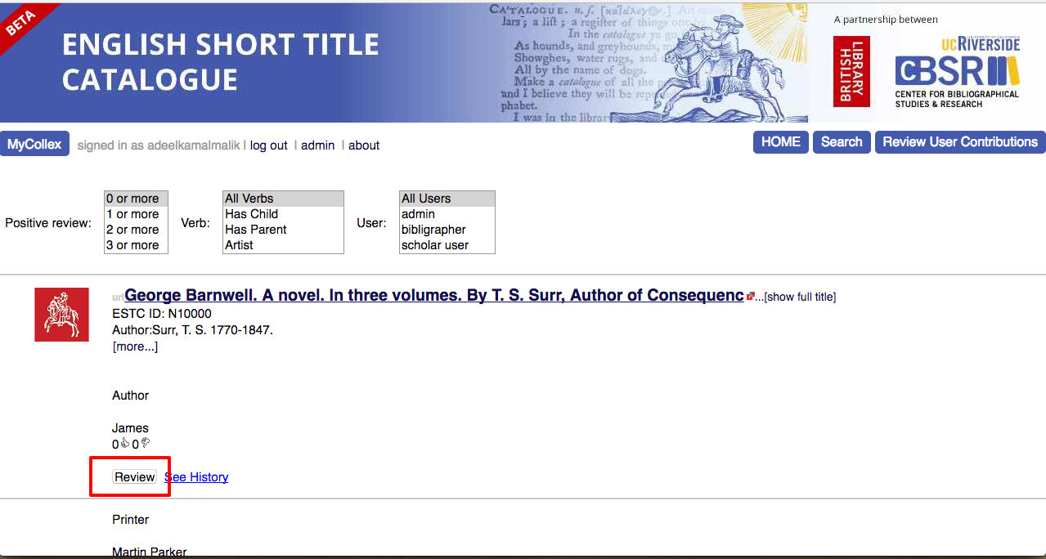
4. User will be able to see a popup window. Add **feedback**, select **Approve / Disapprove** button and click **“OK”** button. 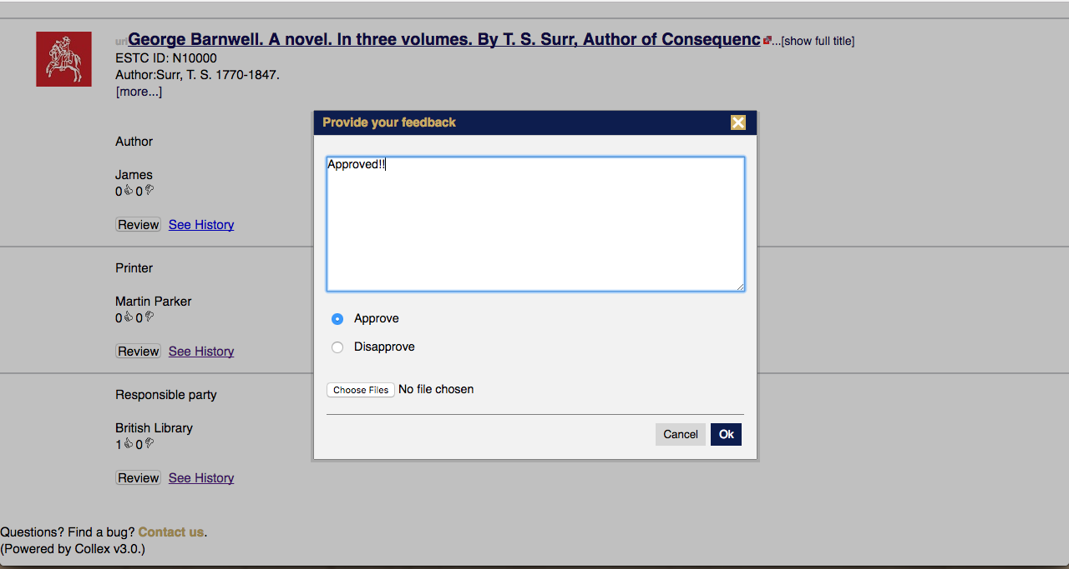
5. **Approved annotations** will become part of that **record** in **Solr index**. 