GRC103 Lab Report: Practical Risk Monitoring with Wazuh
Course: GRC103 – Risk Assessment and Management Techniques
Module: Practical Risk Assessment Workshop
Student: Ester Hunja
Date: 28-10-2025

1. Lab Overview & Objectives
This practical lab demonstrates how a Governance, Risk and Compliance (GRC) analyst can operationalize a risk treatment by deploying a detective control using the open-source Wazuh platform. Through this exercise, Wazuh is configured to monitor a sensitive directory for unauthorized file creation, modification, or deletion events. The exercise integrates technical monitoring with governance and compliance reporting to illustrate how real-time controls feed the risk-management lifecycle.
Learning Objectives:
1. Deploy a Wazuh manager on Ubuntu and a Wazuh agent on a Linux endpoint.
2. Implement a File Integrity Monitoring (FIM) detective control.
3. Generate and analyze alerts reflecting unauthorized file changes.
4. Relate technical monitoring data to risk assessment and compliance requirements.

2. Lab Architecture
Component | Host System | Role | Description
Wazuh Manager | Ubuntu Server VM (in VirtualBox) | Central Risk Monitoring Platform | Collects, analyzes and visualizes agent data via the Wazuh Dashboard
Wazuh Agent | Linux Host Machine (Kali) | Control Agent / Monitored Endpoint | Monitors a sensitive directory and reports changes to the manager
Network Configuration: Both machines use Bridged Adapter mode, sharing the same network segment to enable manager–agent communication on ports 1514 and 1515.

3. Procedures

Part 1 – Deploy Wazuh Manager (Ubuntu VM)
Installed Wazuh Manager using installation script and verified running status.
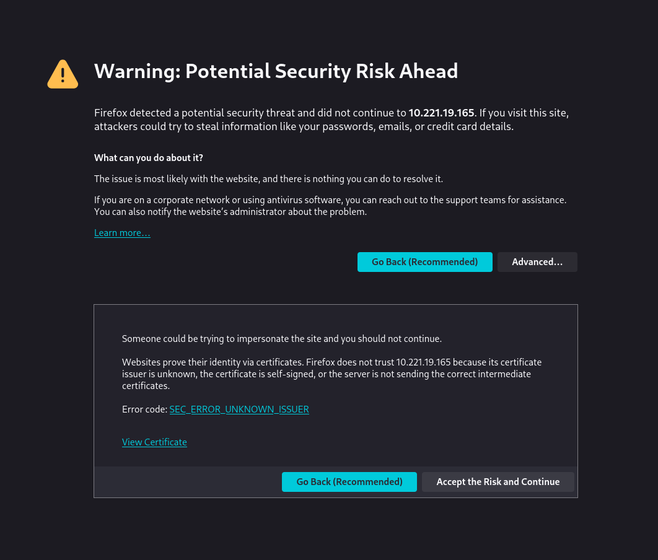

Part 2 – Access Wazuh Dashboard
Confirmed dashboard availability and logged in using default credentials.
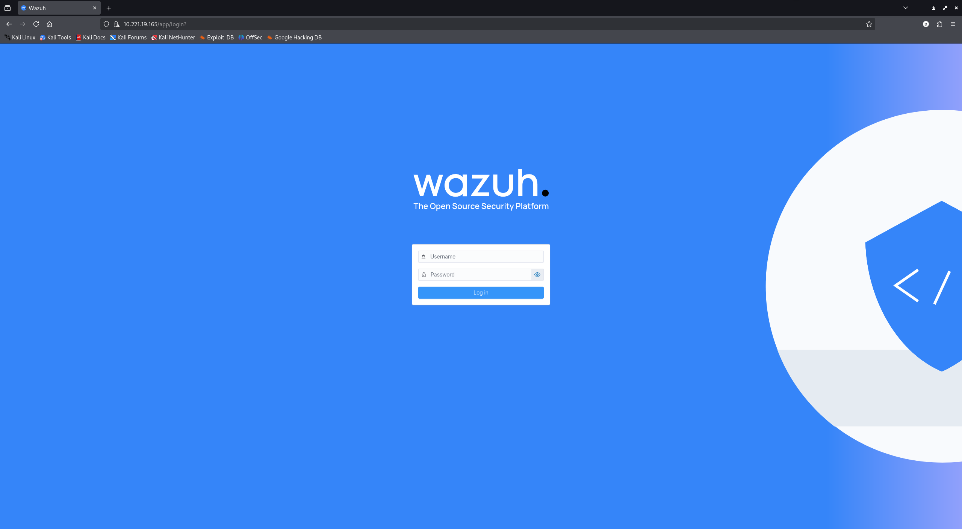

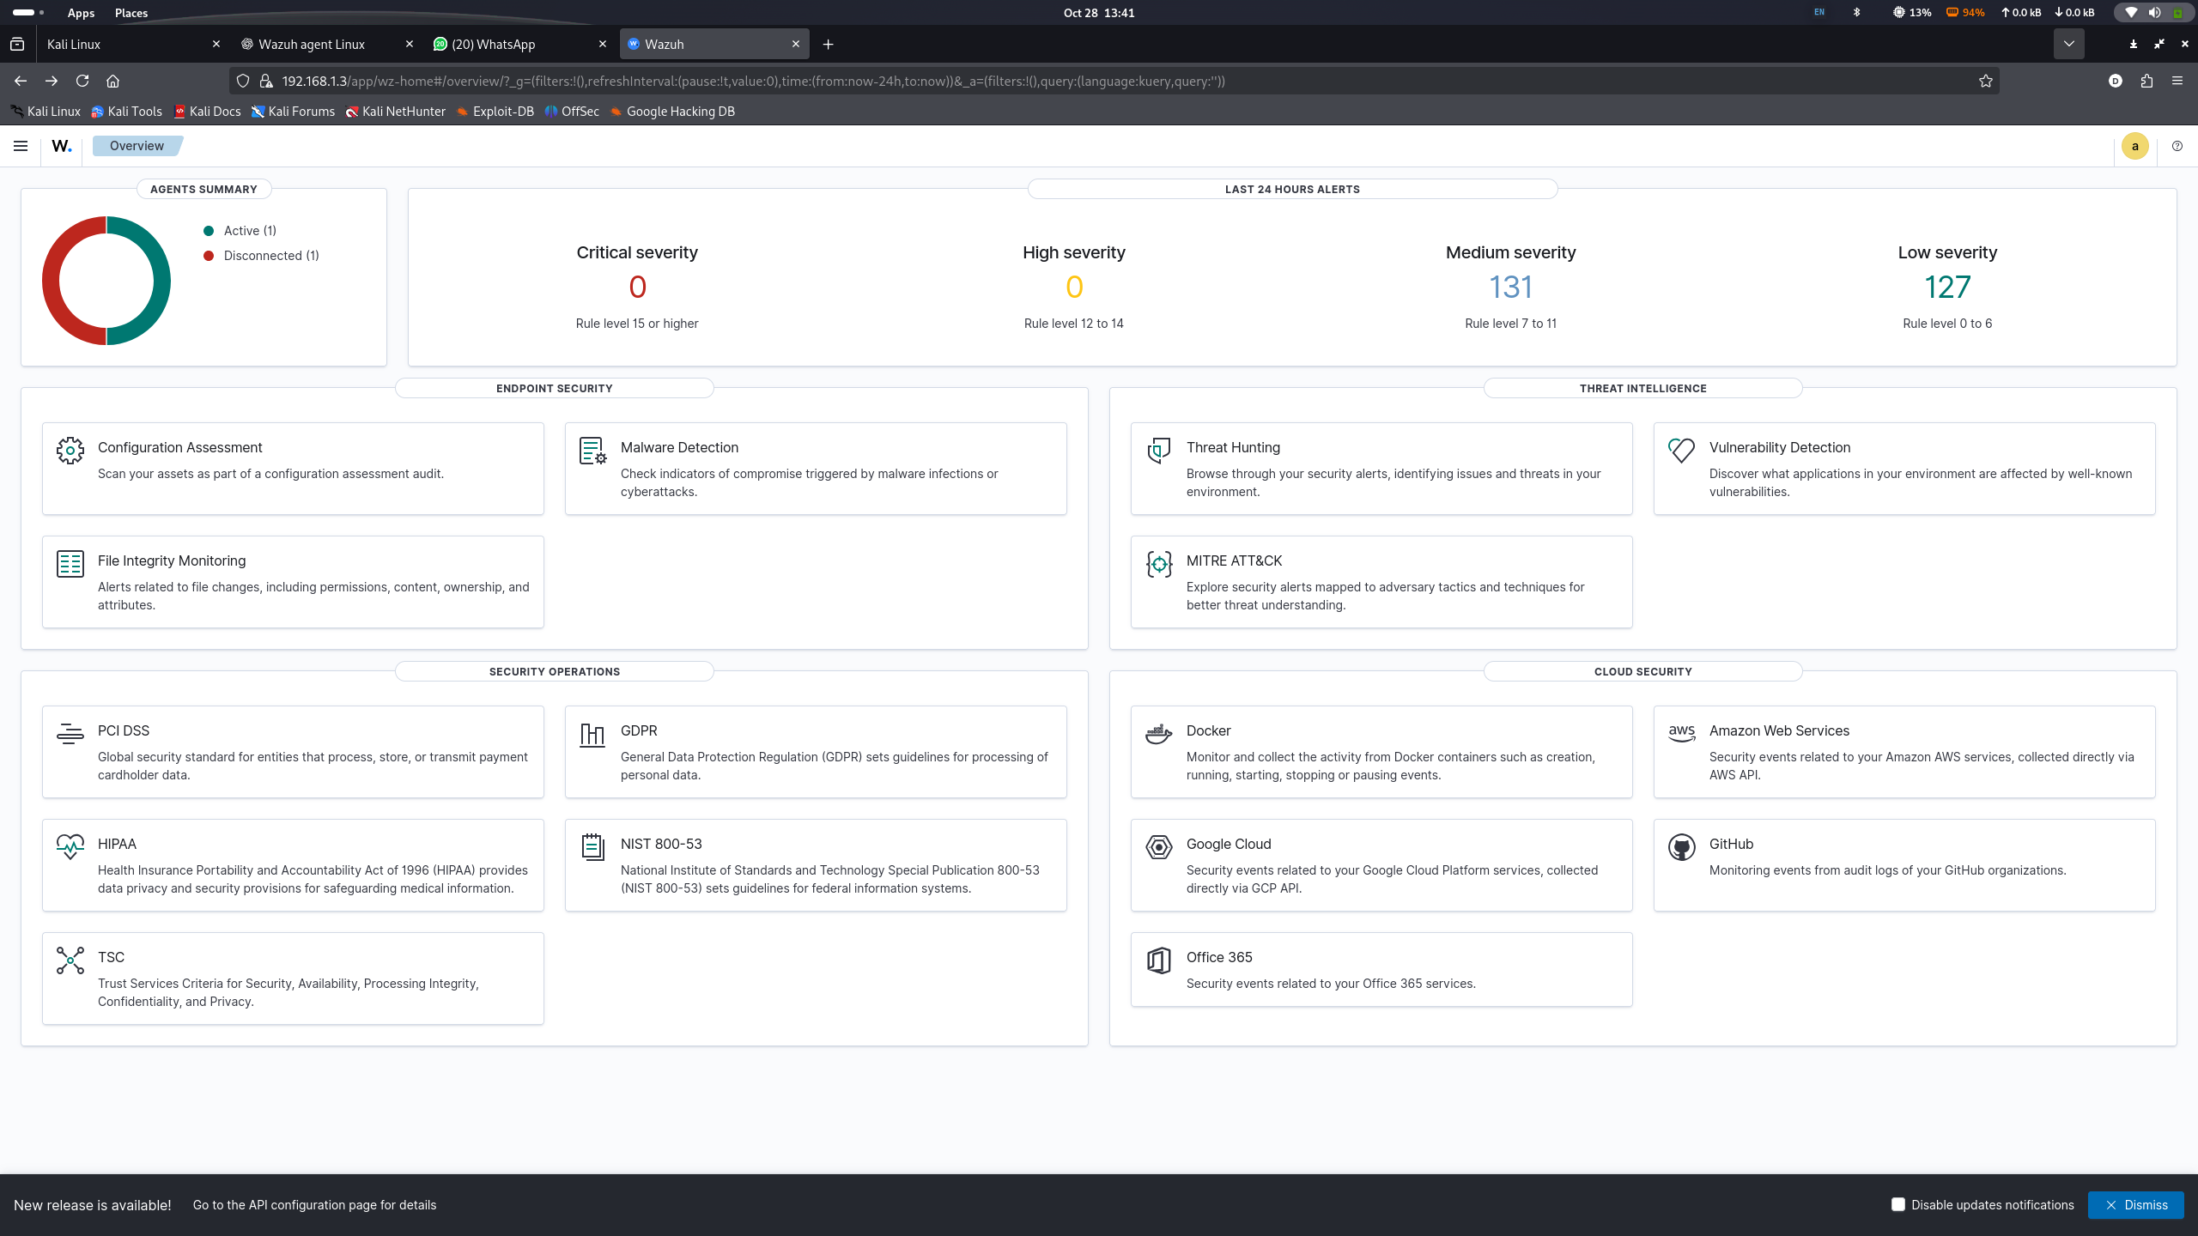

Part 3 – Install Wazuh Agent (Linux Host)
Installed Wazuh agent, configured ossec.conf, registered key, and verified service running.

Part 4 – Agent–Manager Registration Verification
Agent successfully appeared as Active (Green) in Wazuh Dashboard.
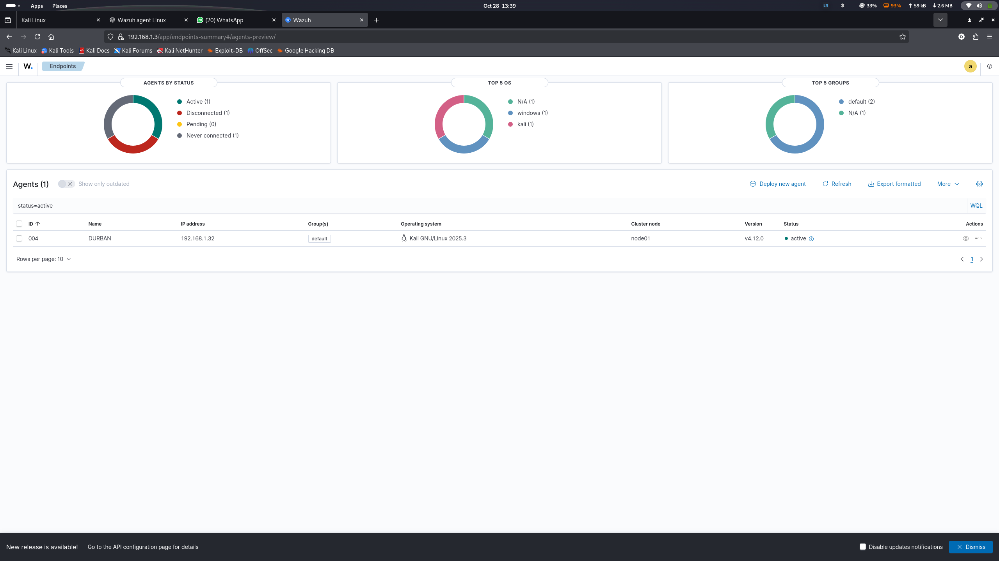

4. Implementing File Integrity Monitoring (FIM)
Configured syscheck module to monitor /home/durban/SensitiveFiles directory in realtime. Restarted agent and verified FIM startup in logs. Simulated file creation, modification, and deletion to trigger alerts. Alerts were visible on Wazuh Dashboard with rule group syscheck.

5. Risk Monitoring & Control Verification
The FIM control successfully identified and logged unauthorized file activities. Dashboard alerts confirmed detective control effectiveness.
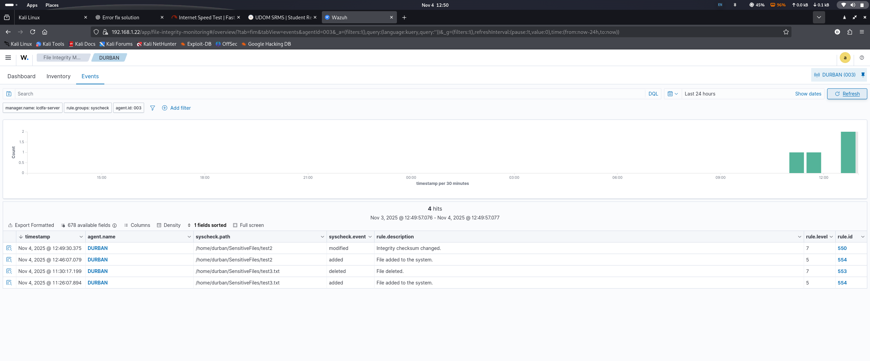
5.1 Risk Identification & Analysis:
Risk: Unauthorized modification/deletion of sensitive files.
Impact: Financial, reputational, and compliance damage.
Quantification: FIM alerts measure frequency and severity of unauthorized activity.
5.2 Control Evaluation & Treatment:
Detective control: File Integrity Monitoring (FIM).
Preventive control: File permissions, RBAC, and MFA.
Corrective control: Backup restoration or response triggered by alerts.

5.3 Key Metrics for Operational Effectiveness:
1. Number of file changes detected.
2. Mean time between detection and response.
3. Percentage of monitored files with alerts.
5.5 Compliance Mapping:
Standards: SOX §404, PCI DSS Req.11.5, HIPAA 164.312(c)(2).
Wazuh provides timestamped evidence of file integrity and supports compliance audits.

6. Conclusion
This lab successfully demonstrated operationalization of a detective control via Wazuh FIM. Unauthorized file changes were detected, alerts were analyzed, and governance objectives were achieved, meeting all GRC lab goals.

