Explore the Darts dataset using statistics

CCT - March 2018

Introduction

The dataset Darts.xls is a spread sheet with information about a contest that the 'Wall Street Journal run from 1990-2002. On this contest the objective was to find witch perform better, the 4 experts or the 4 random Darts. And also compare those against the DJIA (Dow Jones Industrial Average).
The stock-markets ware collected every month during the 14 years and for each stock the analysts ware watching how it will perform in a period of 6 months.
In a overview the dataset is a conjunct of analyses of experts against a dart game and DJIA.

Objective

The objective is to use the exploratory data analysis techniques on the dataset, report the finds using the R Studio as tool and the following mathematical operations

Mode
Median
Arithmetic Mean
Min, Max, Range
Quartiles
Variance
Standard Deviation
z-score
Skewness
Kurtosis
Correlations
Histograms
Box plots

Once the data is analyzed, it will be possible to identify who preforms better, the experts or randomly thrown darts, and how the conclusion is made by applying Confirmatory analysis.

Analyses

Mode
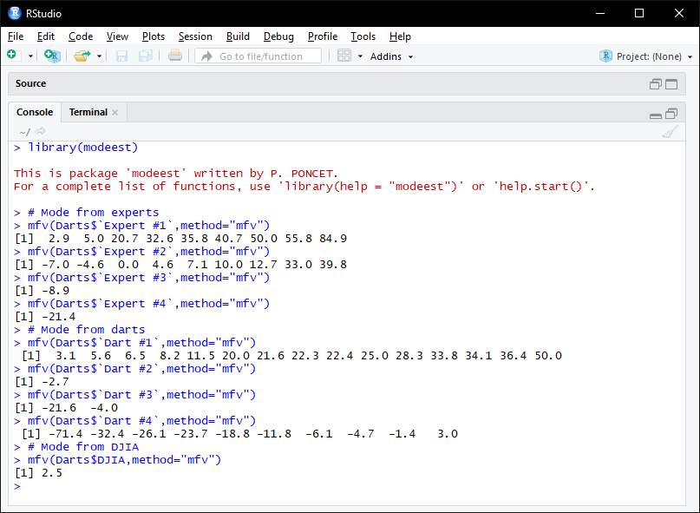

The screenshot above shows that:

Expert 1 had a frequency of positive results when I compare that to Dart 1 we see that Dart 1 results are positive but with lower values.

Expert 2 had a frequency of negative and positive results when I compare that to Dart 2 we see that Dart 2 results are negative. Expert 2 had a better performance.

Expert 3 had a frequency of negative result when I compare that to Dart 3 we see that Dart 3 results are also negative. Expert 3 had a better performance.

Expert 4 had a frequency of negative result when I compare that to Dart 4 we see that Dart 4 results are more to negative. Expert 4 had a better performance.

Experts and Darts had a frequency of negative and positive results when I compare that to DJIA we see that Experts and Darts results are to negative and positive values. Expert and Darts have a wide range from negative to positive perform than the DJA and DJA had a frequency positive but the value was not higher than the Experts and Darts.

Median

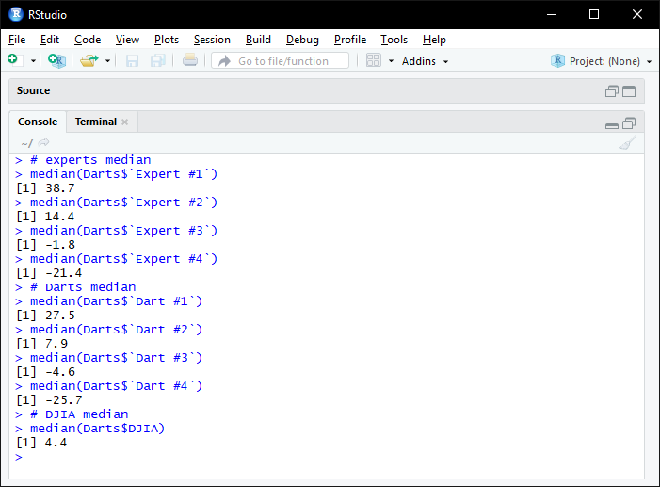
The screenshot above shows that:

Expert 1 had a median results higher when I compare that to Dart 1. We see that bough had a positive result.

Expert 2 had a median results higher when I compare that to Dart 2. We see that bough had a positive result.

Expert 3 had a median results higher when I compare that to Dart 3. We see that bough had a negative result.

Expert 4 had a median results higher when I compare that to Dart 4. We see that bough had a negative result.

Experts and Darts had a median of negative and positive results when I compare that to DJIA we see that Experts and Darts results are from negative to positive values, just bypassing the DJIA. Expert and Darts have a high range from negative to positive perform than the DJA and DJA had a median positive but the value was not higher than the Experts and Darts.

Arithmetic Mean

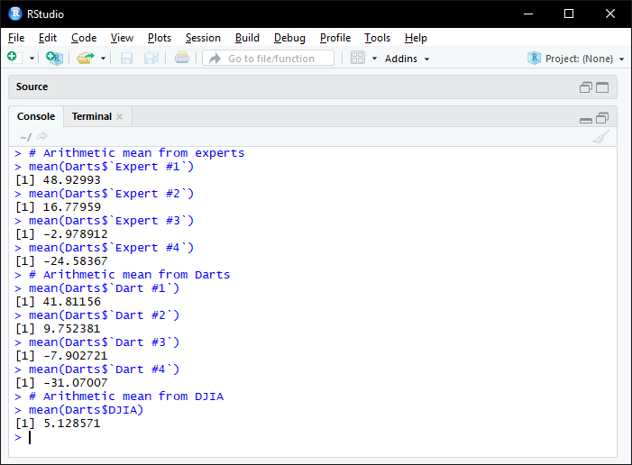
The screenshot above shows that:

Expert 1 had a arithmetic mean or average results higher when I compare that to Dart 1. We see that bough had a positive result.

Expert 2 had a arithmetic mean or average results higher when I compare that to Dart 2. We see that bough had a positive result.

Expert 3 had a arithmetic mean or average results higher when I compare that to Dart 3. We see that bough had a negative result.

Expert 4 had a arithmetic mean or average results higher when I compare that to Dart 4. We see that bough had a negative result.

Experts and Darts had a arithmetic mean of negative and positive results when I compare that to DJIA we see that Experts and Darts results are from negative to positive values, just bypassing the DJIA. Expert and Darts have a high range from negative to positive perform than the DJA and DJA had a arithmetic mean positive but the value was not higher than the Experts and Darts.
Minimum value from Experts, Darts, DJIA
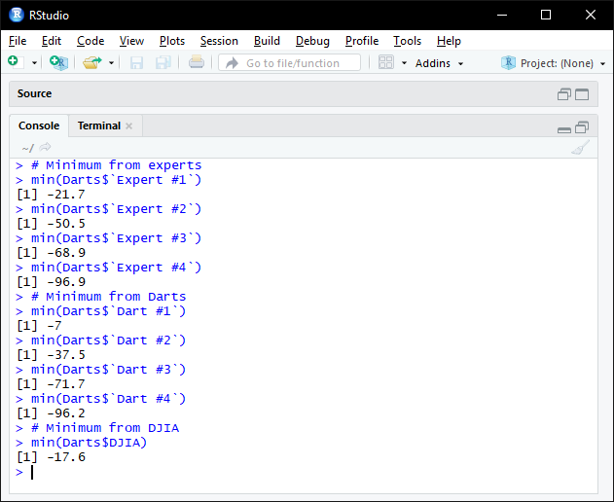

The screenshot above shows that:

Expert 1 had a minimum results lower when I compare that to Dart 1. We see that bough had a result far from each other.

Expert 2 had a minimum results lower when I compare that to Dart 2. We see that bough had a result close to each other.

Expert 3 had a minimum results higher when I compare that to Dart 3. We see that bough had a result close to each other.

Expert 4 had a minimum results higher when I compare that to Dart 4. We see that bough had a result very close to each other, and that the values are nearly one time negative, that is very bad performance.

Experts and Darts had a minimum of lower and higher results when I compare that to DJIA we see that Experts and Darts results are from lower to higher values, just bypassing the DJIA. Expert and Darts have a high range from lower to higher perform than the DJA and DJA had a minimum value better than the Experts and Darts.

Maximum value from Experts, Darts, DJIA

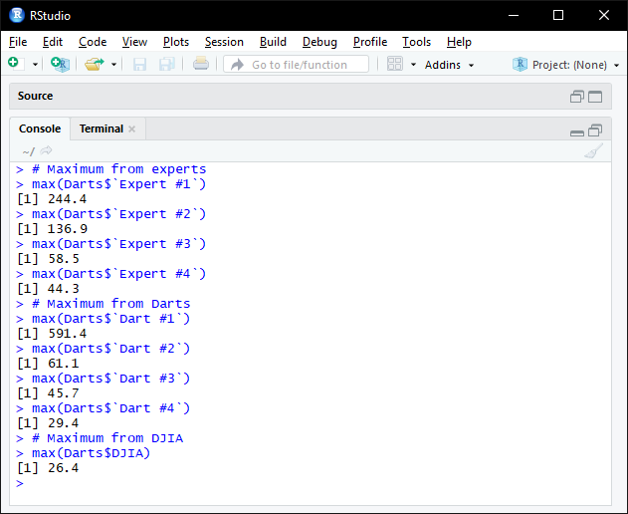

The screenshot above shows that:

Expert 1 had a maximum results lower when I compare that to Dart 1. We see that bough had a very high result and far from each other.

Expert 2 had a maximum results higher when I compare that to Dart 2. We see that bough had a good result and far from each other.

Expert 3 had a maximum results higher when I compare that to Dart 3. We see that bough had a good result and close from each other.

Expert 4 had a maximum results higher when I compare that to Dart 4. We see that bough had a good result and close from each other.

Experts and Darts had a maximum of results higher. when I compare that to DJIA we see that the DJIA has the lowest value.

Range from Experts, Darts, DJIA

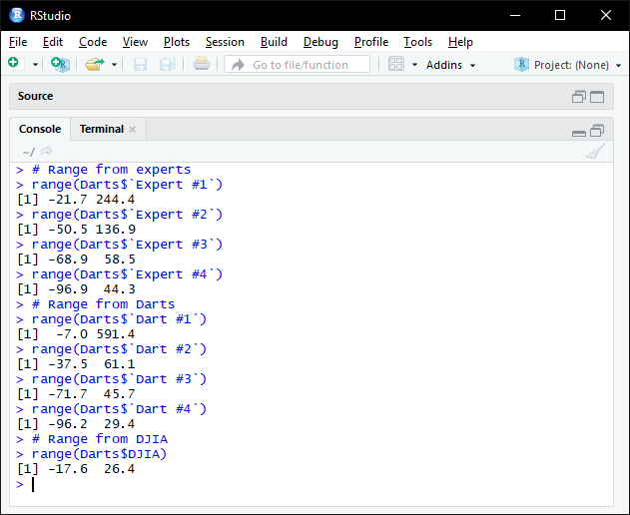
The screenshot above shows that:

Expert 1 had a result of range lower when I compare that to Dart 1. We see that bough had a very wide result and far from each other.

Expert 2 had a result of range higher when I compare that to Dart 2. We see that bough had a very wide result and far from each other.

Expert 3 had a result of range higher when I compare that to Dart 3. We see that bough had a wide result and are close to each other.

Expert 4 had a result of range higher when I compare that to Dart 4. We see that bough had a wide result and are close to each other.

Experts and Darts had a range of results bypassing the range of the DJIA, it is wider.

Quartiles from Experts, Darts, DJIA

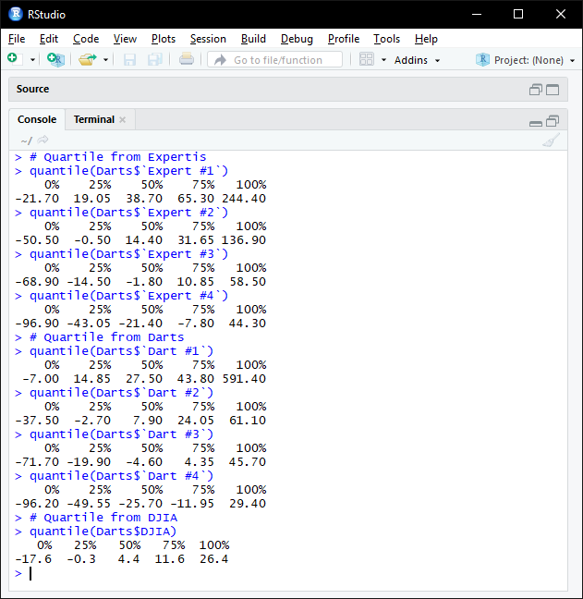
The screenshot above shows that:

Expert 1 had a quartile similar when I compare that to Dart 1. We see that bough had a distributed results, 0%, 25%, 50%, 75% are quite proportional but the 100% brings a higher result that is not proportional to the others.

Expert 2 had a quartile similar when I compare that to Dart 2. We see that Expert 2 has higher results and the 100% from Expert2 is not proportional it is making a higher result.

Expert 3 had a quartile similar when I compare that to Dart 3. We see that Expert 3 has higher results.

The screen shot above shows that Expert 4 had a quartile similar when I compare that to Dart 4. We see that Expert 4 has higher results.

Experts and Darts had a quartile of results bypassing the quartile of the DJIA, and also DJIA holds a better result from 0% to 75% but at 100% the Experts and Darts starts to get better results.

Code for the boxplot in RStudio

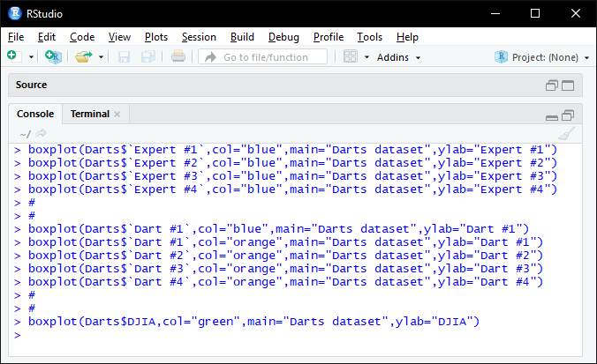

The information bellow represents in a boxPlot are the same results as the quartiles, there we can have a visual of the results and see where the results found are.
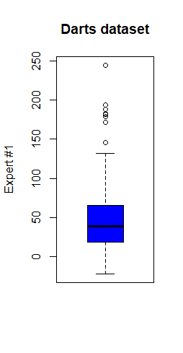
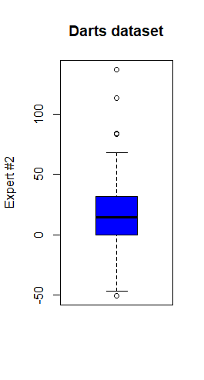
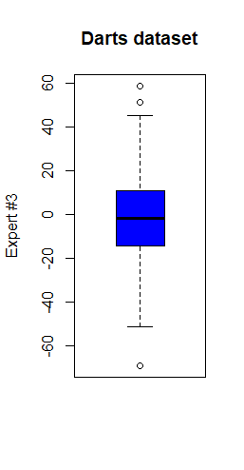
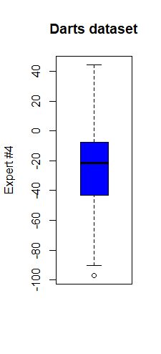
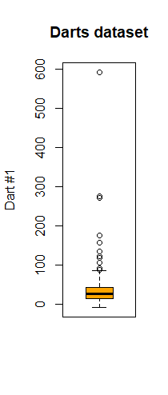
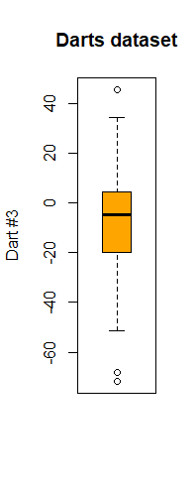
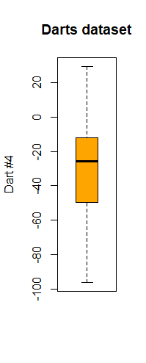
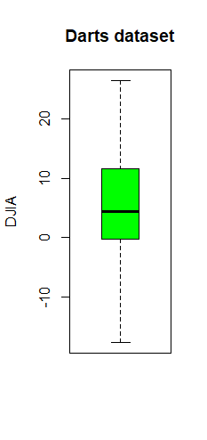
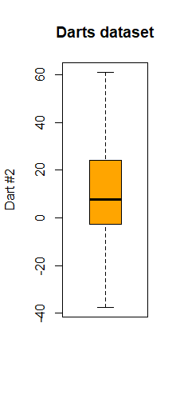

Variance

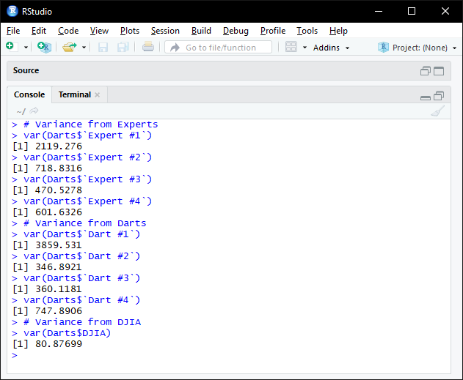
The screenshot above shows that:

Expert 1 had a variance lower when I compare that to Dart 1. We see that bough still have a high value of variance, that means bough have a large variety of numbers.

Expert 2 had a variance higher when I compare that to Dart 2. We see that bough have a considerable variety of numbers.

Expert 3 had a variance higher when I compare that to Dart 3. We see that bough have a considerable variety of numbers.

Expert 4 had a variance lower when I compare that to Dart 4. We see that bough have a considerable variety of numbers.

Experts and Darts had a variance of results higher than DJIA, and also DJIA holds a lower variance of numbers.

Standard Deviation

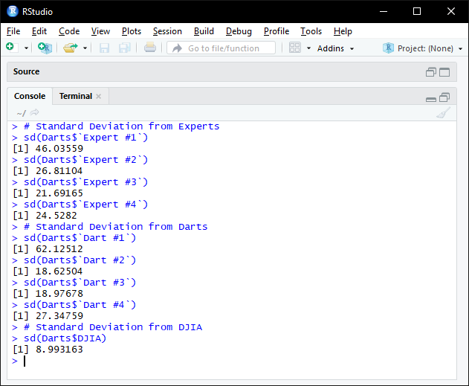
The screenshot above shows that:

Expert 1 had a standard deviation lower when I compare that to Dart 1. We see that from the mean if any result inside the range of the deviation by -/+, it is a normal value and values out of this range will be extra.

Expert 2 had a standard deviation higher when I compare that to Dart 2. We see that from the mean if any result inside the range of the deviation by -/+, it is a normal value and values out of this range will be extra.

Expert 3 had a standard deviation higher when I compare that to Dart 3. We see that from the mean if any result inside the range of the deviation by -/+, it is a normal value and values out of this range will be extra.

Expert 4 had a standard deviation lower when I compare that to Dart 4. We see that from the mean if any result inside the range of the deviation by -/+, it is a normal value and values out of this range will be extra.

The screenshot above shows that Experts and Darts had a higher standard deviation results than DJIA, and also DJIA is not as flexible as Experts and Darts as the range of standard deviation is only 8.99 around the mean.
z-score of lowest value from Experts, Darts, DJIA

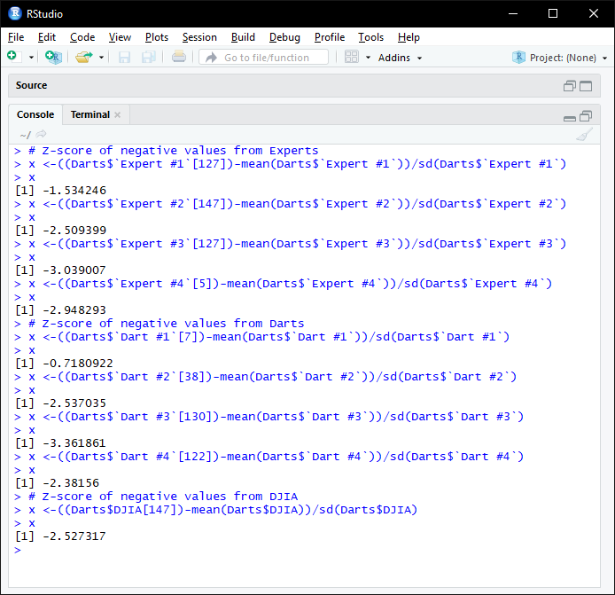
The screenshot above shows that:

Expert 1 had a Z-Score lower when I compare that to Dart 1. We see that from the mean the Z-Score of Expert 1 is -1.53 and Dart 1 is 0.72, so Dart 1 is in a better Z-Score.

Expert 2 had a Z-Score higher when I compare that to Dart 2. We see that bough scores are under -2.5, witch starts to be a bad Score.

Expert 3 had a Z-Score lower when I compare that to Dart 3. We see that bough scores are under -3, witch is a bad Score.

Expert 4 had a Z-Score lower when I compare that to Dart 4. We see that bough scores are under -2, witch is a bad Score.

The screenshot above shows that Experts and Darts had a close Z-Score results when I compare to DJIA. The lowest value of DJIA is close to bad, because it is about -2.5 of score witch by the rule of Z-Score over 2 negative standard deviations the result is not wanted.

Z-Score of highest value from Experts, Darts, DJIA

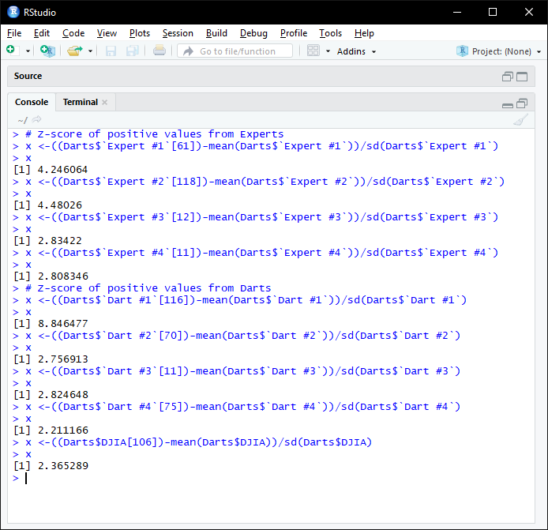
The screenshot above shows that:

Expert 1 had a Z-Score lower when I compare that to Dart 1. We see that from the mean the Z-Score of Expert 1 is - 4.25 and Dart 1 is 8.85 and Dart 1 is in a really high Z-Score.

Expert 2 had a Z-Score higher when I compare that to Dart 2. We see that bough scores are over 2.5, witch starts to be a high and good Score.

Expert 3 had a lower Z-Score when I compare that to Dart 3. We see that bough scores are close to 3, witch is a high Score.

Expert 4 had a higher Z-Score when I compare that to Dart 4. We see that bough scores are over 2, witch is a good Score.

The screenshot above shows that Experts 1 and 2 had high scores and Darts 1 had a score that was too high when I compare to DJIA. The highest value of DJIA is 2.37 of score, which is considerably a high score.

Skewness

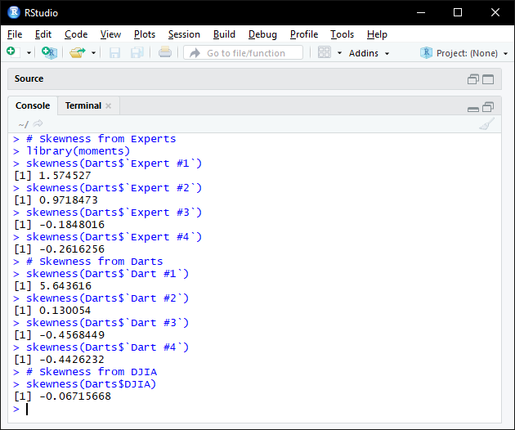
The screenshot above shows that:

Expert 1 had a Skewness result lower when I compare that to Dart 1. We see that bough are not symmetric but the value of Dart 1 is too wide.

Expert 2 had a Skewness result higher when I compare that to Dart 2. We see that bough are not symmetric but the values are close to the symmetry.

Expert 3 had a Skewness result higher when I compare that to Dart 3. We see that bough are not symmetric the values are negative and close to the symmetry.

Expert 4 had a higher Z-Score when I compare that to Dart 4. We see that bough scores are over 2, witch is a good Score.

The screenshot above shows that Experts and Darts are farther when I compare to DJIA. The DJIA has a result nearly symmetric.

Code and histograms of Experts, Darts and DJIA
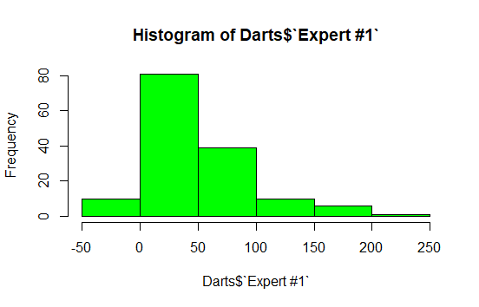
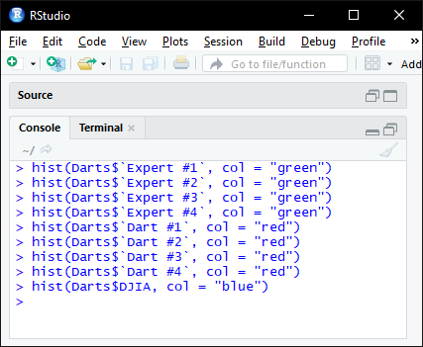
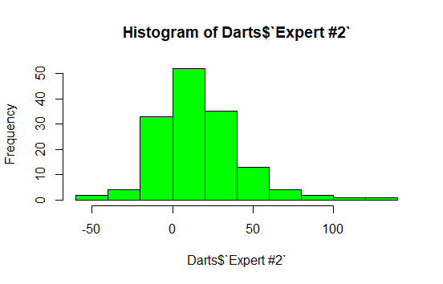
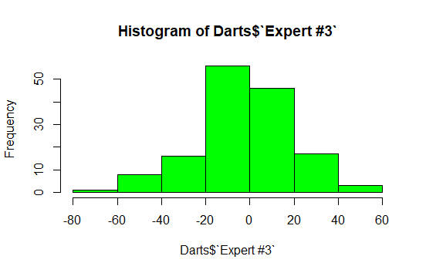
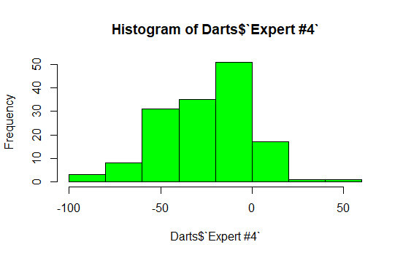
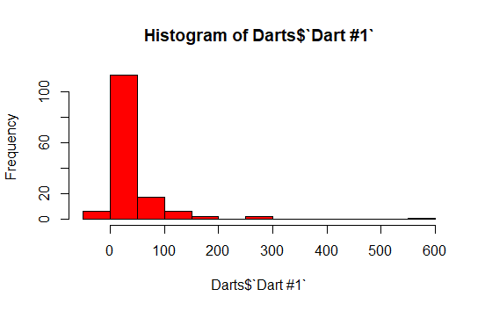

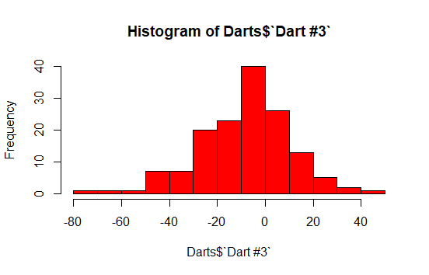
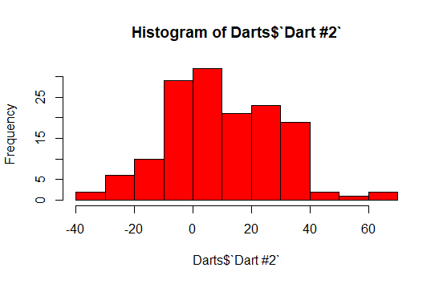
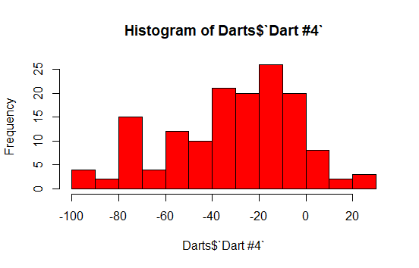
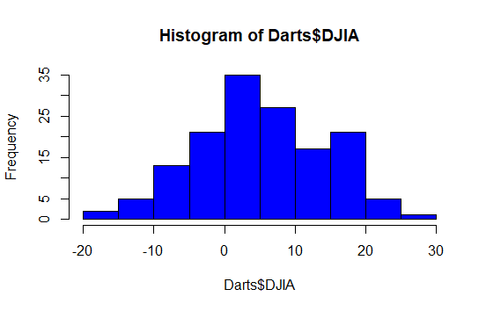

The histograms above are just a graphical representation of the Skewness results found previously, but now we can visualize the shape of the elements and where they are located.
Also when the results are positive the asymmetry of the histogram is to the left and the negative results the asymmetry is to the right.

Kurtosis
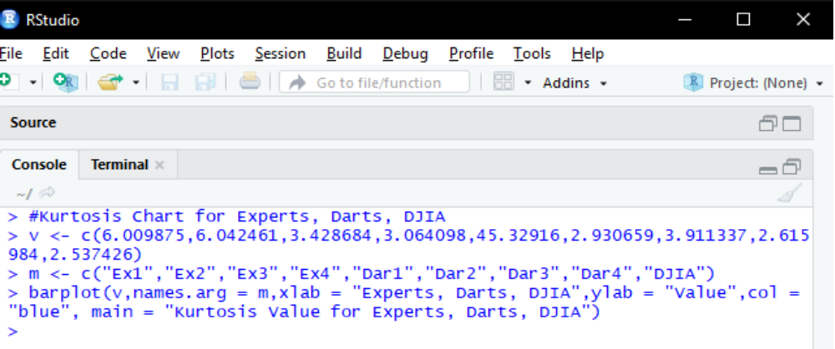
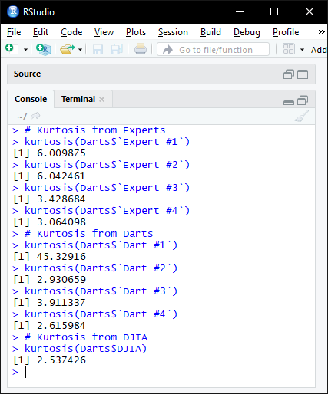
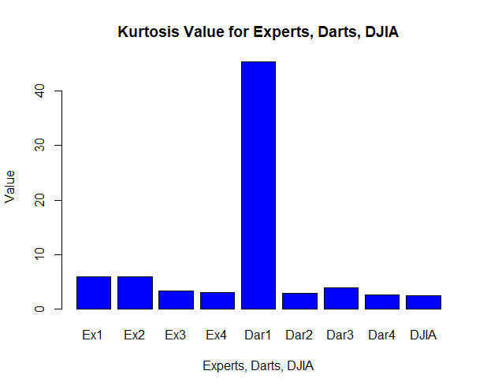
The screenshot above shows the results of the Kurtosis measurement and to visualize it better, the values are passed to a chart where we can see the distribution of the peaks, on this chart we see that, experts have a higher peak than darts. Darts has slightly higher than DJIA, the curiosity in there is about the Dart 1, it is really high, and it is because in previously analysis we saw that Dart 1 had one result that was over the average and acceptable levels.

Correlations

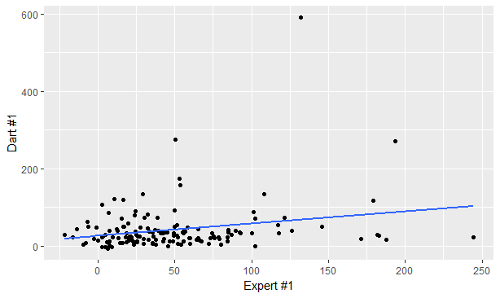
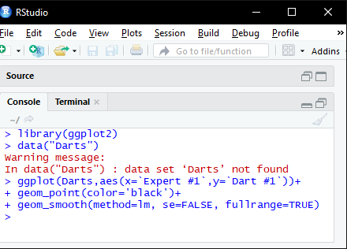
The plot above shows that Expert 1 had a low positive correlation when I compare that to Dart 1. We see that the values are far from each other.

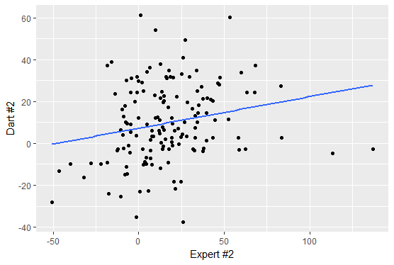
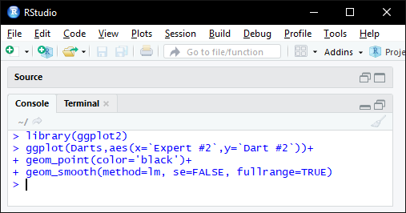
The plot above shows that Expert 2 had a low positive correlation when I compare that to Dart 2. We see that the values are far from each other.

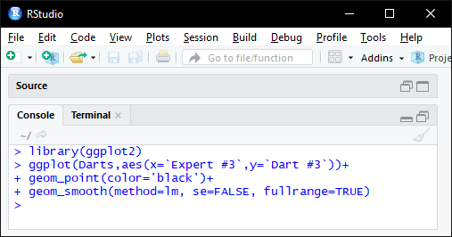
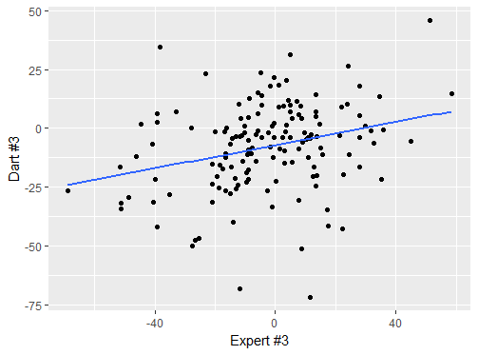

The plot above shows that Expert 3 had a low positive correlation when I compare that to Dart 3. We see that the values are far from each other.

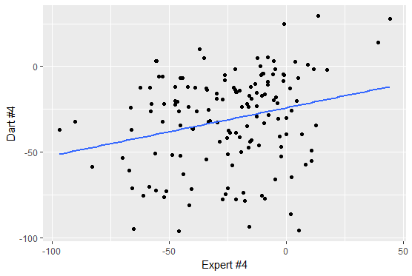
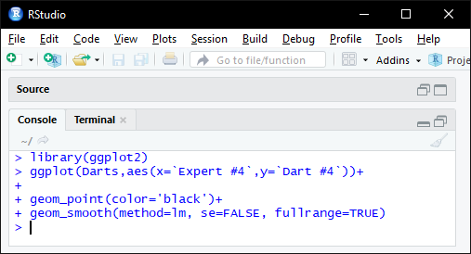

The plot above shows that Expert 4 had a low positive correlation when I compare that to Dart 4. We see that the values are far from each other.

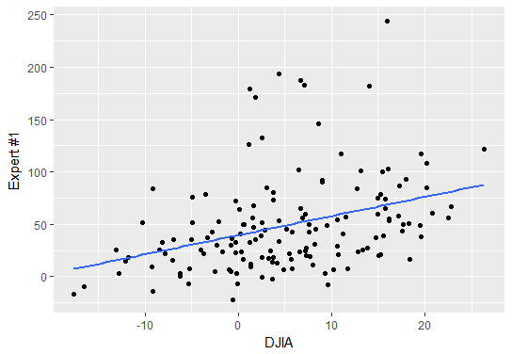
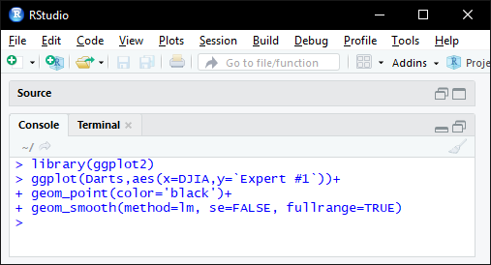

The plot above shows that Expert 1 had a low positive correlation when I compare that to DJIA. We see that the values are far from each other.

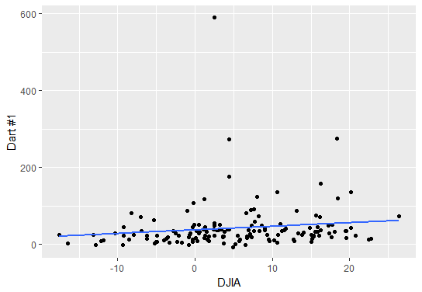
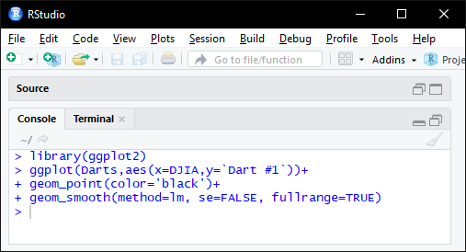

The plot above shows that Dart 1 had a high positive correlation when I compare that to DJIA. We see that the values are closer to each other. And only fewer values from Dart 1 are far. But those are just fractions from the variable.

Confirmatory data analysis

The proposed hypothesis of the project is: Can stock market professionals really do any better than simply throwing darts at pages of stock markets listings?
The exploratory analysis had checked the 4 professionals against 4 Darts dataset and the DJIA average. Basic tools were used to find information intro the dataset.
From the information collected, we can see that the frequency of values for Experts are more to positive and it contrasts with the information from Darts that are more frequently negatives.
The average of the datasets also show that Experts have better results against Darts. At the boxplots we can see in a better picture that experts are not much but still better that Darts, Dart 1 have a result very high but as it occur only one, it is not taken as weight.
Also Experts have more wide variation of results than Darts.
When the Z-Score is analyzed, I have checked from the lowest values, how far from the mean they are, and the same for the highest values, and the numbers shows that Experts remain with better results.
The result of the previous numbers can be seen in the correlation section where we can see clearly that the values of the Experts are better than compared with Darts, those values are not perfectly positive correlation. But shows again that even bough values increase, the Experts results are still concentrated in a better level.
Also the results for conclusion, Experts results are Better than the Darts results and Darts Results are slightly better than the DJIA.
What we should see as well is, the range of values from Experts and Darts are more wide than the range from DJIA, it shows that DJIA was the one more conservative, with no big changes.
The conclusion is: Experts are really better than Darts and Darts are a step better than the DJA.

References

Investor Home (2001). The Wall Street Journal Dartboard Contest.. Available at: http://www.in
vestorhome.com/darts.htm [Accessed on 23th March 2018]

Dartboard (2010). Stock Market Investing Dartboard. Available at: http://www.dartboard.com/s
tock-market-investing-dartboard [Accessed on 23th March 2018]

Shelby Blitz (2017). Exploratory and Confirmatory Analysis: What’s the Difference. Available a
t:https://www.sisense.com/blog/exploratory-confirmatory-analysis-whats-difference/ [Accessed on 23th March 2018]

Tutorials Point (2018). R Tutorial. Available at: https://www.tutorialspoint.com/r/index.htm [Acc
essed on 23th March 2018]

Maths is Fun(2016). Correlation. Available at: https://www.mathsisfun.com/data/correlation.ht
ml [Accessed on 27th March 2018]

I declare that this work is solely mine.

