B.Sc. in Information Technology

Ennio da Silva Vitor, Student N. 2015197
Fernanda Palomino de Oliveira, Student N. 2015203
Thieres Luiz Pereira, Student N. 2015148

Pocket Waiter
No more queues!



© Copyright 2018, by authors:
Ennio da Silva Vitor
Fernanda Palomino de Oliveira
Thieres Luiz Pereira.

All rights reserved.

Abstract
This document reviews the technology growth and its impact on customers’ behaviour regarding daily activities such as ordering products online. Based on research and surveys, a busy market -bars and restaurants- was target and a new way of ordering drinks and food was introduced to facilitate customers lives. Anyone who is in a bar or restaurant and has a device with connection to the internet, is able to order their desired products through a web application, choose the goods, pay and wait for the delivery to their tables, without the need to queue at the bars or wait for waiting staff.

Acknowledgments
We would like to express our gratitude to our families, partners and friends who supported us throughout the course at CCT and especially during this project, in which we worked hard researching and building the application and defending our idea.
We would like to thank all the friendly ideas, constructive criticism, questions and disapprovals. Everything contributed to our engagement, improvement and enthusiasm to deliver the best product we could.
A big thanks to all of our teachers and especially to our supervisor Greg South, who always gave us motivation and good advice to continue with this project work.
It is also important to use this opportunity to thank each other in this group. We are glad to have met and worked together through many projects during these three years in college. We became friends and we will surely maintain this friendship for life.
Summary
Abstract 3
Acknowledgments 4
1. Introduction 6
1.1 The Idea 6
1.2 Problem 7
1.3 Solution 7
1.4 Competitors 8
1.5 Project Deliverables 8
2. Research & Survey 9
2.1 Research 9
2.2 Survey 13
3. Technologies 15
4. Planning, System Analysis and Design 17
4.1 Planning 17
4.1.1 Application’s requirements 17
4.2 System Analysis 18
4.2.1 High level description 18
4.2.2 Use Case Scenario 18
4.3 System Design 19
4.3.1 Use case diagrams: 19
Customer side 19
a) Activity diagram 22
b) Class Diagram 24
c) Sequence diagram 25
d) Statechart diagram 25
Business Side 27
a) Activity diagram 27
b) Sequence diagram 28
c) Statechart diagram 28
ERD 30
5. Team 30
5.1 Individual Roles 31
6. Future of Pocket Waiter 31
7. Pages Art & Design 32
8. Tests 39
8.1 Integration test 39
9. Conclusion 57
10. References 58
Appendix A 61
Appendix B 62

1. Introduction
As society advances into the 21st century, we live in an era where time is scarce and the most common activities such as going to work, college, shopping for clothes, going to the bank, grocery shopping etc can turn into extremely stressful and time consuming tasks.
Technology has given us a better experience with simple routines like waking up in the morning, keeping in touch with friends and family, listening to music, shopping, etc. through the use of websites and applications. All the aforementioned tasks can currently be done through a single device instead of several devices that we would need to carry around, in order to have all of those needs attended.
Additionally, the big wave of e-commerce, internet banking, self-service at supermarkets and food ordering applications instead of the traditional way of going to do things personally, is a response generated by this decreased amount of free time. The goal of this project is to provide more comfort and to act as a time saver for our clients.

1.1 The Idea
The idea for our final project, came about during one of our meetings in which we study and discuss college subjects and projects. As it was easier for all of us, we decided to meet in a bar in town and we spent the day pitching ideas and researching, thinking about something original and attractive and that we could deliver as a finished product. Every couple of minutes we needed to stop the progress, stand up and go to the bar in order to get drinks and snacks. At a certain point we asked ourselves “Wouldn’t it be great if we could order the drinks from our table?” and that is how the idea for Pocket Waiter came about.
From that point on we started focusing our research towards our idea of creating an app that would allow people to order their drinks and food through their smartphones from their table, eliminating the need to physically having to go and queue at the bar or wait for the waiting staff to come around.

1.2 Problem
Collins Dictionary defines ‘problem’ as “a situation that is unsatisfactory and causes difficulties for people”. Following this dictionary definition, the problem we see in the traditional way of ordering products in a busy environment for a client is: to stop the conversation with friends and stand up and out of the comfort of their seats to be in the middle of a high volume of customer struggling to get the attention of the waiting staff and bartenders, this process of ordering and paying is slow and unsatisfactory.
In case of customers that go to the bar alone to enjoy themselves or maybe to wait for somebody to arrive, it can be even worse. If they were lucky to find a table, each time they have to stand up and walk to the bar and wait for their turn to be served, they run the risk of losing their seats to other customers around.
On the businesses’ side, the problem is to have stressed staff handling many clients at the bar with a large amount of products being ordered out loud, many times with music playing in the background, people waving to get their attention etc. At the same time these tired staff need to handle high volume of cash and card payments, which are more likely to have mistakes and ending in a frustrating experience for everybody.

1.3 Solution
After all the problems mentioned above, we decided to present a final project that will contribute to improve the customer experience. Pocket Waiter is an user friendly web application to optimize the process of ordering products by having the entire process - from choosing a product to the payment - online, through our web page.
With our solution, customers will walk to restaurants and bars, choose a table, get any smartphone or tablet with internet access and go online to the Pocket Waiter web page. Once connected, the clients will have to login as a customer, enter some information such as table’s number and table’s code so the bartender and waiting staff will know where to delivery the orders and also for the menu from that specific establishment to pop up on the screen. Once the menu is open, clients will be able to select their beverages and meals and confirm the order, proceeding then, to the payment page that will be handled by Paypal and wait to receive everything at their tables, avoiding queueing in the crowd and any stress regarding the process.

1.4 Competitors
In our initial research we found two applications that are providing similar features. Those applications are called QuickServe and Hoom. The difference is that both applications need to be downloaded and installed on your device which limits the reach of the application itself. We differentiate ourselves through mobile friendly browsing, which will give the user more flexibility with the usage of our web application.

1.5 Project Deliverables
Pocket Waiter documentation will be delivered to CCT College on the 6th of May of 2018, including the following items:
- User’s Guide
- Technical Report
- System Tests
- DataBase Report
- Technologies
- Appendix (errors and changes)

2. Research & Survey

2.1 Research
In our research, we collected and investigated relevant facts that helped us to develop arguments to support this project.

The usage of smartphones in Ireland
According to a research carried by Statcounter in 2015, Irish people are one of the largest smartphone users of the western world. Representation in the graphic below:
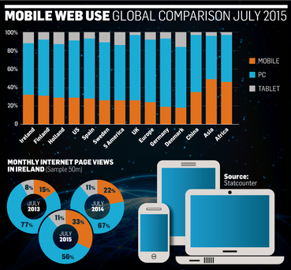

The research also indicates that mobile phones are going to overtake PC’s as the main resource to access internet in the next few years. One of the reasons why Ireland holds this numerous accesses to the internet, is the price for data, one of the cheapest in Europe.
Another survey released by Deloitte in December of 2016, points that 86% of the Irish population between 18 and 75 years old have access to the internet and a smartphone. The research shows the smartphone being top priority over other tech devices such as tablets and laptops.
This convinced us that Irish people are comfortable using their smartphones and that they would probably receive our web application as a good alternative to order drinks etc.

Drinks and Food Industry in Ireland
According to Drinks Industry Group of Ireland (DIGI), there are around 210,000 employees in hospitality in the whole country, generating a profit of 6.4bi euros per year. Addiotionally, this industry supports 12,000 farm families, pays 2.9 billion Euro in wages and purchases 5.7 billion Euro in materials and services.
DIGI also says that most of the tourism around Ireland is done because foreigners want to go for pubs, drink pints and listen to live irish music.

The numbers mentioned above pictures the importance of this sector in the country and also that we are targeting a large scale market to launch our product. It is a world of good possibilities for Pocket Waiter’s future.

Irish Customers Experience
This exploratory study searched topics such as "Pubs and restaurants having problems to quickly serve and offer comfort to their customers on busy hours or days", in order to collect information about customer’s experience at establishments around Dublin city. As expected, the outcome reinforced that Pocket Waiter would work effectively on the improvement of both sides, businesses services and customers experiences.

Customer reviews taken from Google searches:
Customer Name | Business Name | Date
Brendan Martin | Buskers | 13-10-2017
Terrible drink and waiting time just to be served was insane. Prices for the quality is outrageous. €6 for a pint of Guinness that i would have happily thrown away.
https://www.google.ie/maps/place/Buskers/@53.3458359,-6.2614804,18z/data=!4m15!1m7!3m6!1s0x48670e9cb559ea73:0x2600c7a819c83012!2sTemple+Bar,+Dublin!3b1!8m2!3d53.3449379!4d-6.2674731!3m6!1s0x0:0xfa8cd85856400f40!8m2!3d53.3458359!4d-6.2603861!9m1!1b1

Customer Name | Business Name | Date
Joey Riz | The Palace | 13-10-2017
This place was nice to grab a pint but it was super busy and the bartenders seems a bit overwhelmed. Service suffered a bit because of it but not terrible. They did pour a good pint.
https://www.google.ie/maps/place/The+Palace+Bar/@53.3458948,-6.2607006,18z/data=!4m15!1m7!3m6!1s0x48670e9cb559ea73:0x2600c7a819c83012!2sTemple+Bar,+Dublin!3b1!8m2!3d53.3449379!4d-6.2674731!3m6!1s0x48670e84ca01c163:0x754042cd7609c648!8m2!3d53.3458948!4d-6.2596066!9m1!1b1

Customer Name | Business Name | Date
Tracy Palmer | Buskers | 13-10-2017
Bar service is pretty poor when it’s busy.
https://www.google.ie/maps/place/Buskers/@53.3458359,-6.2614804,18z/data=!4m15!1m7!3m6!1s0x48670e9cb559ea73:0x2600c7a819c83012!2sTemple+Bar,+Dublin!3b1!8m2!3d53.3449379!4d-6.2674731!3m6!1s0x0:0xfa8cd85856400f40!8m2!3d53.3458359!4d-6.2603861!9m1!1b1

Customer Name | Business Name | Date
N/A | Oliver St. John Gogarty | 13-10-2017
Quite slow service, otherwise OK.
https://www.google.ie/maps/place/Oliver+St.+John+Gogarty/@53.3455806,-6.2628024,18z/data=!4m15!1m7!3m6!1s0x48670e9cb559ea73:0x2600c7a819c83012!2sTemple+Bar,+Dublin!3b1!8m2!3d53.3449379!4d-6.2674731!3m6!1s0x48670e835479ef59:0x20640a40c1e17d01!8m2!3d53.3455805!4d-6.2617081!9m1!1b1

Customer Name | Business Name | Date
N/A | The Czech Inn | 13-10-2017
It is full and takes to be served and the food come.
https://www.google.ie/maps/place/The+Czech+Inn/@53.3449473,-6.2689876,18z/data=!4m15!1m7!3m6!1s0x48670e9cb559ea73:0x2600c7a819c83012!2sTemple+Bar,+Dublin!3b1!8m2!3d53.3449379!4d-6.2674731!3m6!1s0x48670e9d537b153b:0x9cc29153617eef44!8m2!3d53.3449472!4d-6.2678933!9m1!1b1

Technology and Food Delivery
Research from McKinsey, studied the food delivery market in 16 countries around the World during a period of six months and it says that the delivery market stands at 83 billion Euros of the total food market income and that three quarters of the deliveries are still being received as calls. However, consumers that are already used to the convenience and transparency of purchasing goods online are surely expecting the same kind of experience when it comes to ordering their meal. “The rise of digital technology is reshaping the market”, says McKinsey, and we agree.
Online food delivery has existed for almost two decades, one in which a customer logs in to a website or application to compare menus of different restaurants, prices etc, choose their meal, place their orders and the restaurants will be responsible to deliver everything to the customer’s home. And recently, a new delivery way were introduced to this market, where the platform does not provide only the tools to compare menus and prices, but they also provide their own driver to collect the prepared food at the restaurants and deliver to the customer’s door. This in turn makes customers’ and businesses’ lives easier.

Below we can see the progress of offline orders (by calls) and online orders (through websites/apps) counting those 16 studied countries for periods from 2015 until a projection in 2020.
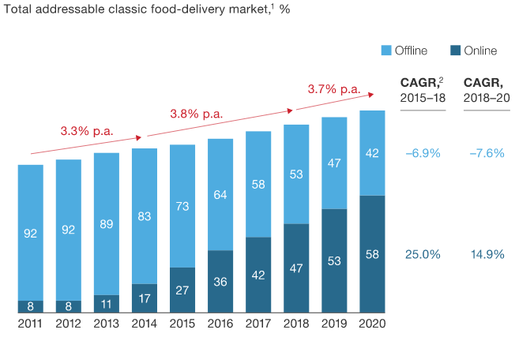

2.2 Survey
We used a survey to record and examine the opinion of potential users of Pocket Waiter. The survey was conducted in Ireland, in the location we chose to launch the web application and we counted with 62 participants who live all around the country and mainly in Dublin. Those people were asked to respond a question anonymously and online by a link sent to their emails or social media. They needed to give some information about themselves such as gender: female, male and prefer not to say and to select the age categories they fit in: age from 18 to 24, 25 to 34 and over 35 years old. This way we could get their true opinion.
Survey: “A new app is launched that allows you to order food and/or drinks from your table in a pub/restaurant using your phone/tablet instead of queuing at the bar.”
Below we can see the graphs extracted from Google Forms.

Graph 1 - shows the question and the choices of answer an interview could select.
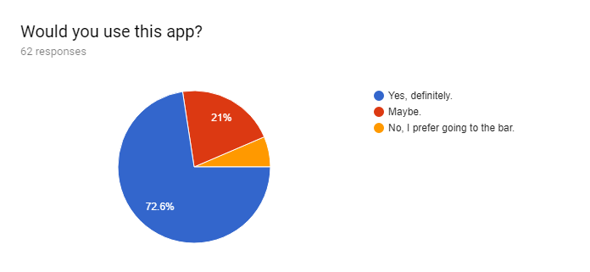
As result, we received the impressive amount of 45 people - representing 72.6% of the entire population sample - who would definitely use Pocket Waiter as their way of ordering drinks in a bar. Next, 13 people said they are open to try our web application and 4 people said they wouldn’t use it because they prefer going to the counter.

Graph 2 - shows that we received 34 responses from women and 28 from men.
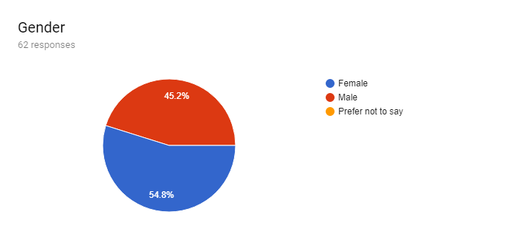
Graph 3 - shows the different age classification of the participants. 7 people are between 17 and 25 years old; 47 people are between 26 and 34 and 8 people are above 35 years old.
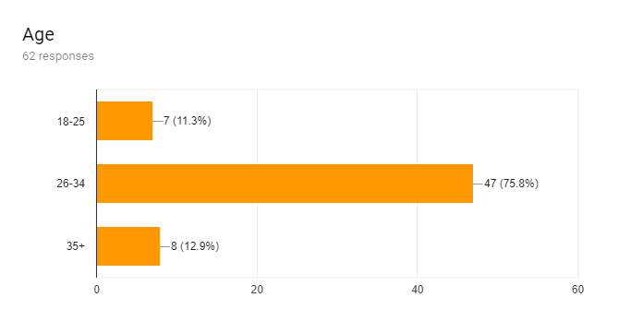
We are very satisfied with the outcome of this survey, which shows that Pocket Waiter will fulfill our expectations and has a high probability to succeed as an application to be launched in the real market.

3. Technologies
Once the main idea was finalised, we researched which technologies we would need to use to deliver Pocket Waiter on time and as a finished product, while meeting CCT’s requirements for the final project.
Our initial idea was to build a native application that would run on both Android and Apple smartphones. We studied frameworks that provide the functionality to write and work in one code that later would be available for different platforms. We initially chose the Ionic Framework, however, the tight schedule combined with many other projects we had to deliver to our lecturers didn’t give us much opportunity to learn enough of this framework, so we couldn’t benefit from using its features.

We decided to use technologies that we are more familiar with and that we have used in past projects we worked on in CCT. These are the technologies chosen:
- PHP
PHP is a server scripting language, and a powerful tool for making dynamic and interactive Web pages. We are going to use it handle the login connection, shopping cart connection and database queries;
- JavaScript
JavaScript is the programming language of HTML and the Web. We are going to use it to validate forms on our web application;
- HTML
Hyper Text Markup Language, describes the structure of Web pages using markup and used to create the layout of our web application;
- CSS
Cascading Style Sheets is a language that describes the style of an HTML document;
- jQuery
jQuery is a cross-platform JavaScript library designed to simplify the client-side scripting of HTML.To format the website so it can be displayed in mobile devices;
- SQL
SQL is a standard language for storing, manipulating and retrieving data in databases;
- Paypal REST API
In order to allow the customer to pay for the goods purchased through the app, we will integrate the PayPal checkout button into our application. This provides higher security and reliability as PayPal API will manage every aspect from the moment the client proceed to the payment page.
- Heroku
Heroku is a platform to deploy applications in the cloud, runtime environment, offers free plugins and free hosting for up to 1000 hours per month, what worked very well for our project as we didn’t need to worry about spending money in the development phase. Also, with Heroku the developer does not need to worry about configuring servers or databases, with only a few commands everything is integrated into the application and ready to use.

These technologies allowed us to deliver a functioning application, build a foundation and allow to upscale the application with new features in the future. Additionally, future updates or new releases won’t impact the user experience, in case of iOS or Android rollouts. The requirements will be a browser app, which is included in basically every smartphone and internet access.

4. Planning, System Analysis and Design
This section has the objective to identify all the problems and solutions to develop the software that will allow the customer to purchase products at the table and get a fast service, without the stress of going at the bar or waiting for a waiter.

4.1 Planning
Planning the system is an essential phase in the SDLC (System Development Life Cycle). Project Management ensures the delivery of a high-quality software, prioritized strategies and goals and keeps the team motivated, to accomplish tasks on time. Below we can see the requirements for this system.

4.1.1 Application’s requirements
Front End
- Read code, verify in the database which restaurant/pub owns that table and redirect to the restaurant’s menu page.
- Allow user to add/remove items to their order
- Pay Paypal
- Send email confirmation to user’s email address with a receipt

Back End
- Allow admin to add food category to the menu.
- Categories of food such as: Starters, Main, Dessert, Drinks etc.
- Allow admin to add, delete and hide items in the menu .
- Description of the products, price, allergens.
- Allow both PW admin and staff admin to add tables to the restaurant. (The unique code for each table will be their ID in the database table).
- Allow user to view a list of all orders to be prepared/served. (This list has to be automatically refreshed and has to show orders in an order from the oldest to the newest).
- Allow user to confirm orders/mark as in progress/mark as on the way/mark as served, (served orders will disappear from the list).
- Allow admin to view/print reports of orders received by a given period
- Allow admin to view/print report showing the time since receiving the order and serving it.

Note: the back office, a device such as a tablet or a smartphone in the kitchen/bar must be always logged in the Pocket Waiter web application, to facilitate the access to the list of orders, so the servers don’t have to login and logout from the app all the time. The downside is that there is no control of knowing who served the order but I guess this should not be a problem for the final project.

4.2 System Analysis
The Analysis phase involves collection, interpretation, identification and decomposition of the system.

4.2.1 High level description
When the customer arrives at the pub or a restaurant where the business have table service, he or she goes to the front counter, to place a order. And only after this process the customer is able to go and find a place to sit. If the customer has the option to sit, they have to wait to be served and this process can take time when the business is busy.

4.2.2 Use Case Scenario
User type the number of the table.
- User gets access to the menu.
- User select items in the menu / confirm selected items.
- User proceeds payment by card / Paypal .
- User receives receipt by email
- Transaction is finished

4.3 System Design
In the Design of the system phase, a completely new system is defined or an existing system is modified in order to meet the new requirements.

4.3.1 Use case diagrams:

Customer side
The process where the traditional system runs can be described as below:
- The staff and customer have to handle the process to place orders.
- The staff and customer have to handle payment process.
- The staff have to handle the print receipt to the customer.
- The service process is handled by staff and customer.
- The staff and customer handle the customer services process.
The system is quite slow and the customer also is included into it. The customer can be at the front counter or at the table, and in any of those two options the staff and customer are having direct contact to complete every process.
Traditional System Use Case Diagram:
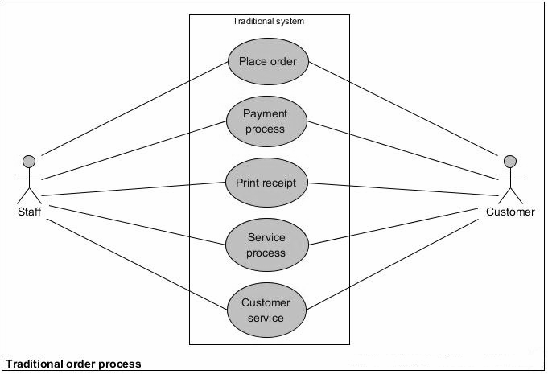

By developing the web based application, the user case scenario changes, as we can see in the diagram below. The new system will reduce the work of the staff and customer, and allow for a faster service.

The customer will handle all the processes below:
- Chooses a table.
- Enter table code.
The system will display:
- The menu.
Then the user will:
- Choose food or drink.
- Place payment.
The system will:
- E-mail the receipt to the customer.
- Confirms payment.
Pocket Waiter Use Case Diagram (customer side):
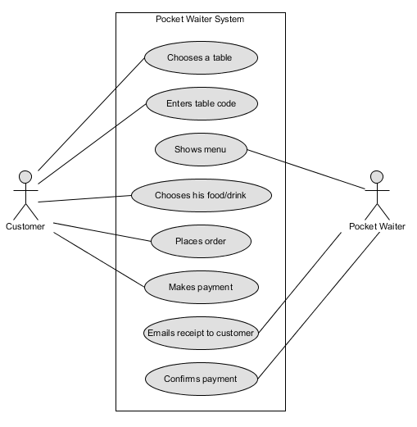

At the business side we can see that the system ‘Pocket Waiter’ will display the order.

The staff will:
- Accept the order.
- Prepare the order.

Then the system will print the receipt. And the staff will deliver the product.
Pocket Waiter Use Case Diagram (business side ex.bar):
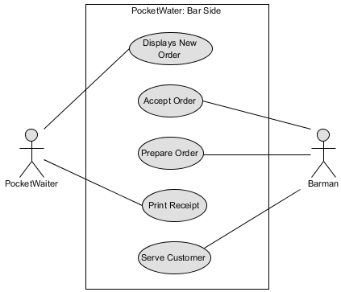

a) Activity diagram
The sequence of activities in the diagram below, shows the customer order process.
At the start of the process the customer can log out without any order been created.
As the user gets access to the customer view, the customer will select the menu option and the option to select a table will appear, if the use select a table that does not exists, the system will return to the same page and the user can correct the input.
Once the customer inserts the correct code for the table, the system will return the menu related to the restaurant where the user is in.
The next step of the process is for the customer to select the items and check out, then the confirmation is returned, also the customer has the option to view the order before logging out from the web site and the process is finished.
Activity Diagram:

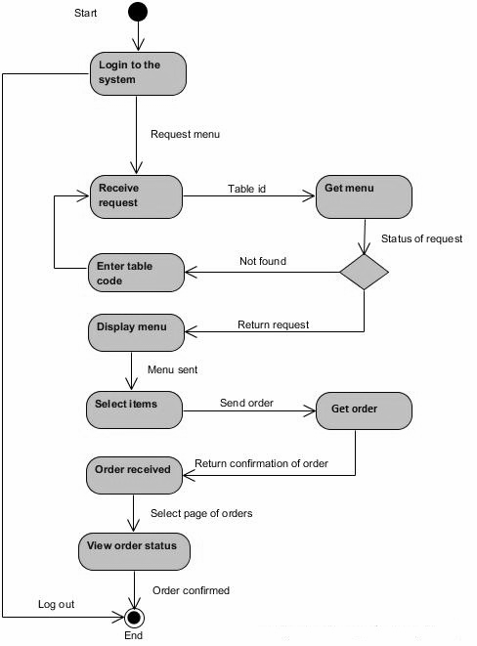

b) Class Diagram
The Class Diagram shows the possible classes that are going to be implemented
during the development phase of the application.

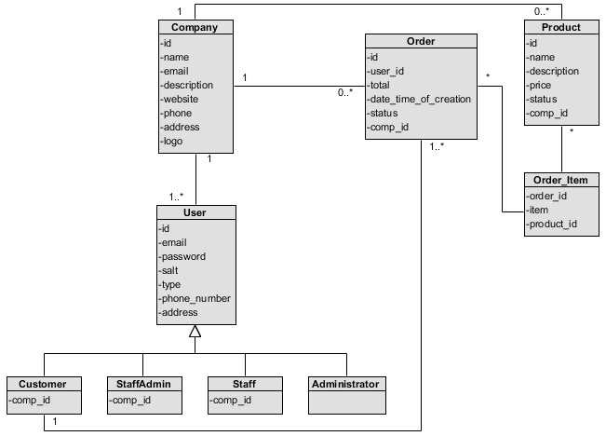

c) Sequence diagram
The sequence diagram below, shows the interaction of the classes when the customer attempts to create a order.
There, four steps are identified:
First: the customer logs into the system and access the menu of the restaurant.
Second: The customer selects the products and check out.
Third: The customer follows the status of the order.
Fourth: The customer logs out of the system.
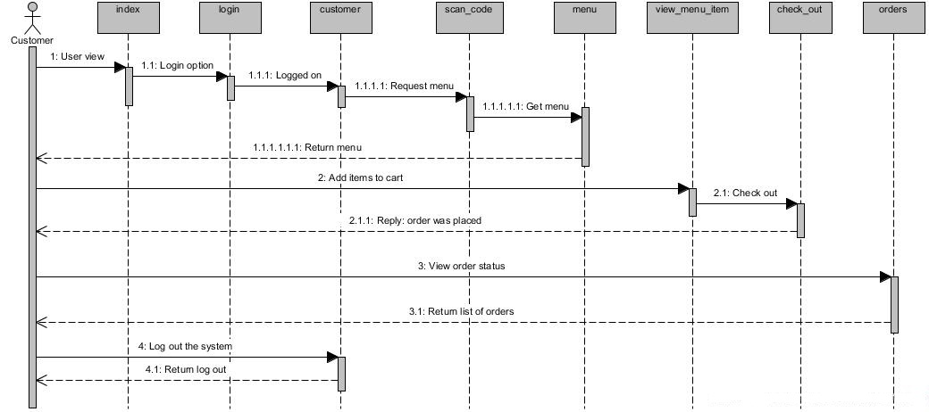

d) Statechart diagram
For more information about the customer process to buy a product, the statechart diagram models the process with more details. For every event in the process a state is identified and the process starts to become more clear.
The diagram below shows the start event of the process, the customer attempting to log in into the system and for this event the state is as a potential order. Next, the table id is sent and the order is in process. Then the products are selected and the state is that the order is confirmed. To complete, the event complete the process and the state now is order completed. The next event is to save the order and the state is order placed. The final event is order placed, and the order process finishes.
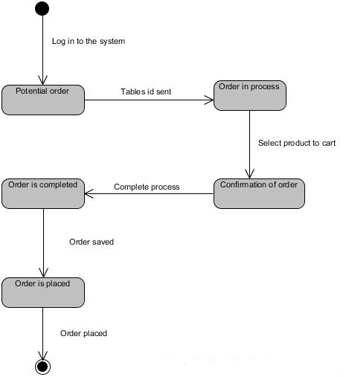

Business Side

a) Activity diagram
The activity diagram below shows the process when the operational staff from the business log in to the system to accept orders. The diagram complements the class diagram and models the user case of the business side to better understand how the activities of the staff will be created.
One the staff log into the system, the queue of orders is retrieved, then the next order is selected, as the order in on screen, the staff will check the order as “being prepared”. The staff can view the list of orders to be prepared and once ready the order is checked as ready, a receipt is printed and the process finishes with the order been delivered.
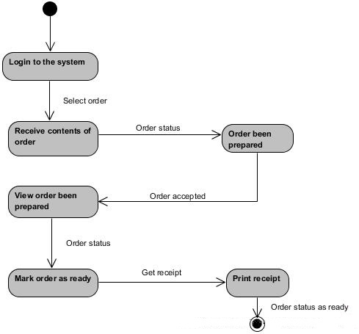

b) Sequence diagram
The sequence diagram below, shows the interaction of the classes in order to accomplish the requests of the operational business staff. Once the staff is logged in to the system the page for the queue of orders is streamed. The staff will edit the status of the order. As the order is ready the staff check the order as ready, a receipt is printed and now the status for the order is: ready. And the process finishes.

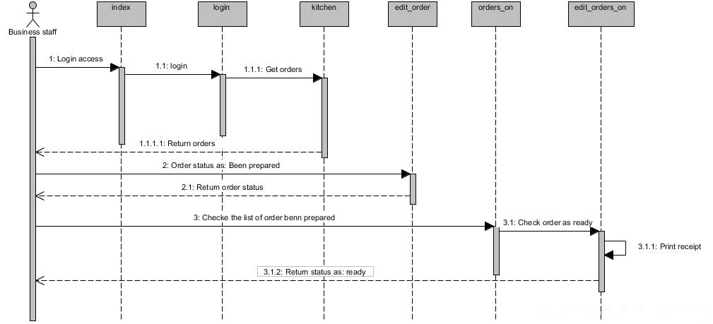

c) Statechart diagram
To better understand the process where the order is placed and the process to complete it, the statechart diagram has to be used, the diagram below shows that: when the staff log into the system, the status of the order is in the queue, then the event of select a order to work with brings the order to the status of display the items of the orders. The staff set the status of the order and now the order is: ‘being prepared’ . The order is prepared and the staff set the status again, and now the order is ready. With the order ready the staff print the receipt to the order and now order and receipt is ready. To finalize the process the order is delivered and the status is on order delivered and the process finishes.
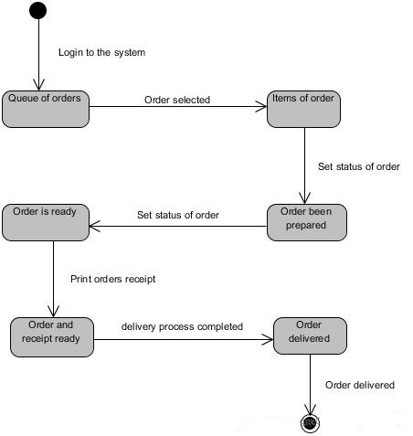

ERD
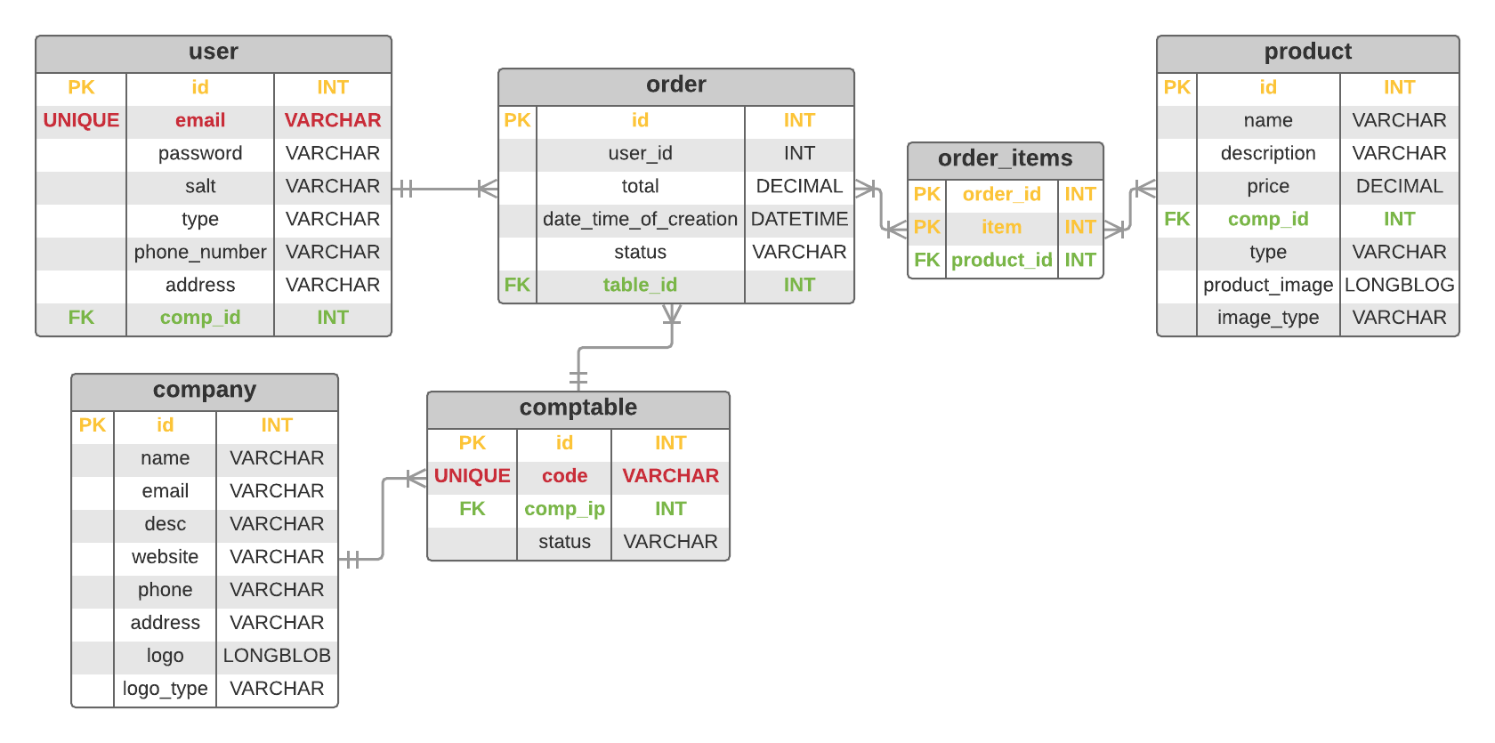

5. Team
Pocket Waiter was created in 2018 by PVP Solutions - a group of three students of Information Technology at CCT College in Dublin, Ireland.

Ennio da Silva Vitor is Brazilian, holds a Bachelor’s degree (Honours) in Business Administration & Management, has 6 years of experience in logistics and industrial production.

Fernanda Palomino de Oliveira is Brazilian, holds a Bachelor’s degree (Honours) in Business Administration & Management, has 5 years of experience in banking, investments and insurance.

Thieres Luiz Pereira is also Brazilian, holds a Bachelor’s degree (Honours) in Information Technology, has 5 years of experience as a graphic designer.

5.1 Individual Roles
As a group, we worked together in every part of this project in order to meet the requirements of the system and to delivery the final project on time. It included researching, regular meetings outside class, coding etc. However, we divided the project into different areas and assigned those as responsibilities to each of team member. This way our work was completed in a more engaged, organized and clear manner.
The tasks were assigned as below:
System Design & Analysis
Ennio da Silva Vitor was responsible for the phases of planning, design and analysis of the system from both user and technical side, user stories, user cases, sequence and class diagrams.

Project Management & Research
Fernanda Palomino de Oliveira was responsible for the deliverables, analysis and overview of the project, keeping the prototype to deadlines and maintaining the group focused on the end goal. Additionally, she was responsible for researching and bringing in facts to support and defend this project idea.

Development & UI/UX
Thieres Luis Pereira was responsible for the art & design of the project, coding and database development, implementation and tests.

6. Future of Pocket Waiter
The success of Pocket Waiter depends on achieving both back and front end excellence, combined to a well structured marketing plan which will be presented to restaurants, bars and also advertised to end users. To follow the company’s growth, we will need the collaboration of more developers and experienced IT people as well as marketing and sales professionals. This way we will actively participate in the market, achieving more recognition and customers.

We strongly believe in our idea and after the conclusion and deployment of the Pocket Waiter project, we are willing to move forward and continue to work together for improvements in the current system, adding new features and creating more functionalities according to the feedbacks of performance, either provided by our clients and to meet the market needs. Also, we want to bring back the idea of using Ionic framework to build a native application, giving the customer the option of downloading our product, if preferred.

7. Pages Art & Design
In this chapter we can see the pictures of our project prototype, style, design and functionality.
Image 1 Login page, where users can log in into the system.
Image 2 Register page, where users can register an account to use the webapp.

Image 1 Image 2
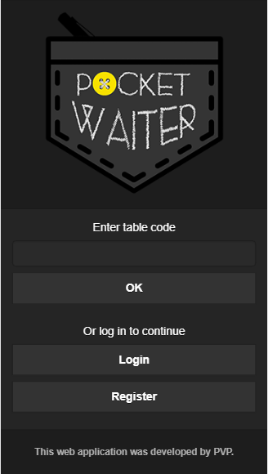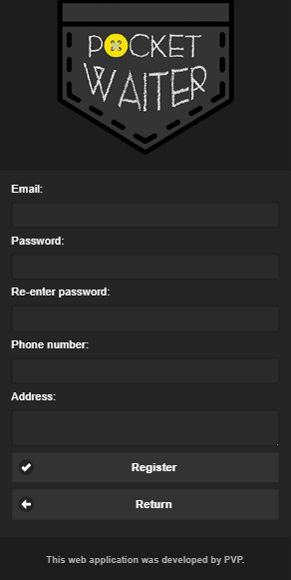
Customer view
Image 3: The customer login to the system Image 4: Customer web page
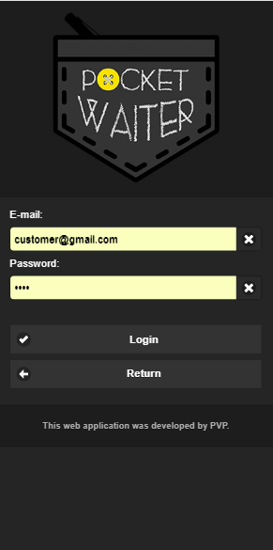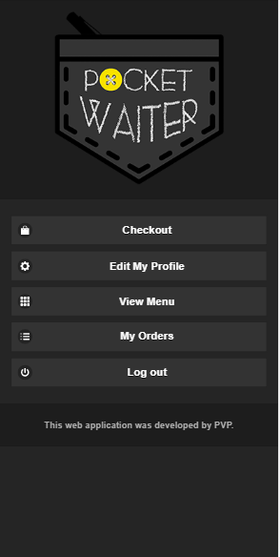

Image 5: Orders Image 6: User view Menu ‘Selecting a table’
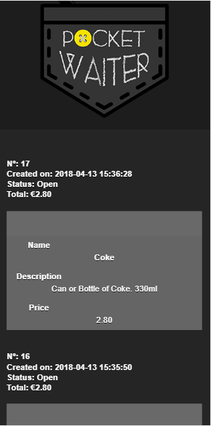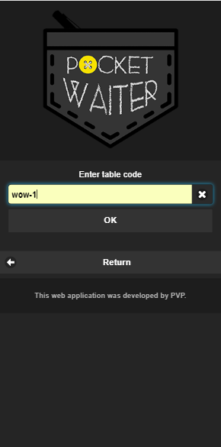

Image 7: Menu from the restaurant Image 8: Check out page
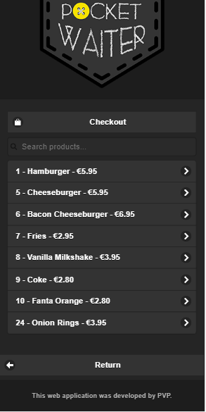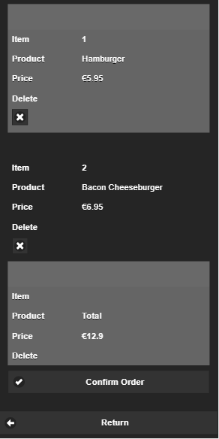
Image 9: Order placed web page Image 10: Edit my profile
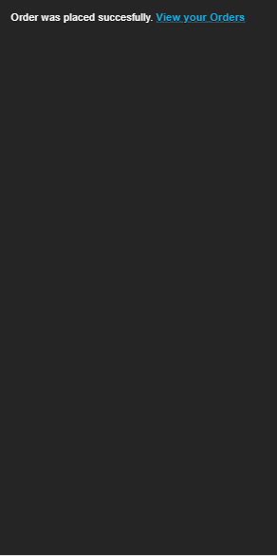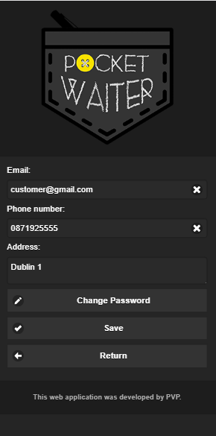

Image 11: Change password
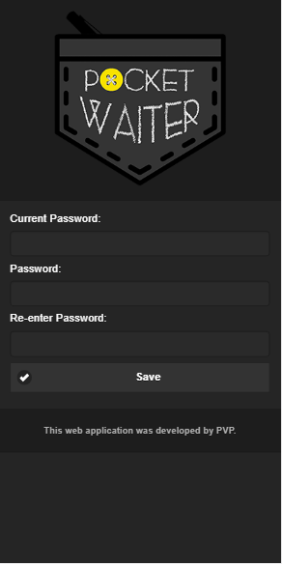

Administrator web page
Image 12: admin page Image 13: Create a New user
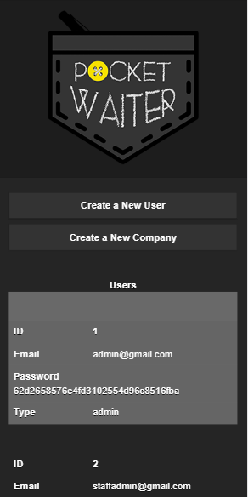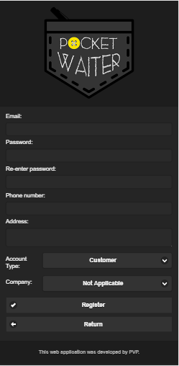

Image 14: Create a new company
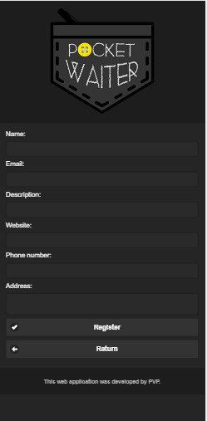

Operational staff
Image 15: Orders view Image 16: Order selected
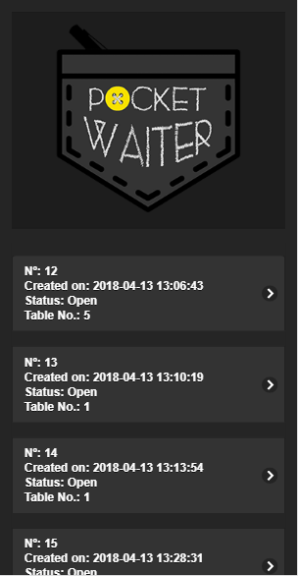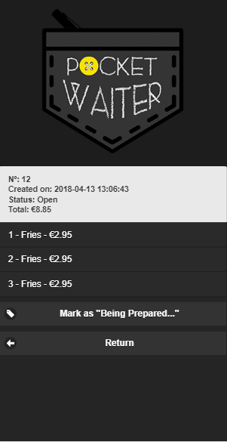

Image 17: Orders been prepared Image 18: Order been prepared selected
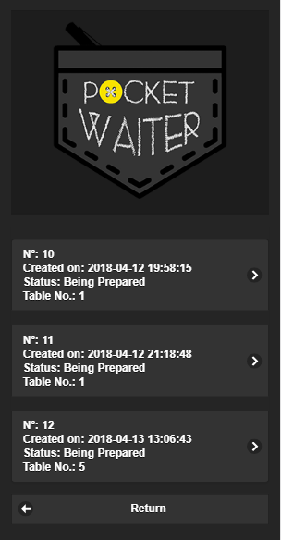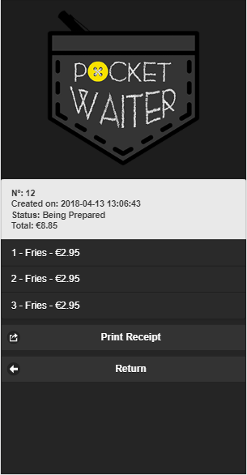

Image 19: Printing Receipt
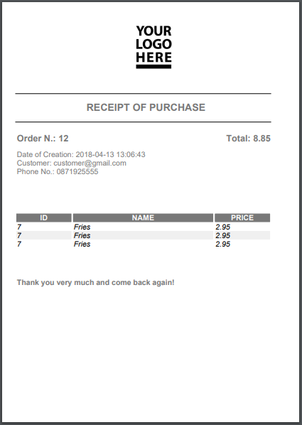

Business staff view

Image 20: Staff view Image 21: Create new user
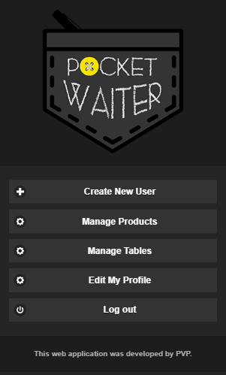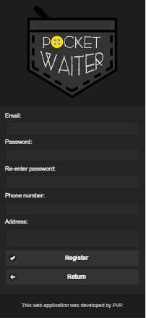

Image 22: Manage Products Image 23: Manage Tables
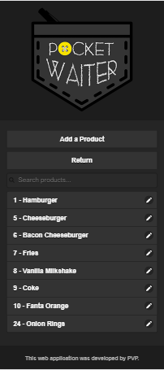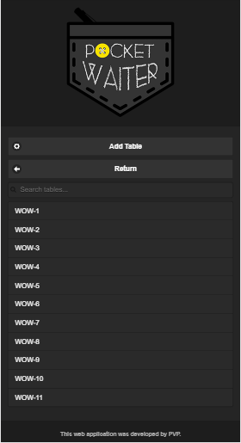

Image 24: Edit my profile Image 25: Change Password
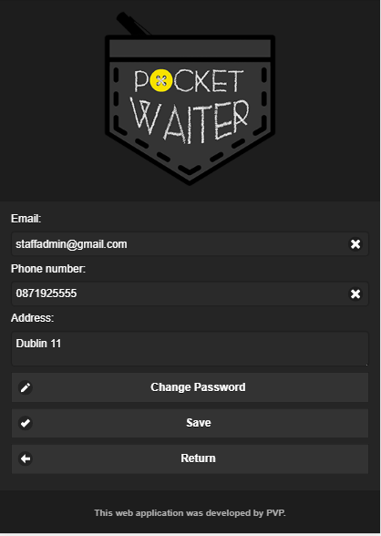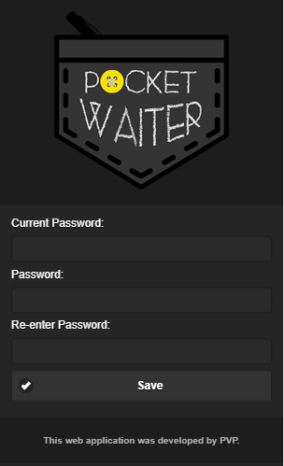

8. Tests
Testing is a very important stage of any system development. It is executed to ensure that errors, in any part of the application, will be detected before the deployment.
Finding errors and fixing them during the development of the system will minimise the costs regarding to the corrections and also the application will be more powerful and well made.
In order to make good use of tests, a test plan should be created containing suitable executions that will be applied to the code when necessary.

8.1 Integration test
Here the user interface needs to be tested and reported. This should include every existing item of the system. Also, for every data passed as a registration, the data will be checked to see if the same value is in the database, this can be confirmed as the data is been used again to access the application.
Also the test will be based on the user scenario, user interface, validation (security test) and Alpha test (Where users will test the application and check if any error occur, if any improvement can be done and acceptance is ok )

Note: The tests below were executed according to the use case scenarios - part of the system analysis chapter of this document.

The first step of this test is checking user scenario, then user interface and validation or security test.

Test Plan |  |  |  |  |  | Page: 1 | Of: 17
Tester: PVP | Date Designed: 14-04-2018 |  |  | Date Conducted: 14-04-2018
Results: Passed: Passed |  |  | Test ID: 1
Requirement addressed: Register page |  |  | Objective: Register a new user to the system
Test cases: Data Field |  |  | Test cases; Value entered
1) Register form E-mail, Password, re-enter password, phone number and address
Expected Results/Notes: After register new customer, their information should appear in the Administrator page
Actual Results/Notes: The registration was successfully processed and the new customer is in the data base.
The picture in the left is the registration page and the picture in the right is the administrator page showing the list of current users in the database.
Screenshot of Results
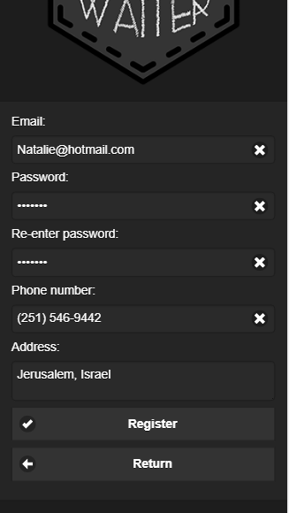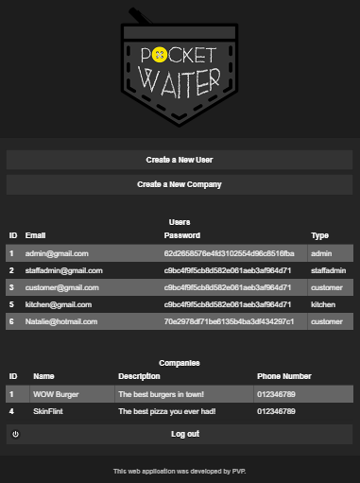

Test Plan |  |  |  |  |  | Page: 2 | Of: 17
Tester: PVP | Date Designed: 14-04-2018 |  |  | Date Conducted: 14-04-2018
Results: Passed: Passed |  |  | Test ID: 2
Requirement addressed: customer page |  |  | Objective: Access the customer page with the new user
Test cases: Data Field |  |  | Test cases; Value entered
1) login form E-mail, Password
Expected Results/Notes: Login the new customer to display options for customer
Actual Results/Notes: The new user is logs to the application as a customer and the customer options are now available
Screenshot of Results
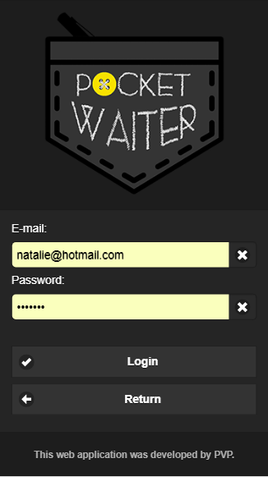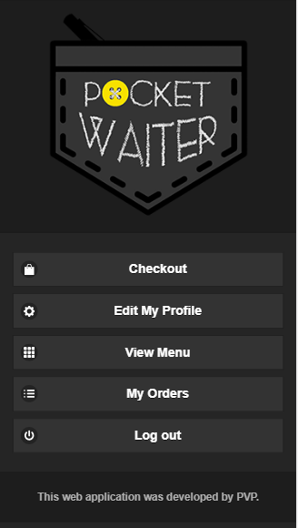

Test Plan |  |  |  |  |  | Page: 3 | Of: 17
Tester: PVP | Date Designed: 14-04-2018 |  |  | Date Conducted: 14-04-2018
Results: Passed: Passed |  |  | Test ID: 3
Requirement addressed: customer page |  |  | Objective: Get access to the menu after inserting the table’s code
Test cases: Data Field |  |  | Test cases; Value entered
1) Enter table code table code
Expected Results/Notes: Expected to get the menu from the business where the customer is.
Actual Results/Notes: Based on the code on the table the user can access the menu.
Screenshot of Results

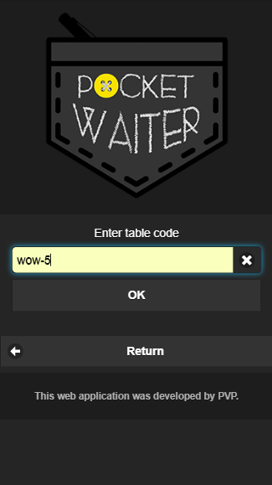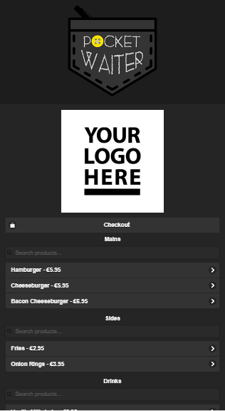

Test Plan |  |  |  |  |  | Page: 4 | Of: 17
Tester: PVP | Date Designed: 14-04-2018 |  |  | Date Conducted: 14-04-2018
Results: Passed: Passed |  |  | Test ID: 4
Requirement addressed: customer page |  |  | Objective: Complete a order and check out
Test cases: Data Field |  |  | Test cases; Value entered
1) Select item add to cart
Expected Results/Notes: Expected to select the items in the menu and check out the order
Actual Results/Notes: The orders were sent to the cart and the user finished the process with the payment.
Screenshot of Results

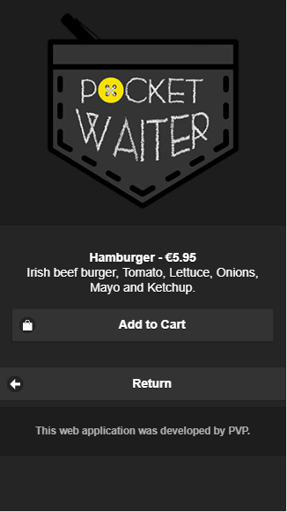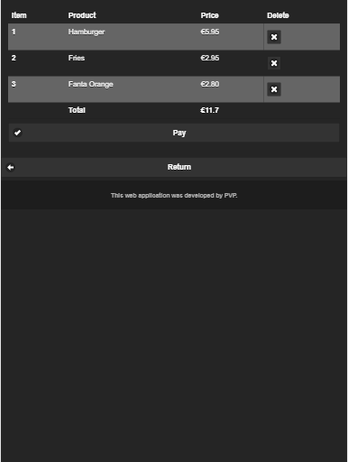

Test Plan |  |  |  |  |  | Page: 5 | Of: 17
Tester: PVP | Date Designed: 14-04-2018 |  |  | Date Conducted: 14-04-2018
Results: Passed: Passed |  |  | Test ID: 5
Requirement addressed: customer page |  |  | Objective: Order’s view
Test cases: Data Field |  |  | Test cases; Value entered
1) View your Orders click
Expected Results/Notes: To get the list of orders for the current customer.
Actual Results/Notes: The orders are displayed and also rolling down the page, we can also see previous orders.
Screenshot of Results

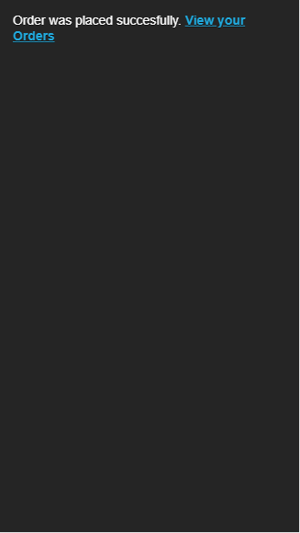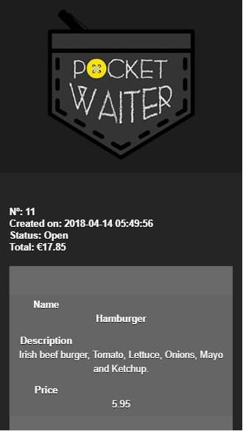

Test Plan |  |  |  |  |  | Page: 6 | Of: 17
Tester: PVP | Date Designed: 14-04-2018 |  |  | Date Conducted: 14-04-2018
Results: Passed: Passed |  |  | Test ID: 6
Requirement addressed: customer page |  |  | Objective: Edit User’s information
Test cases: Data Field |  |  | Test cases; Value entered
1) E-mail, phone number E-mail, phone number
Expected Results/Notes: To correct the users information on the system.
Actual Results/Notes: Attempt to edit ‘N’ to ‘n’ in the email field and (251) to 251 in the phone number field. Succeeded.
Screenshot of Results

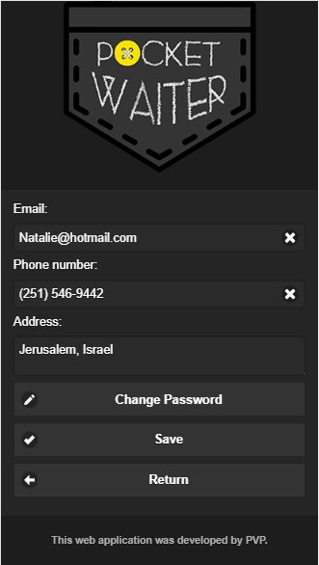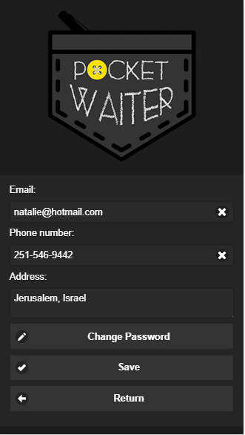

Test Plan |  |  |  |  |  | Page: 7 | Of: 17
Tester: PVP | Date Designed: 14-04-2018 |  |  | Date Conducted: 14-04-2018
Results: Passed: Passed |  |  | Test ID: 7
Requirement addressed: operational staff page |  |  | Objective: Order’s View
Test cases: Data Field |  |  | Test cases; Value entered
1) E-mail, password E-mail, password
Expected Results/Notes: Expected to access the staff page and to get the queue of orders
Actual Results/Notes: The picture on the right side shows the queue of orders.
Screenshot of Results

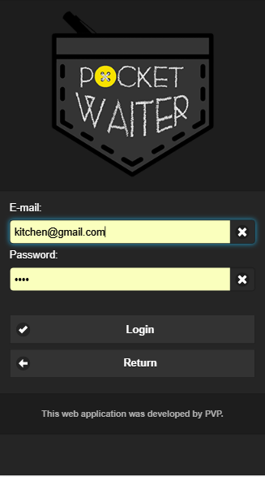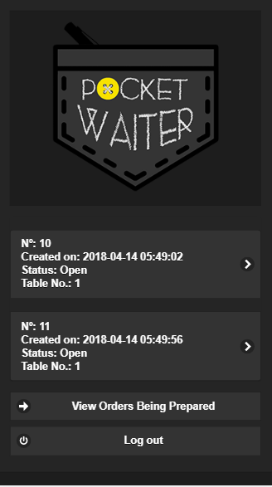

Test Plan |  |  |  |  |  | Page: 8 | Of: 17
Tester: PVP | Date Designed: 14-04-2018 |  |  | Date Conducted: 14-04-2018
Results: Passed: Passed |  |  | Test ID: 8
Requirement addressed: operational staff page |  |  | Objective: Process an order
Test cases: Data Field |  |  | Test cases; Value entered
1) Select an order Set the status of the order
Expected Results/Notes: Expected to select an order, set status as ‘Been prepared’ and after the order is ready, set status as ‘ready’
Actual Results/Notes: The picture on the left side shows the selected orders and on the right side it shows the order to be tagged as ready. Succeeded.
Screenshot of Results
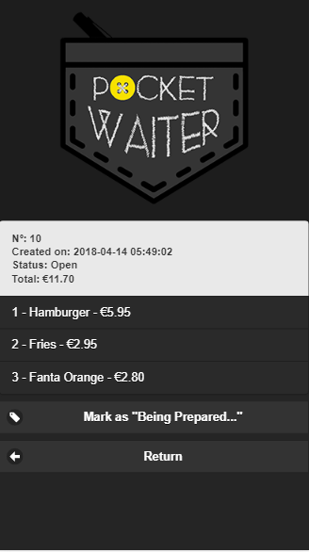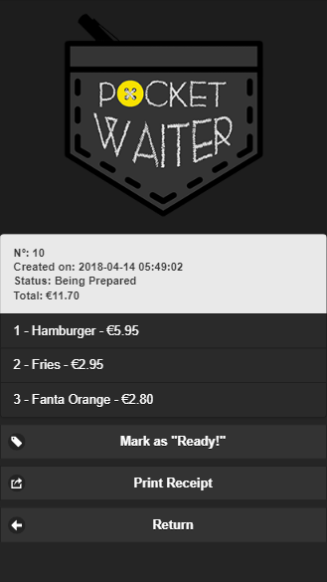

Test Plan |  |  |  |  |  | Page: 9 | Of: 17
Tester: PVP | Date Designed: 14-04-2018 |  |  | Date Conducted: 14-04-2018
Results: Passed: Passed |  |  | Test ID: 9
Requirement addressed: operational staff page |  |  | Objective: Print receipt of order
Test cases: Data Field |  |  | Test cases; Value entered
1) Print receipt (Button) Clicking the button
Expected Results/Notes: Expected to get the receipt of the order.
Actual Results/Notes: The picture on the left side shows the selected orders and on the right side it shows the receipt in PDF.
Screenshot of Results

Note: The following tests were based on the user interfaces and also will cover the remaining type of views of the system.

Test Plan |  |  |  |  |  | Page: 10 | Of: 17
Tester: PVP | Date Designed: 14-04-2018 |  |  | Date Conducted: 14-04-2018
Results: Passed: Passed |  |  | Test ID: 10
Requirement addressed: index page |  |  | Objective: Quick order
Test cases: Data Field |  |  | Test cases; Value entered
1) Enter table code Code from the physical table at the business site
Expected Results/Notes: Expected to get the menu of determined business, place an order and when checking out, they will be asked to login..
Actual Results/Notes: Items chosen in the menu, login worked and the items were in the cart to checkout.
Screenshot of Results

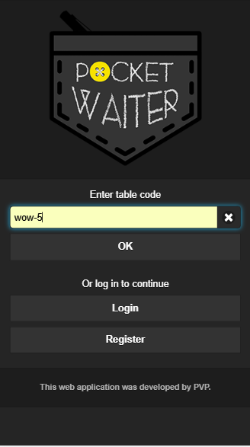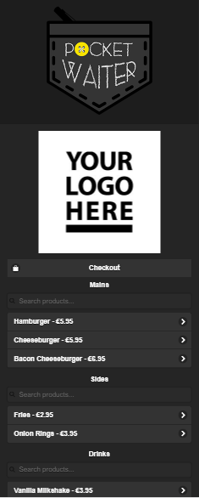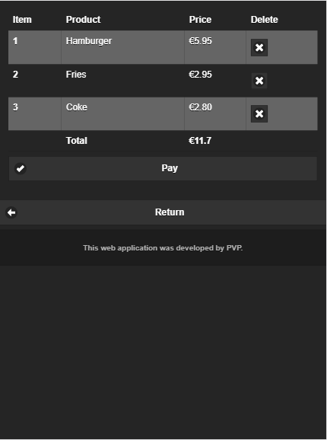

Test Plan |  |  |  |  |  | Page: 11 | Of: 17
Tester: PVP | Date Designed: 14-04-2018 |  |  | Date Conducted: 14-04-2018
Results: Passed: Passed |  |  | Test ID: 11
Requirement addressed: Administrator webpage |  |  | Objective: Create different user types at the administrator page
Test cases/ Data Field |  |  | Test cases / Value entered
Create a New user E-mail, password, re-enter password, phone number, address, account type and company if applicable
1) User form thomas@gmail.com, thomas,thomas, 111-111-111-1111, Concord, California, United States, customer
2) User form tom@gmail.com, tomtom, tomtom, 222-222-222-2222, Syracuse, New York, United States, Administrator
3) User form Robert@gmail.com, robert, robert, 333-333-333-3333, Manhattan, New York City, New York, Staff Member
4) User form jackson@gmail.com, jackson, jackson, 444-444-444-4444, Washington, D.C., United States, Staff
Expected Results/Notes: Expected to register different types of user in the application.
Actual Results/Notes: The users were successfully registered. The picture on the right side shows the created users ID 7, 8, 9 and 10, matching with the above mentioned ones.
Screenshot of Results

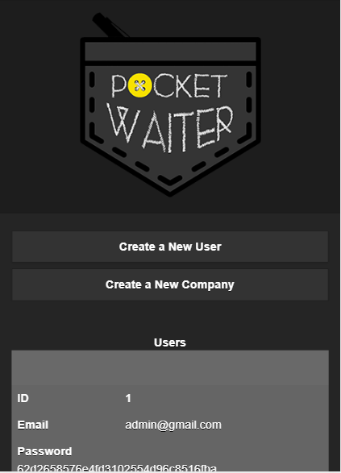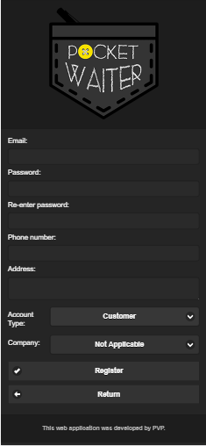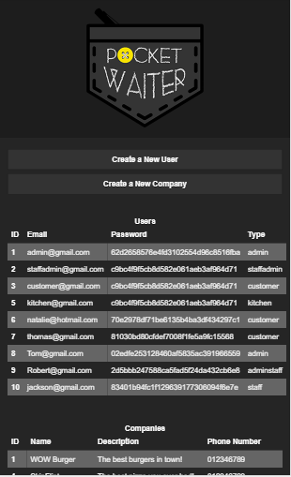

Test Plan |  |  |  |  |  | Page: 12 | Of: 17
Tester: PVP | Date Designed: 14-04-2018 |  |  | Date Conducted: 14-04-2018
Results: Passed: Passed |  |  | Test ID: 12
Requirement addressed: Administrator webpage |  |  | Objective: Create a new company in the application.
Test cases/ Data Field |  |  | Test cases / Value entered
Create a New company Name, E-mail, Description, Website, phone number, address, Logo.
1) Company form Famous Restaurant, famous@gmail.com, The famous restaurant from Dublin, www.famous.ie, 555-555-555-5555, Dublin, Dublin, Ireland
Expected Results/Notes: Expected to register new companies in the application
Actual Results/Notes: The new company was successfully registered
Screenshot of Results

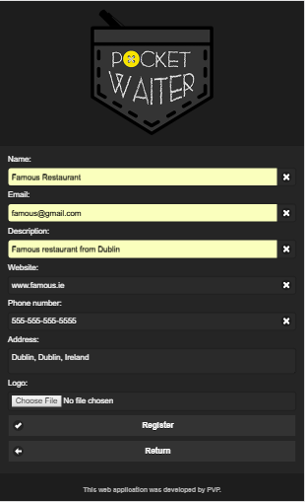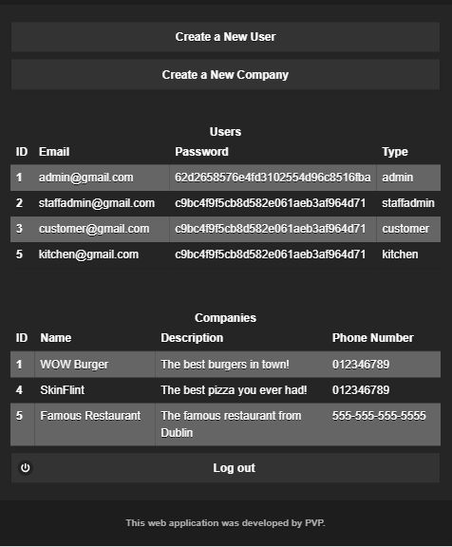

Test Plan |  |  |  |  |  | Page: 13 | Of: 17
Tester: PVP | Date Designed: 14-04-2018 |  |  | Date Conducted: 14-04-2018
Results: Passed: Passed |  |  | Test ID: 13
Requirement addressed: Business staff webpage |  |  | Objective: Create a new customer account from the staff page.
Test cases/ Data Field |  |  | Test cases / Value entered
Create a New user E-mail, password, re-enter password, phone number, address.
1) Register form userfrom@staffadmin.com, userfrom, userfrom, 666-666-666-6666, From new company
Expected Results/Notes: Expected to register new user in the application, the type of user can be only created as “customer”.
Actual Results/Notes: The user was successfully registered.
Screenshot of Results

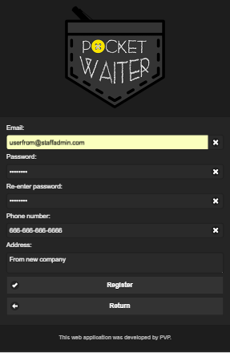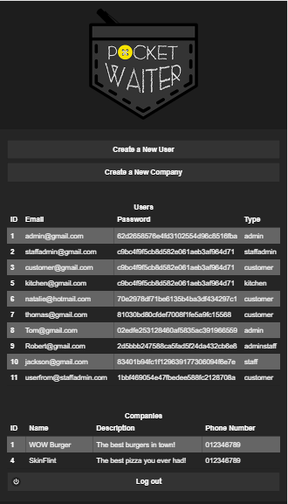

Test Plan |  |  |  |  |  | Page: 14 | Of: 17
Tester: PVP | Date Designed: 14-04-2018 |  |  | Date Conducted: 14-04-2018
Results: Passed: Passed |  |  | Test ID: 14
Requirement addressed: Business staff webpage |  |  | Objective: Add a new product to the menu in the ‘manage products’ section
Test cases/ Data Field |  |  | Test cases / Value entered
Create a New user E-mail, password, re-enter password, phone number, address.
1) Register form userfrom@staffadmin.com, userfrom, userfrom, 666-666-666-6666, From new company
Expected Results/Notes: Expected to add a new product to the menu
Actual Results/Notes: The user successfully added an item to its related menu
Screenshot of Results
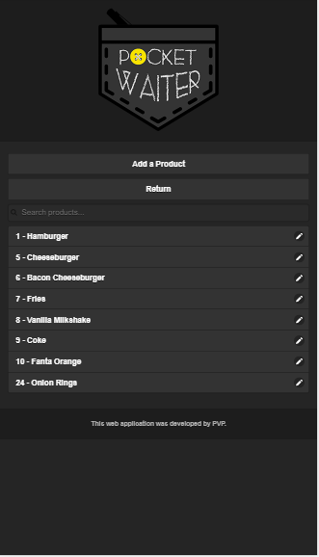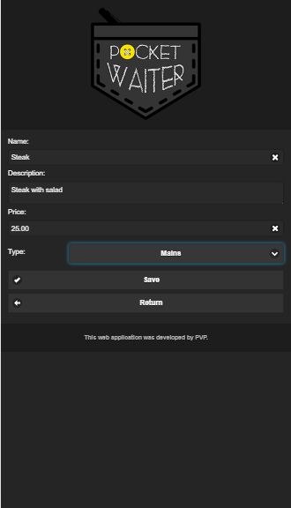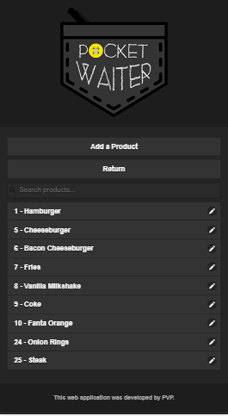

Test Plan |  |  |  |  |  | Page: 15 | Of: 17
Tester: PVP | Date Designed: 15-04-2018 |  |  | Date Conducted: 15-04-2018
Results: Passed: Passed |  |  | Test ID: 15
Requirement addressed: Business staff webpage |  |  | Objective: Add a new table in ‘manage tables’ section
Test cases/ Data Field |  |  | Test cases / Value entered
1) Add table Code
Expected Results/Notes: Expected to add a new table code to the application
Actual Results/Notes: The user successfully added a new code to the system. The new code is wow-12.
Screenshot of Results
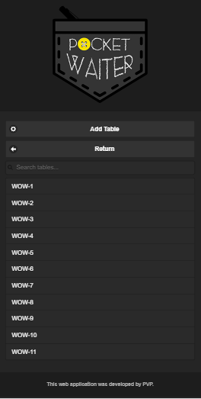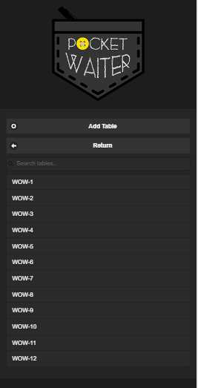

Test Plan |  |  |  |  |  | Page: 16 | Of: 17
Tester: PVP | Date Designed: 15-04-2018 |  |  | Date Conducted: 15-04-2018
Results: Passed: Passed |  |  | Test ID: 16
Requirement addressed: Business staff webpage |  |  | Objective: Update staff information
Test cases/ Data Field |  |  | Test cases / Value entered
1) form and change password, Email, Phone number, address, password
Expected Results/Notes: Expected to update information in the application
Actual Results/Notes: E-mail, phone number and address, was successfully updated as shown in the pictures. The password is also changed from ‘test’ to ‘testtest’
Screenshot of Results
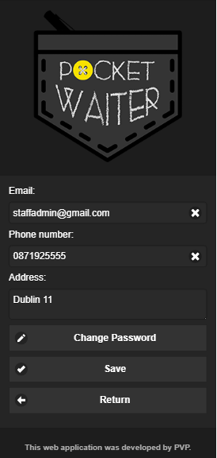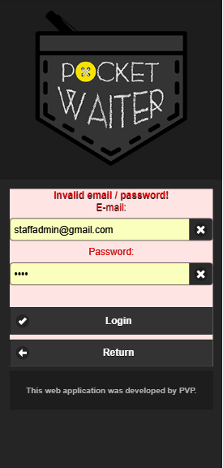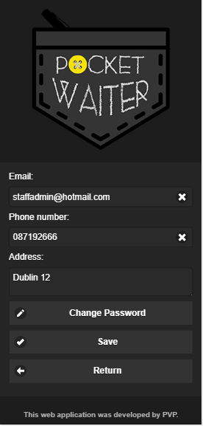

The test below validates the system, blocking unauthorized access into the application.

Test Plan |  |  |  |  |  | Page: 17 | Of: 17
Tester: PVP | Date Designed: 15-04-2018 |  |  | Date Conducted: 15-04-2018
Results: Passed: Passed |  |  | Test ID: 17
Requirement addressed: All users |  |  | Objective: Test unauthorized access
Test cases/ Data Field |  |  | Test cases / Value entered
1) customer, kitchen, staffadim and admin E-mail, password
Expected Results/Notes: Different accesses through the pages. Users will only log to the page categories that is specified as in the database
Actual Results/Notes: As we can see in the picture in the left, the only registration available for the users is to create a new customer and any other type of user has to be granted by the administrator (the administrator page does not contain a option to choose the type of user, it has to be done directly by accessing the database manually). It makes the program more secure. The users access uses “session”, so even if a person tries to access any other page of the application, they won’t succeed.
At the left side, the form to registrate a new user. At the middle, the session to start for customer. At the right side the PHP request to compare the information in the database. in the login page.
Screenshot of Results

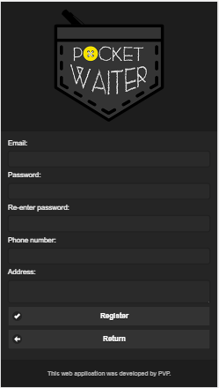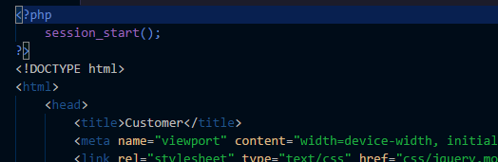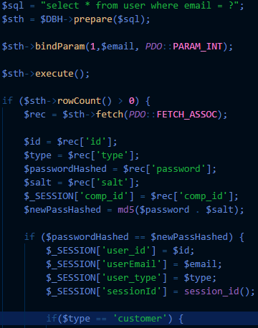

9. Conclusion

Nowadays a large majority of people have smartphones or any other mobile devices with access to the internet and based on this fact, the idea of this project came about, aiming to use technology in order to add more comfort to their leisure time. Pocket Waiter was created to be an ally for those who just want to sit back, relax and receive food and drinks at their tables, without any hassle.
During the development of this web application, hours of work were devoted on research and analysis of how software for a new way of ordering food and drinks at bars and restaurants would contribute to the customer’s best experience and how it would be accepted and utilized by clients. We conducted an anonymous online survey which was an useful tool that provided us important information about potential end users of the system - men and women mostly from 25 to 34 years old who had the chance to give their opinion and contributed for the foundation of this project defense. The outcome of this survey will also enable the elaboration of a future marketing plan, targeting the section of the population who appreciates what turns their lives easier.
In addition, this project provided us the exciting opportunity to combine topics we enjoy such as technology and socializing and experience all the steps of a system development. It enabled us to learn, explore resources, fail, fix the mistakes, acquire knowledge, share experiences and constructive criticism, what made the group grow strong, diligent and enthusiastic.
We are grateful to have completed this task successfully and Pocket Waiter will not stop here, we will work hard, studying and improving the system in order to deploy a professional and well made web application and later a native application to the market.

10. References
- Hirschberg C., Rajko A., Schumacher T., and Wrulich M. (2018). The Changing Market for Food Delivery [online] Available at: https://www.mckinsey.com/industries/high-tech/our-insights/the-changing-market-for-food-delivery [Accessed 08 Mar. 2018].

- Independent.ie. (2018). Irish mobile phone usage highest in the western world, global stats reveal - Independent.ie. [online] Available at: https://www.independent.ie/business/technology/irish-mobile-phone-usage-highest-in-the-western-world-global-stats-reveal-31480385.html [Accessed 22 Mar. 2018].

- The Drinks Industry, (2013). Significant Contribution To The Irish Tourism Sector [online] Available at: http://www.drinksindustry.ie/news/archive-news/ significant-contribution-to-the-irish-tourism-sector/ [Accessed 17 Oct. 2017].

- W3Schools, (2018). [online] Available at: https://www.w3schools.com/ [Accessed 22 Apr. 2018].

- Atlassian, (2018). Software Testing: A Culture of Quality [online] Available at: https://www.atlassian.com/software-testing [Accessed 22 Apr. 2018].

- Oxford Online Dictionary, (2018). Research [online] Available at: https://en.oxforddictionaries.com/definition/research [Accessed 22 Apr. 2018].

- Tutorial Point, (2018). Standard Diagrams [online] Available at: https://www.tutorialspoint.com/uml/uml_standard_diagrams.htm [Accessed 22 Apr. 2018].

- Microsoft, (2012). Testing for Continuous Delivery with Visual Studio [online] Available at: https://msdn.microsoft.com/en-us/library/jj159342.aspx [Accessed 22 Apr. 2018].
- Ionic, (2018). The top open source framework for building amazing mobile apps. [online] Available at: https://ionicframework.com/framework [Accessed 22 Apr. 2018].

Appendix A
Changes in the application
Initially we were going to build a native application to give the customer the ability to download our app and have the functionalities a native app offers.
To help us build an application that would run in different operating systems without the need to code for each OS, a framework - Ionic - was chosen as a solution.
Ionic is a free and open source framework to build native and progressive applications and allow the users to create apps using a blank design or one of the ready templates. Ionic handles the code and make it available for many operating systems.
Although it is a great framework to use, some knowledge about other technologies such as node.js, typescript, angular.js, cordova etc. is required and at the commencement of the development of this project, we had little or no knowledge about those mentioned tools. This fact combined to the tight deadline and also with all the other projects that teachers were requiring of us, we wouldn’t have time to learn enough skills to make a good use of this framework and delivery the project on time.
We decided then, to leave the idea of a native app and started working on a web application, using technologies that we all have good knowledge and skills. In this way we can make sure to deploy a final quality product.
However, we are willing to learn and get more experience about the framework for future
development projects.

Appendix B

Our source code is available on GitHub and can be accessed through the link: https://github.com/thierespereira/pocketwaiter

? Paypal will handle the entire process regarding payments and security of credit card data.
? Paypal will handle the entire process regarding to payments and security of credit card data.

