Ennio da Silva Vitor student number:

Design your own database:

ERD and Create Table Scripts

CCT-2016

Design phase

Now a day, for private or personal application the support of a data base to generate specific reports that will feed their needs is very important. The data base can be implemented in many different areas of knowledge, and to this Continuous Assessment, the “Car insurance data base” have been chosen. This data base will collect information of the customer, car that they use, company that they have the policy, policy, bills not paid and which analyst is analyzing the information in the data base.
The purpose of this data base is to collect information about the customers that are in debt with their contracts.
Every time that a customer do not pay the insurance bill, hi or her name will be stored in the system, followed by the information of the car, information of the bill, and information of the contract(policy) that they have.
This data base can generate reports as example:

SELECT COUNT (engine) AS num_of_cars
FROM car
WHERE engine = 5.2;

The code above will retrieve the number of car that have the engine size = 5.2 liters from the indebted customers. So, the analyst can see which type of car is most common to the indebted customer.

SELECT id_customer, f_name, surname, dob, address, phone_number
FROM customer
WHERE address LIKE '%Dublin%';

The code above will generate a report with the ID, name, surname, data of birth, address, and phone number of all the customers that have the address in Dublin. This report will geographically select a group of customers.

SELECT * FROM bills_not_paid b
LEFT OUTER JOIN policy p
ON b.bills_name = p.policy_description;

This query generates a reports where it select all the information from the first table called biils_not_paid, and matches with b.bills_name = p.policy_description. It means the user can visualize all the information about the bill and in addition the user car see the contents of the policy for the bill. This table will show also the rows from bills_not_paid that does not matches with the policy table.

SELECT *
FROM customer c
INNER JOIN company y
ON c.address = y.address;

This query is similar to the previous one, the difference is that the report will just show the tables that really matches with c.address=y.address. The result of this reports shows the list of customers that are based in the same city as the company is based.

The idea to create this data base came along the actual situation that makes the Irish population and its residents to spend more money with.(The increased price of the insurance policies in Ireland).
As any event generated that affect the economy, companies or experts have to identify the characteristics of the problems and then find solutions to avoid or minimize it.
Personally, creating this data base I expect to understand how the insurance companies process and analyse their information to get ready to deal with adversities. In this case with the indebted customers.
To the company side, this data base will collect information from the moment when the customer stops to pay the policy. And then the result of the data will reveal the main characteristics from a customer that does not pay the policy properly. Information such as , age, local where the customer lives, type of contract that they are not affording to pay, period where have more customers with problems to pay, type of car that is most common to be without a valid policy, the main price of policy that negatively affect the customer and parts of the company that have more problem to deal with broken contracts.
Above we can see in details using a diagram how the data base is created and how each table is related to each other.

Diagram of the data base

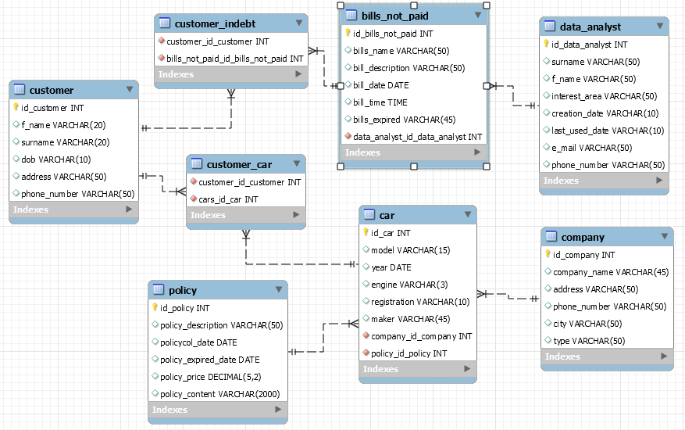

The data base create scripts

CREATE TABLE insurance.customer (
id_customer INT NOT NULL AUTO INCREMENT,
f_name VARCHAR(20),
surname VARCHAR(20),
dob VARCHAR(10),
address VARCHAR(50),
phone_number VARCHAR(50),
PRIMARY KEY (id_customer)
)

CREATE TABLE insurance.customer_indebt (
id_customer INT NOT NULL,
id_bills_not_paid INT NOT NULL,

FOREIGN KEY (id_customer),
REFERENCES insurance.customer (id_customer),

FOREIGN KEY (id_bills_not_paid),
REFERENCES insurance.bills_not_paid (id_bills_not_paid)
)

CREATE TABLE insurance.bills_not_paid (

id_bills_not_paid INT NOT NULL AUTO_INCREMENT,
bills_name VARCHAR(50),
bill_description VARCHAR(50),
bill_date DATE,
bill_time TIME,
bills_expired VARCHAR(45),
id_data_analyist INT NOT NULL,

PRIMARY KEY (id_bills_not_paid),

FOREIGN KEY (data_analyist_id_data_analyist),
REFERENCES insurance.data_analyist (id_data_analyist)
)

CREATE TABLE insurance.data_analyst (
id_data_analyist INT NOT NULL AUTO_INCREMENT,
surname VARCHAR(50),
f_name VARCHAR(50),
interest_area VARCHAR(50),
creation_date VARCHAR(10),
last_used_date VARCHAR(10),
e_mail VARCHAR(50) NULL,
phone_number VARCHAR(50),
PRIMARY KEY (id_data_analyist)
)

CREATE TABLE insurance.customer_car (
id_customer INT NOT NULL,
id_car INT NOT NULL,

FOREIGN KEY (id_customer),
REFERENCES insurance.customer (id_customer),

FOREIGN KEY (id_car),
REFERENCES insurance.car (id_car)
)

CREATE TABLE insurance.car (
id_car INT NOT NULL AUTO_INCREMENT,
model VARCHAR(15),
year DATE,
engine VARCHAR(3),
registration VARCHAR(10),
maker VARCHAR(45),
id_company INT NOT NULL,
id_policy INT NOT NULL,
PRIMARY KEY (id_car),
FOREIGN KEY (id_company)
REFERENCES insurance.company (id_company),
FOREIGN KEY (id_policy)
REFERENCES insurance.policy (id_policy),
)

CREATE TABLE insurance.company (
id_company INT NOT NULL AUTO_INCREMENT,
company_name VARCHAR(45),
address VARCHAR(50),
phone_number VARCHAR(50),
city VARCHAR(50),
type VARCHAR(50),
PRIMARY KEY (id_company)
)

CREATE TABLE insurance.policy (
id_policy INT NOT NULL AUTO_INCREMENT,
policy_description VARCHAR(50),
policycol_date DATE,
policy_expired_date DATE,
policy_price DECIMAL(5,2),
policy_content VARCHAR(2000),
PRIMARY KEY (id_policy))

The table insert scripts

INSERT INTO insurance.customer (id_customer, f_name, surname, dob, address, phone_number)

VALUES (1, 'Abraham', 'Lincoln', '1809-02-12', '9 The drive, Tallaght, Dublin 24', '0877035958');

INSERT INTO insurance.bills_not_paid (id_bills_not_paid, bills_name, bill_description, bill_date, bill_time, bills_expired, data_analyst_id_data_analyst)

VALUES (1, 'Car insurance', 'based in Dublin', '2015-11-09', '00:00:00', '2016-11-09', 1);

INSERT INTO insurance.data_analyst (id_data_analyst, surname, f_name, interest_area, creation_date, last_used_date, e_mail, phone_number)

VALUES (1, 'da Silva Vitor', 'Ennio', 'Car insurance ', '2016-11-09', '2016-11-16', 'ennio.vitor@hotmail.com', '0877035958');

INSERT INTO insurance.car (id_car, model, year, engine, registration, maker, company_id_company, policy_id_policy)

VALUES (1, 'Aldi r8', '2015', '5.2', '15D0000', 'Aldi', 1, 1);

INSERT INTO insurance.company (id_company, company_name, address, phone_number, city, type) VALUES (1, 'Ennio\'s insurance', '9 The drive, Tallaght, Dublin 24', '0877035958', 'Dublin', 'Broker');

INSERT INTO insurance.policy (id_policy, policy_description, policy_date, policy_expired_date, policy_price, policy_content)
VALUES (1, 'Car insurance', '2015-11-09', '2015-11-09', 6500.00, 'paragraphs: .....');

