Student name: Ennio da Silva Vitor Student number:

Commands

Deliverable 5:

INSERT INTO insurance.data_analyst
(surname, f_name, interest_area, creation_date, last_used_date, e_mail, phone_number)

VALUES
('Christopher', 'John', 'read access', '2016-11-09', '2016-12-22', 'Christopher@hotmail.com', '0177035958'),
('Shrader Lawrence', 'Jennifer ', 'write access', '2016-11-09', '2016-12-22', 'Shrader.Lawrence@hotmail.com', '0277035958'),
('Jeffrey Hanks', 'Thomas', 'update access', '2016-11-09', '2016-12-22', 'Jeffrey.Hanks@hotmail.com', '0377035958'),
('Fiona Roberts', 'Julia', 'delete access', '2016-11-09', '2016-12-22', 'Fiona.Roberts@hotmail.com', '0477035958'),
('Kong-sang', 'Chan', 'read access', '2016-11-09', '2016-12-22', 'Kong.sang@hotmail.com', '0577035958')
;

Deliverable 6: The script for the 5 users are the same, the only change is where the “LIKE ” command gives permission to the user 1 or 2 or 3 or 4 or 5. but to this assignment all of then have permission to access the bill_not_paid table to modify the table on their way.

SELECT id_bills_not_paid AS 'Bill ID', bills_name 'Type', bill_description 'Description', bill_date 'Date', bill_time'Time', bills_expired'Expired date'
FROM insurance.bills_not_paid
WHERE data_analyst_id_data_analyst LIKE '%1%';
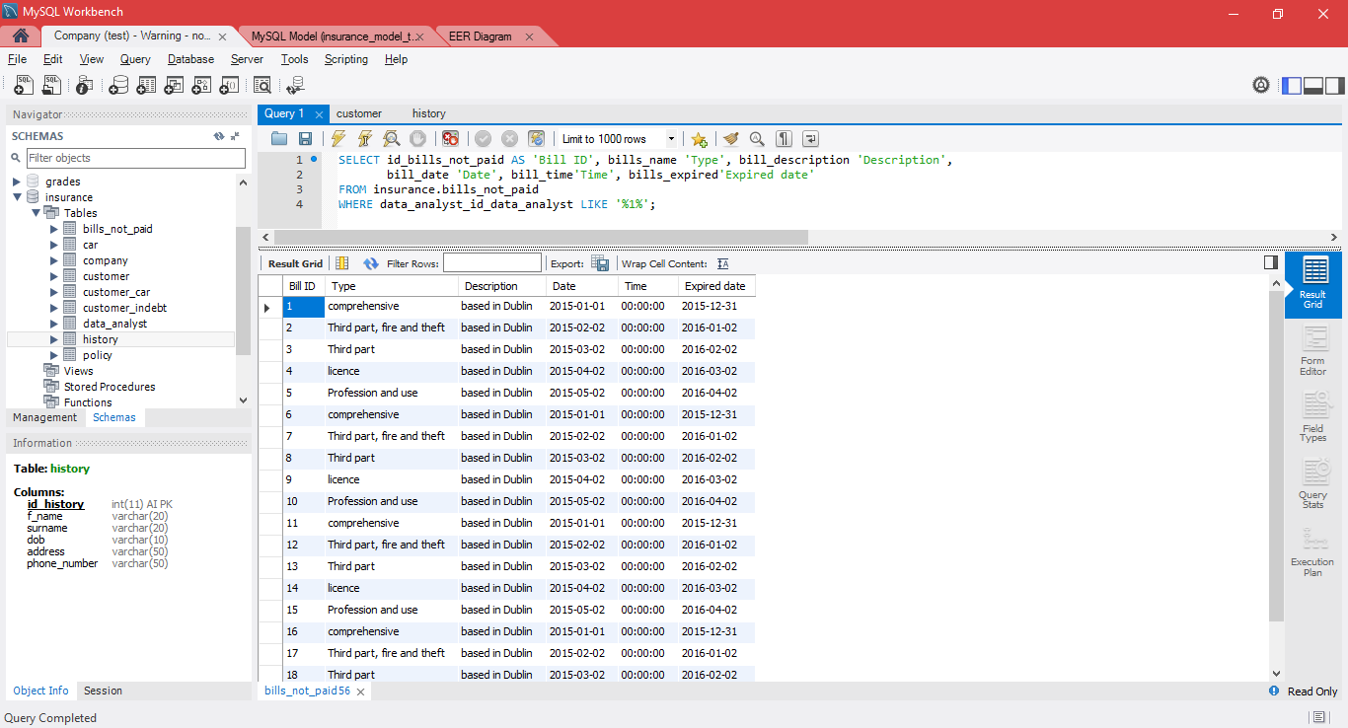

Deliverable 7:

At the command prompt (admin): This command will:

Create a customer_backup.sql:

C:\WINDOWS\system32>cd\
C:\>cd xampp\mysql\bin
C:\xampp\mysql\bin>mysqldump -u root -p insurance customer > C:\Users\Ennio\Desktop\customer_backup.sql
Enter password:

Drop the table customer:

MariaDB [(none)]> USE insurance;
MariaDB [(insurance)]> SET FOREIGN_KEY_CKECKS=0;
DROP TABLE customer;

Recover the table customer by select the backup source saved previously:

MariaDB [(insurance)]> SOURCE C:\Users\Ennio\Desktop\customer_backup.sql;
MariaDB [(insurance)]> SET FOREIGN_KEY_CKECKS=1;

At the command prompt (admin): This command will:

Create a policy_backup.sql:

C:\WINDOWS\system32>cd\
C:\>cd xampp\mysql\bin
C:\xampp\mysql\bin>mysqldump -u root -p insurance policy > C:\Users\Ennio\Desktop\policy_backup.sql
Enter password:

Drop the table policy:

MariaDB [(none)]> USE insurance;
MariaDB [(insurance)]> SET FOREIGN_KEY_CKECKS=0;
DROP TABLE policy;

Recover the table policy by select the backup source saved previously:

MariaDB [(insurance)]> SOURCE C:\Users\Ennio\Desktop\policy_backup.sql;
MariaDB [(insurance)]> SET FOREIGN_KEY_CKECKS=1;

Deliverable 8:

USE `insurance`;

DELIMITER $$

DROP TRIGGER IF EXISTS insurance.customer_AFTER_INSERT$$
USE `insurance`$$
CREATE DEFINER = CURRENT_USER
TRIGGER `insurance`.`customer_AFTER_INSERT`

AFTER INSERT ON `customer`
FOR EACH ROW
BEGIN
INSERT INTO insurance.history (f_name, surname, dob, address, phone_number)
VALUES (new.f_name, new.surname, new.dob, new.address, new.phone_number);
END$$
DELIMITER ;

Insert into the table customer
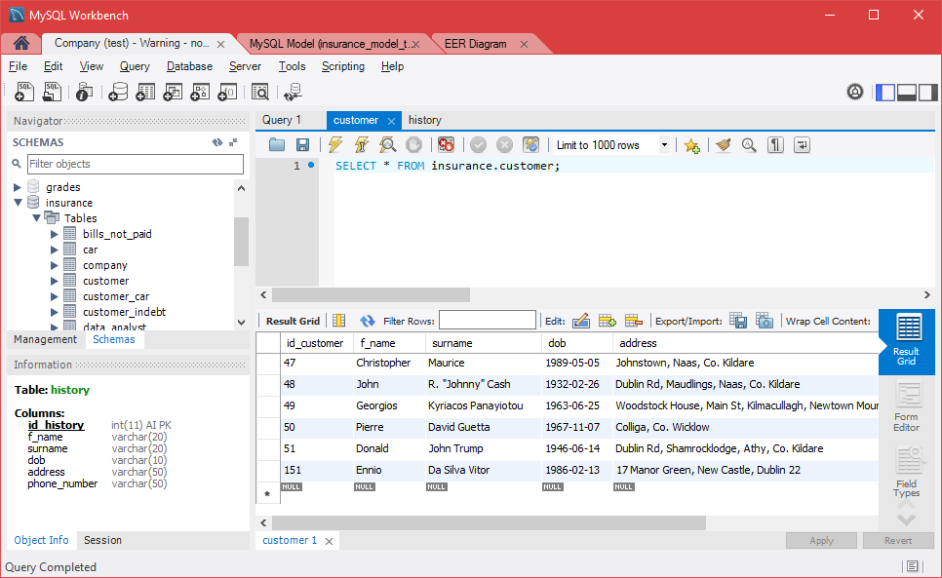

Trigger worked and the data is saved in the table history too.
