Student name: Ennio da Silva Vitor Student number:

Reports

1st Report:

SELECT bills_name AS Bills, bills_expired AS Expired_date
FROM bills_not_paid
WHERE bills_expired = '2015-12-31' OR bills_expired ='2016-01-02'
ORDER BY bills_name
;

This report is showing the list of bills that are expired from 2015-12-31 and 2016-01-02,
also the list is sorted by the name of the bills.
With this report we can identify at that time, the type of bills that have not been paid.

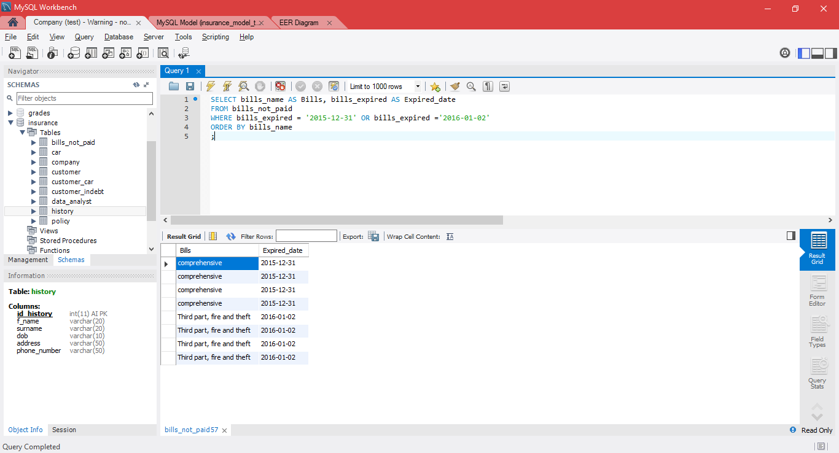

2nd Report:

SELECT f_name AS Name, surname AS Surname, address As Address,
phone_number AS Phone, bills_not_paid_id_bills_not_paid AS Bill_ID
FROM customer C
INNER JOIN customer_indebt c_i
ON c.id_customer = c_i.customer_id_customer
WHERE C.address LIKE "%Dublin 4%"
;

This report is JOIN the table customer with the table link customer_indebt.
By select those two tables we can visualize the informations of the customer and the bill id of each unpaid bill that is connected to them.

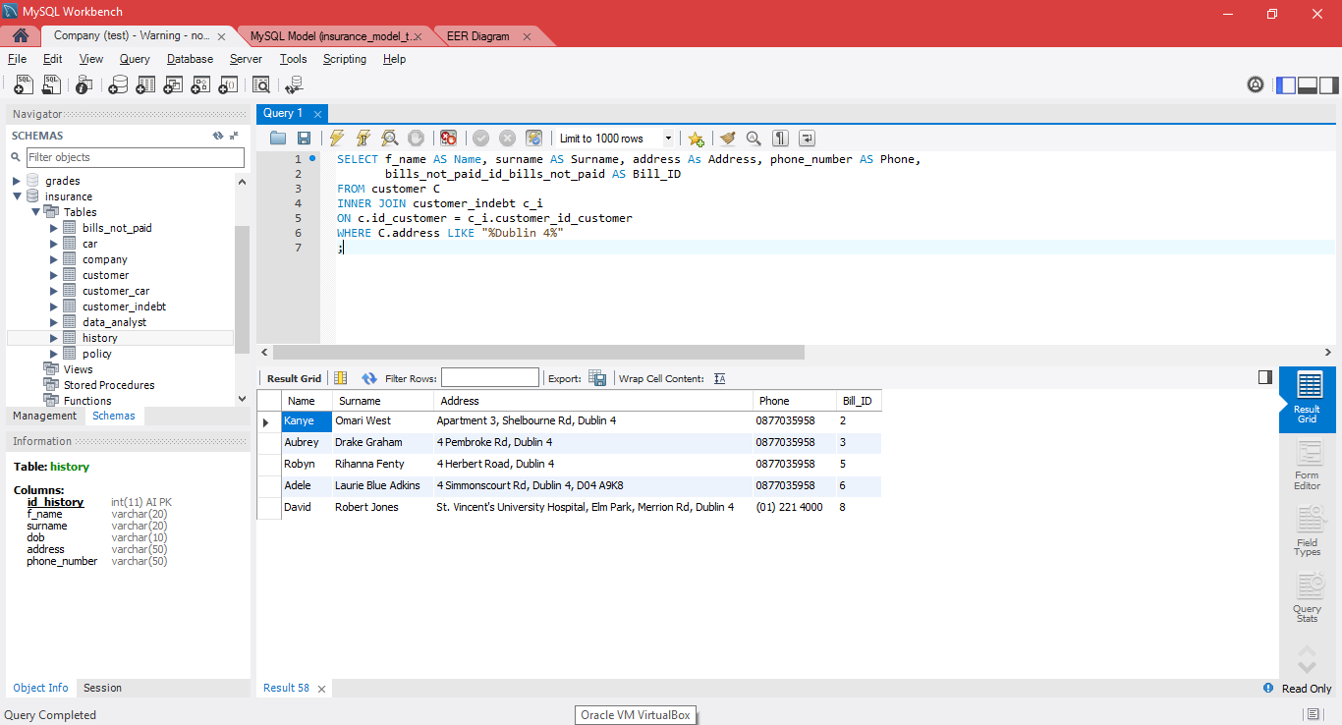

3rd report:

SELECT id_policy AS 'Policy ID', policy_description AS Description,
policy_expired_date AS 'Expired date', policy_price*1.3 AS 'New Price'
FROM policy
WHERE policy_expired_date = '2015-12-31'
;

This report is selecting the columns ip_policy, policy_description, policy_expired_date and policy_price from the table policy, but the rows will only be selected where the policy_expired_date is equal to 2015-12-31, because to this report, we are adding 30% on the normal price for the customers that did not pay the policies until the expired date from that time.

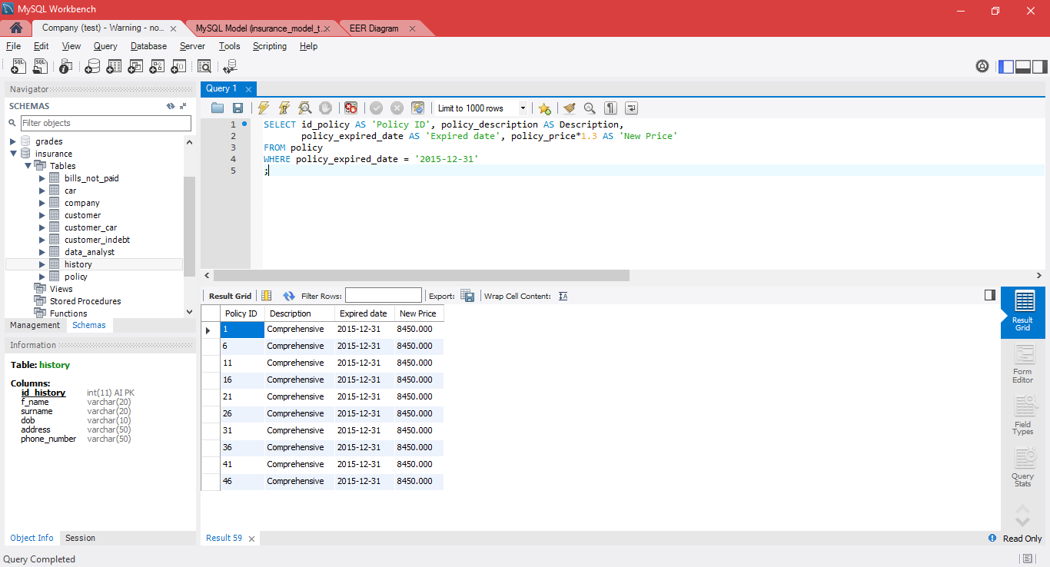

4th Report:

SELECT LEFT(f_name, 1) AS 'Name', UPPER(surname) AS 'Surname',
dob AS 'Data of birth', SUBSTRING(address,1,40) AS 'Address'
FROM customer
WHERE dob >= '1990-01-01' OR address LIKE "%Dublin 24%"
ORDER BY dob
;
This report shows the Name, Surname, Data of birth and address of customer that burn from 1990-01-01 or that they live in “Dublin 24” . The report is ordered by the date of birth and to set a format to the report the commands LEFT, UPPER and SUBSTRING were used to format the columns that contains values set as VARCHAR.
To the column name: we want only the 1st letter of the name.(LEFT command).
To the column Surname: We want all the words in uppercase.(UPPER command).
And to the column address: We want the first 40 indexes from the 1st index.

