*Index No- AG/GT/2012/3502*

**The rationale for ecological sanitation**

1. Background

Ecological sanitation, shortly called as “EcoSan” strives to bring the elements contained in wastewater streams back into the natural cycle. It is not a one specific technology. It is a multidisciplinary approach including sanitary engineering, logistics, social sciences, financing, management, agriculture, hydrogeology and *etc*. Actually it is a new philosophy. A paradigm shift in this century. In general sanitation people consider only about health, life quality and the environment. EcoSan is advanced than that. It is based on a holistic view of material flows. EcoSan gives sanitation solutions under major five categories. Those are socio-cultural, technical, economic, environmental, human health and institutional.

EcoSan talks about a closing loop. Waste is no more a waste it is a resource. Ecosan products can be used for various purposes such as N, P K as fertilizer, Organic matter as soil improver and water as irrigation purposes. We excrete the same amount of nutrients that we take up in our diet (except for children who retain a small proportion for growth of bones). The amount of excreted nutrients by one person is the same amount that is needed as fertiliser to grow the food for that person. It is such a beautiful well-balanced loop.

But it is sad to say Sri Lanka has not still embraced these concepts. We have conventional sanitation yet. It is an open system. Mostly it has a centralized waste water treatment system. It focuses on treatment and discharge, “Flush-and-forget” or “Drop-and-store”. But EcoSan focuses on sustainability. People think this only deals with toilets or about a specific toilet or waterless sanitation. Some think this is a solution for poor, developing areas not for rich. No, those are apparently incorrect. There are lots of misconception about EcoSan. If so what EcoSan consists of for real? Basically it is about excreta management (faeces, urine), greywater management, industrial wastewater treatment, solid waste management and storm water management. EcoSan plays a major role in all those areas. It talks about waste streams such as urine, faeces, grey water, anal wash water and conventional domestic waste water. Separation of those streams is the most important and essential step to do. There are different treatment methods, disposal methods and reusing ways are there. EcoSan products give a complete fertilizer including N, P and K. In addition to those nutrients S, K, C and Mg are there as macro nutrients and some micro nutrients too.

Why there is a need for EcoSan? There is a sanitation crisis prevailing in the world now. Environment has been seriously damaged with this increasing population. Diseases are spread by improper sanitation practices. So we want high-tech, advanced waste water treatment plants to have right amount of pure water at right moment in right quantity. That is why we need EcoSan.

1. Present status of EcoSan

Despite intense activities and great achievements in terms of reaching the Millenium Development Goal (MDG) on safe drinking water and basic sanitation, there are still 2.5 billion people in the world that lack access to improved sanitation. Around 1 billion people are still practicing open defecation. The number of deaths that can be contributed to sanitation-related diseases is still on average around 2 million per year of which children under 5 years are the most affected group. About 2.4 billion people globally live under highly unsanitary conditions and have such poor hygiene behaviors. Water stored at home is frequently contaminated by inadequate water management in the home. These issues are receiving increasing attention, but still a need for greater mobilization of resources and involvement of decision-makers at all levels.

WHO takes the initiation in environmental sanitation and hygiene action over the past years and developed some key materials intended for policy-makers and technical people dealing with these issues. These materials include guidelines, best practice documents and promotion materials. [6th South Asian Conference on Sanitation (SACOSAN VI) was be held at Dhaka, Bangladesh](http://www.susana.org/en/events/past-event-pages/details/64) on 11-13 Jauary 2016 in Dhaka with motto of "Better Sanitation, Better life".

“South Asian Conference on Sanitation (SACOSAN), a government led biennial convention held on a rotational basis in each SAARC country provides a platform for interaction on sanitation. SACOSANs are intended to develop a Regional agenda on sanitation, enabling learning from the past experiences and setting actions for the future. The objectives of such conferences are to accelerate the progress in sanitation and hygiene promotion in South Asia and to enhance quality of people's life. The SACOSAN process is instrumental to generate political wills towards better sanitation in the region. South Asian countries namely; Afghanistan, Bangladesh, Bhutan, India, Maldives, Nepal, Pakistan and Sri Lanka are the participating countries. The first conference was held in Bangladesh in 2003, the second in Pakistan in 2006, the third in India in 2008, the fourth in Sri Lanka in 2011 and fifth the fifth in Nepal in 2013. The sixth SACOSAN will be hosted by Bangladesh from 11-13 Jauary 2016 in Dhaka" (http://www.susana.org)

1. World scenario of EcoSan

A new United Nations resolution aims to take efforts to attain the sanitation Millennium Development Goal (MDG) target. Otherwise the world will miss the MDG sanitation target by almost 1 billion people. The Sustainable Sanitation 5 Year Drive to 2015 (5YD) was conceptualized by the United Nations Secretariat Advisory Board (UNSGAB) members.  According to (Dietvorst, 2011) The needs to keep sanitation high on the political agenda, promote national coordination, improve sanitation monitoring while supporting sustainable sanitation solutions.

The Sustainable Sanitation Alliance (SuSanA) provides a networking, sharing and knowledge management platform to the actors in sanitation who are working hard to solve the sanitation crisis. SuSanA supports open dialogue through the open discussion forum where shared learning can take place with questions, answers, opinions and experiences being shared among the community members.

1. Sri Lankan scenario of EcoSan

Sri Lankan Government said the island had achieved the United Nations’ Millennium Development Goals on water and sanitation that targeted a coverage of 84.5 percent by 2015, three years ahead. Sri Lanka had a total coverage in water and sanitation of 85.5 percent in 2011 and had set its own target to reach 100 percent by 2020.  Sri Lanka’s access to quality drinking water is around 82 percent and access to pipe-borne water in 2011 is over 40 percent. We have an annual target of two percent to increase the pipe-borne water supply. Sri Lanka is confident of achieving this target easily, because of reconstruction programs are centered to provide better sanitation and quality water supply for all people. While Sri Lanka tops the other countries in South Asia with improved sanitation facilities and safe drinking water, many in India, Bangladesh, Pakistan, Nepal, Afghanistan and Bhutan die and suffer due to water and sanitation-related health problems.

Though we have a good island wide coverage for water and sanitation, there are pockets in slums, the coastal belt and the estate sector where more attention needs to be paid to improving access to safe drinking water and sanitation.  New projects are to start to provide safe drinking water for the people in the coastal belt. These projects cover the entire island including Matara, Hambantota, Batticaloa, Jaffna, Trincomalee, Mannar, Gampaha and Kandy. Slum dwellers are also to get access to pipe-borne water, but there is a problem here as most slums are regarded as temporary structures, prevents the Water Board from providing them with a piped water supply. Providing quality drinking water and better sanitation facilities is important as a preventive tool to many water and sanitation-related illnesses. Improving school sanitation is another important area that needs urgent attention as there are over 1,299 schools with poor sanitary facilities. It has become a serious issue due to poor maintenance. Of the 1,299 schools, there are a few schools which don’t have any toilets, but the majority suffer due to poor maintenance. However, the Ministry together with the Ministries of Education and Health has plans to address the issue of school sanitation. Building a toilet is not the only issue as it needs better maintenance, to sustain the facility. The Government alone cannot address this issue and needs the support of the school authorities, parents, the community and the students. We need to increase the number of toilets and rest-rooms in schools. Providing better sanitary facilities for girls’ schools is another important requirement.  Some NGOs are helping improve sanitation in rural schools. Unicef Sri Lanka is in action for water and sanitation. Apart from that, the Ministry is also involved in a program with the Samurdhi Authority to build toilets in rural areas through our Community Water and Sanitation Project. Thousands of toilets have thus been built by a rotating fund. Here the community is playing a vital role by taking part in building toilets to their own communities. It is easy to manage these projects when the community in that area is given the opportunity to manage their own affairs. Under this project, we have been able to build toilets, village by village. Public toilets, which are built at transport points, are in poor condition due to poor maintenance. The responsibility of maintaining them lies with the local authorities, who should pay attention to improve the quality of their services. In Sri Lanka there is only five percent access to drainage systems which is a serious issue. This need to be tackled soon as it contaminates the ground water resources. Every family has access to a toilet in Sri Lanka, but that does not mean that every family has its own toilet. Over 200,000 people still practice open defecation, especially in the coastal belt, rural villages and plantation sectors. Of the 20 million population, over 1.4 million people do not have safe toilet facilities. The value for improved sanitation facilities (% of population with access) in Sri Lanka was 92.30 as of 2012. As *Figure1* below shows, over the past 22 years this indicator reached a maximum value of 92.30 in 2012 and a minimum value of 67.60 in 1990.

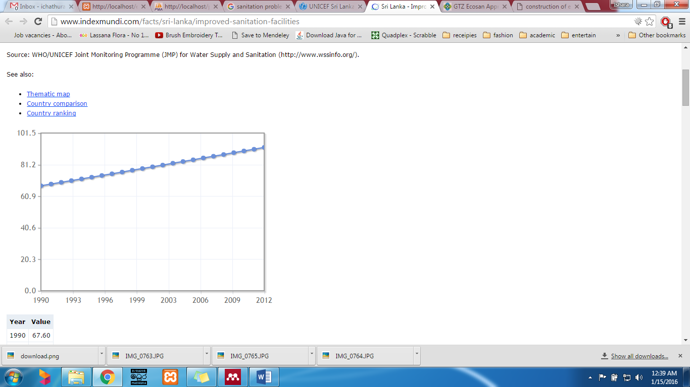Source: WHO/UNICEF Joint Monitoring Programme (JMP) for Water Supply and Sanitation (http://www.wssinfo.org/).

Figure 1- Sri Lanka - Improved sanitation facilities

Though we are forward in South Asia region, we are way behind when compared to other developed countries. We have targeted only for sanitation not for sustainable sanitation. While the world is trying to turn conventional sanitation system into EcoSan we are still trying to provide toilet facilities to each individual in the country. People still do not know about this concept and we will have to try hard to convince them for this.

1. An example

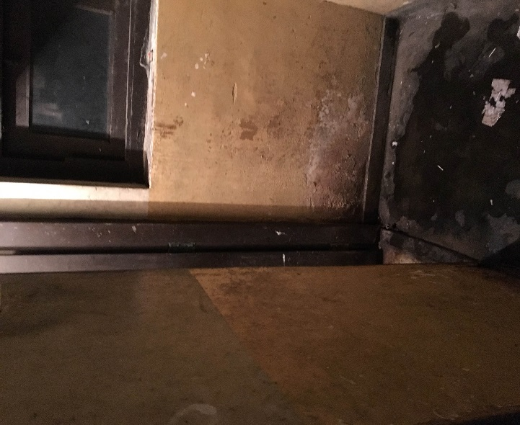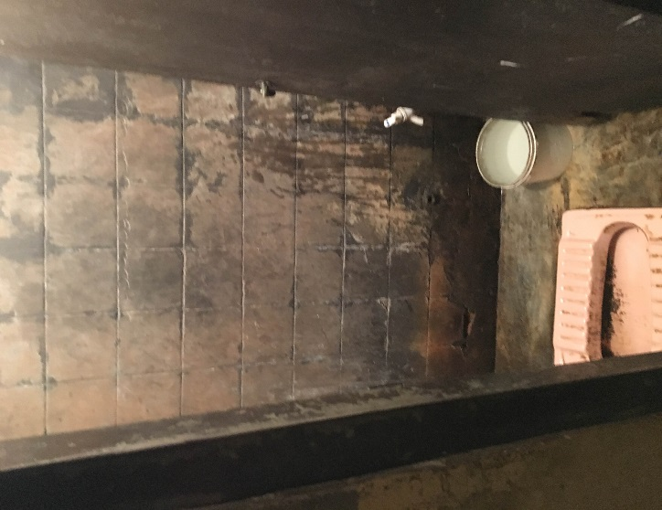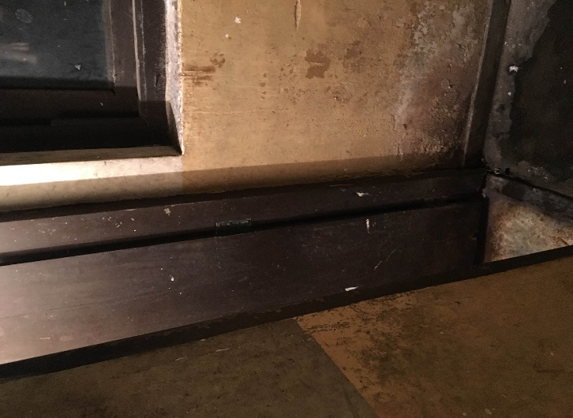I took my example the latrine at Ambalangoda shopping complex run by Urban Council. It is not open to public only for the shopkeepers. Around 20 people use this. There are Sinhalese, Muslims and also male, female among them. But they all have only single pit latrine. *Figure 2* shows it.

Figure 2 Pit latrine at Ambalangoda UC Shopping complex

It is true that this should be maintained by Urban Council since they pay a tax for them for building maintenance. But in my point of view, they can get together, collect money and replace this properly since those few people are the only users. Customers face problems when passing by this toilet. And you won’t believe these people still use this latrine daily. They do not care about the hygiene. These are the attitudes we have to change in Sri Lankan scenario. In one side the government does not want to and in the other side people do not want to change. Only a little effort is needed to repair this and have a proper toilet here.

First there should be two separate toilets for male and female. Limiting factor here is the space. Since there is no one responsible for cleaning or maintain, we should go for a latrine that requires less attention. If it is in an organization there is no problem as there are allocated cleaning staffs for that. I recommend to have one rubber curtain urinal for men as on *Figure 3.* Reasons that I selected it, are;

* + Quick and easy to clean
  + Does not need frequent and costly replacement of blocking fluid
  + Can be inspected without losing blocking fluid
  + Much less likely to develop hard blockages

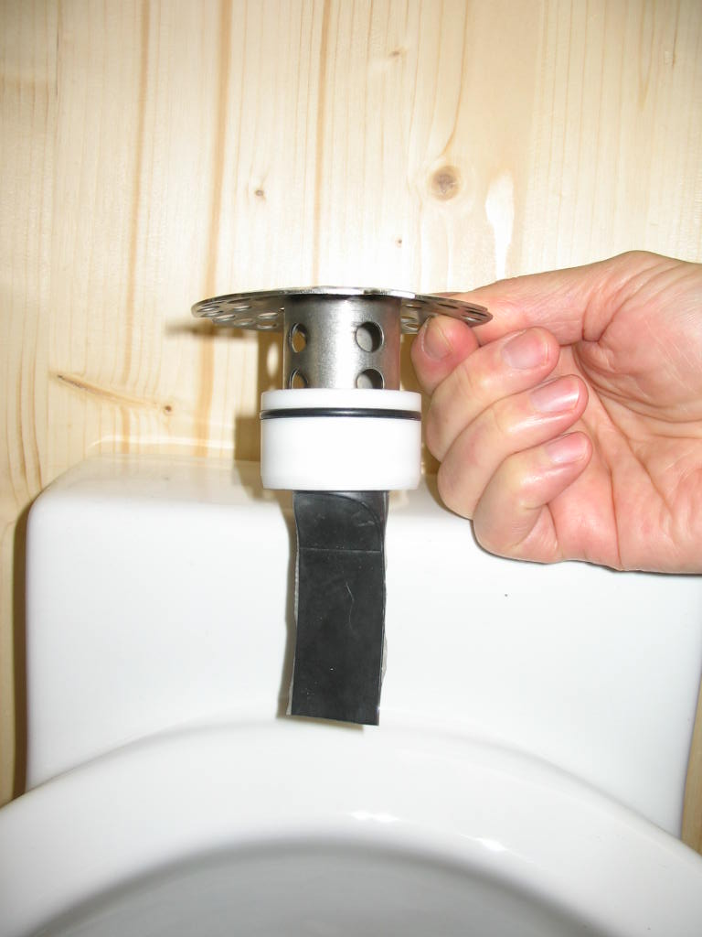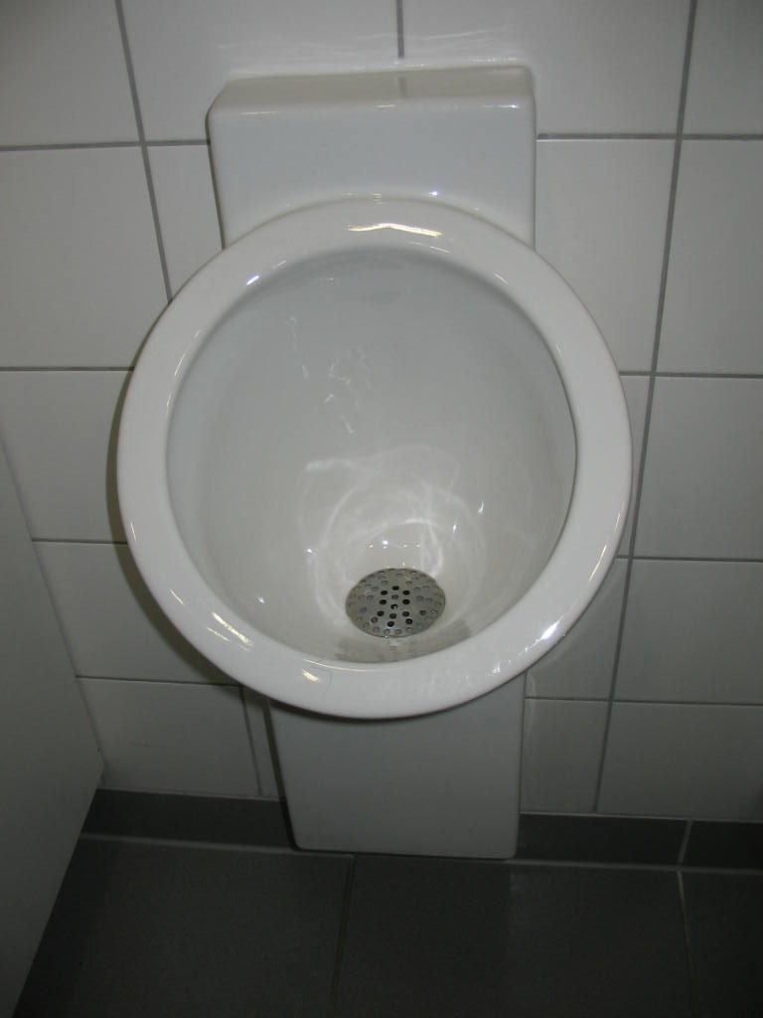

Figure 3 Rubber curtain Urinal

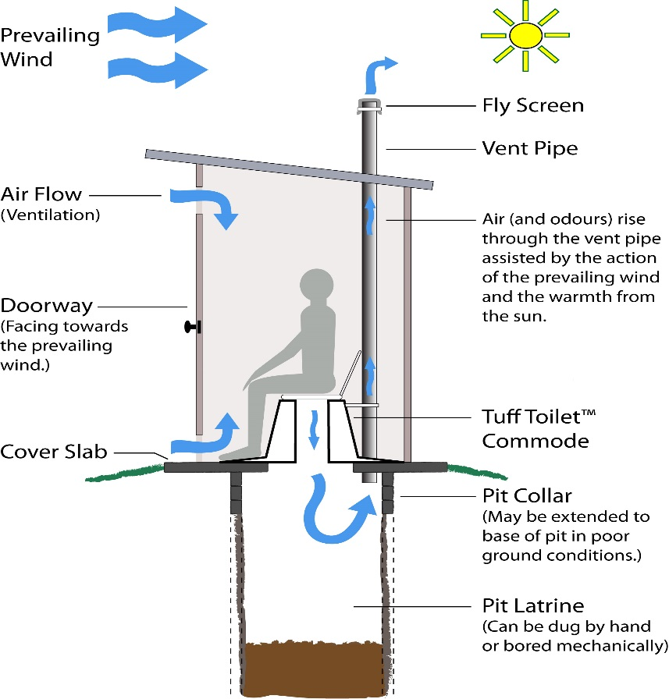

Figure 4 VIP toilet

And we can have a VIP (Ventilated Improved Pit) toilet there. Since there is a space constraint, single VIP would be suitable. *Figure 4* explains the mechanism of a VIP toilet. It naturally controls the odor, significantly reduces pathogens and flies are also controlled by fly screen. It can be built and repaired with locally available materials. It does not require constant source of water. There is a potential for storing faecal materials as soil conditioner.

References

<http://www.susana.org/en/>

<http://www.ircwash.org/news/sustainable-sanitation-five-year-drive-2015-0>

<http://www.sundayobserver.lk/2011/04/03/fea02.asp>

<http://www.indexmundi.com/facts/sri-lanka/improved-sanitation-facilities>

<http://www.unicef.org/srilanka/activities_883.htm>