

**ffxgdfgfxedgEnvironmental awareness and motivation programme for schools**

.

BSc Green Technology (UG),

University of Ruhuna

Most of the people in our country don’t think about the nature. They throw garbage everywhere, cut down more trees and they only rush for their success. Even though people want a supervision about the value of the environment, as undergraduates it is difficult to address the elders directly and change their minds or attitudes. But we can change the attitudes of the younger generation and small children who are still attending to the school.

As Green technology undergraduates in University of Ruhuna, our purpose is to make nature friendly people in Sri Lanka. For that our 1st program was held in Deniyaya Central College. 2nd one in our faculty, 3rd one again in a Deniyaya college, 4th one in Kaluthara vidyalaya and 5th one in Mathugama. We hope to continue our program all over the country with the collaboration of Help-o Eco Green company Ltd.

1

Introduction



2

Project Goal

Make a nature friendly relax minded young generation.

3

Project Objectives

1. Give knowledge to the students about the environment and aware them about the effects of destroying environment.
2. Teach them what are the environmental problems aroused today.
3. Aware how to get rid of these environmental problems.
4. Aware how to keep environment clean with their other problems.
5. Give knowledge about the new environmental concepts and make desire to learn the subject.
6. To aware the subject of Green Technology and why they must learn and try to get actions according to it
7. Teach them to get this idea to the society and also to their family members first.

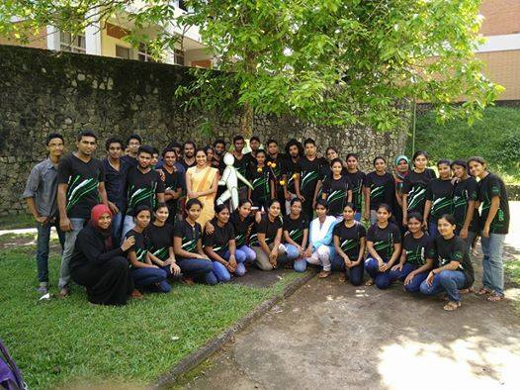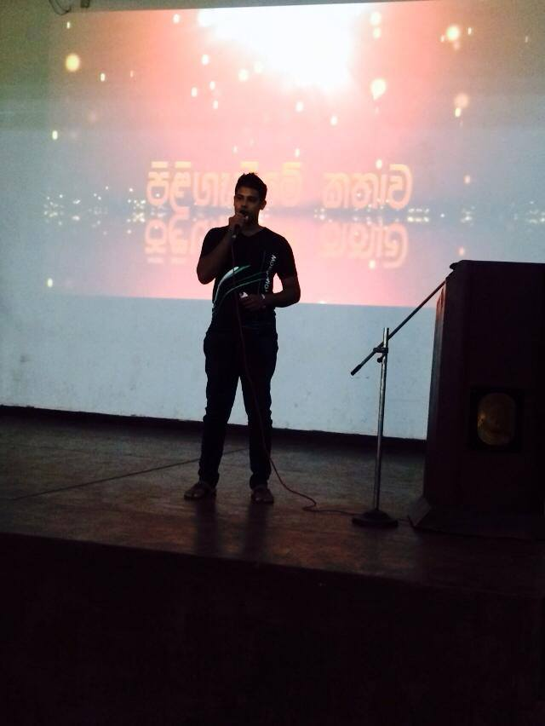

4

Project Activities

1. Power point based lectures to give knowledge on the environment, problems in today and how to get rid of it.
2. Open conversation on the all the problems the students have and give solutions.
3. Drama on the environmental protection and young generation.
4. Various games and activites
5. Prizes awarding questions at last to check the awareness.
6. Tree planting or compost preparing field programme with the participation of students.
7. Check the sustainability of the field work via phone calls,mails and social media.

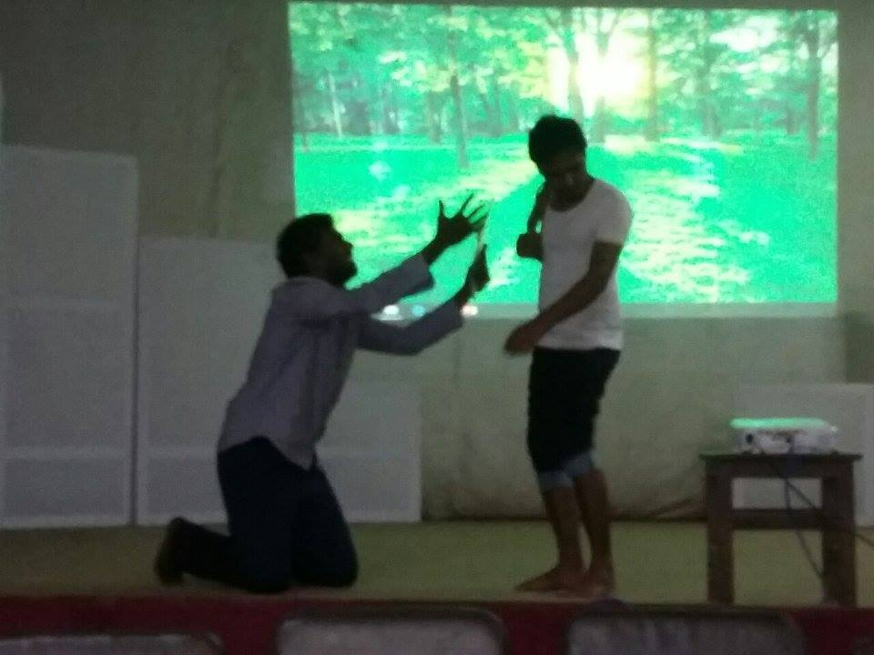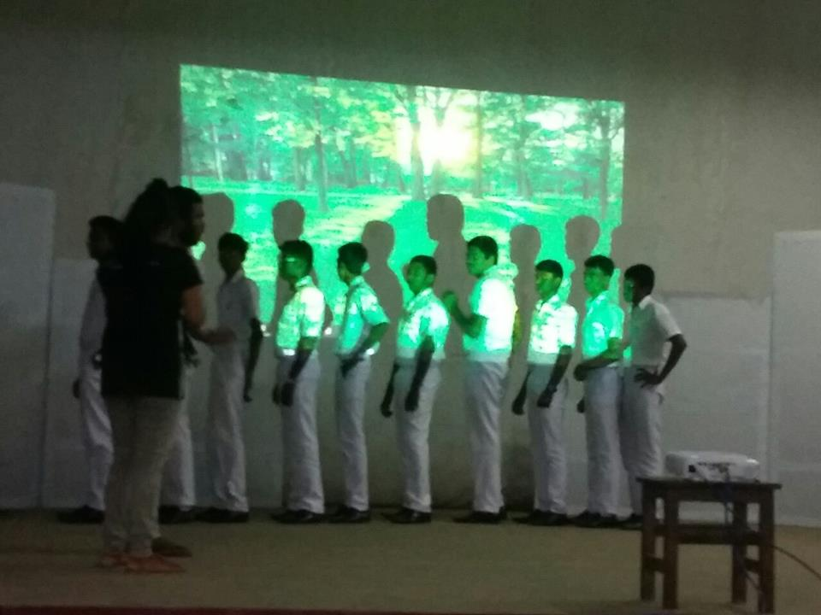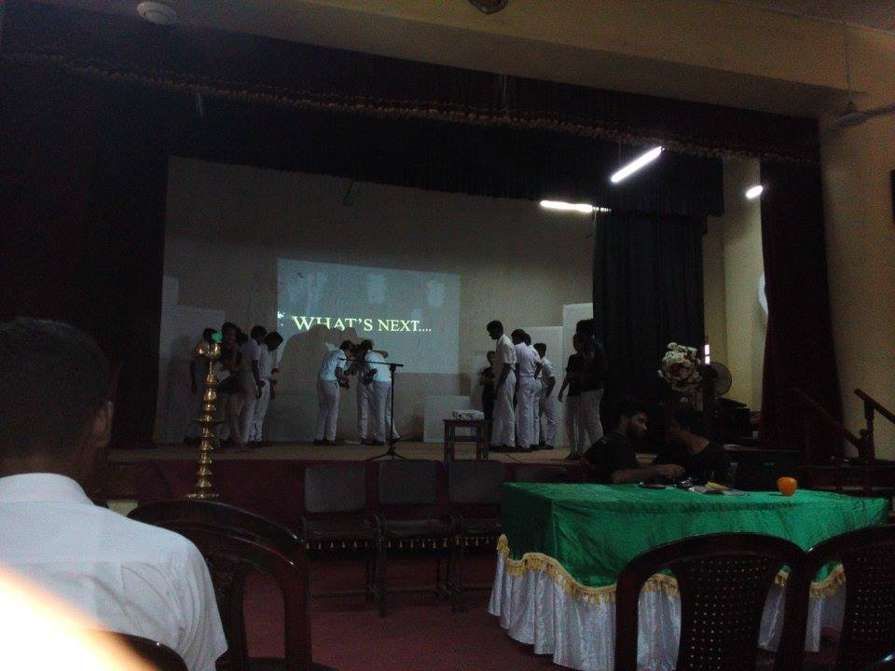

5

Project Sustainability

Participants for the project are the 1st, 2nd, 3rd and 4th batch of BSc Green Technology course, University of Ruhuna. We hope to do two programs per one month. We select the areas from anywhere in Sri Lanka. We are hoping to give priority to requested schools. After doing two programs, we are hoping to make a report including the success and failures and with the suggestions to recover all the failures. All the field works we have done in the schools will be displayed on social media and reported. We hope to identify new field works that can be practiced in the schools. All the programme schedule and activities will be updated according to the area, school and the target audience under the main activity list we mentioned before.



7

Budget.

Per month

* Transport cost = 50000.00

(25000 per bus* 2)

* Food cost per participants – (50 students from university)* 1000 per day = 50000
* Refreshmets for participants – 100 per one student* 150 = 15000* 2 = 3000

Have to update

6

Time Frame.

2 programs per month will be held.

Have to update